Create http application balancer with auto scaling

(my screenshot of application load balancer with auto scaling)

First ,I created AMI

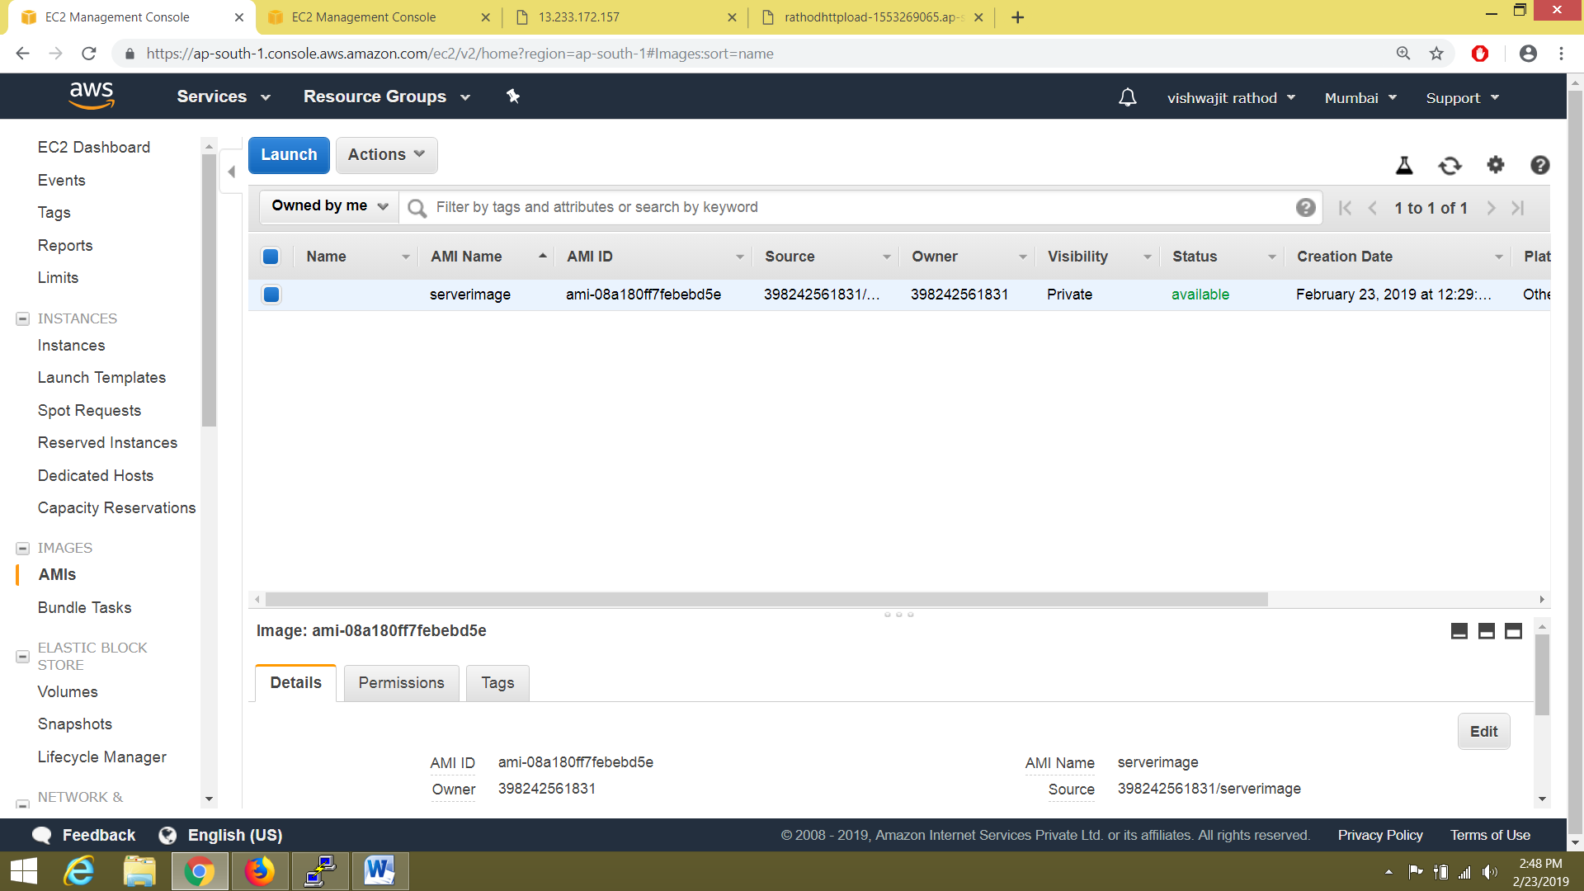

Then create auto scale launch configuration using that AMI

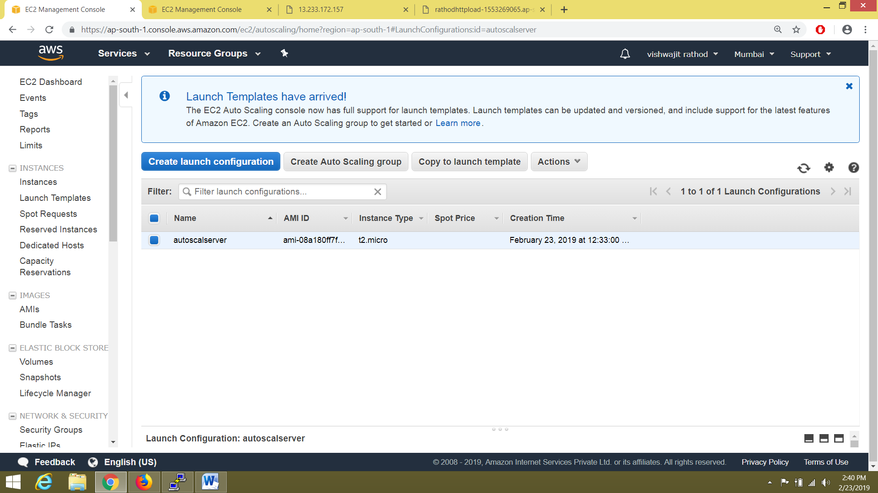

Then I create http load balancer and target group

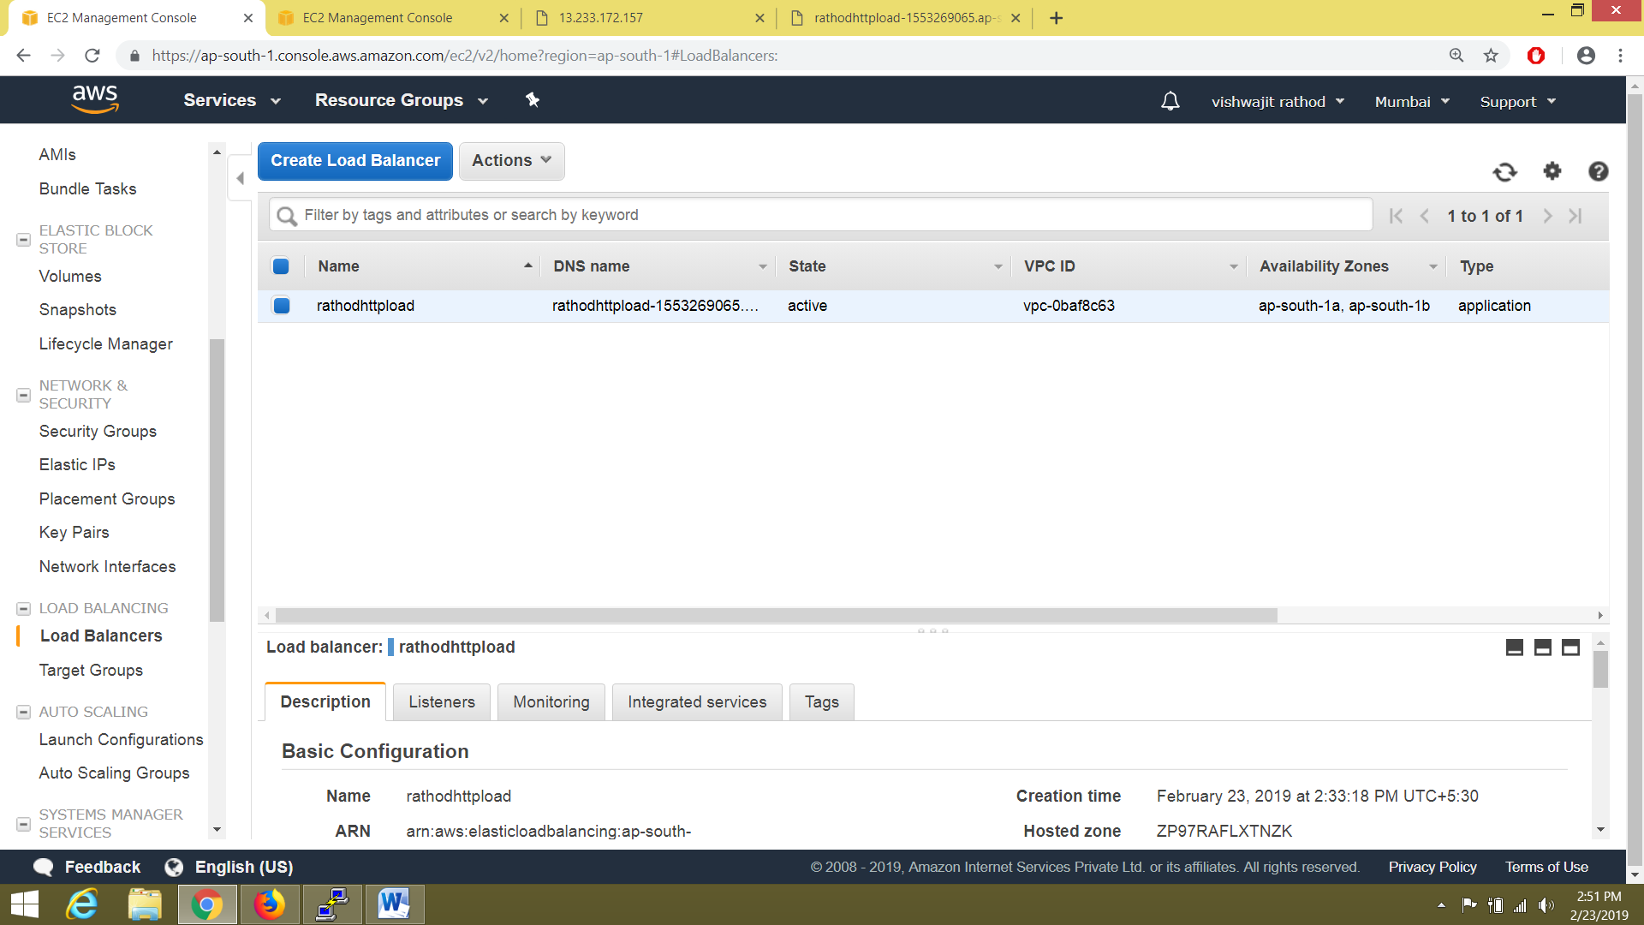

Then create auto scaling group and in this select target group which I created in application load balancer

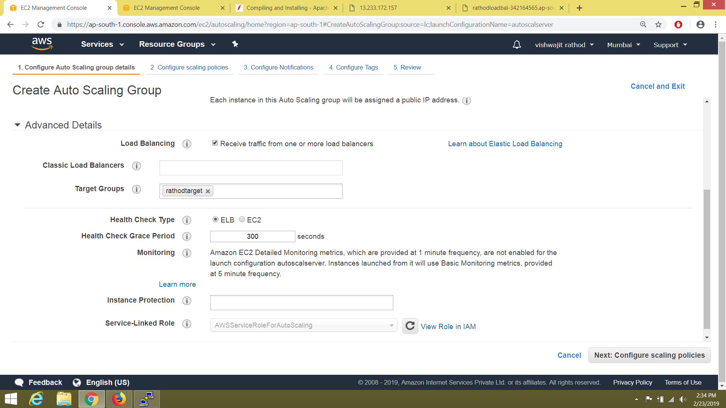

**Then I enter dns at browser ,my http load balancer working with auto scaling**



