Create classic load balancer with auto scaling

(my screenshot of classic load balancer with auto scaling)

First ,I created AMI

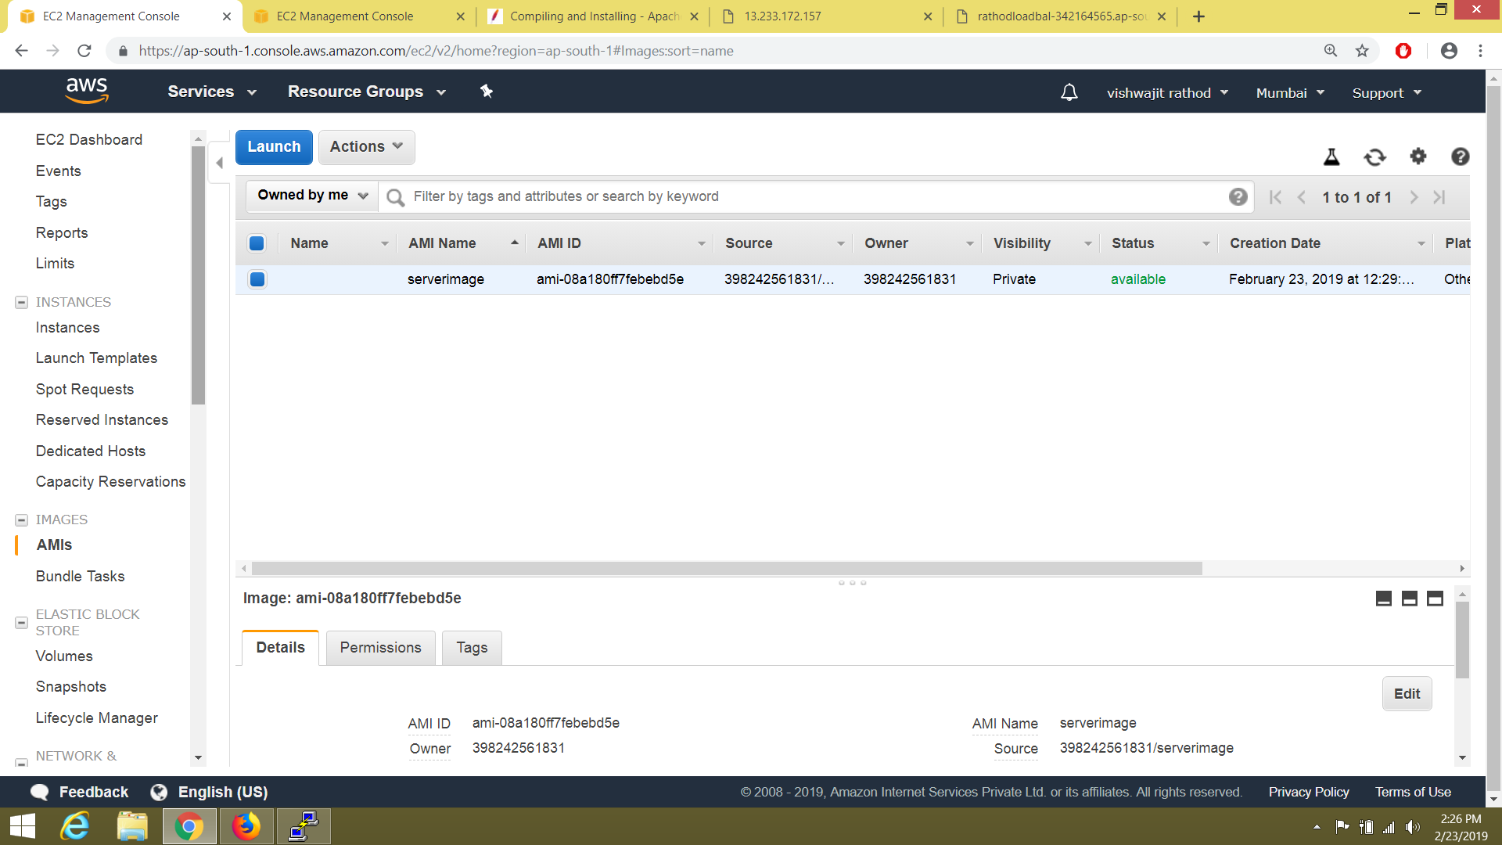

Then create auto scale launch configuration using that AMI

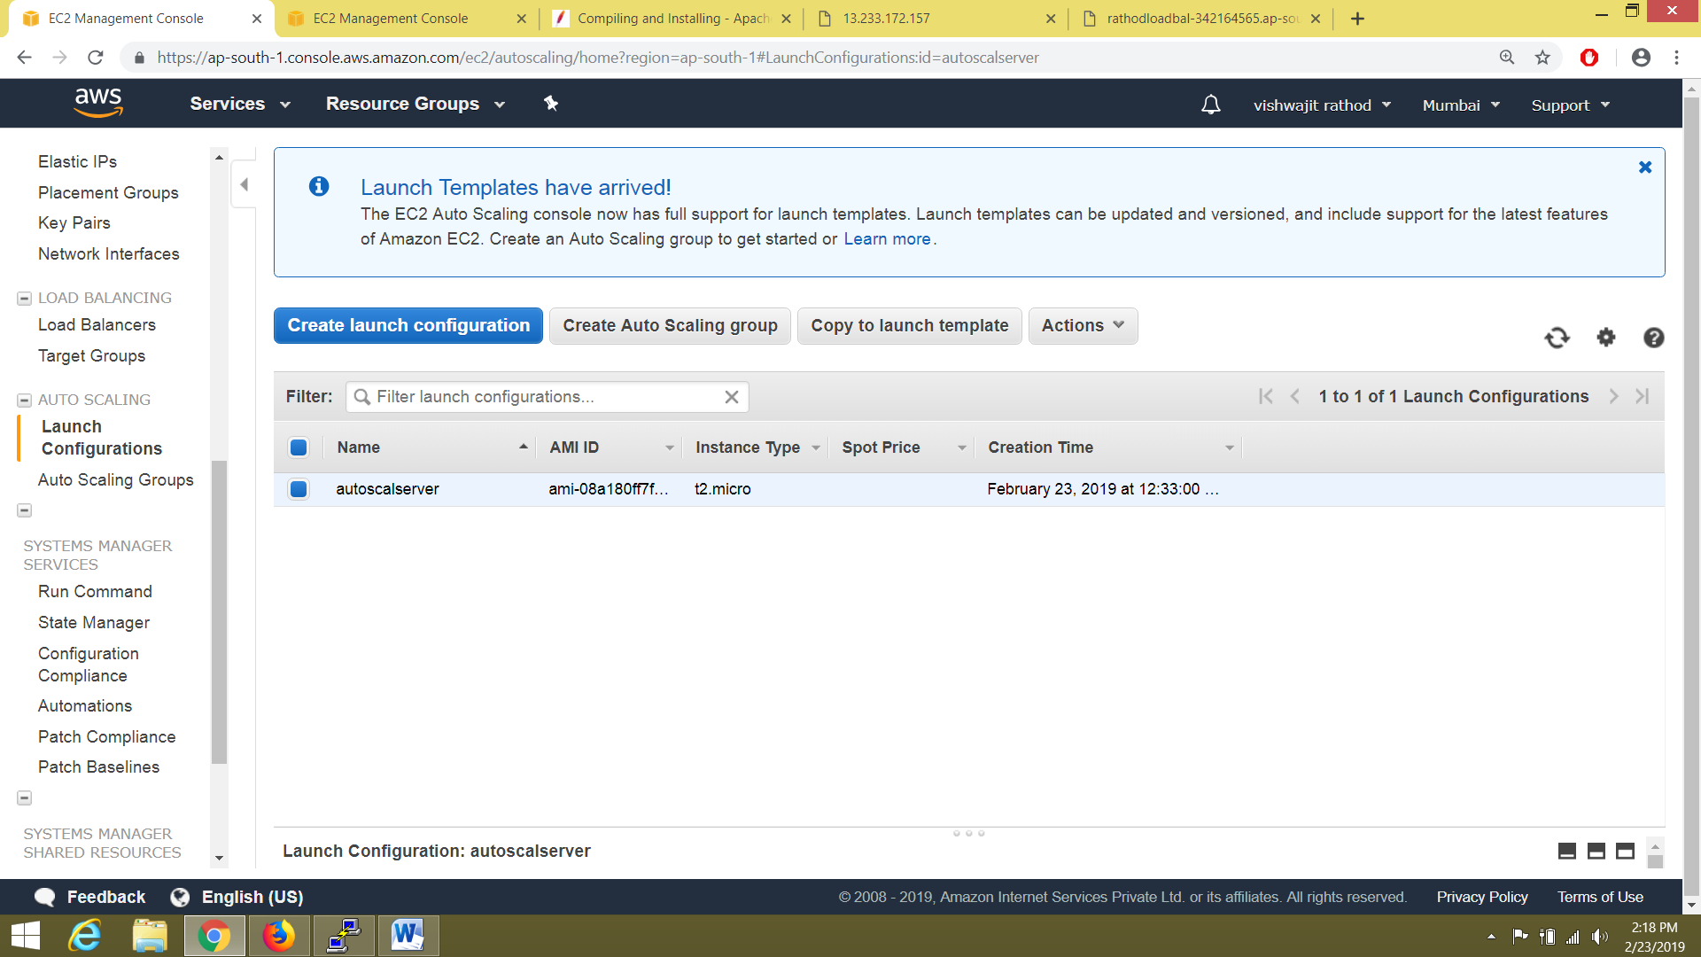

Then I create classic load balancer

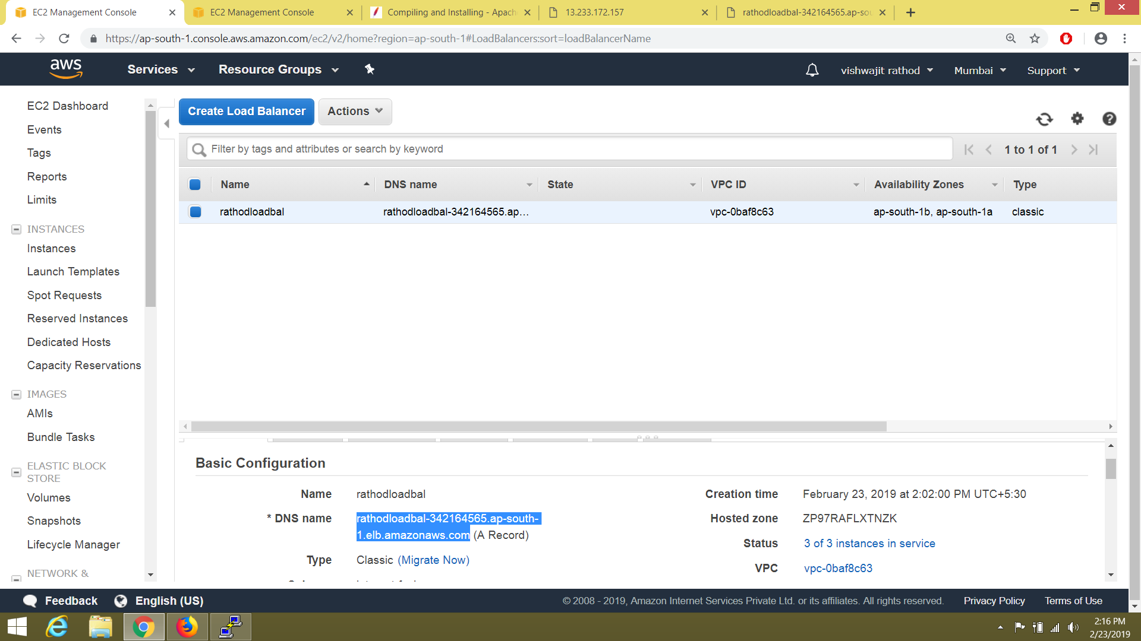

Then create autoscaling group

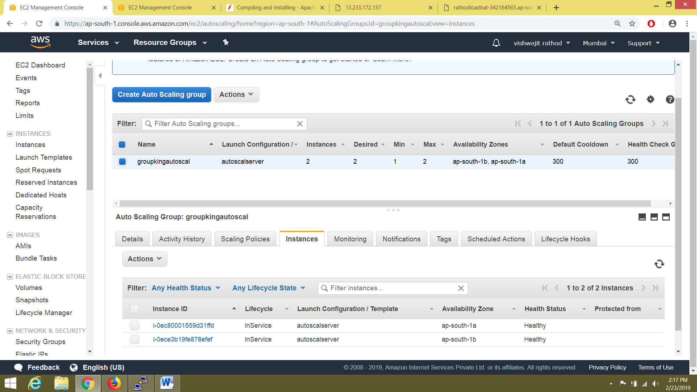

**Then I enter dns at browser ,my classic load balancer working with auto scaling**



