|  |
| --- |
| LockedMe.com  (Application Screenshot) |

Version History:

|  |  |
| --- | --- |
| Author | Vishwajit Jogalekar |
| Purpose | Screenshot of application |
| Date | 17th Aug 2021 |
| Version | 1.0 |

Contents

1.Main menu display

2. Display Files in ascending order.

3.Add new File

4. Delete files from directory

5. Search file

6. Exit From Application

1. Main menu display.

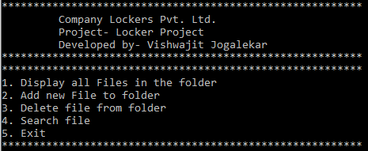

1. Display contents of file

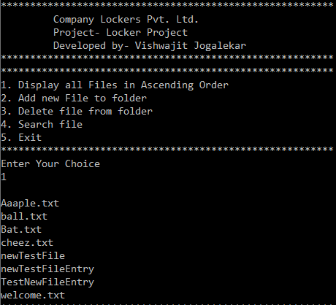

1. Add file to folder.

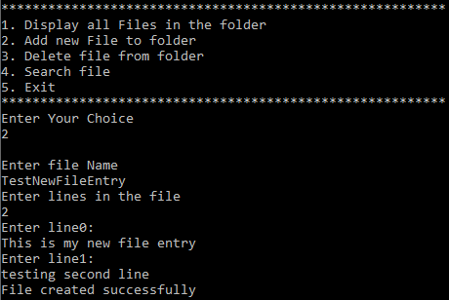

1. Delete file from folder.

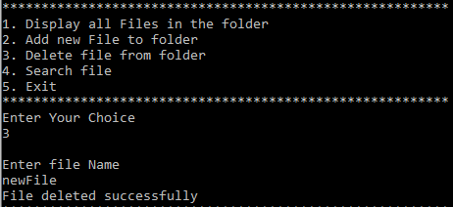

1. Search file in directory.

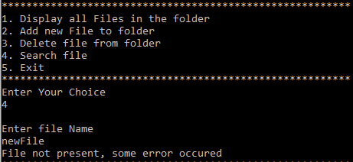

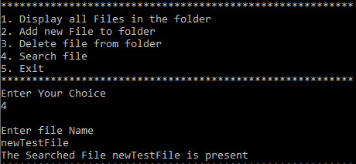

1. Exit from application

