AI IVR Voice Agent for Healthcare — Project Documentation
Date: 2025-10-22

1. Project Overview
This document describes a detailed design and implementation plan for a real-time AI-powered telephony voice agent for the healthcare industry. The agent will handle inbound/outbound calls, perform customer validation, answer benefit eligibility questions, provide doctor/appointment information, and assist with portal password resets. Core capabilities include speech-to-text (real-time), conversation intelligence, speech analytics, sentiment analysis, context understanding, automatic categorization, and summary generation.

2. High-Level Architecture
The architecture follows a telephony <-> AI streaming pattern. Core external systems include RingCentral (telephony), Azure OpenAI (LLMs), and supporting speech/analytics components. The included diagram shows components and data flows.
Architecture Diagram:
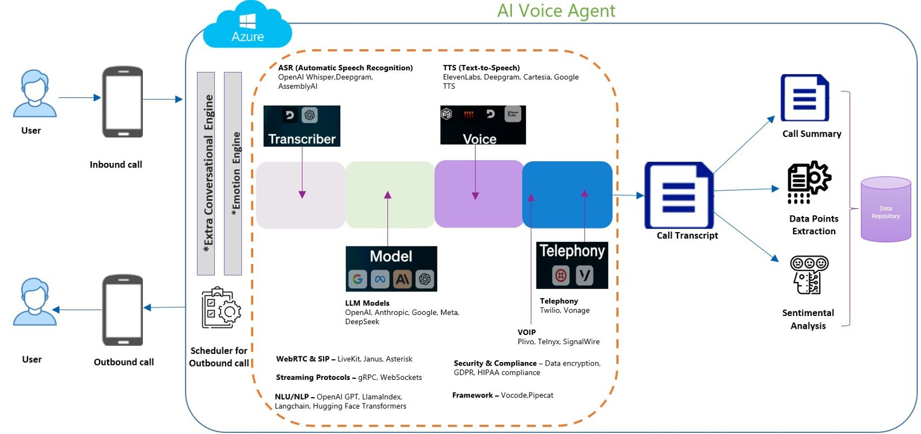

3. Business Use Cases
Primary use cases handled by the IVR AI agent:
• Benefit eligibility lookup — user calls, agent authenticates caller and determines coverage/eligibility details.
• Provider lookup & appointment scheduling — agent finds the right doctor, provides details, and helps schedule an appointment.
• Portal password reset — after validation, agent initiates secure password reset flow or sends portal reset link.

4. Functional Requirements
Core functional requirements:
• Real-time bidirectional audio streaming between RingCentral and AI services.
• Accurate speech-to-text conversion (target: ≥90% accuracy across scenarios).
• Robust speaker diarization and caller/agent labeling.
• Caller authentication and PII-safe verification flows.
• Contextual intent detection and slot-filling for appointment scheduling and eligibility checks.
• Summary generation and call transcript storage in the data repository.
• Sentiment analysis for both customer and agent on each call segment.
• Automatic categorization (e.g., eligibility, scheduling, password reset, complaint).
• Detailed logging, monitoring, and accuracy measurement across models.

5. Non-functional Requirements
• System must meet HIPAA & GDPR compliance where applicable (encryption at rest and transit).
• High availability (SLA depending on business needs; recommend 99.9% for telephony glue components).
• Low latency (sub-second response for streaming segments; end-to-end <5s for short responses).
• Scalability to handle concurrent calls with autoscaling components.
• Extensible model evaluation framework to swap and benchmark speech/LLM models.

6. Component Design & Technology Stack
Suggested components and technologies:
• Telephony / IVR: RingCentral Programmable Voice for PSTN/SIP bridging, call controls, webhooks, and media streams. Optionally use WebRTC for browser components.
• Realtime Media Gateway: A lightweight media relay (e.g., a custom WebSocket server or media pipeline) to connect RingCentral RTP to AI streaming endpoints (use gRPC/WebSocket).
• ASR (Speech-to-Text): Azure Speech Services (Speech-to-Text) for enterprise grade & compliance, or OpenAI Whisper / Deepgram as alternatives for research/benchmarking.
• LLM / NLU: Azure OpenAI (GPT-4o / GPT-4o-mini or suitable deployment) for intent understanding, context tracking, and prompt-run generation. Use local or hybrid models for privacy-sensitive environments.
• Conversation Orchestrator: A Python microservice (FastAPI) that orchestrates ASR transcripts, calls Azure OpenAI for intent, maintains context state, and issues TTS responses.
• TTS (Text-to-Speech): Azure Neural TTS or Eleven Labs (I will not use it as it will require paid services) for natural agent voices where permitted.
• Conversation Intelligence: A pipeline for transcript processing: diarization, sentence segmentation, entity extraction, summarization (LLM), categorization, sentiment analysis.
• Data Store: Encrypted object store for transcripts (Azure Blob Storage) and a relational DB (Azure SQL) for metadata and audit logs.
• Authentication & Identity: Use secure KYC flows: verify DOB, member ID, last 4 of SSN or policy number. Integrate with provider identity APIs.
• Monitoring & Analytics: Application Insights / Prometheus + Grafana for telemetry, model performance dashboards.
• Security & Compliance: TLS everywhere, key vaults for secrets (Azure Key Vault), role-based access control, audit logs.

7. Data Flow (Typical Call)
1. Incoming call received by RingCentral. RingCentral streams audio to the Realtime Media Gateway.
2. Gateway forwards audio frames to ASR (Azure Speech/Whisper) for incremental transcription (streaming).
3. Conversation Orchestrator receives transcribed tokens and maintains per-call context/state.
4. For each agent response: orchestrator calls Azure OpenAI (with prompt + context) for intent and reply generation.
5. Generated reply is sent to TTS for audio synthesis, then streamed back to caller via RingCentral.
6. Orchestrator logs transcripts, extracted entities, sentiment, categories, and summary to data store.
7. After call, conversation intelligence jobs run batch analytics, evaluation, and model benchmarking.

8. Model Strategy, Benchmarking & Accuracy
Approach: Evaluate multiple ASR and LLM models across representative datasets and live A/B testing to achieve ≥90% accuracy for critical tasks (ASR WER, intent classification accuracy, extraction F1).
Key steps:
• Create labeled dataset from sample calls (transcripts, intents, slots, sentiment labels).
• Benchmark ASR models: Azure Speech, Whisper (large), Deepgram — measure WER by call type (noisy, accented, medical jargon).
• Benchmark NLU models: Azure OpenAI, fine-tuned models , and open-source alternatives (Llama-based) for intent classification.
• Use precision/recall/F1 for entity extraction; measure intent classification accuracy and end-to-end task success (e.g., appointment successfully scheduled).
• Continuously log predictions and human-reviewed ground truth to compute rolling metrics and drive re-training or prompt changes.

9. Prompt Engineering & Conversation Templates
Design prompts that include: system instructions (role & constraints), verified customer context (anonymized), dialogue history truncated to relevant turns, and explicit extraction directives for structured outputs (JSON).
Example structured response prompt (pseudocode):
System: You are a HIPAA-compliant healthcare assistant. DO NOT output PHI in free form. Output a JSON with keys: intent, slots, actions, summary, sentiment.
User Transcript: [...recent turns...]
Assistant: Extract intent and fill slots. If authentication needed, respond with 'AUTH_REQUIRED' and list required fields.
Keep temperature low for deterministic responses. Use chain-of-thought-free prompts and force concise JSON for downstream parsers.

10. Conversation Intelligence Features
• Automatic summarization and call highlights (diagnosis, recommended follow-ups).
• Entity extraction: patient name (redacted), member ID, appointment date/time, provider name.
• Classification: call reason categorization and urgency tagging.
• Sentiment timeline across the call (negative/neutral/positive segments).
• Agent quality scoring and automated QA checks.

11. Security, Privacy & Compliance
Because this system touches healthcare data, follow HIPAA practices: encrypted storage, minimum PII in logs, config for data retention, access controls, and regular audits. Use Azure Key Vault for secrets and ensure all external vendors sign BAAs where required.

12. Implementation Roadmap & Milestones (Tentative Timelines)
• M1: Prototype — inbound call -> ASR -> basic LLM reply (sandbox) in 4 weeks.
• M2: Authentication flow & appointment scheduling integration (connect EHR/appointments API) in 8-10 weeks.
• M3: Full conversation intelligence pipeline and model benchmarking in 12-16 weeks.
• M4: Compliance review, BAA signings, and production hardening in 18-24 weeks.

13. Testing, Evaluation & A/B Testing
Testing must include unit tests, integration tests with RingCentral sandbox, and human-in-the-loop evaluation. Implement A/B testing for ASR/LLM variants and track business KPIs: call containment rate, average handling time (AHT), task completion rate, and customer satisfaction (CSAT).

14. Ops, Monitoring & Cost Considerations
Considerations:
• Autoscaling orchestrator and model endpoints to manage peak call volumes.
• Instrumented logs and alerts for transcription latency, call failures, or model degradation.
• Cost controls: use mixed model strategy (cheaper smaller models for simple intents, larger models for complex extraction).

15. Appendix: High-Level Integration Notes
RingCentral integration notes: use Programmable Voice for webhooks, Media Streams API for real-time media, and OAuth for auth.
Azure OpenAI notes: use request/response or streaming APIs; keep prompts and user PII out of logs; use deployment-specific keys.
ASR/TTS: Azure Speech SDK supports real-time streaming; use adaptive punctuator for improved transcripts.

