**MySQL Assignment - 1**

1. Write the query to get only the product Code and product name from the products table.

Query:

SELECT productCode, productName

FROM products;

Output:

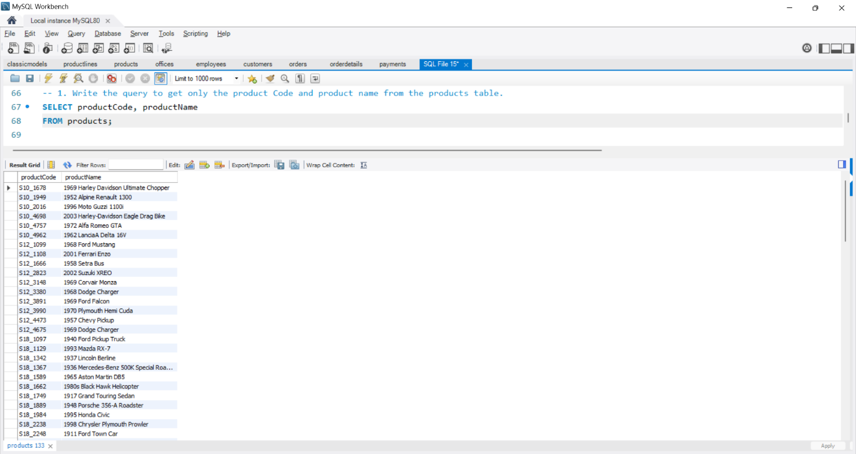

2. Write the query to arrange the customer details based on the country name in descending order.

Query:

SELECT *

FROM customers

ORDER BY country DESC;

Output:

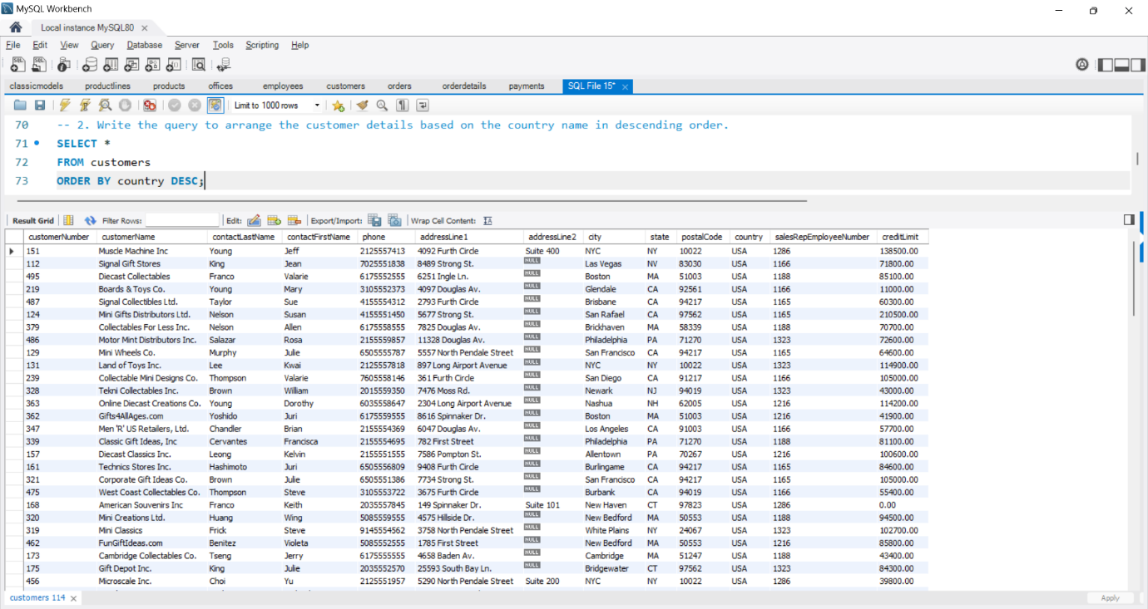

3. Write the query to find the order number, order date, and status for the customers having comments about shipment.

Query:

SELECT orderNumber, orderDate, status

FROM orders

WHERE comments IS NOT NULL;

Output:

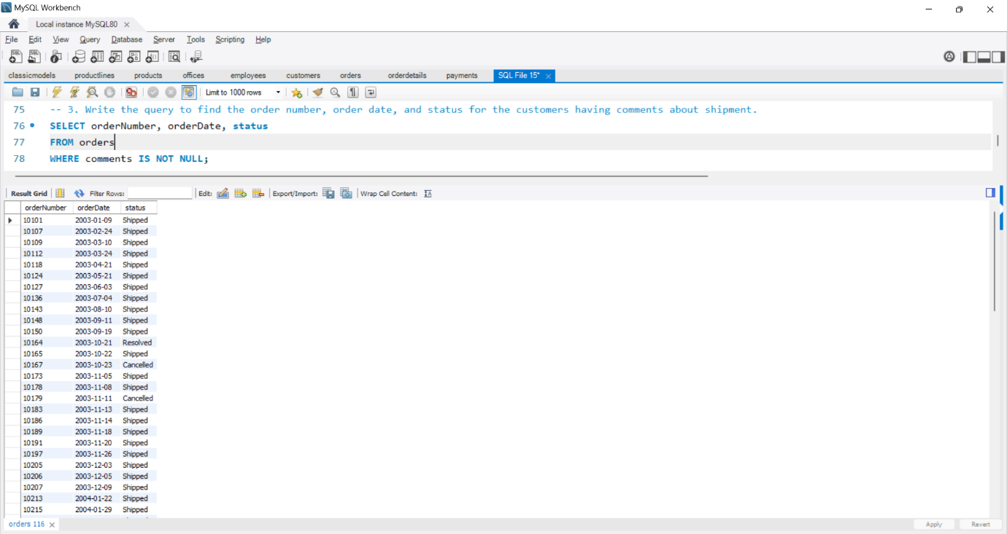

4. Write the query to find the customer who has made the highest payment along with the payment date.

Query:

SELECT *

FROM payments

ORDER BY amount DESC

LIMIT 1;

Output:

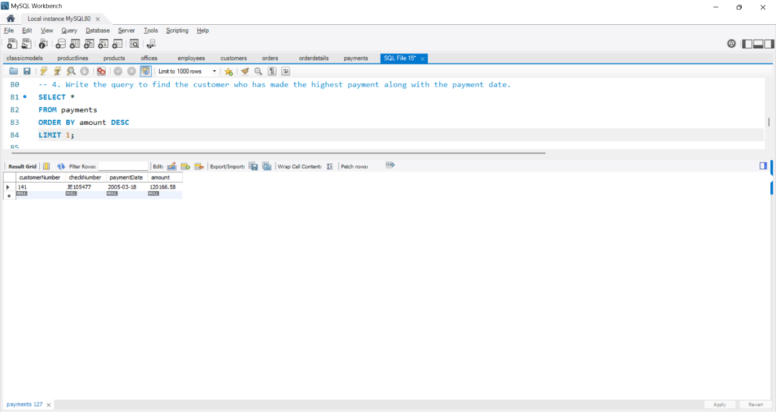

5. I have a list of the top five customers who made the highest payment and write a query to find the next top five customers who made the highest payment.

Query:

SELECT *

FROM payments

ORDER BY amount DESC

LIMIT 5 OFFSET 5;

Output:

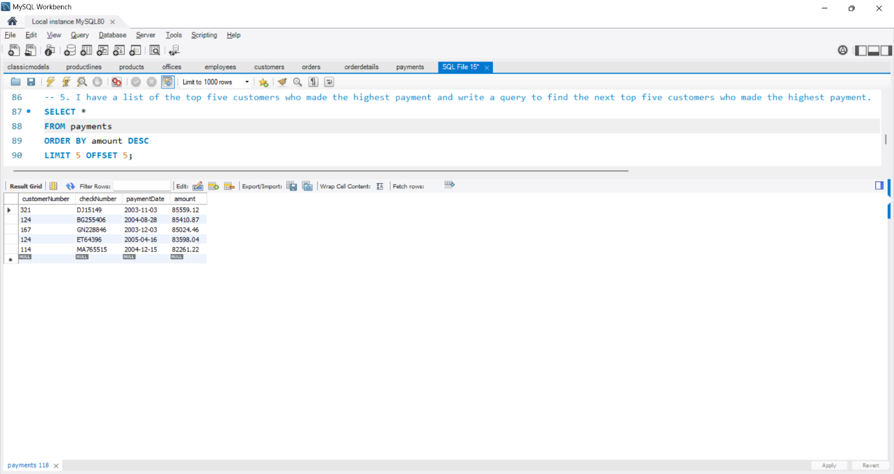

6. Write the query to find the customer details whose credit limit is between 10,000 to 1,00,000.

Query:

SELECT *

FROM customers

WHERE creditLimit BETWEEN 10000 AND 100000;

Output:

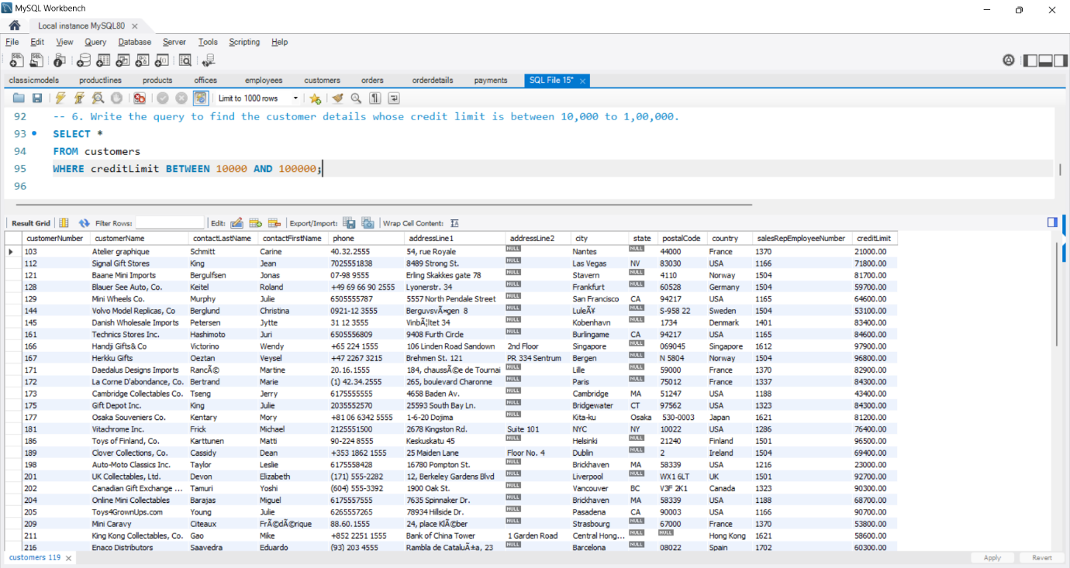

7. Write the query to get the Employee number, lastname, and first name from the employees' table whose last name starts with 'B'.

Query:

SELECT employeeNumber, lastName, firstName

FROM employees

WHERE lastName LIKE "B%";

Output:

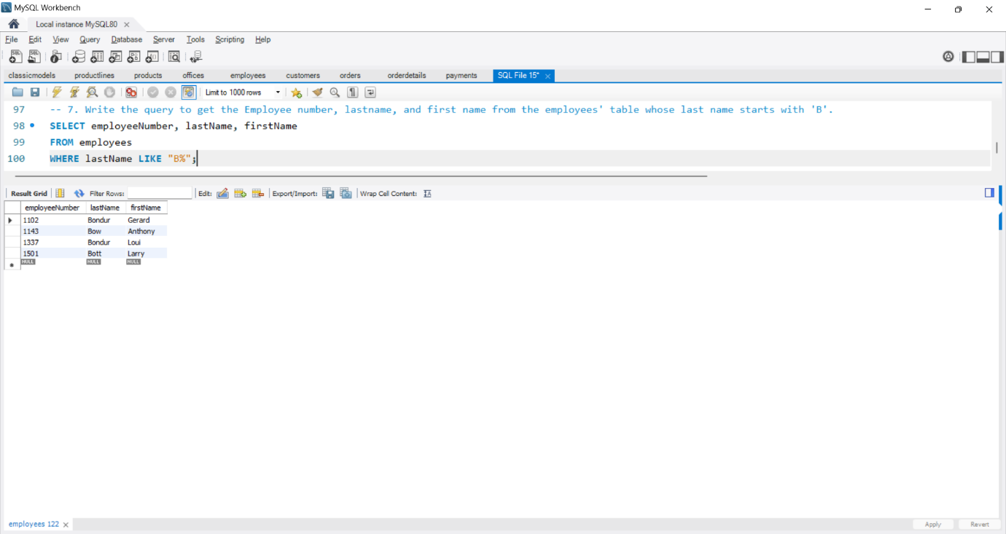

8. write a query to select the order whose total amount is greater than 50,000.

Query:

SELECT o.*

FROM orders o

JOIN orderdetails od ON o.orderNumber = od.orderNumber

GROUP BY o.orderNumber

HAVING SUM(od.quantityOrdered * od.priceEach) > 50000;

Output:

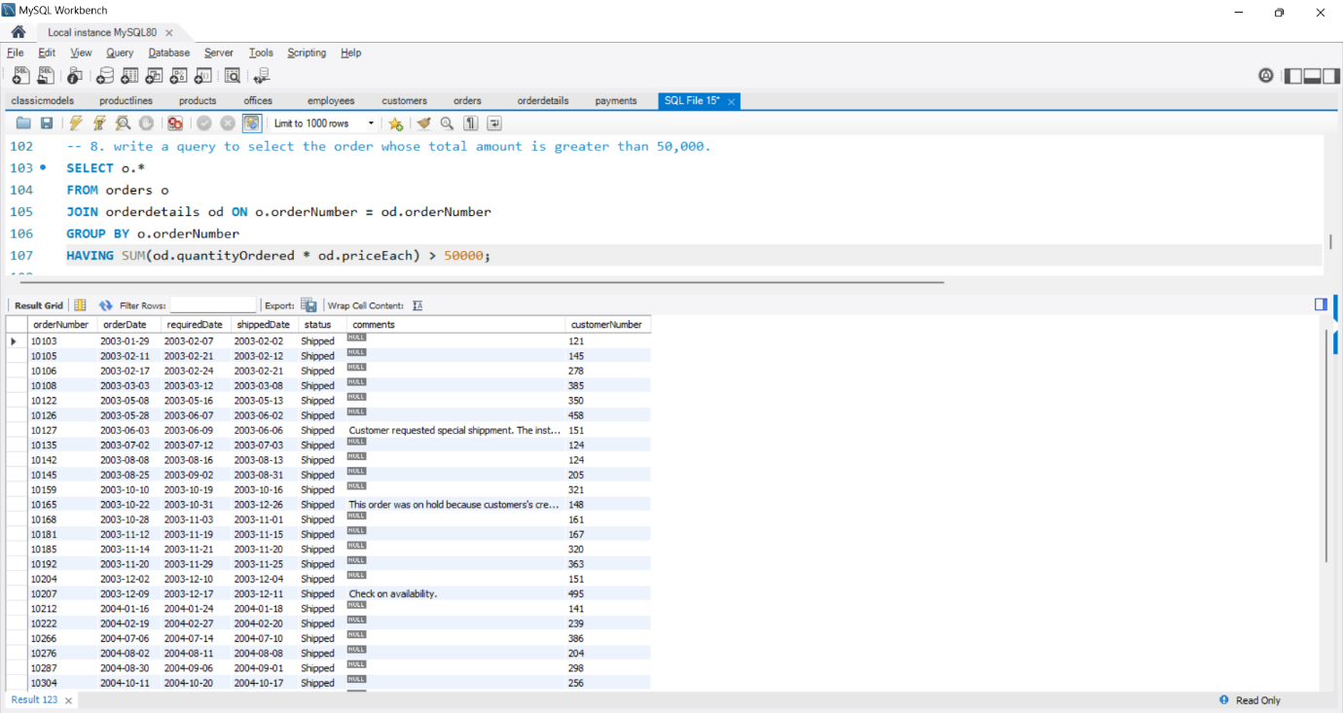

9. Write the query to find the productcode, product name & text description from the tables products and product lines.

Query:

SELECT p.productCode, p.productName, pl.textDescription

FROM products p JOIN productlines pl

ON p.productLine = pl.productLine;

Output:

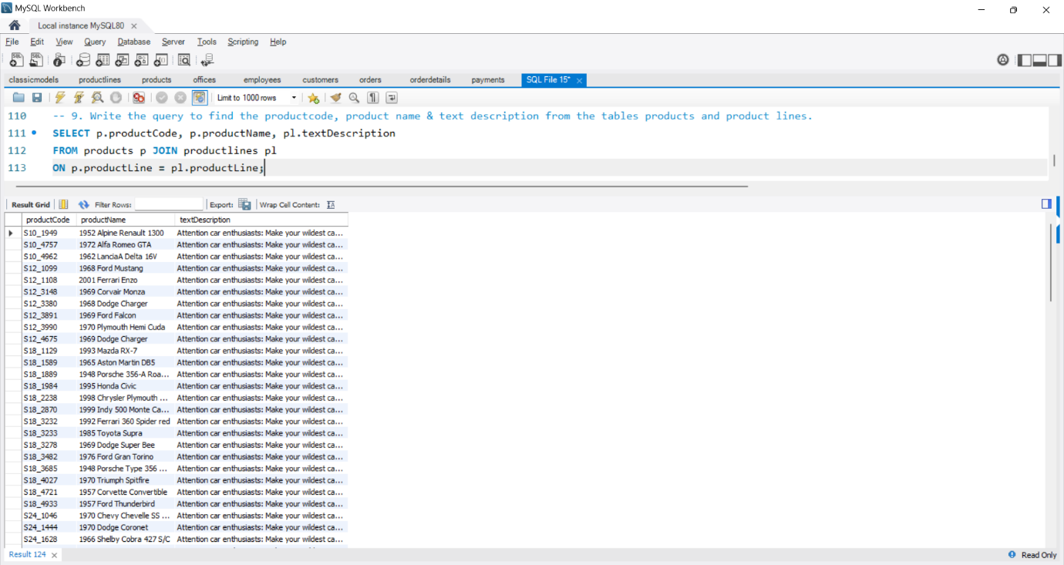

10. Write the query to get the customer number, customer name, order number, status from the tables order, payments, and customers who have no order.

Query:

SELECT c.customerNumber, c.customerName, o.orderNumber, o.status

FROM customers c

LEFT JOIN orders o ON c.customerNumber = o.customerNumber

WHERE o.orderNumber IS NULL;

Output:

