**MySQL Assignment-2**

1. Write a query to calculate the total number of products in the database.

Query:

SELECT count(productCode) as TotalProducts

FROM products;

Output:

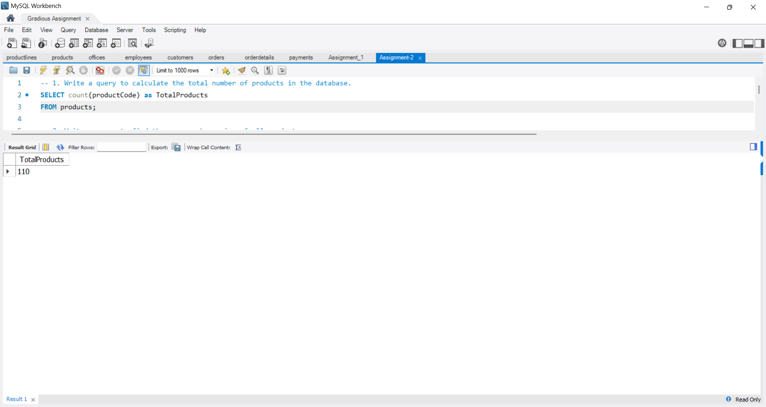

2. Write a query to find the average buy price of all products.

Query:

SELECT avg(buyPrice) as AvgProductPrice

FROM products;

Output:

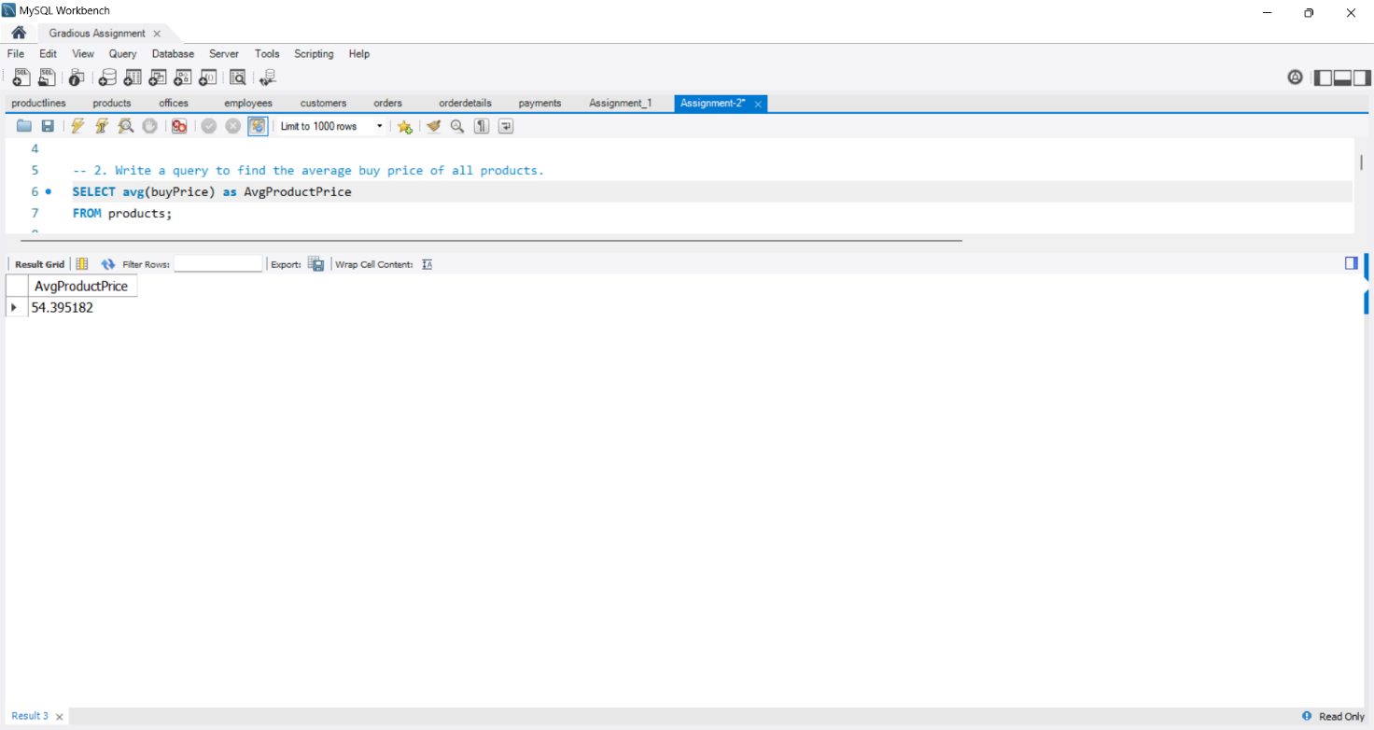

3. Write a query to determine the maximum quantity in stock across all products.

Query:

SELECT max(quantityInStock) as MaxStockQuantity

FROM products;

Output:

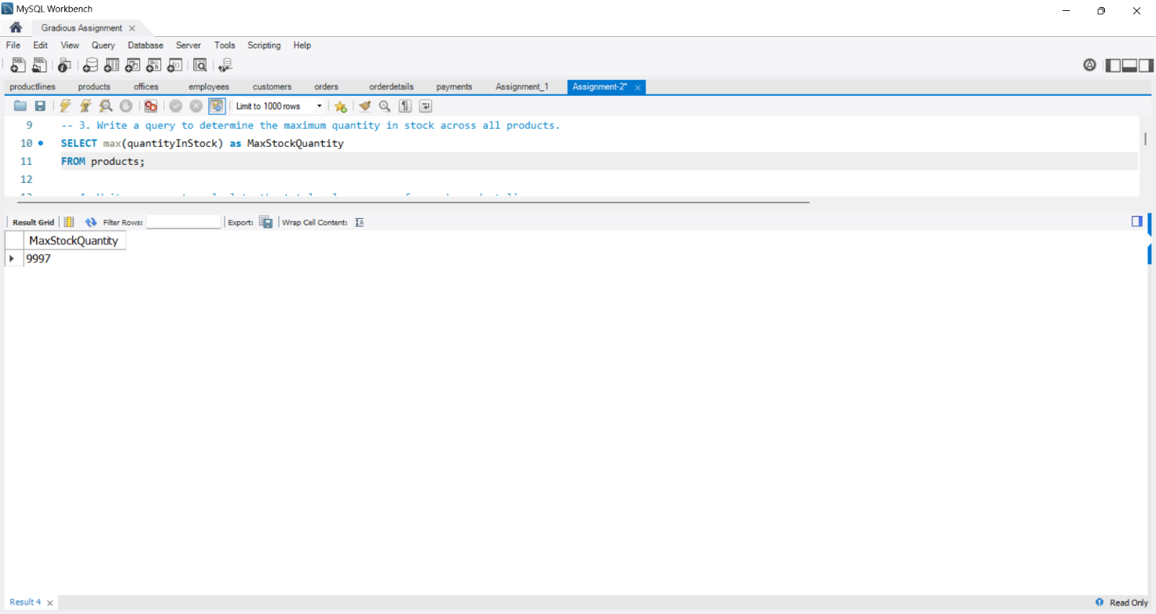

4. Write a query to calculate the total sales revenue for each product line.

Query:

SELECT p.productLine, sum(od.quantityOrdered * od.priceEach) as totalSalesRevenue

FROM products p

JOIN orderdetails od

ON p.productCode = od.productCode

GROUP BY p.productLine;

Output:

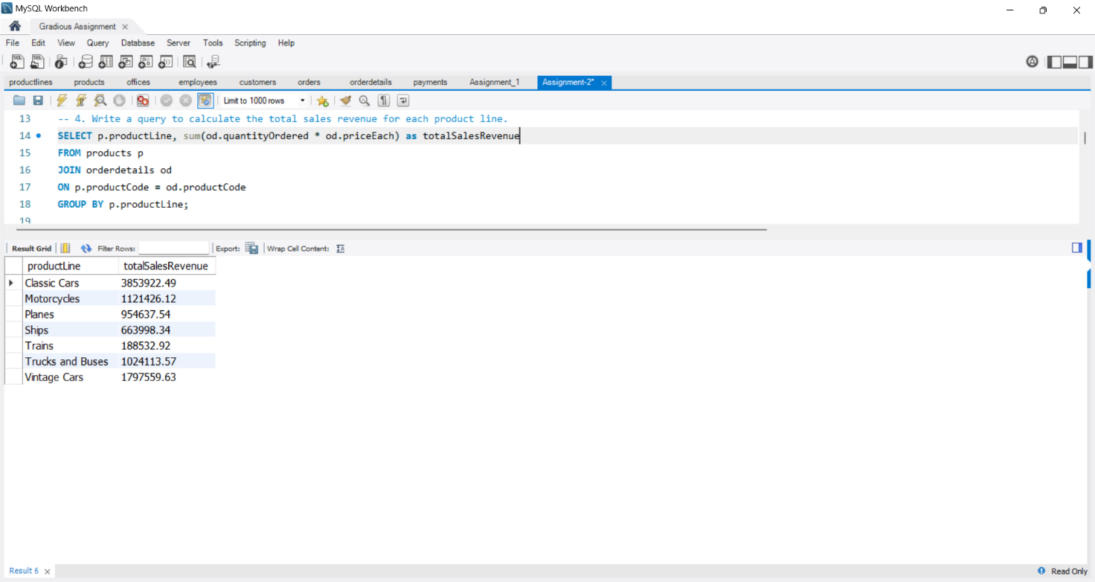

5. Write a query to determine the average credit limit for all customers.

Query:

SELECT avg(creditLimit) as AvgCreditLimit

FROM customers;

Output:

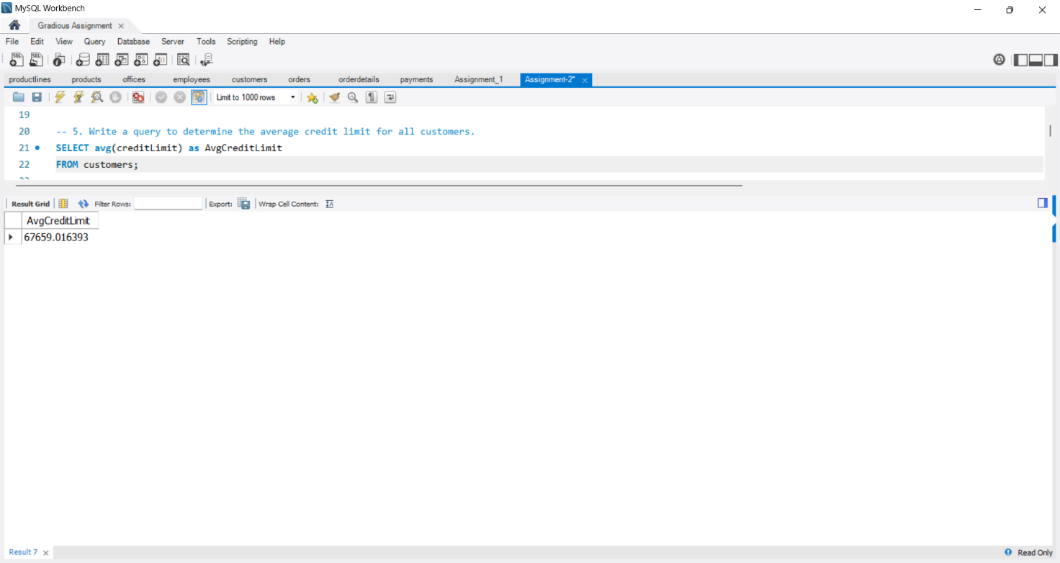

6. Write a query to find the highest payment amount made by a customer.

Query:

SELECT max(amount) as MaxPaymentAmount

FROM payments;

Output:

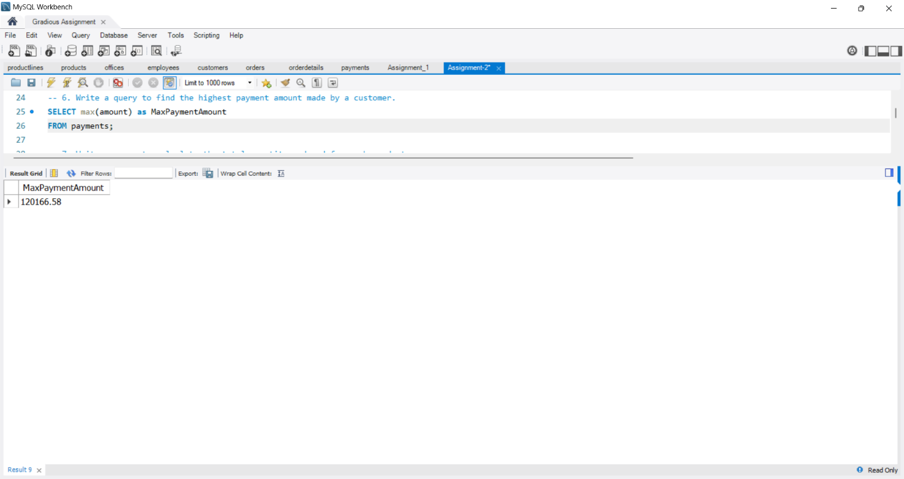

7. Write a query to calculate the total quantity ordered for each product.

Query:

SELECT productCode, sum(quantityOrdered) as totalQuantityOrders

FROM orderdetails

GROUP BY productCode;

Output:

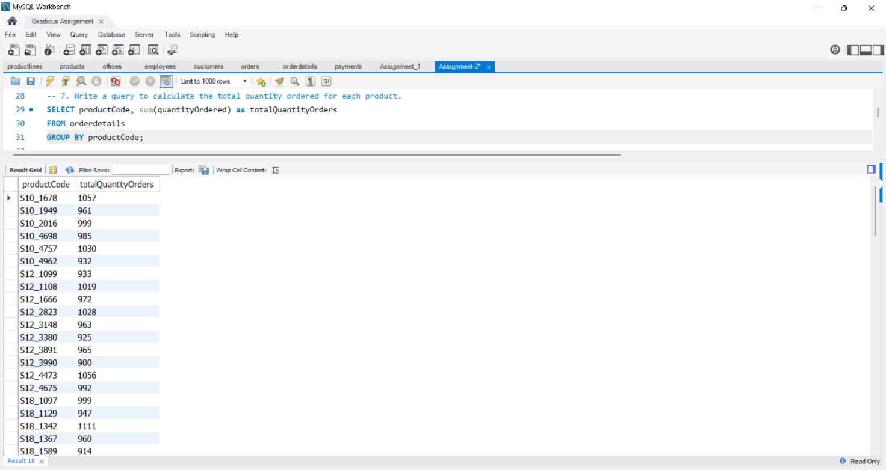

8. Write a query to determine the number of employees in each office.

Query:

SELECT officeCode, count(employeeNumber) as employees

FROM employees

GROUP BY officeCode;

Output:

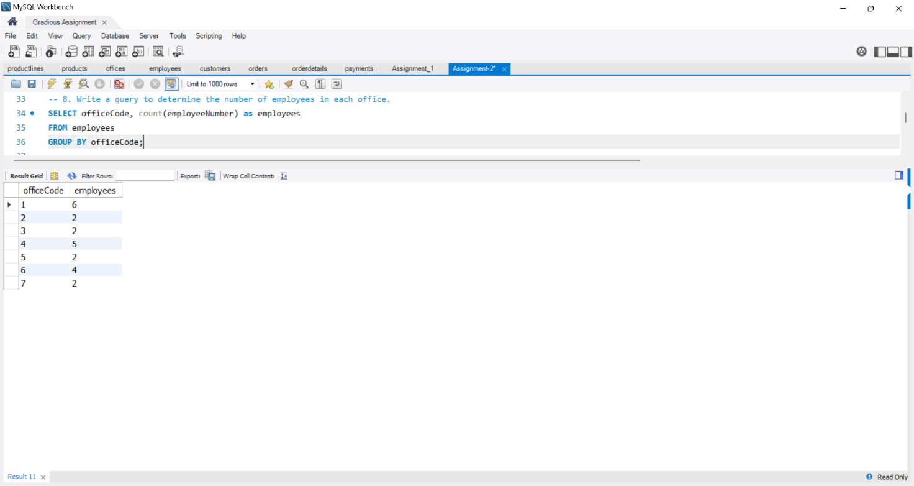

9. Write a query to calculate the average price for each order.

Query:

SELECT orderNumber, sum(quantityOrdered * priceEach) / sum(quantityOrdered) as avgPrice

FROM orderdetails

GROUP BY orderNumber;

Output:

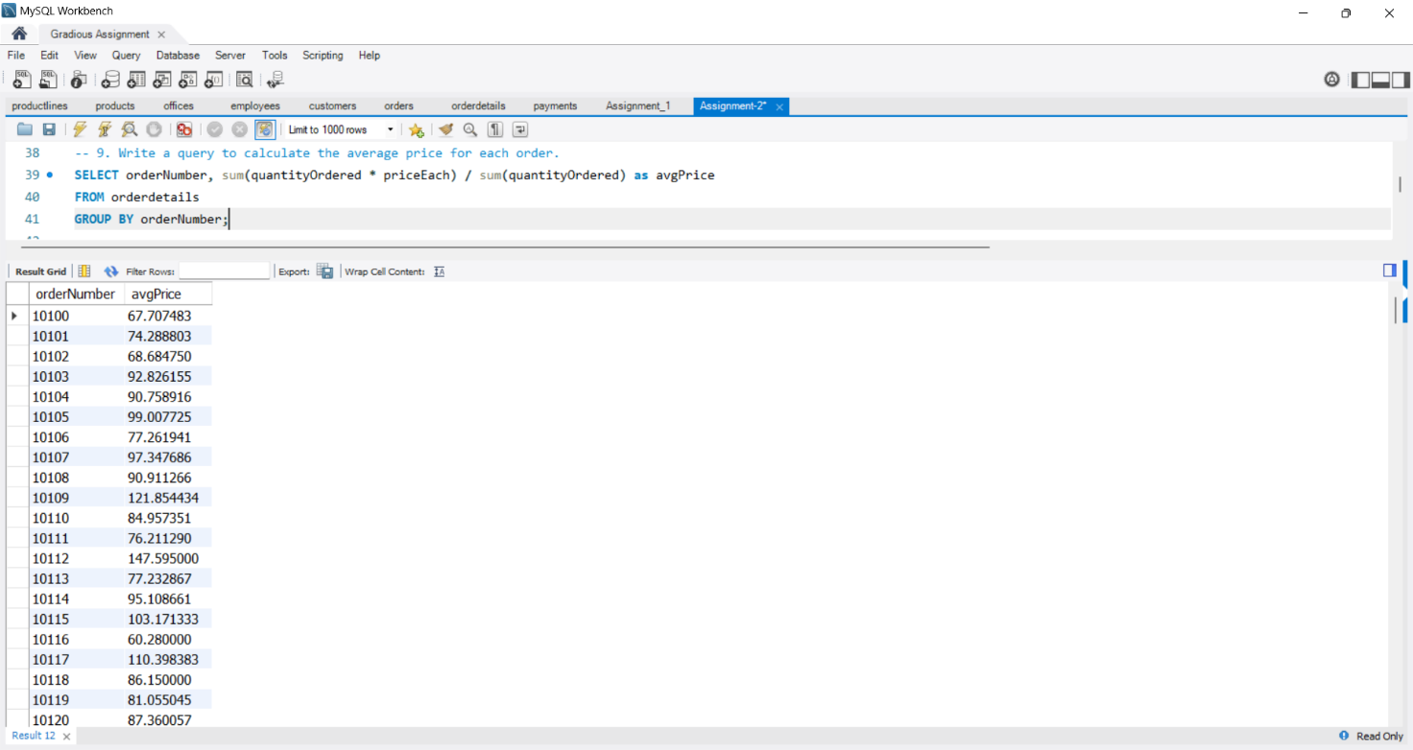

10. Write a query to determine the total sales revenue for each country.

Query:

SELECT c.country, sum(od.quantityOrdered * od.priceEach) as totalRevenue

FROM customers c

JOIN orders o ON c.customerNumber = o.customerNumber

JOIN orderdetails od ON o.orderNumber = od.orderNumber

GROUP BY c.country;

Output:

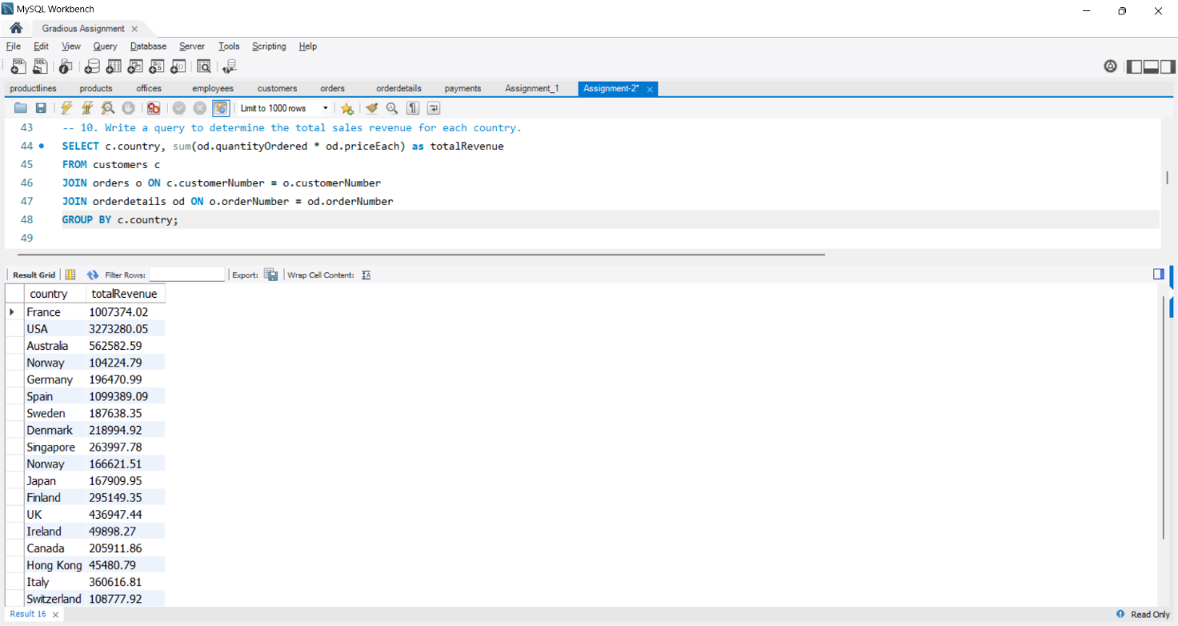

11. Write a query to calculate the average quantity in stock for each product line.

Query:

SELECT productLine, avg(quantityInStock) as avgStock

FROM products

GROUP BY productLine;

Output:

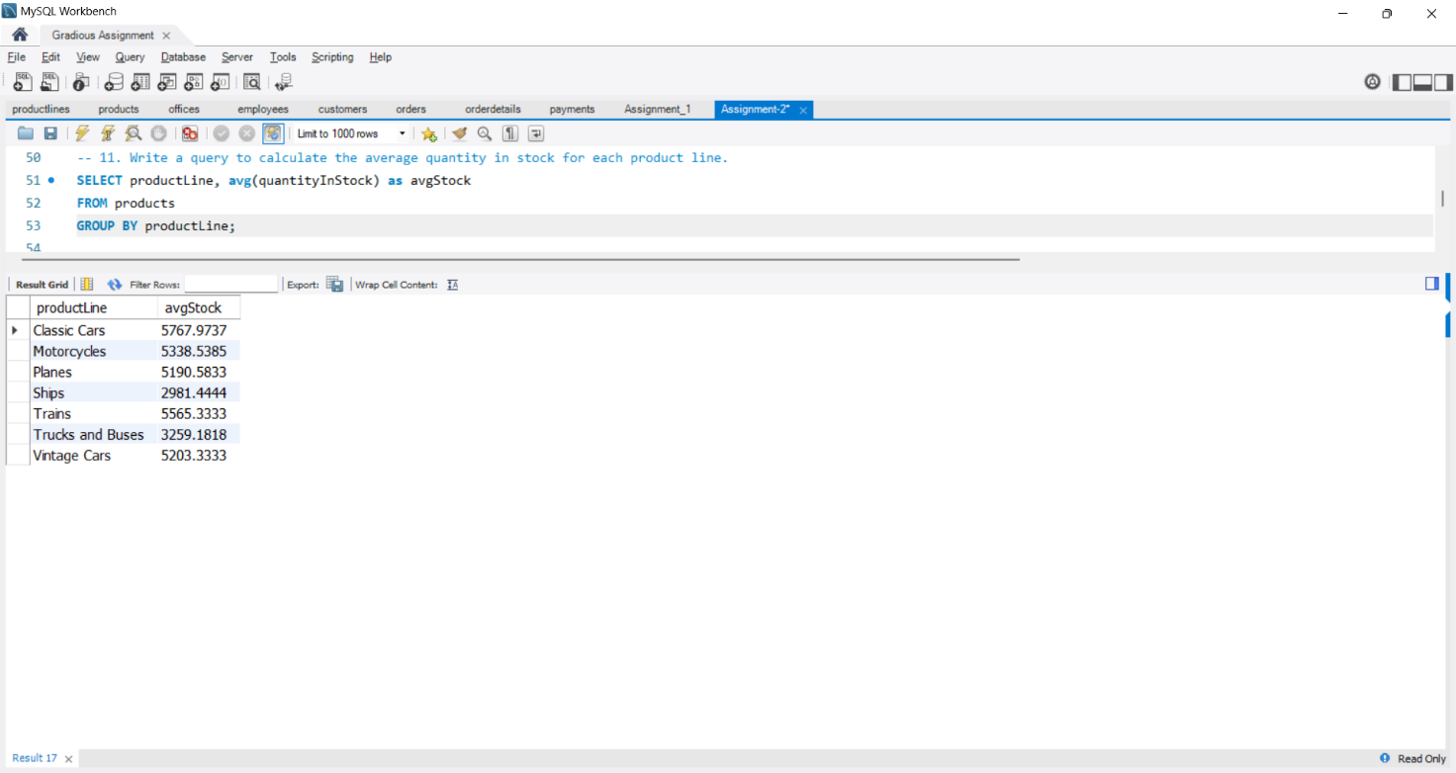

12. Write a query to determine the total number of orders placed by each customer.

Query:

SELECT customerNumber, count(orderNumber) as totalOrders

FROM orders

GROUP BY customerNumber;

Output:

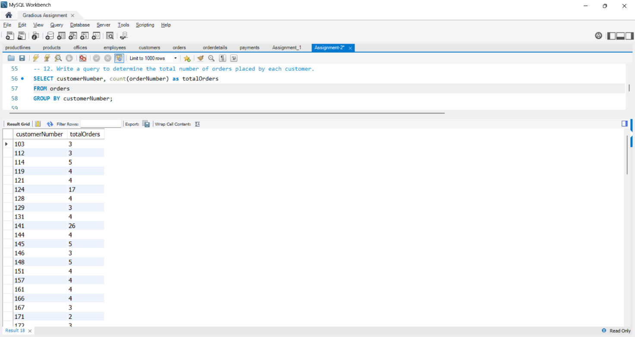

13. Write a query to find the maximum credit limit among all customers.

Query:

SELECT max(creditLimit) as maxCreditLimit

FROM customers;

Output:

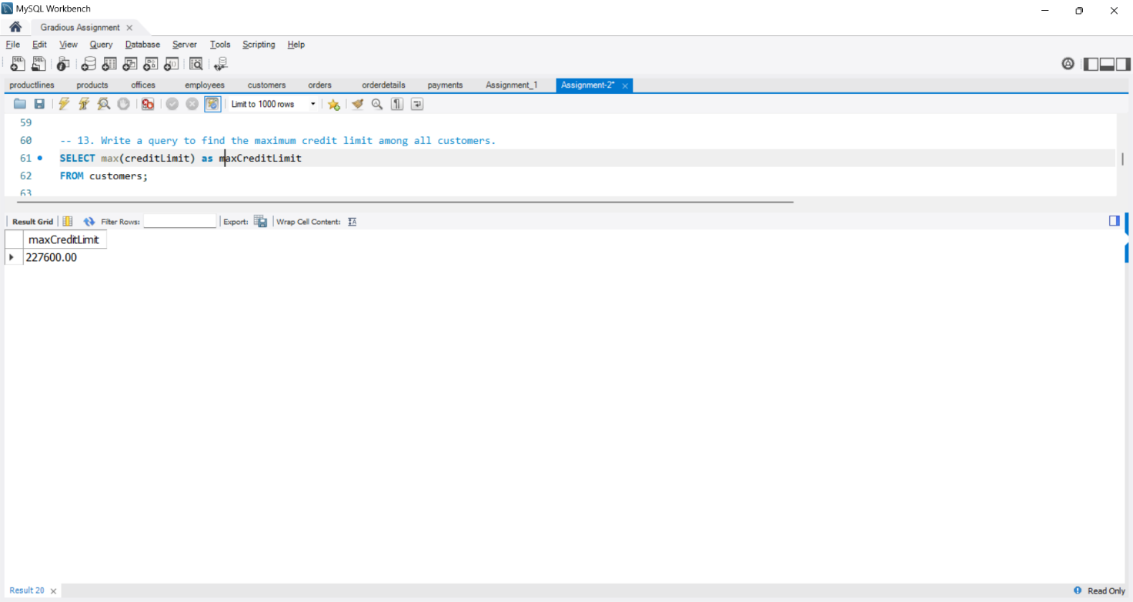

14. Write a query to count the number of offices in each country.

Query:

SELECT country, count(officeCode) as totalOffices

FROM offices

GROUP BY country;

Output:

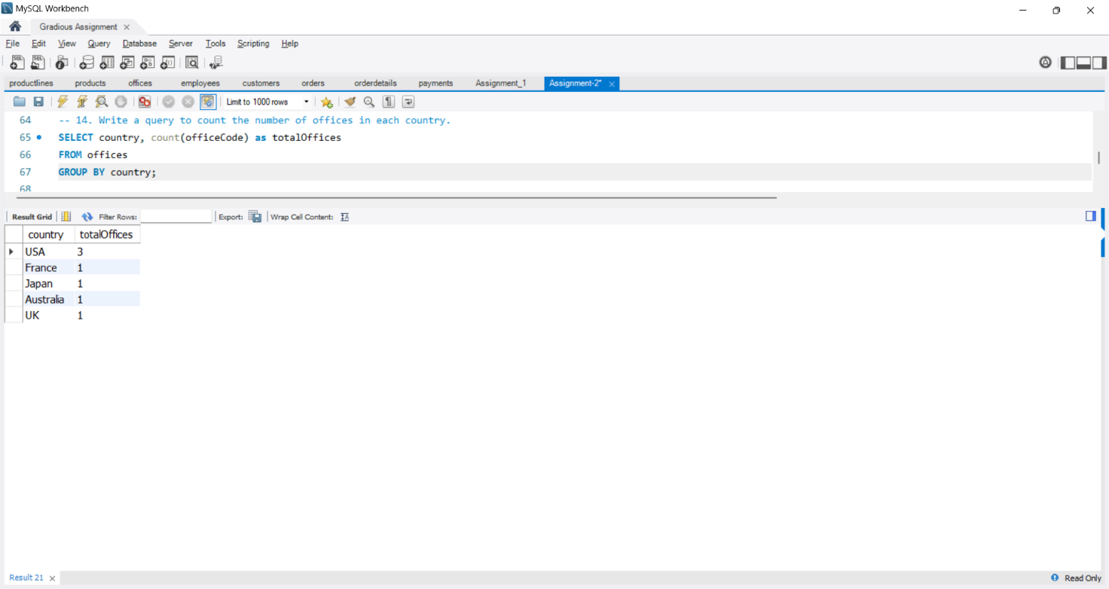

15. Write a query to calculate the average payment amount for each customer.

Query:

SELECT customerNumber, avg(amount) as avgPayment

FROM payments

GROUP BY customerNumber;

Output:

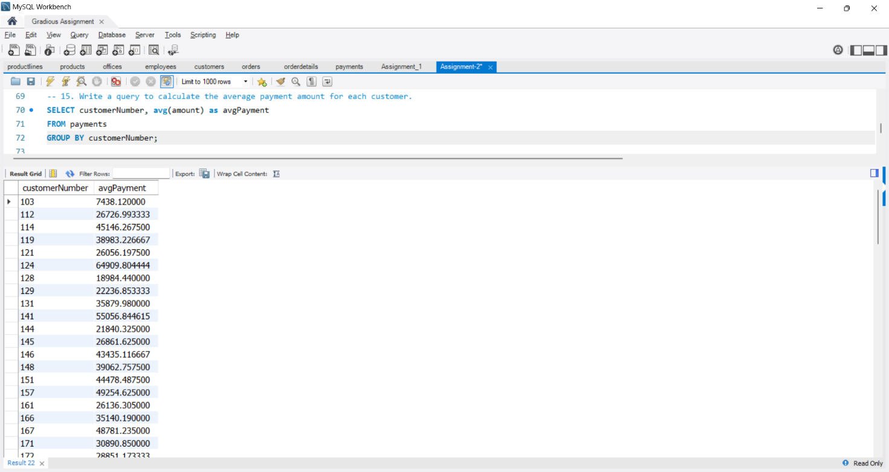

16. Write a query to determine the number of products in each product line.

Query:

SELECT productLine, count(productCode) as totalProducts

FROM products

GROUP BY productLine;

Output:

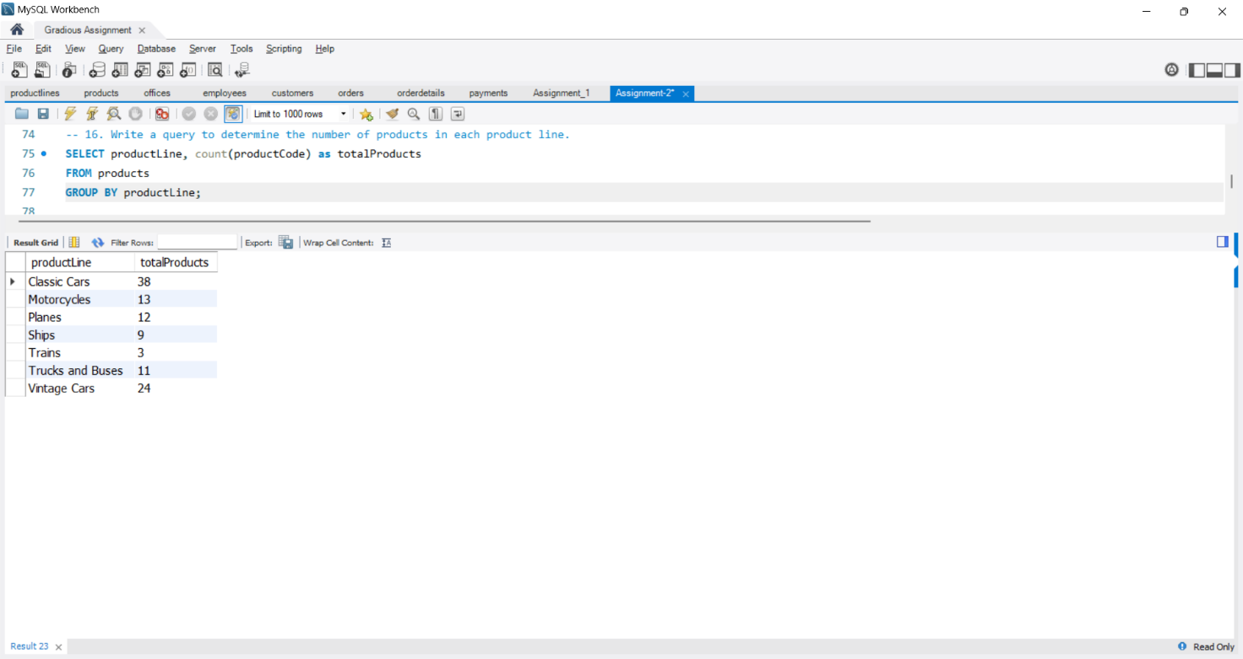

17. Write a query to count the number of customers in each state.

Query:

SELECT state, count(customerNumber)

FROM customers

WHERE state IS NOT NULL

GROUP BY state;

Output:

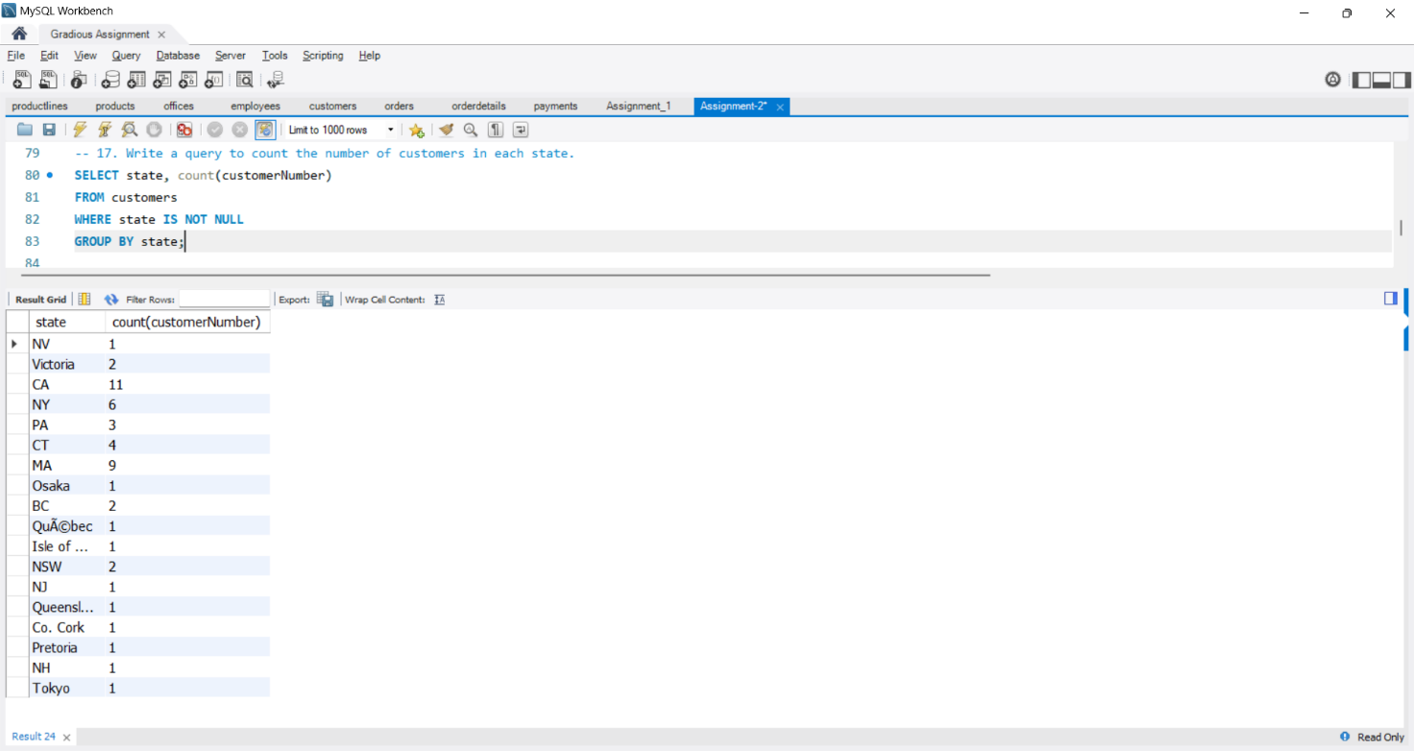

18. Write a query to find the minimum payment amount among all customers.

Query:

SELECT min(amount) as minPaymentAmount

FROM payments;

Output:

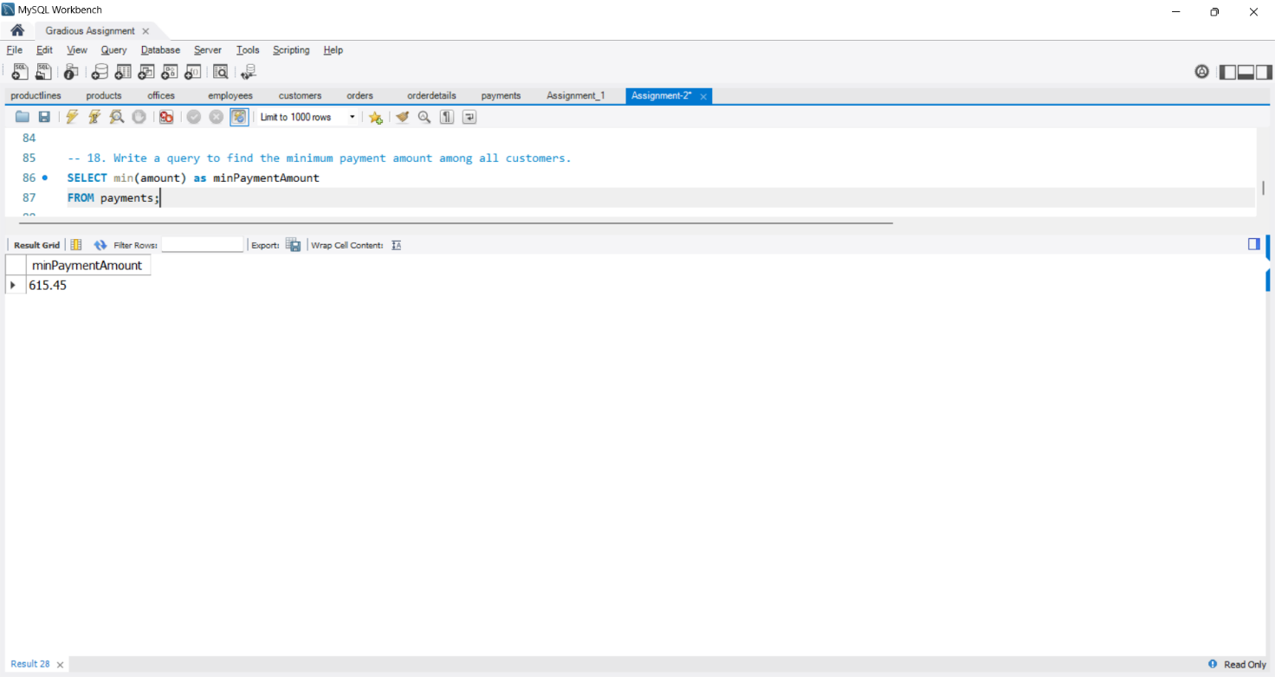

19. Write a query to calculate the average sales revenue per order.

Query:

SELECT avg(orderTotal) as avgRevenuePerOrder

FROM (

SELECT orderNumber, sum(quantityOrdered * priceEach) as orderTotal

FROM orderdetails

GROUP BY orderNumber

) as orderTotals;

Output:

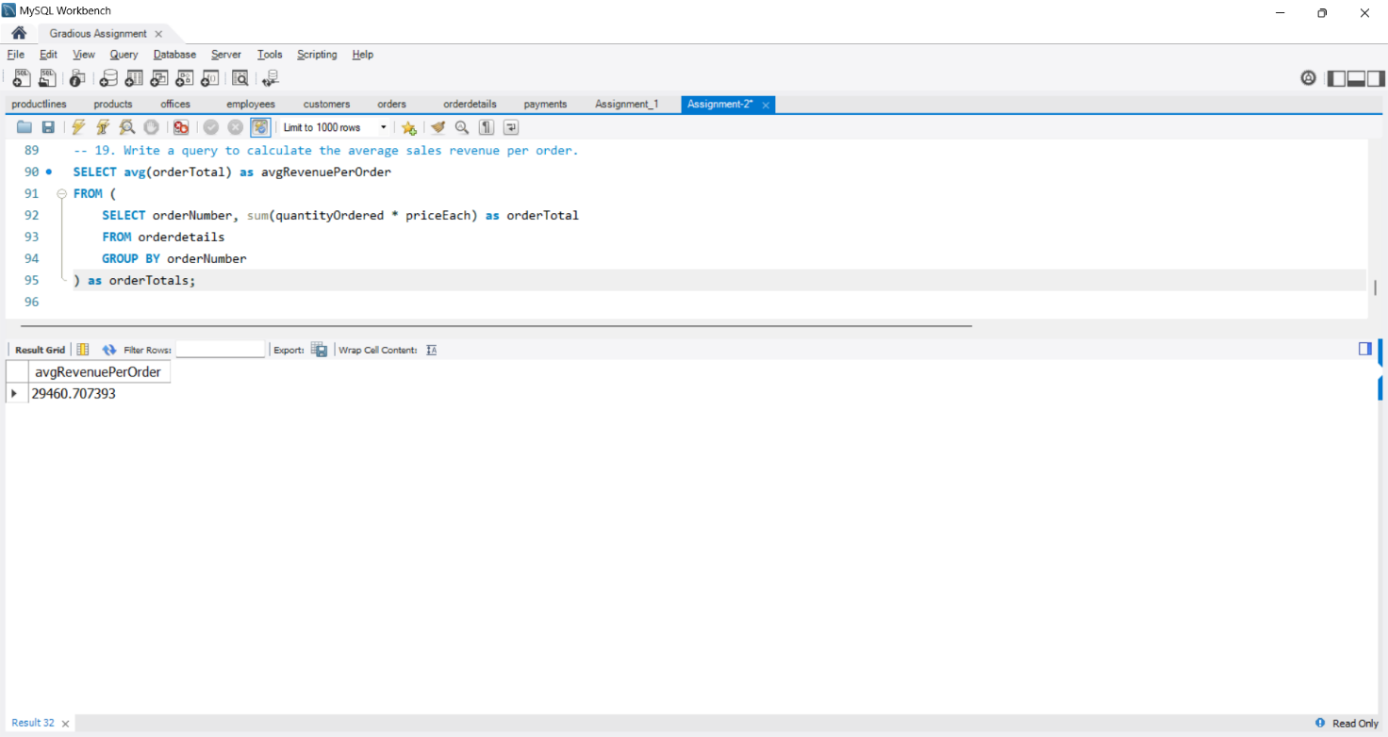

20. Write a query to determine the total quantity ordered for each product line.

Query:

SELECT p.productLine, sum(od.quantityOrdered) as totalOrders

FROM products p

JOIN orderdetails od ON p.productCode = od.productCode

GROUP BY p.productLine;

Output:

