Full Name: Krishna Kumar

Employee ID: 852142

Wipro Email-ID: Krishna.kumar61@wipro.com

Project Name (You are billing / or Bench) : Morganstanley (Billable)

Competency Group:

Part 1: Orientation and Setup

Test docker version

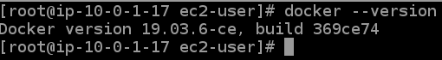

Test docker Installation

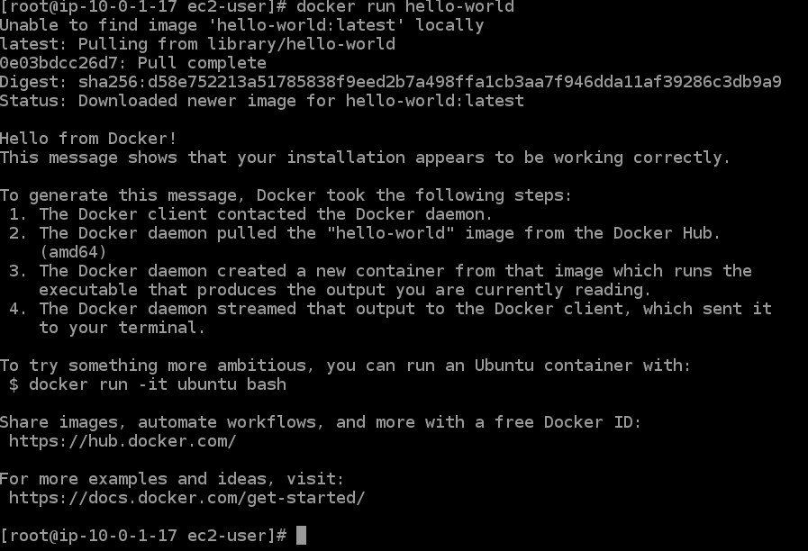

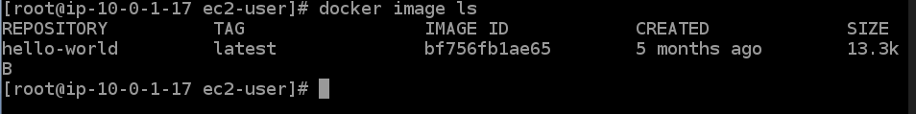



**Part 2 : Build and Run your image**

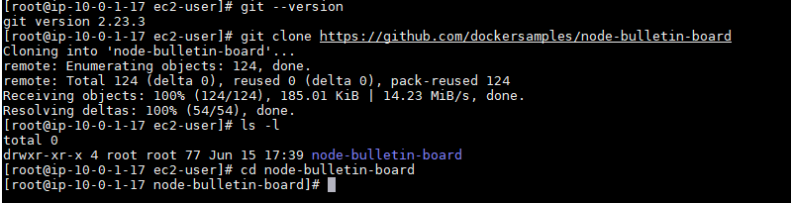

Build and test image (Image name: kris852142img)

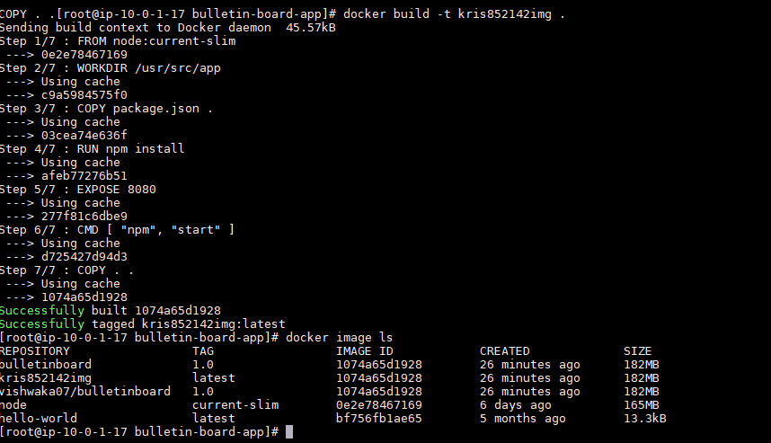

Run image as container (container name: kris852142cont)





Allowed the expose port in firewall, able to see the webpage

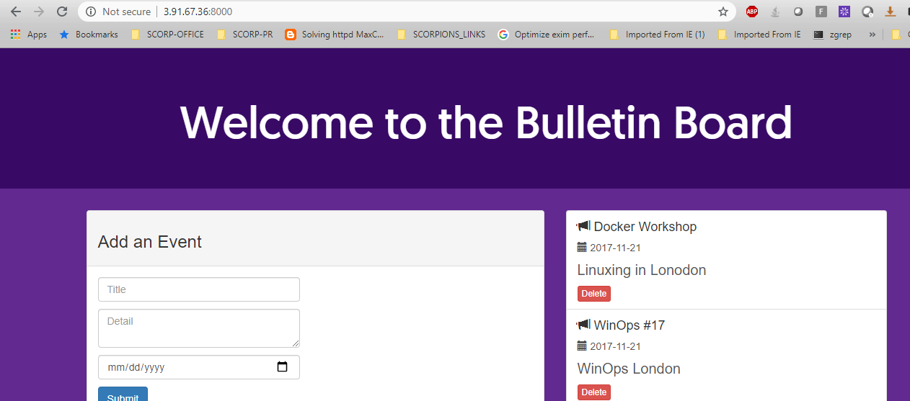

**Part 3 : share image on docker hub**

