Project Report

Database Management Systems Lab

An interactive E-Commerce website

Submitted by Advait Raykar 28

Parv Kapoor 24

Vishwa Kalyanaraman 11

Objective: The goal of this project was to build an interactive e-commerce website incorporating concepts learnt in Database systems lab, having real world applications.

Overview: The website’s functioning and creation can be divided into two parts:

1. Front end: The entire front end for the website has been made using HTML, CSS, and JavaScript which are sufficient for expressing basic functionality of the website. It was used to create a simple and easy to use user interface modelled on real world E-commerce websites.
2. Back End: The entire back end for the website was made using PHP and MySQL. This involved entering, updating, altering, deleting data from the user database. The aforementioned database was made using SQL and was a solid application of knowledge gained during DBMS lab sessions as part of our academic curriculum.

Detailed Specifications: The website has all the features that are observed in modern day online commerce websites namely cataloguing available items, signing up of new users, signing in of existing users, adding items to the cart, removing items from the cart and contact information for the administration in case of any discrepancies/queries. The website also has additional capability of keeping track of all orders received and all the orders placed are stored in the database. Drawing inspiration from real world e commerce websites, The administrator access allows one to modify the quantity of products using the user interface designed. All in all, The primary focus was on setting up a database and retrieving data from it as and when user/admin requires.

ER diagram:

A close up of a map

Description generated with high confidence

DDL Commands:

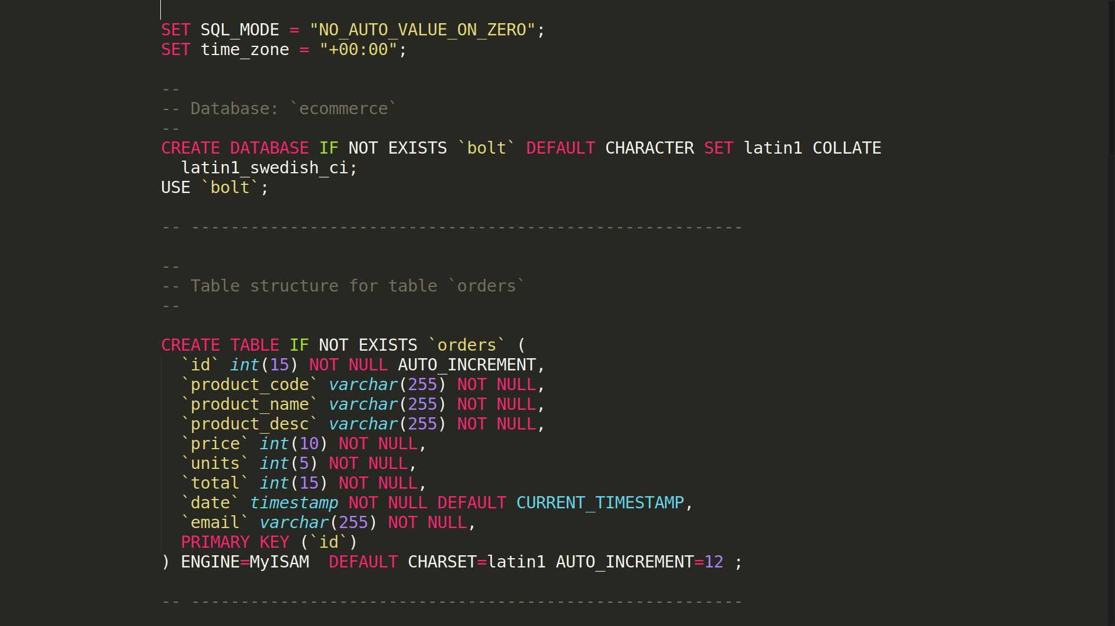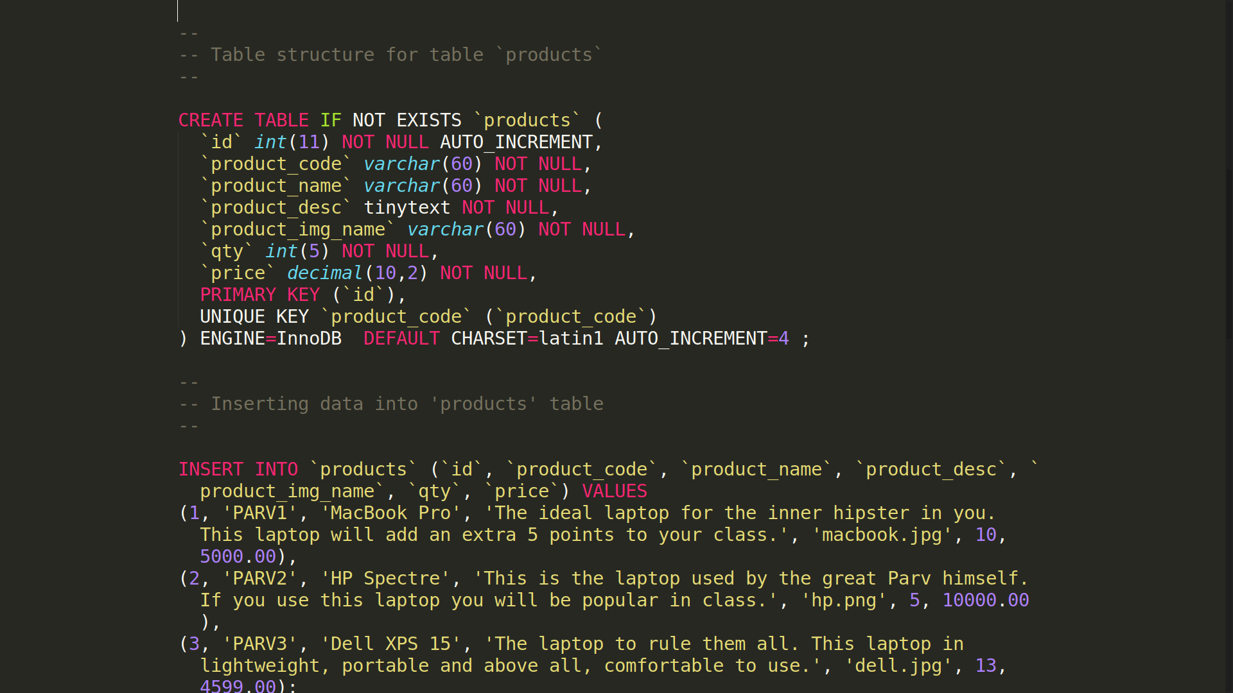

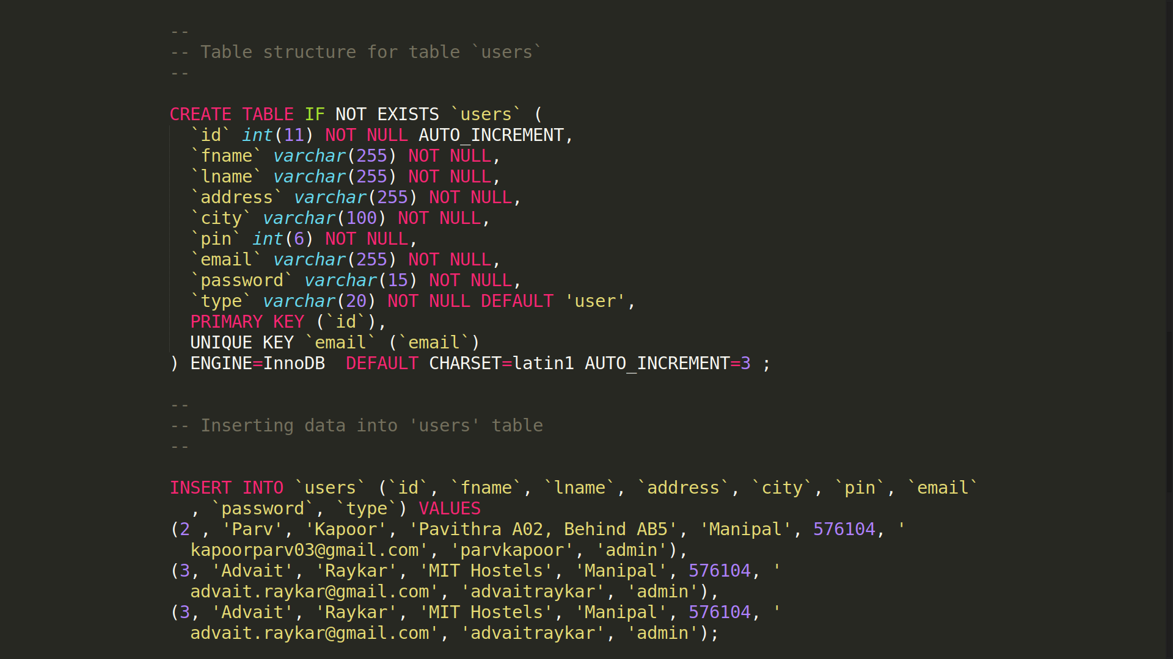Relational Table Data:

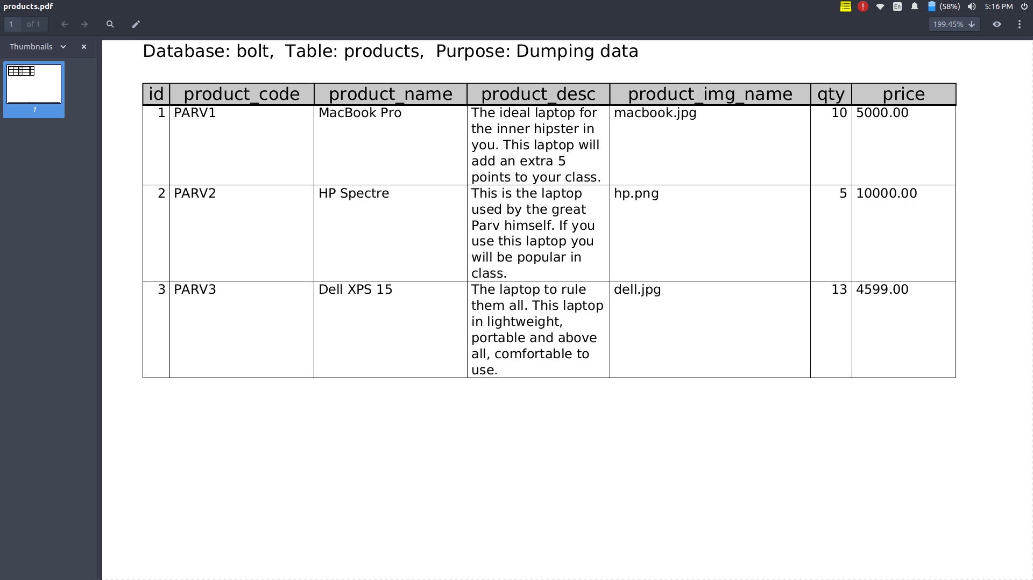Table: ‘products’

Table: ‘users’

