SUPRIYA SINGH

A Challenging career that will enable me to exhibit my professional competency to the cognizant and will enable me to expose my talent to the max to reach the height of success.

**PROFESSIONAL PROFILE**

**Professional experience in Research and Development field. Ability to handle different projects**

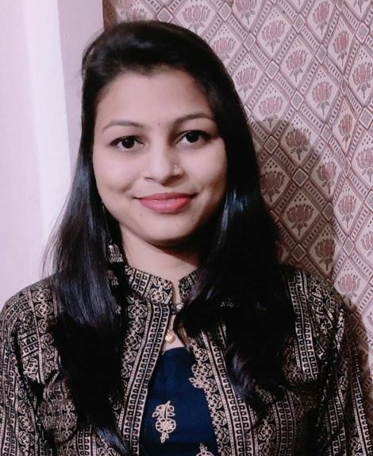

# PERSONAL

Name:- Supriya singh

# Address:-

Block no .11, Qtr no.82 Ekta Nagar, Chargaon Complex, Post- Kondha,Tah-Bhadrawati,Dist- Chandrapur 442503 Bhadrawati.

# Phone:-

8208760729

# Email:-

[singh.supriya1798@gmail.com](mailto:singh.supriya1798@gmail.com)

# Birthday:-

17/11/1998

# Gender:-

Female

# Marital Status:-

Single

# CUSTOM SECTION STRENGTH

* **Good Listener**

# Co-operative

* **Hardworking**

# Honest

**WORK EXPERINENCE**

**Organization:-** Shubhum Beauty Care ,Thane. Duration:-May 2019 to Jun2019.

Designation:-Trainee

**Organization:-**. AVN Footstep ,Baddi **Duration**:-Apr 2021 to till Now **Designation**:- R&D Chemist.

To Design and Develop skin care,hair care.

Handlling technical batches for the product up to 500 KG.

# EDUCATION AND QUALIFICATIONS

**SSC-CBSE Delhi** Jun 2013 – Aug 2014

Kendriya vidyalaya ordnance Factory Chanda, Bhadrawati 66.50%

**HSC-CBSE Delhi** Jun 2015 - Aug 2016

Kendriya vidyalaya ordnance Factory Chanda,Bhadrawati 63.60

**B.Tech Cosmetics** Aug 2016 - Aug 2020 Vidyabharati Mahavidyalaya ,Amravati

73.76%

**M.Tech Cosmetics** Aug2020 – Aug2022 Pursuing

# Technical Proficiencies.

**Familiar with basic operating systems like Microsoft word, Excel Outlook.**

**MS-CIT 92%.**

**Regional in Athletes 2012 -2013.**