

**INFORMATICS INSTITUTE OF TECHNOLOGY**

**In collaboration, with**

**UNIVERSITY OF WESTMINSTER (UoW)**

BSc/ BSc (Hons) in Computer Science

Final Year Project 2017/18

System Requirement Specification

For

**User Experience Enhancement in Scrum**

**using Gamification Elements**

By

2014081

Vishwa Kanahcna Perera

Supervised by

Mr. Pumudu Fernando

____________________ _________________

Signature of Supervisor Signature of Student

**Table of Contents**

Table of Figures 2

1 Stakeholders 3

1.1 Onion Model 3

1.2 Stakeholder Descriptions 4

2 Requirement elicitation techniques 8

2.1 Gamification element selection 8

2.1.1 Observation 8

2.1.1 Literature review 8

2.2 Functional requirement identification 8

2.2.1 Questioner 8

2.2.2 Interviews 8

2.2.3 Literature review 8

3 Execution 8

4 Result analysis 8

5 Analysis models 8

5.1 Use case diagram 8

5.2 Use case descriptions 8

5.3 Test cases 8

5.4 Domain model 9

5.5 Activity Diagram 9

6 Functional requirements 9

7 Nonfunctional requirements 9

8. Other requirements 9

Scope refinement 9

Table of Figures

Figure 1: Onion Model 3

1 Stakeholders

## 1.1 Onion Model

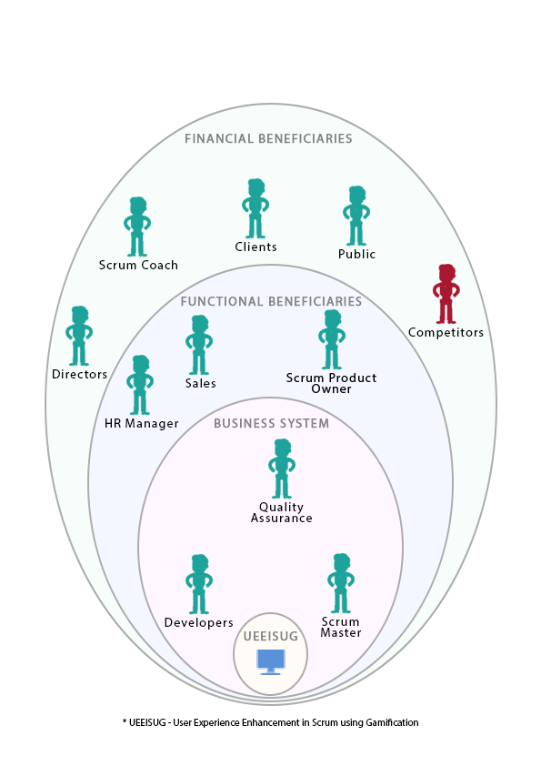

Figure : Onion Model

## 1.2 Stakeholder Descriptions

|  |  |
| --- | --- |
| **Stakeholder** | **Developers** |
| **Role** | Normal Operator |
| **Benefits** | * Tracking Personal Development * Rewards per milestone. * Recognition inside the organization. * Motivation to work. |
| **Interest in Solution** | High interest |
| **Responsibilities** | * Journalized daily work carried out by updating the scrum board. |

|  |  |
| --- | --- |
| **Stakeholder** | **Quality Assurance** |
| **Role** | Normal Operator |
| **Benefits** | * Tracking Personal Development * Rewards per milestone. * Recognition inside the organization. * Motivation to work. |
| **Interest in Solution** | High interest |
| **Responsibilities** | * Journalized daily work carried out by updating the scrum board. * Inform team about issue in the current version of the product. |

|  |  |
| --- | --- |
| **Stakeholder** | **Sales** |
| **Role** | Functional Beneficiary |
| **Benefits** | * Better products to market. * Increase in quality of the production. |
| **Interest in Solution** | Medium interest |
| **Responsibilities** | * Increase the sales. |

|  |  |
| --- | --- |
| **Stakeholder** | **Scrum Master** |
| **Role** | Normal Operator |
| **Benefits** | * Tracking Personal Development * Rewards per milestone. * Recognition inside the organization. * Motivation to work. * Make it easy to work with scrum team. |
| **Interest in Solution** | High interest |
| **Responsibilities** | * Journalized daily work carried out by updating the scrum board * Check Team’s progress. * Know the weight of contributions done by scrum team members |

|  |  |
| --- | --- |
| **Stakeholder** | **Scrum Product Owner** |
| **Role** | Functional Beneficiary |
| **Benefits** | * Fast Project delivery from the scrum team. * Knowledge about the Scrum team |
| **Interest in Solution** | Medium Interest |
| **Responsibilities** | * Conveying needs of the user to the scrum team. |

|  |  |
| --- | --- |
| **Stakeholder** | **HR Manager** |
| **Role** | Functional Beneficiary |
| **Benefits** | * Easy to manage human resources. * Early prediction on progress of a newly formed team with old employees. |
| **Interest in Solution** | Medium interest |
| **Responsibilities** | * Optimize HR solutions. |

|  |  |
| --- | --- |
| **Stakeholder** | **Directors** |
| **Role** | Financial Beneficiary |
| **Benefits** | * Happy work environment increases the productivity of the employees, which eventually lead to upward progress in the production. |
| **Interest in Solution** | Medium interest |
| **Responsibilities** | * Increase the revenue generation. |

|  |  |
| --- | --- |
| **Stakeholder** | **Scrum Coach** |
| **Role** | Financial Beneficiary |
| **Benefits** | * Profit increment. (With the increase in using of scrum methodology due to this system. More organizations will thrive to learn the scrum methodology.) * Increase in demand in job market. |
| **Interest in Solution** | Medium interest |
| **Responsibilities** | * Teach about scrum methodology. |

|  |  |
| --- | --- |
| **Stakeholder** | **Public (Society)** |
| **Role** | Financial Beneficiary |
| **Benefits** | * Health improvements due to less stress due to employee satisfaction. |
| **Interest in Solution** | Interest |
| **Responsibilities** |  |

|  |  |
| --- | --- |
| **Stakeholder** | **Competitors (Negative Stakeholder)** |
| **Role** | Financial Beneficiary |
| **Benefits** | * Know the market’s responses to the current problem. * Learn from competitors mistakes |
| **Interest in Solution** | Medium interest |
| **Responsibilities** |  |

|  |  |
| --- | --- |
| **Stakeholder** | **Hacker (Negative Stakeholder)** |
| **Role** | Financial Beneficiary |
| **Benefits** | * Know the market’s responses to the current problem. * Learn from competitors mistakes |
| **Interest in Solution** | Medium interest |
| **Responsibilities** | * Teach about scrum methodology. |

# 2 Requirement elicitation techniques

## 2.1 Gamification element selection

In order to identify what is the most relevant gamification element for the problem the author has used following elicitation techniques;

### 2.1.1 Observation

### 2.1.1 Literature review

## 2.2 Functional requirement identification

To identify the necessary functionalities of system, the author has used the following elicitation techniques;

### 2.2.1 Questioner

### 2.2.2 Interviews

### 2.2.3 Literature review

# 3 Execution

4 Result analysis

# 5 Analysis models

## 5.1 Use case diagram

## 5.2 Use case descriptions

## 5.3 Test cases

## 5.4 Domain model

## 5.5 Activity Diagram

# 6 Functional requirements

6. Functional requirements (FR no., FR, Input, process, output, priority, Use case) - all low-level functions

# 7 Nonfunctional requirements

7. Nonfunctional requirements

# 8. Other requirements

# ../../../Downloads/logoRewamp2.PNGScope refinement