**Self-Organizing Map (SOM)**

**Procedure:**

**Step 1:** Define the SOM architecture 20x20 neuron grid and determine the number of iteration for convergence

**Step 2:** Parameter setting for SOM

* Initial width of topological neighborhood of winning neuron = 15
* Time constant for initial topological neighborhood size = 10000/log(15)
* Initial time-varying learning rate = 1
* Time constant for the time-varying learning rate = 10000
* Total iteration = 10000

**Step 3:** Initialize the weight of each neuron randomly between 0 and 1

Loop {

**Step 4:** Find the best matched winning neuron based on the smallest Euclidean distance between input and each neuron.

**Step 5:** Compute the neighborhood function between each neuron and winning neuron.

neighborhood=exp(-d^2/2*variance^2)

**Step 6:** Update the weight of neurons

W(t+1) = W(t)+learningRate*neighborhood*(input-W(t))

}

**Step 7:** Plot the self-organizing map

**Result:**

1. Aggregation training dataset before running SOM

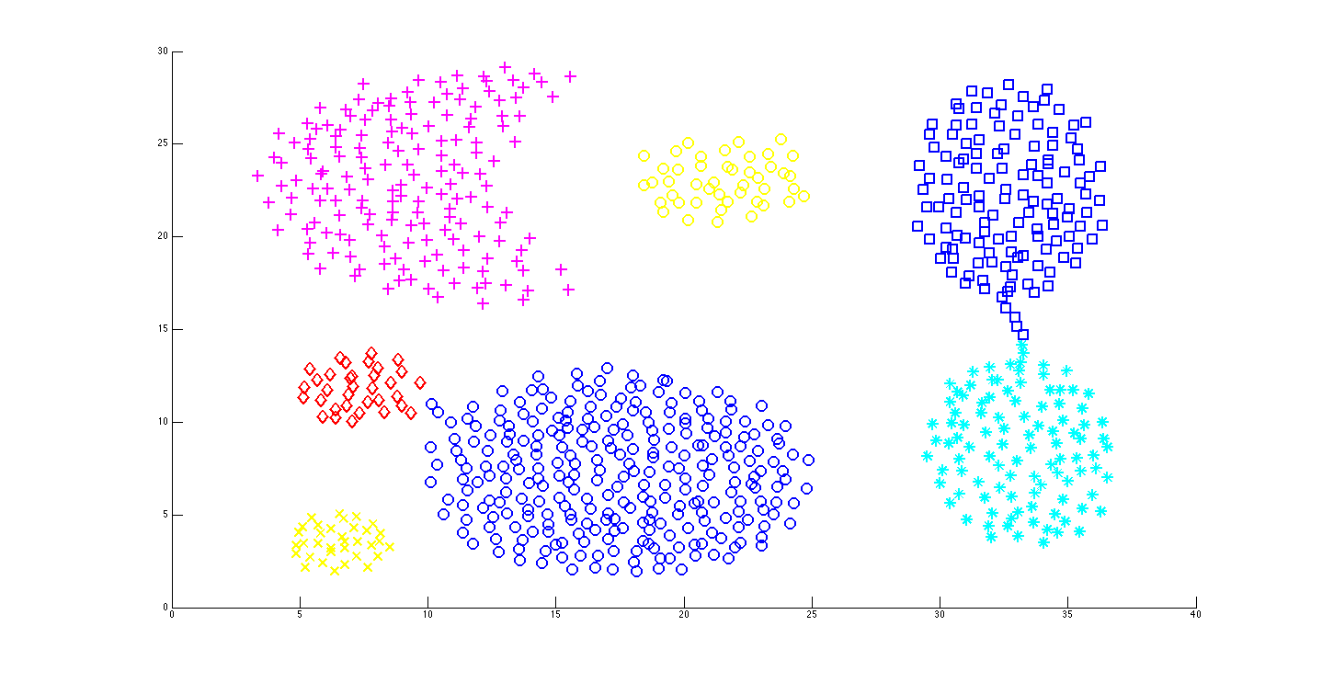

2. SOM captures the patterns of 7 different clusters after 10000 iterations of optimization for the weights of neurons. The dimension of SOM is 20x20.

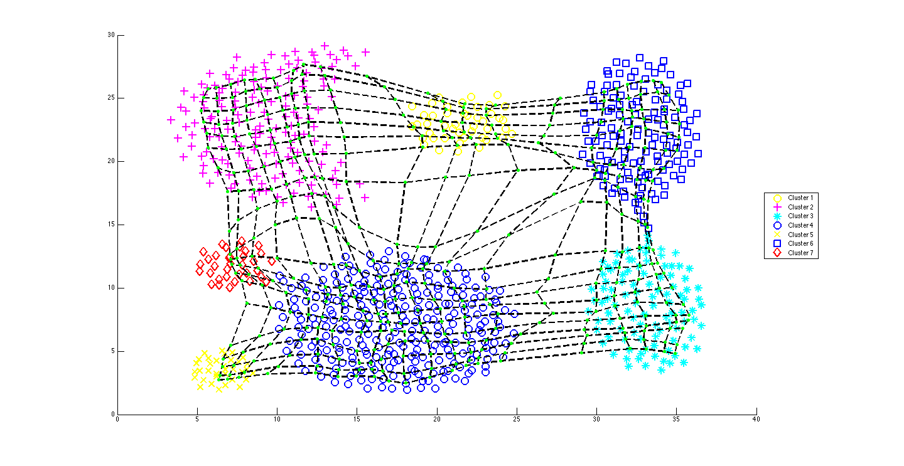

3. This is the same result with less color for clear demonstration of pattern capture.

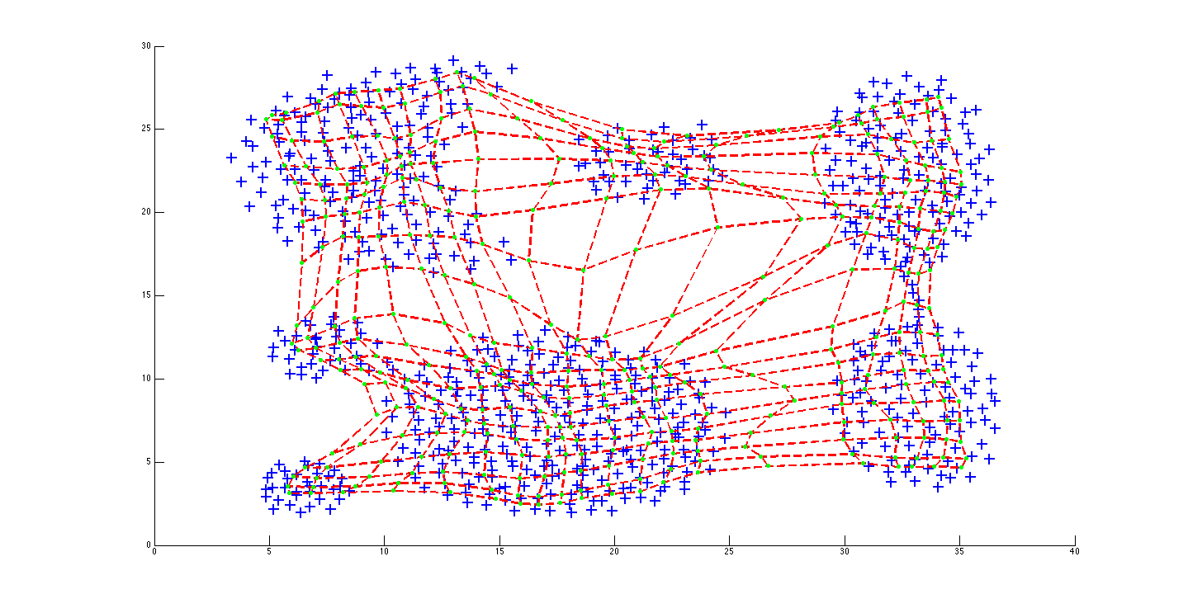

4. SOM captures the patterns of 7 different clusters after 10000 iterations of optimization for the weights of neurons. The dimension of SOM is 8x8. This is not very decent pattern recognition.

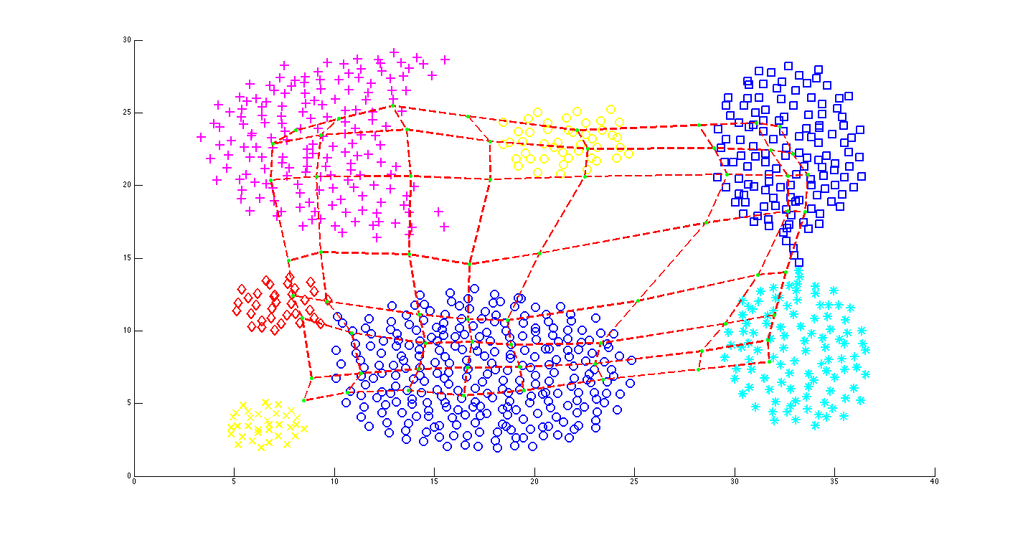

**Conclusion:**

Since we used a huge number of training dataset, so after we tried different dimension, initial width of topological neighborhood and learning rate of SOM, it can be inferred that for the future use of pattern detection of skin health data, the larger dimension of SOM and initial width of topological neighborhood, the more accurate pattern detection we will be able to obtain, which you can see by comparing figure 2 and figure 4.

**Appendix:**

Data resource:

[1] “Aggregation Shape Sets Clustering Datasets” - <http://cs.joensuu.fi/sipu/datasets/>, Speech and Image Processing Unit, School of Computing, University of Eastern Finland