Assessment brief

Create a copy of the bike website you created in DSD602. We are going to modify it to include authorization and authentication.

1. Set the following Password properties to make it easier for debugging

• RequireDigit = false;

• RequireLowercase = false;

• RequireNonAlphanumeric = false;

• RequireUppercase = true;

• RequiredLength = 6;

• RequiredUniqueChars = 1;

• RequireConfirmedEmail = false;

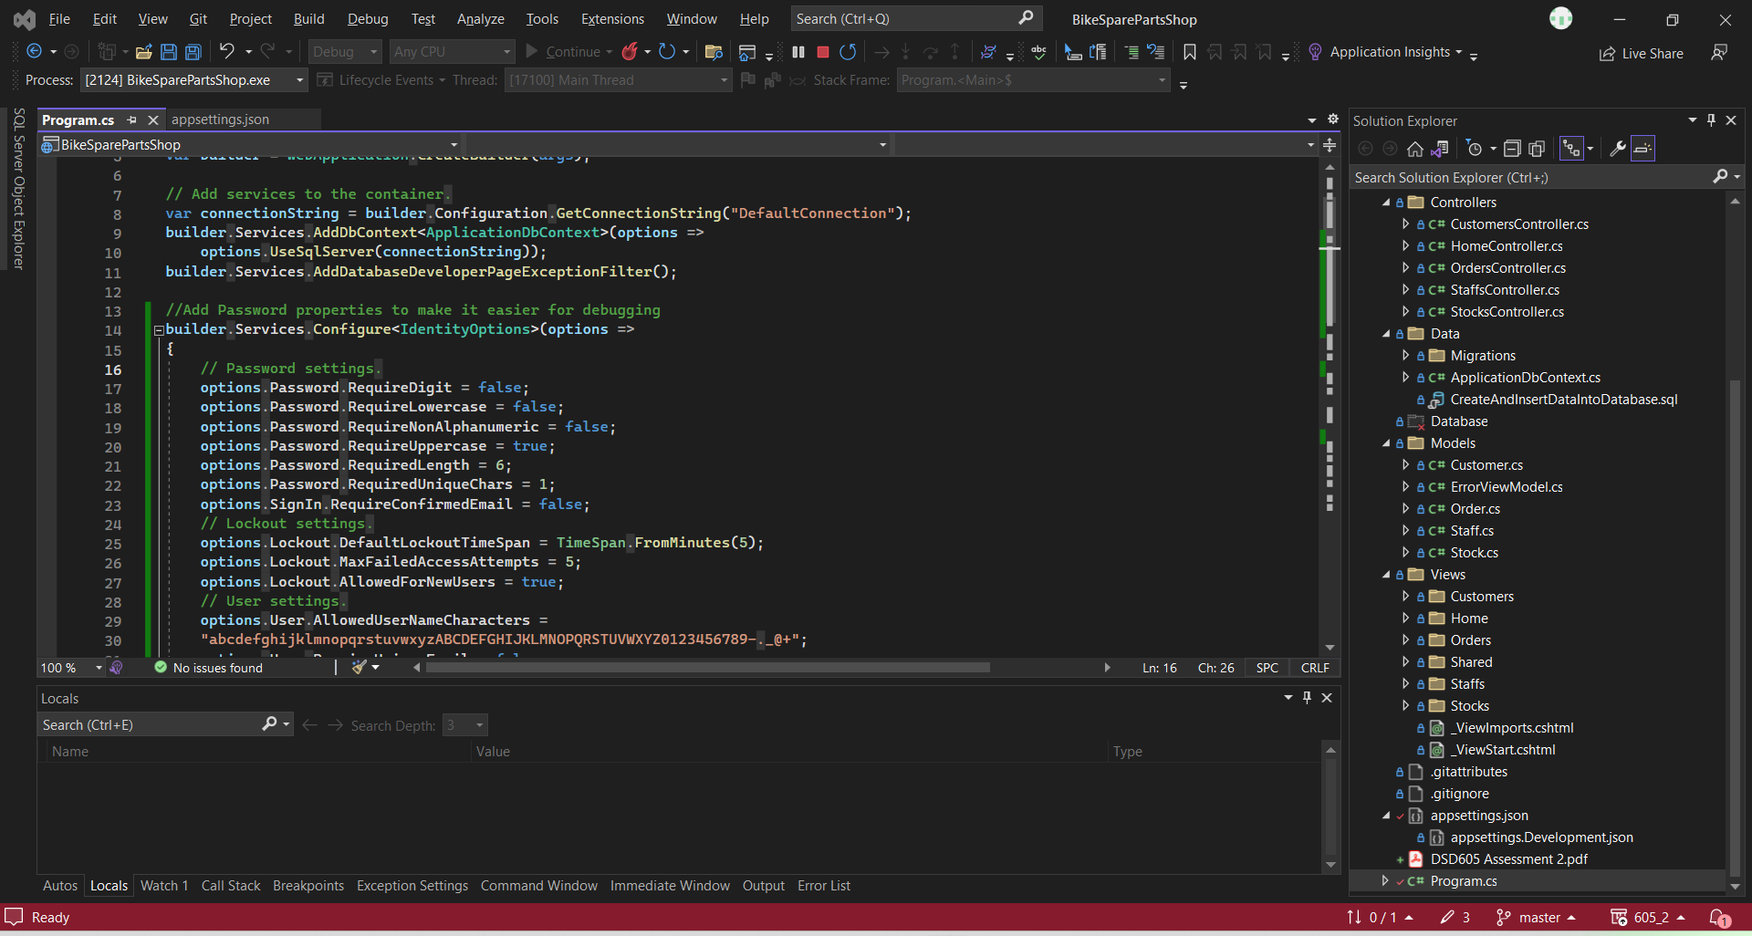

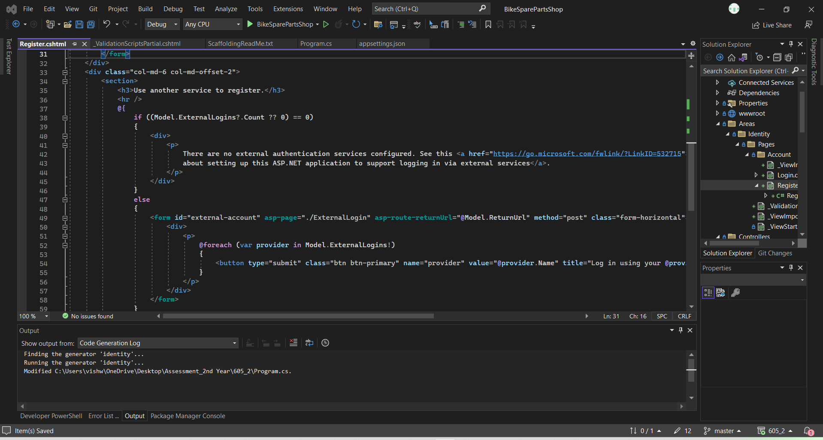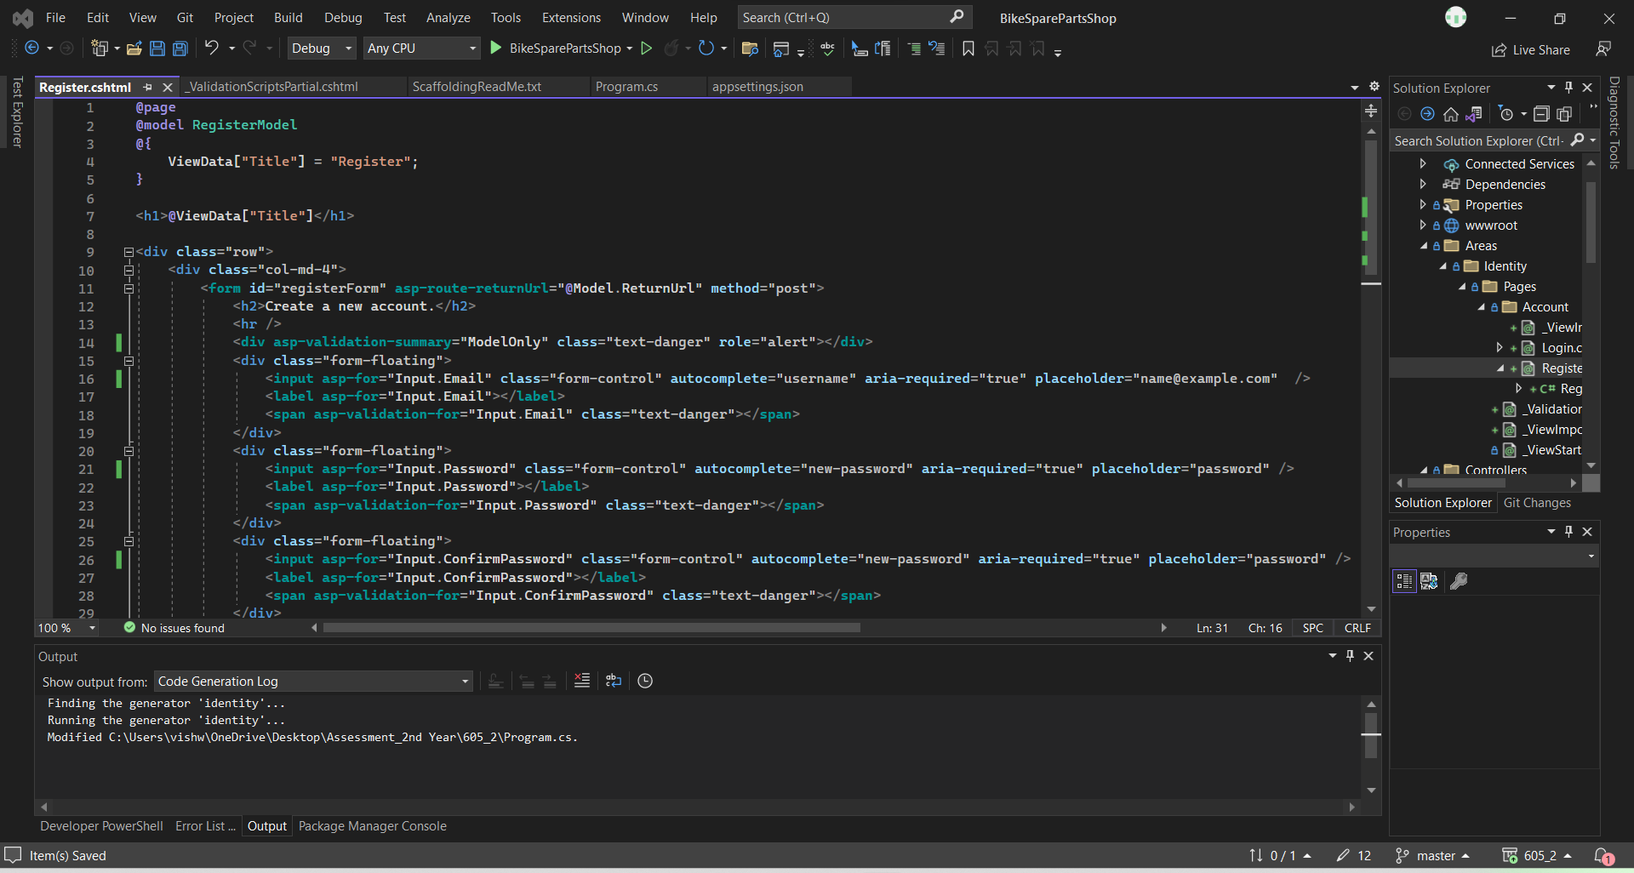

2. Modify the Register Page to automatically set confirm email to true

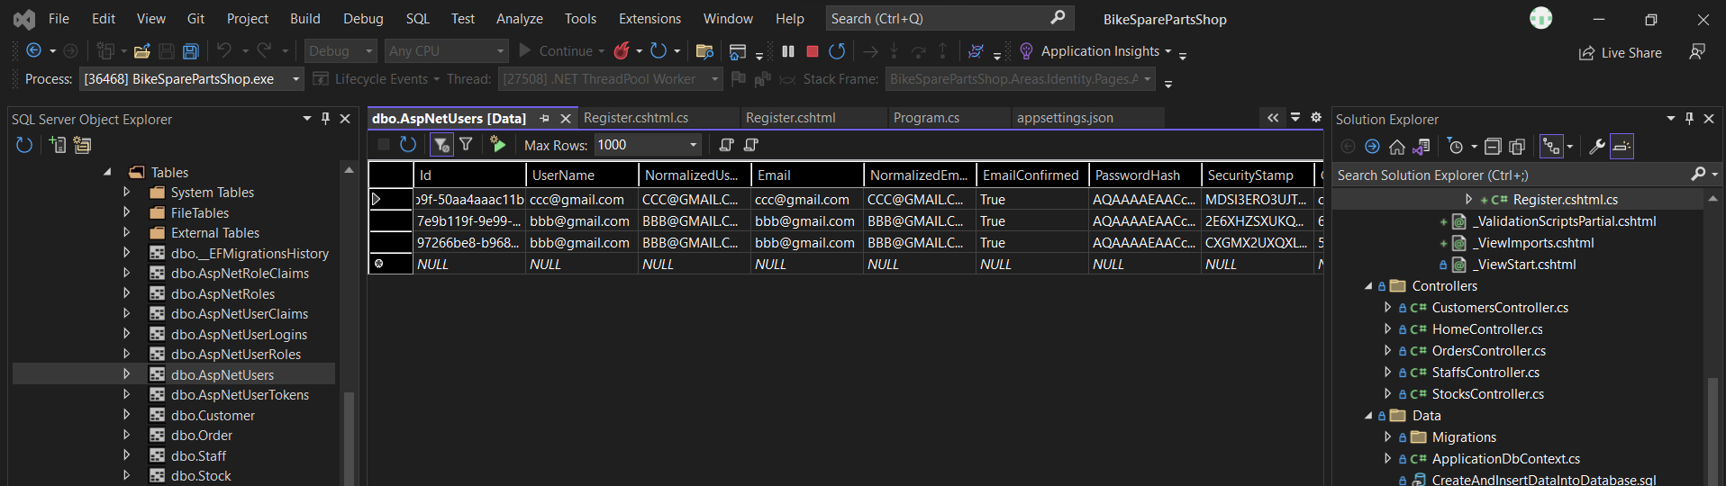

3. Customise the Access Denied page to add an image of your own choice, something unique

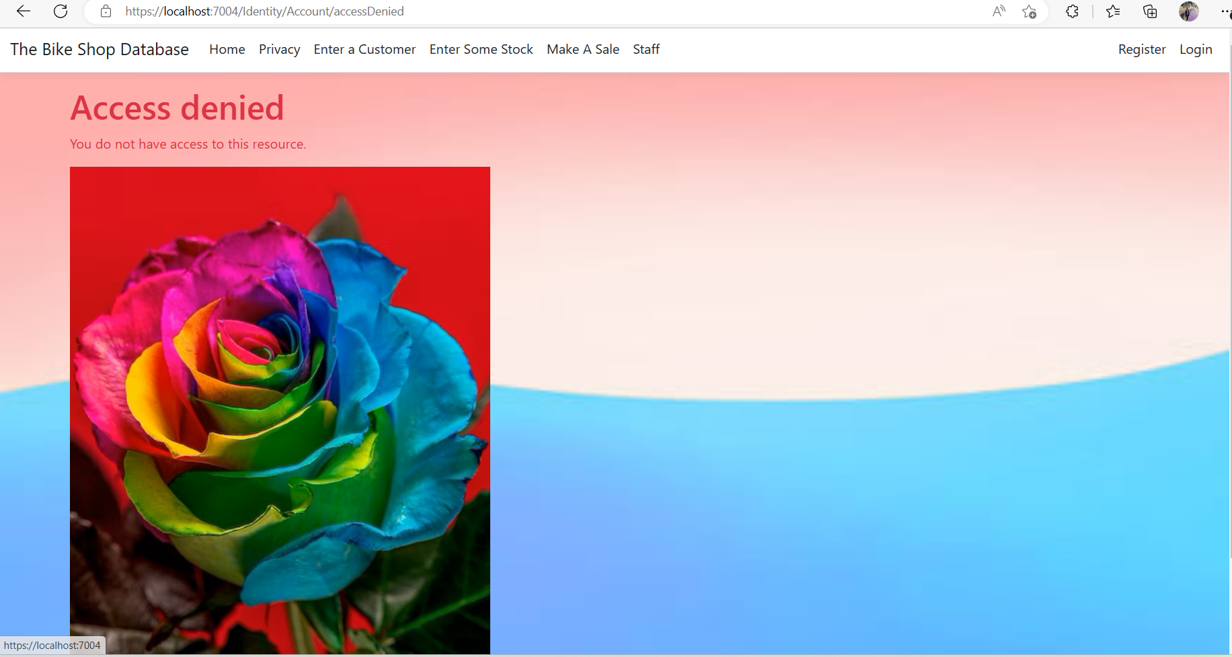

4. Add the following staff into your ASPNetUsers table via the Identity Register system(These guys are in your staff table already)

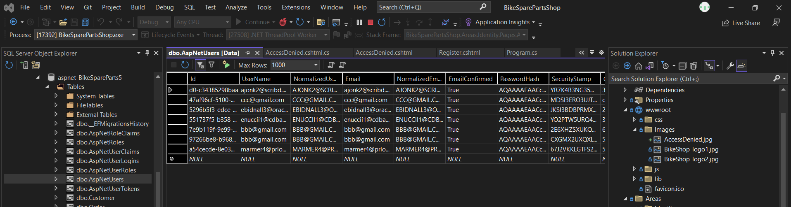

5. Create the roles of Admin, Manager, Staff, using the RoleManager interface.

• Eddie: Manager

• Alasdair: Manager

• Phillipa: Admin

• Elsworth: Staff

• Maye: Staff

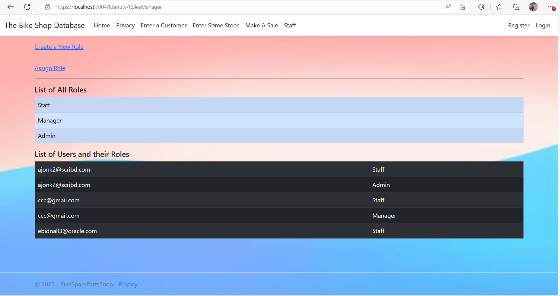

Create the claims below, using the ClaimsManager interface

6. Create the following staff User Claims

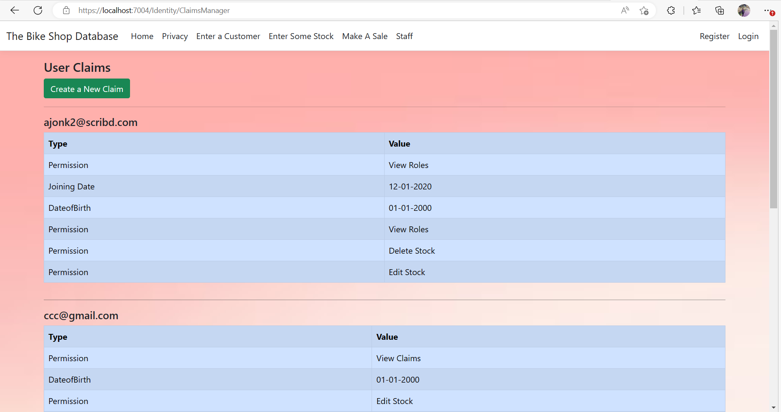

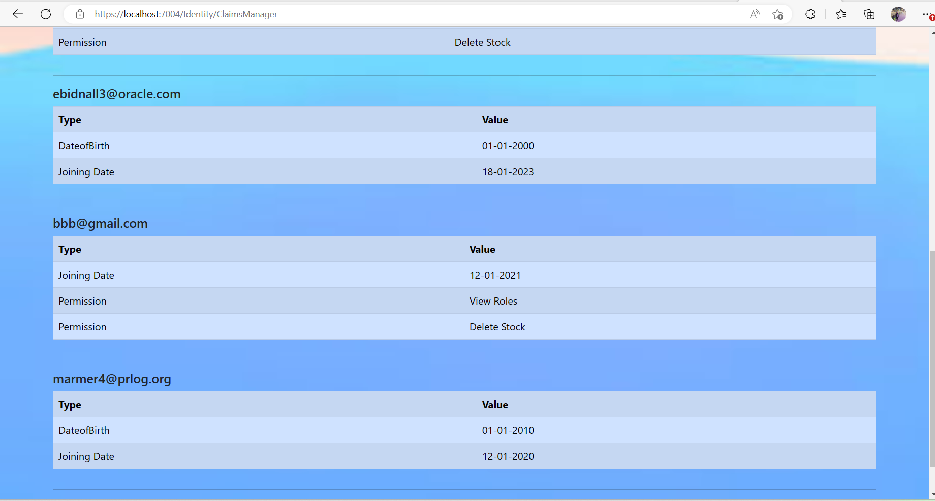

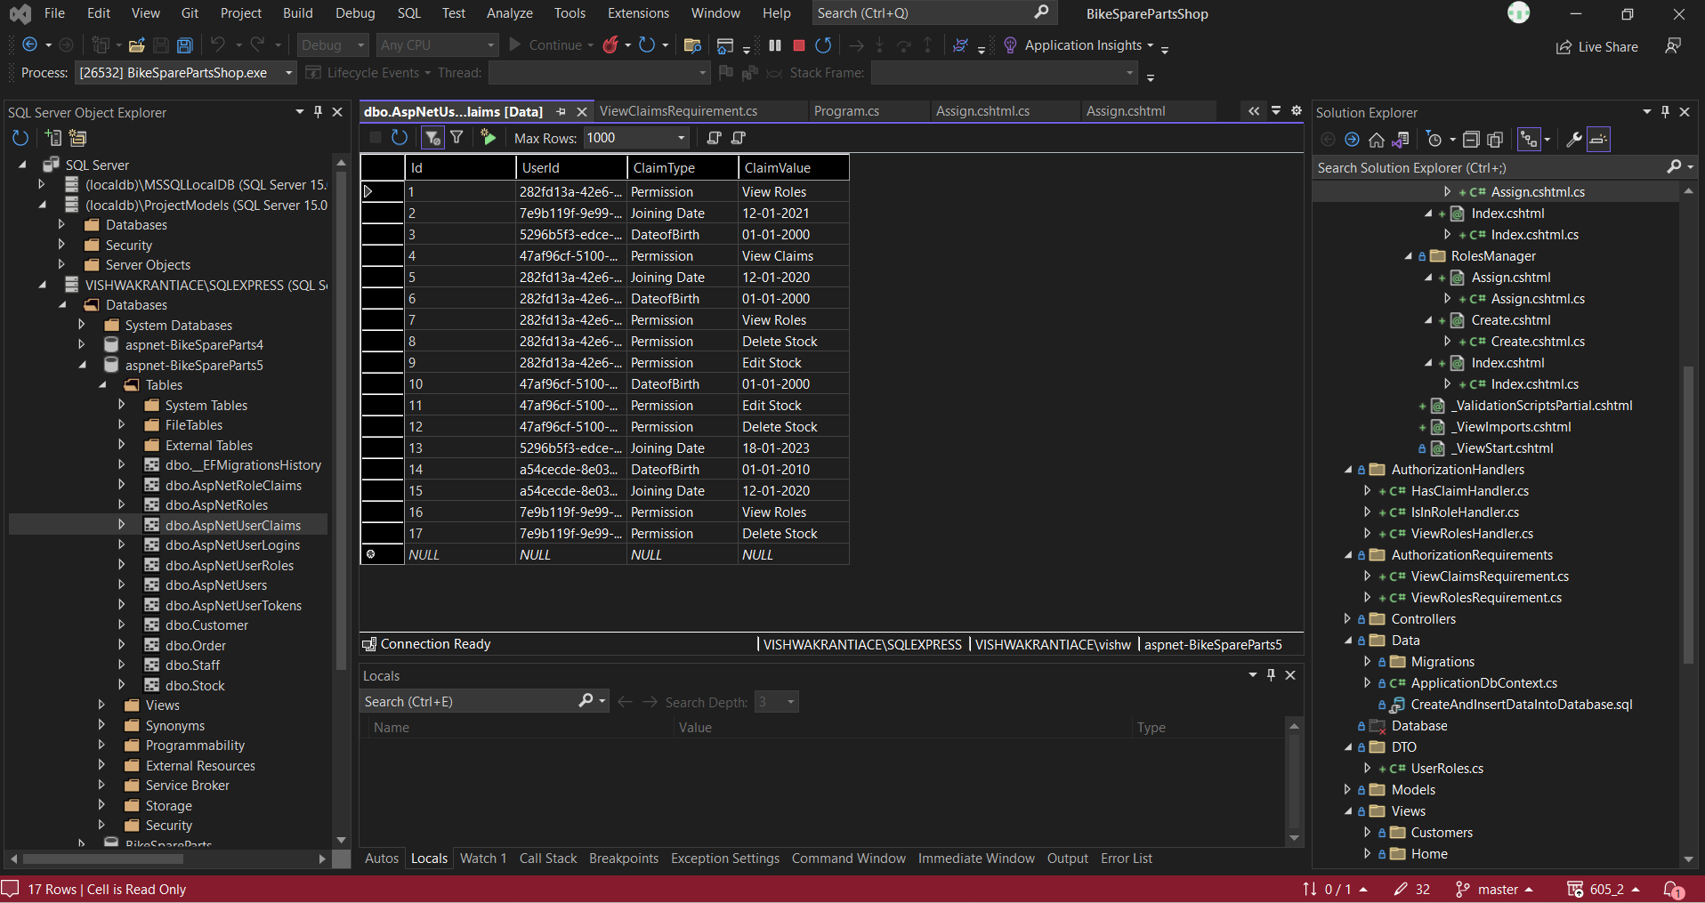

* 1. 7. Create the following policies and apply them.
  2. i) Staff with over 6 months of service and permission “View Roles” can view RolesManager folder
  3. ii) Staff with over 6 months of service and permission “View Claims” can view ClaimsManager Folder
  4. iii) Staff with permission Delete Stock can Delete Stock
  5. iv) Staff with permission Edit Stock can Edit Stock
  6. v) Staff over 18 can add stock
  7. vi) Staff in Admin Role can view the Staff details by controlling the StaffsController.