**DSD _ 602 _ Assessment _ 2 _ Vishwakranti**

Case Study

The *Bike Spare Parts* shop sells a range of bicycles, bike parts, and accessories and is planning to set-up a digital presence. At the moment, they use a printed monthly catalogue to market their products. The company also sponsors a High School bike race in their town and uses the event pictures to create a yearly *Bike Spare Parts* calendar. They have a long-term relationship with the town’s photographer, who is responsible for taking and storing images. They are fully dependent on the photographer to retrieve any old images.

The company’s new marketing strategy is to launch an e-commerce website in the second half of the year. The new website will contain images of all products, a digital copy of yearly calendar, and video from the high school bike race and so on. Firstly, they would like to take custody of and manage their digital assets. Therefore, they have requested you to provide the following information for *Bike Spare Parts*: -

1. **Determine and discuss the top five challenges of managing the digital assets which apply *to Bike Spare Parts*. [10 marks] (250-300 words)**

* Challenge 1: Transfer of existing written and photographic content to digital storage.

The existing data has to be transferred to the new digital storage in batches depending upon the amount (MB, GB or TBs) that needs to be transferred. The data transfer has to be scheduled during a period when the data is not being accessed or updated.

* Challenge 2: Determining the format for saving written and photographic content to be used for storage.

It’s very crucial to select the correct format for saving the photos and text for storage. The photos need to be optimized for storage and the text needs to be saved as per the requirements for its future use.

* Challenge 3: Providing a web portal to the town’s photographer to transfer the images taken for the high school bike race. It should also include the historical data possessed by the photographer related to the race

A web portal needs to be provided for the transfer of the photos taken by the photographer of the high school bike race. It needs to be simple to use and should log all the activities that are carried out on the portal. There needs to be adequate error logging to debug any errors found during operation. There also should be proper archival strategies to be used to upload historical data for the race so that it can be found quickly in future searches based on dates and context of the events.

* Challenge 4: Create a dynamic e-commerce website that can be updated regularly

A dynamic ecommerce website needs to be designed which can be updated regularly and can showcase the new parts that are being advertised by the company.

* Challenge 5: Setup a data redundancy protocol in case of failure of one set of storage

Data redundancy is key to maintain the ongoing operations of the company and there needs to be a detailed strategy to save data in multiple storages and copies of such data should exist so that if one backup fails then the other backup can be accessed without interrupting the daily processes of the company. It should be easy to restore the data from the backups.

1. **Explain Digital Asset Management and discuss four core characteristics and four factors to consider in selecting suitable DAM software. [10 marks] (250-300 words)**

* The four characteristics of Digital Asset Management are

1. Storage

Storing the data in appropriate format is vital for the daily operation of the company. It becomes imperative that the format is optimized so that data transfer can be achieved in a reasonable amount of time. A suitable DAM software will allow the company to store data in multiple formats and allow for transcoding between formats.

2. Search Capability

The search capability of the DAM software should match the needs of the company. It is vital for the DAM software to provide a wide ranging option to search on. The search should allow the company to find their required documents or assets in a timely fashion.

3. Availability

The DAM software should allow the company to access their data around the clock and should provide an always on option. The availability of the data is a prime need for a company which wants to make changes and edits to their existing data.

4. Ability to share the data securely

The DAM software should allow the sharing of the content in a secure fashion. The data sharing should have policies in place which control the length of time the data is available for sharing and should be available for authorized personnel only.

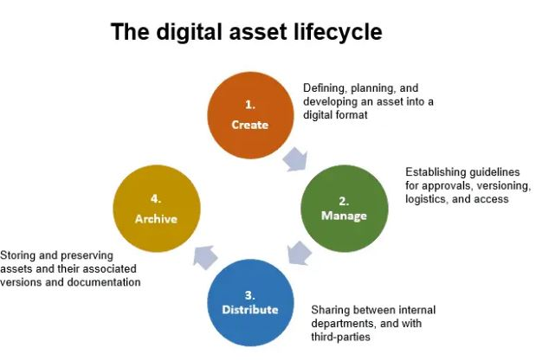

* The four factors to consider while selecting a suitable DAM software are integration with existing products, security, ease of use, and 24/7 customer support. The DAM software should provide APIs which will allow easy integration with existing company products without too much effort. Security offered by the DAM software should be optimal for the policies of access practiced by the company. The DAM software should be easy to use and should provide adequate user manuals for on boarding of users who are new to the platform. The customer support for the DAM software should be available whenever there are critical defects or interruption in the daily use of the software. The customer support should allow the company to log defects in real time and get feedback as soon as possible on the timeline for a fix to the DAM software.

1. **Justify the need for Digital Asset Management (DAM) by explaining five benefits it will add to *Bike Spare Parts*. [10 marks] (250-300 words)**

* The five benefits of a Digital Asset Management software are

1. Ability to access data in one place

The ability to access data in one place is highly valuable to a company which is facing growth of their business. The DAM software should have an easy to use interface which allows for browsing and quick retrieval of the stored data. This will benefit the company by allowing them to streamline their upstream and downstream processes.

1. Ability to search the data using a single portal

Searching and finding the data through the DAM software will benefit the company and allow them to locate their data in a quick fashion. This allows the company to spend less time on searching and more time in developing their business and planning their strategies for growth

1. Ability to update or delete data

The ability to modify the data in one place will allow the company to make quick edits to their existing portfolio. The benefits of making changes to existing data will help the company save time in their development processes and streamline access to the data from their in-house IT staff

1. Ability to transfer data to different formats

The benefit of having the ability to transfer data between formats is that it allows for use of the same data over a range of multimedia and social media platforms. The same data can be manipulated and stored in different formats which allows the company to optimize their use in different types of digital content.

1. Ability to access the data from any device.

If the company is able to access the data from multiple devices then it becomes easy to share and distribute the content as they need.

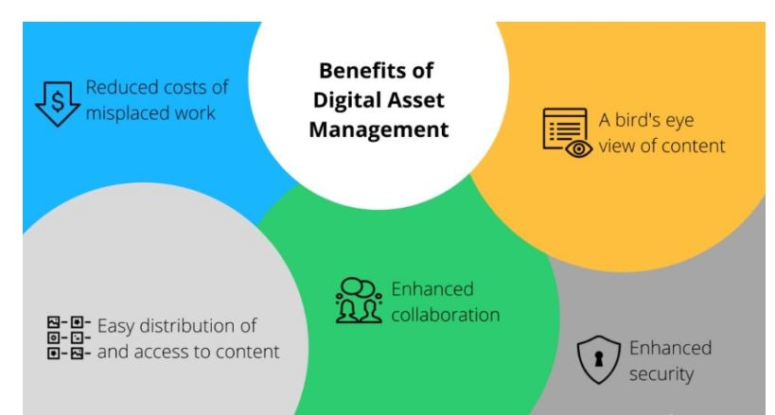

References:

(DigitalAssetManagement, n.d.)

(DigitalAssetManagementLifeCycle, n.d.)