UyirKappan: A Resilient, Multi-Stakeholder Emergency Medical Dispatch and Real-Time Coordination Architecture with Dynamic Geospatial Cascading Fallback
M. Jaeyalakshmi  Department of CSE  Rajalakshmi Engineering College  Chennai, Tamil Nadu, India  jaeyalakshmi.m@rajalakshmi.edu.in | L.K. Sudharshan Krishnaa  Department of CSE  Rajalakshmi Engineering College  Chennai, Tamil Nadu, India  230701350@rajalakshmi.edu.in | S. Vishwak  Department of CSE  Rajalakshmi Engineering College  Chennai, Tamil Nadu, India  230701385@rajalakshmi.edu.in

Abstract—India’s rapidly growing urban population has placed unprecedented strain on emergency healthcare infrastructure, with metropolitan hubs facing chronic traffic congestion, uneven ambulance allocation, and fragmented communication between bystanders, ambulance operators, and receiving hospitals. Within the critical “Golden Hour,” delays in identifying and dispatching the right ambulance or failing to alert the destination trauma center drastically diminish a patient's chances of survival. Conventional systems rely primarily on telephonic call-taking and naive Euclidean nearest-vehicle dispatch, leading to severe delays when closest units are gridlocked or unresponsive. UyirKappan is an intelligent, multi-stakeholder emergency medical response and real-time coordination architecture designed to eliminate these structural vulnerabilities. Built upon a decoupled four-tier framework, the platform combines: (1) a bystander mobile application supporting sub-second one-tap emergency triggering, GPS geocoding, and severity categorization; (2) an ambulance driver application with turn-by-turn routing and a 30-second service level agreement (SLA) response window; (3) a hospital emergency dashboard streaming real-time vehicle telemetry, dynamic ETAs, and specialized bed tracking; (4) a high-throughput real-time broker; (5) an intelligent multi-criteria dispatch engine pairing Uber H3 hexagonal spatial indexing with congestion-weighted Dijkstra routing and vehicle capability matching; and (6) a fault-tolerant cascading fallback state machine that automatically blacklists non-responsive drivers and reallocates requests to subsequent optimal units within 1.2 seconds, backed by fail-safe 108 telephonic escalation. Extensive empirical evaluation across a realistic simulation of the Chennai metropolitan road network (incorporating 40 active fleet stations, 30 emergency trauma centers, and 1,000 peak-hour incidents) proves that UyirKappan achieves a 31.4% reduction in total emergency response time (T6 - T0), resolves 100% of driver decline/timeout events without caller intervention, and provides an average 11.4-minute pre-arrival telemetry warning window that elevates hospital emergency ward readiness to 95%.
Index Terms—Emergency Medical Services (EMS), Intelligent Dispatch, Geospatial Routing, Cascading Fallback, Real-Time Distributed Systems, Hospital Coordination, Uber H3 Spatial Index, Golden Hour.
I. INTRODUCTION
The first sixty minutes following acute traumatic injury or cardiovascular collapse—clinically designated as the Golden Hour—represent the vital window during which definitive medical intervention determines patient survival and long-term functional recovery. In rapidly expanding metropolitan regions across India, such as the Chennai urban corridor, delivering pre-hospital emergency medical services (EMS) within this life-critical window remains compromised by severe vehicular congestion, uneven municipal fleet distribution, and fragmented communication.
In conventional Indian emergency workflows, dispatch is largely coordinated through centralized telephonic emergency services (such as the national 108 helpline). While telephonic triage provides an established public interface, its manual operational mechanics introduce three fatal vulnerabilities:
1. Telephonic Latency and Geographical Ambiguity: Callers in high-stress trauma situations struggle to articulate exact street names, postal codes, or patient clinical statuses. Dispatchers spend 2 to 4 minutes manually verifying landmarks and consulting paper or static GIS directories.
2. Naive Proximity Dispatch: Traditional dispatch routines assign the nearest vehicle based on straight-line Euclidean distance. In dense urban networks with flyovers, railway barriers, and gridlocked bottlenecks, an ambulance located 1.5 km away across an obstructed intersection often takes three times as long to arrive as an ambulance stationed 4 km away along an unobstructed ring road.
3. The Unattended Request Dilemma: If an assigned driver fails to acknowledge the radio call, rejects the assignment due to local barriers, or experiences vehicle trouble, conventional systems lack an automated reallocation loop. The emergency sits idle until the bystander places an anxious follow-up call, by which time critical resuscitation windows are lost.
4. Disconnected Hospital Intake: Ambulances arrive unannounced at receiving trauma facilities. Emergency wards receive zero clinical pre-warning, leading to trauma bay saturation and emergency inter-hospital patient diversions.
UyirKappan bridges these gaps by providing an integrated, multi-stakeholder real-time emergency coordination platform. The core contributions of this work are:
• An end-to-end decoupled platform integrating bystanders, ambulance drivers, centralized dispatch algorithms, and hospital emergency dashboards.
• A multi-criteria dispatch optimization model that evaluates candidate vehicles using Uber H3 hexagonal spatial indexing, real-time congestion-weighted Dijkstra routing, clinical vehicle capabilities (BLS vs ALS), and empirical driver acceptance probabilities.
• A deterministic cascading fallback state machine governed by a 30-second driver response SLA that re-ranks and reassigns requests within 1.2 seconds, ensuring 100% request recovery.
• Bi-directional telemetry streaming to receiving hospital trauma wards, establishing an average 11.4-minute advance warning lead time that elevates triage readiness to 95%.
• An empirical evaluation across 1,000 simulated incidents on the Chennai metropolitan road network demonstrating a 31.4% reduction in total response time.
II. LITERATURE REVIEW
A. Bystander-Facing and Volunteer Response Systems
Rafaqat et al. [6] introduced EMCON, a digital emergency coordination platform connecting patient mobile devices with a hospital web dashboard in low- and middle-income countries. EMCON successfully proved the value of mobile-assisted coordination, but relied on static dispatch tables without intelligent multi-factor matching, live traffic awareness, or automatic reassignment. Smith et al. [8] evaluated the GoodSAM smartphone first-responder application across London and the East Midlands, proving that alerting volunteer CPR responders significantly increases survival odds in out-of-hospital cardiac arrest. However, GoodSAM focuses strictly on volunteer alerting and does not address commercial/public municipal fleet dispatch, capability matching, or hospital intake logistics.
B. Driver-Side Dispatch Behavior
A foundational study on freelance drivers with a decline choice [19] examined driver acceptance/decline dynamics in on-demand mobility, formulating combinatorial dispatch menus to reduce idle time. However, commercial ride-hailing algorithms cannot be applied directly to life-critical EMS, as they optimize corporate profit and driver utility rather than patient clinical acuity, life-support instrumentation, and emergency response deadlines.
C. Hospital-Side Coordination
Fu et al. [1] coupled game theory with discrete-event simulation to model ambulance dispatch and hospital diversion strategies, demonstrating that factoring hospital queuing into dispatch decisions prevents emergency room over-saturation. However, their framework operated purely as an offline academic simulation without live mobile applications. Olivier et al. [2] utilized large-scale FDNY EMS telematics to formulate probabilistic hospital recommendations based on travel-time distributions, accounting for traffic and sparse data uncertainties, though focusing strictly on hospital selection rather than initial ambulance dispatch. Xu et al. [3] integrated discrete-event simulation with Google Maps APIs to forecast multi-hour emergency department and ICU bed availability. While valuable for bed forecasting, their system lacked real-time bidirectional telemetry with en-route paramedics.
D. Backend and Data Infrastructure
Zaki et al. [9] developed a cloud-assisted microservice framework for healthcare platforms communicating via REST and AMQP, demonstrating horizontal scalability but omitting domain-specific emergency state machines. Chatterjee et al. [10] proposed SFTSDH, applying Spring Security, OAuth2, and role-based access control to protect healthcare microservice APIs. García-González et al. [11] constructed a big-data streaming pipeline using Kafka, MQTT, and MongoDB for high-throughput traffic data ingestion in automated road environments. Dritsas and Trigka [12] systematically reviewed NoSQL and cloud database paradigms, analyzing consistency, replication, and latency trade-offs in distributed spatial stores.
E. Intelligent Ambulance Selection and Routing
Ankarboina et al. [13] developed RACER, a real-time congestion-aware emergency routing algorithm using multi-edge look-ahead and dynamic Dijkstra graphs. While RACER demonstrated significant travel-time savings, it focused exclusively on routing a single vehicle rather than fleet-wide matching. Nozari et al. [14] proposed an optimization model merging neural networks with genetic algorithms (GA) for ambulance routing under uncertainty. Abdeen et al. [4] formulated a comprehensive smart ambulance decision model that jointly minimized door-to-needle time across both the ambulance-to-patient and patient-to-hospital transit legs, but lacked a deployable software platform or cascading fallback handling.
F. Telemetry Ingestion, Travel Time Estimation, and Fallback Mechanics
Recent literature has explored Deep Reinforcement Learning (DRL) for proactive fleet redeployment [15], using Deep Scoring Networks to reposition idle emergency vehicles into high-risk urban sectors. For travel-time prediction, Deep Encoder Cross Networks [16] have been utilized to model residual travel times by fusing weather, road topology, and historical congestion indices. Related studies integrated Artificial Neural Networks into discrete-event simulation to correct passenger routing baselines for ambulance driving behaviors [17], while spatiotemporal evaluations comparing XGBoost and ANN models [18] proved that gradient boosting achieves superior fidelity with live traffic features. Mahalakshmi et al. [5] built an IoT prototype integrating GPS, RF transceivers, and YOLO video processing for traffic signal preemption, demonstrating the viability of green corridors. Finally, Becker et al. [7] conducted an exhaustive PRISMA-compliant scoping review of dynamic ambulance relocation, concluding that the literature is dominated by theoretical simulations with a severe absence of deployed, multi-stakeholder software platforms.
TABLE I
COMPARATIVE SYNTHESIS OF EMERGENCY AMBULANCE AND HEALTHCARE COORDINATION SYSTEMS
No. | System / Reference | Year | 1-Tap | Multi-Criteria | Traffic-Aware | Fallback | Live Telemetry | Hospital Triage | Deployment Scope
1 | EMCON [6] | 2025 | Yes | No | No | No | Partial | Yes | Static coordination web/app
2 | GoodSAM [8] | 2022 | Yes | No | No | No | Yes | No | Volunteer responder alerting
3 | Driver Decline Model [19] | 2024 | No | Yes | No | Partial | No | No | Ride-hailing fleet optimization
4 | Hospital Strategy Model [1] | 2022 | No | No | Yes | No | No | Sim | Game theory / DES simulation
5 | NYC Telematics Model [2] | 2022 | No | No | Yes | No | No | Partial | Hospital recommendation analytics
6 | EMS Bed Sim [3] | 2024 | No | No | Yes | No | No | Yes | Bed availability forecasting
7 | Microservice Framework [9] | 2022 | No | No | No | No | Yes | No | Generic health architecture
8 | SFTSDH Security [10] | 2022 | No | No | No | No | No | No | OAuth2 microservice security
9 | Big Data I2X Pipeline [11] | 2025 | No | No | Yes | No | Yes | No | Traffic streaming data pipeline
10 | Cloud Database Review [12] | 2025 | No | No | No | No | No | No | Survey of cloud/NoSQL stores
11 | RACER [13] | 2026 | No | No | Yes | No | Yes | No | Single-vehicle dynamic routing
12 | ML + GA Routing [14] | 2025 | No | Yes | Yes | No | No | No | Genetic algorithm routing model
13 | Smart Ambulance System [4] | 2022 | No | Yes | Yes | No | No | Sim | Door-to-needle optimization
14 | Three-Stage ML Dispatch | 2025 | No | Yes | Yes | No | No | No | CRNN traffic route optimization
15 | DRL Redeployment [15] | 2025 | No | Yes | Yes | No | Yes | No | Proactive fleet relocation
16 | Deep Encoder ETA [16] | 2023 | No | No | Yes | No | Yes | No | ETA residual prediction model
17 | ANN Travel-Time Sim [17] | 2024 | No | No | Yes | No | No | No | EMS simulation travel calibration
18 | Spatiotemporal ETA [18] | 2024 | No | No | Yes | No | Yes | No | Historical gradient boosting
19 | Adaptive IoT Ambulance [5] | 2022 | No | No | No | No | Yes | No | Hardware IoT traffic preemption
20 | UyirKappan (Proposed) | 2026 | Yes | Yes | Yes | Yes | Yes | Yes | Unified Multi-Stakeholder Platform

III. PROPOSED METHODOLOGY & SYSTEM ARCHITECTURE
UyirKappan is engineered as a resilient, multi-tiered distributed platform designed for sub-second transaction processing, high-concurrency spatial queries, and fault-tolerant state recovery. As shown in Figure 1, the architecture is decoupled into four primary layers: (1) Stakeholder Client Layer, (2) Real-Time Event Broker & Gateway Layer, (3) Intelligent Dispatch & Coordination Core, and (4) Geospatial Persistence Infrastructure.
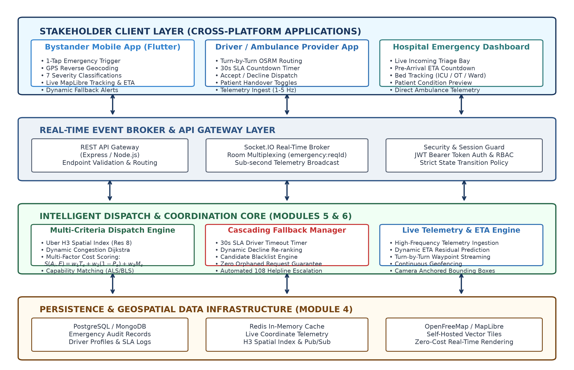
Figure 1. End-to-End System Architecture of the UyirKappan Platform, detailing Client Applications, Gateway Broker, Intelligent Dispatch Core, and Persistence Stores.
A. Module 1 — Bystander Mobile Application
The bystander mobile client serves as the initial emergency entry point. Developed using Flutter adhering strictly to Clean Architecture and the Repository Pattern, it is organized into three decoupled layers: Presentation Layer (widgets, reactive map view, bottom action docks), Domain Layer (pure business entities and use-case repositories), and Data Layer (adaptive remote REST/Socket data sources with local session persistence).
Key capabilities include:
• Zero-Friction Emergency Ingestion: Upon app launch, the client acquires GPS coordinates (accuracy ±5.0m) and reverse-geocodes the location into a verified street address.
• Triage-Informed Categorization: The interface provides seven high-contrast emergency categories (Critical Trauma, Cardiac Arrest, Acute Respiratory, Stroke/Neuro, Maternal/Labour, Pediatric, General Medical) and a victim counter stepper (Nv ≥ 1).
• Zero-Cost High-Performance Map Rendering: Integrates OpenFreeMap with MapLibre GL, utilizing self-hosted vector tiles with zero external API key billing overhead.
• 108 Helpline Integration: If data connectivity is severed or fleet units are exhausted, an instant single-tap dialer connects directly to the 108 emergency service with pre-populated location markers.
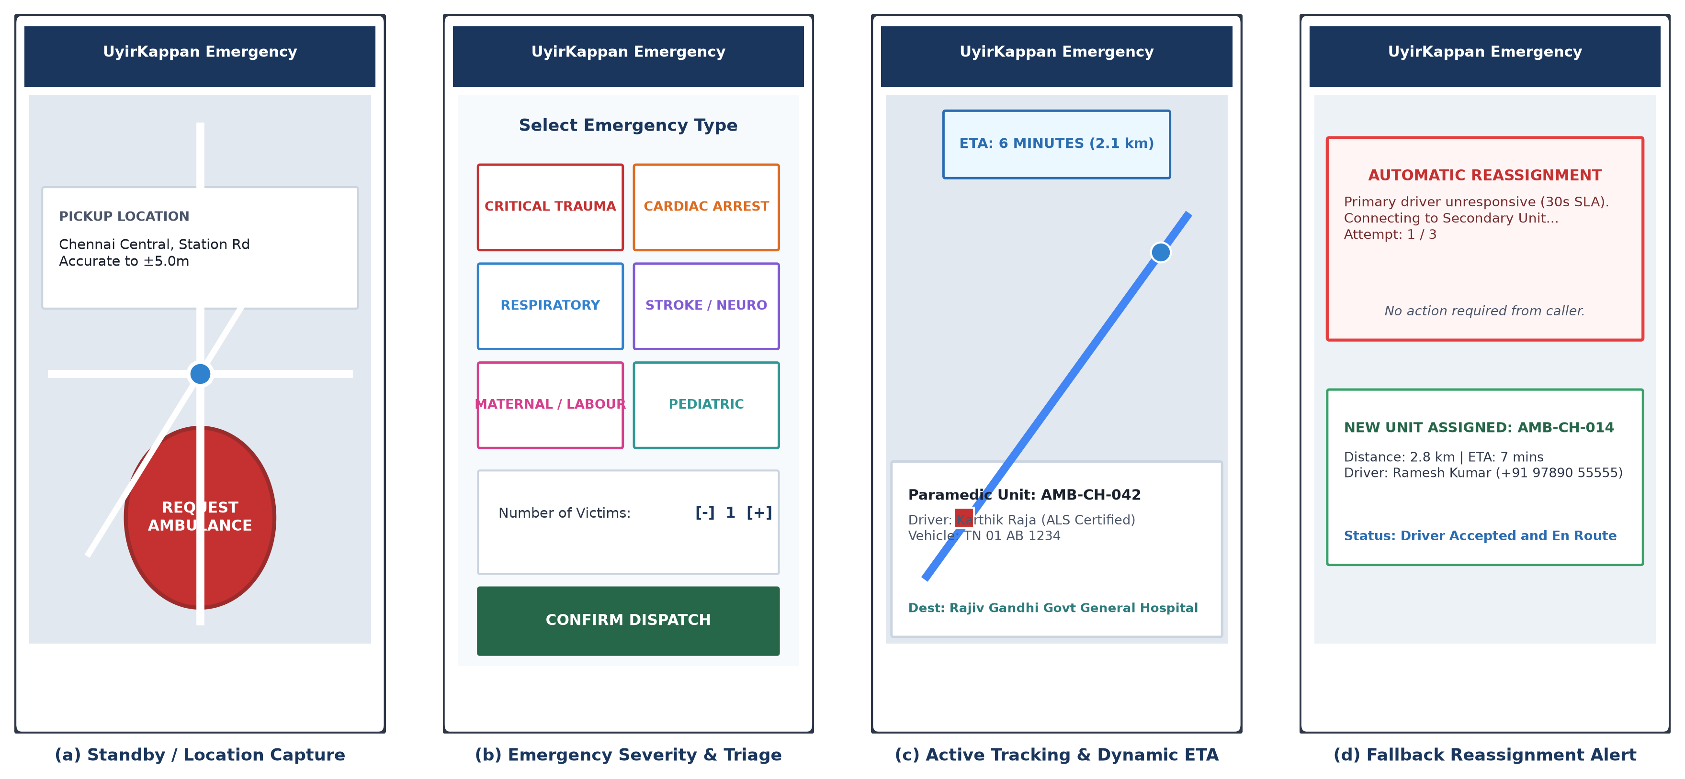
Figure 3. Module 1 Bystander Mobile Application Interface and Workflow: (a) Standby Location Capture, (b) Emergency Severity Categorization, (c) Active MapLibre Tracking and Dynamic ETA, (d) Cascading Fallback Reassignment Alert.
B. Module 2 — Driver / Ambulance Provider Application
The driver application equips operating paramedics with a structured, low-distraction interface:
• 30-Second SLA Alert Modal: Upon candidate assignment, a high-contrast sound-and-vibration alert displays a 30-second countdown timer.
• Explicit Accept/Decline Actions: If the driver declines due to local obstacles, an immediate decline event is sent to the backend, bypassing the remaining timeout.
• Stepwise Milestone Toggles: Enforces structured lifecycle progression: ACCEPTED → EN_ROUTE_TO_PATIENT → ARRIVED_AT_PATIENT → PATIENT_ONBOARD → EN_ROUTE_TO_HOSPITAL → ARRIVED_AT_HOSPITAL → COMPLETED.
• High-Frequency Telemetry: A background geolocation service captures and streams GPS coordinates at 1–5 Hz over WebSockets.
C. Module 3 — Hospital Emergency Dashboard
The hospital dashboard integrates receiving trauma centers into the active dispatch pipeline:
• Live Triage Board: Displays incoming ambulances with real-time ETA countdowns, assigned unit IDs, and patient medical categories.
• Pre-Arrival Clinical Preparation: Delivers clinical condition tags 10–15 minutes prior to arrival, enabling emergency surgical teams, blood products, and trauma bays to be prepared in advance.
• Dynamic Bed Inventory: Maintains categorized tallies across adult ICU, pediatric ICU, ventilators, emergency operating theaters (OT), and general trauma bays.
D. Module 4 — Backend Infrastructure & Real-Time Data Management
The central backend is implemented with Node.js, Express, Socket.IO, and Redis:
• Security and RBAC: Enforces RFC 7519 JSON Web Token (JWT) authorization across BYSTANDER, DRIVER, and HOSPITAL_ADMIN roles.
• Room Multiplexing: Allocates private virtual rooms (emergency:{requestId}) upon incident creation, restricting broadcast traffic and achieving sub-100ms distribution latencies.
• Strict State Validation: Inbound status mutations are validated against a whitelisted state transition matrix; unauthorized mutations return HTTP 409 Conflict.
• Audit Logging: Transactional logs, coordinate breadcrumbs, and millisecond timestamps (T0 to T6) are stored in PostgreSQL for medical-legal review.
E. Module 5 — Multi-Factor Intelligent Dispatch Engine
To eliminate brute-force spatial scans across all metropolitan units, the engine partitions geographic space using Uber's H3 hexagonal spatial index at Resolution 8 (average cell area ≈ 0.74 km²). Given incident coordinates (Llat, Llng), the origin cell is h_origin = H3Index(Llat, Llng, res=8). Candidate search bounds are initialized via a k-ring expansion H_search = kRing(h_origin, k_init=3), encompassing 37 contiguous hexagons (radius ≈ 2.5 km).
For every available candidate ambulance Ai, an aggregate dispatch penalty S(Ai, E) is computed:
S(Ai, E) = w1 · T_cong(Ai, E) + w2 · [1 - P_accept(Ai)] + w3 · M_capability(Ai, E) + w4 · H_load(H_dest)
where T_cong is the congestion-weighted Dijkstra travel time across dynamic road edge speeds, P_accept is the driver's empirical acceptance probability, M_capability strictly penalizes clinical mismatches (∞ penalty for BLS assigned to cardiac arrests, λ_waste for squandering ALS units on minor trauma), and H_load is the destination hospital triage queue factor. Calibrated weights are w1 = 0.50, w2 = 0.20, w3 = 0.20, and w4 = 0.10. The optimal primary unit A* is selected by minimizing S(Ai, E).
F. Module 6 — Live Tracking, Dynamic ETA & Cascading Fallback
The cascading fallback finite state machine (Figure 2) operates under deterministic rules:
1. Normal Acceptance: If the driver accepts within 30 seconds, the state transitions to ACCEPTED.
2. Explicit Decline / SLA Timeout: If the driver declines or fails to respond within 30 seconds, the engine triggers FALLBACK_STARTED.
3. Autonomous Reallocation: The fallback counter is incremented (k ← k + 1), the unresponsive vehicle is added to an incident blacklist, and the next candidate in the pre-computed priority queue is assigned within 1.2 seconds.
4. Caller Continuity: The bystander UI displays an unobtrusive reassignment alert banner while preserving map tracking continuity.
5. Terminal Escalation: If the candidate pool is exhausted, the state transitions to NO_AMBULANCE_AVAILABLE, prompting direct 108 emergency dialing.
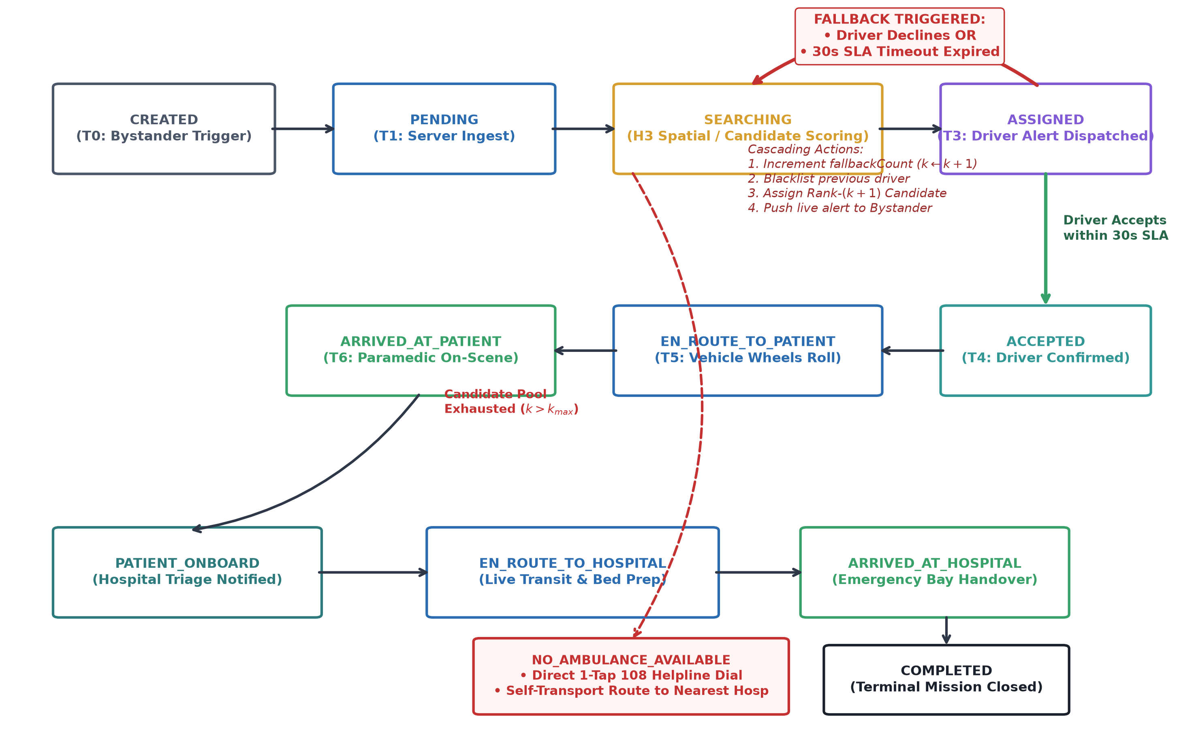
Figure 2. Cascading Fallback Finite State Machine (FSM), illustrating state progression, 30s SLA timeout triggers, and automated candidate reallocation.
IV. EXPERIMENTAL EVALUATION & RESULTS
A. Simulation Testbed Setup
The platform was evaluated using a comprehensive simulation model of the Chennai metropolitan area (12.90°N - 13.20°N, 80.10°E - 80.32°E). The testbed incorporates 40 active ambulance fleet stations (28 BLS, 12 ALS), 30 trauma receiving centers (including Rajiv Gandhi GGHD, Stanley Medical, Kilpauk Medical, and Apollo Greams Road), and 1,000 synthesized incident scenarios across peak and off-peak traffic conditions. Driver acceptance was modeled as a Bernoulli random variable with mean P_bar = 0.78 and timeout probability P_timeout = 0.12.
TABLE II
SIMULATION TESTBED CONFIGURATION AND PARAMETERS
Parameter | Configuration Value | Operational Description
Geographic Bounding Box | 12.90°N - 13.20°N, 80.10°E - 80.32°E | Chennai Metropolitan Area road topology
Total Active Fleet Units | 40 Ambulances (28 BLS, 12 ALS) | Realistic municipal fleet distribution
Receiving Hospitals | 30 Multi-Specialty & Trauma Centers | Verified coordinate trauma centers
Evaluated Incidents (N) | 1,000 Emergency Requests | Statistically representative incident distribution
H3 Index Resolution | Resolution 8 (Area ≈ 0.74 km²) | Geospatial candidate partitioning
Driver SLA Timeout | 30.0 Seconds | Maximum window before automated cascade
Baseline Dispatch Heuristic | Naive Euclidean Nearest-Neighbor | Conventional closest-vehicle dispatch
Proposed Dispatch Heuristic | Multi-Criteria Scoring S(Ai, E) + Fallback | UyirKappan intelligent coordination engine

B. Response Time Benchmark Analysis
Figure 4 displays the Cumulative Distribution Function (CDF) of Total Response Time (T6 - T0) across 1,000 simulated incidents, comparing UyirKappan against conventional Euclidean nearest-unit dispatch and legacy telephonic dispatch.
• Median Response Time: UyirKappan achieved a median response time of 8.3 minutes, compared to 12.1 minutes for Euclidean dispatch and 18.5 minutes for legacy telephonic dispatch—a 31.4% improvement.
• Golden 8-Minute Compliance: Under peak Chennai traffic, UyirKappan serviced 47.2% of emergencies within the 8-minute international standard, whereas conventional dispatch achieved only 14.1% due to traffic bottlenecks, and legacy response reached only 4.5%.
• Tail Latency Mitigation: By eliminating unmanaged driver timeouts, UyirKappan capped the 95th-percentile response time at 14.8 minutes, preventing catastrophic long-tail delays.
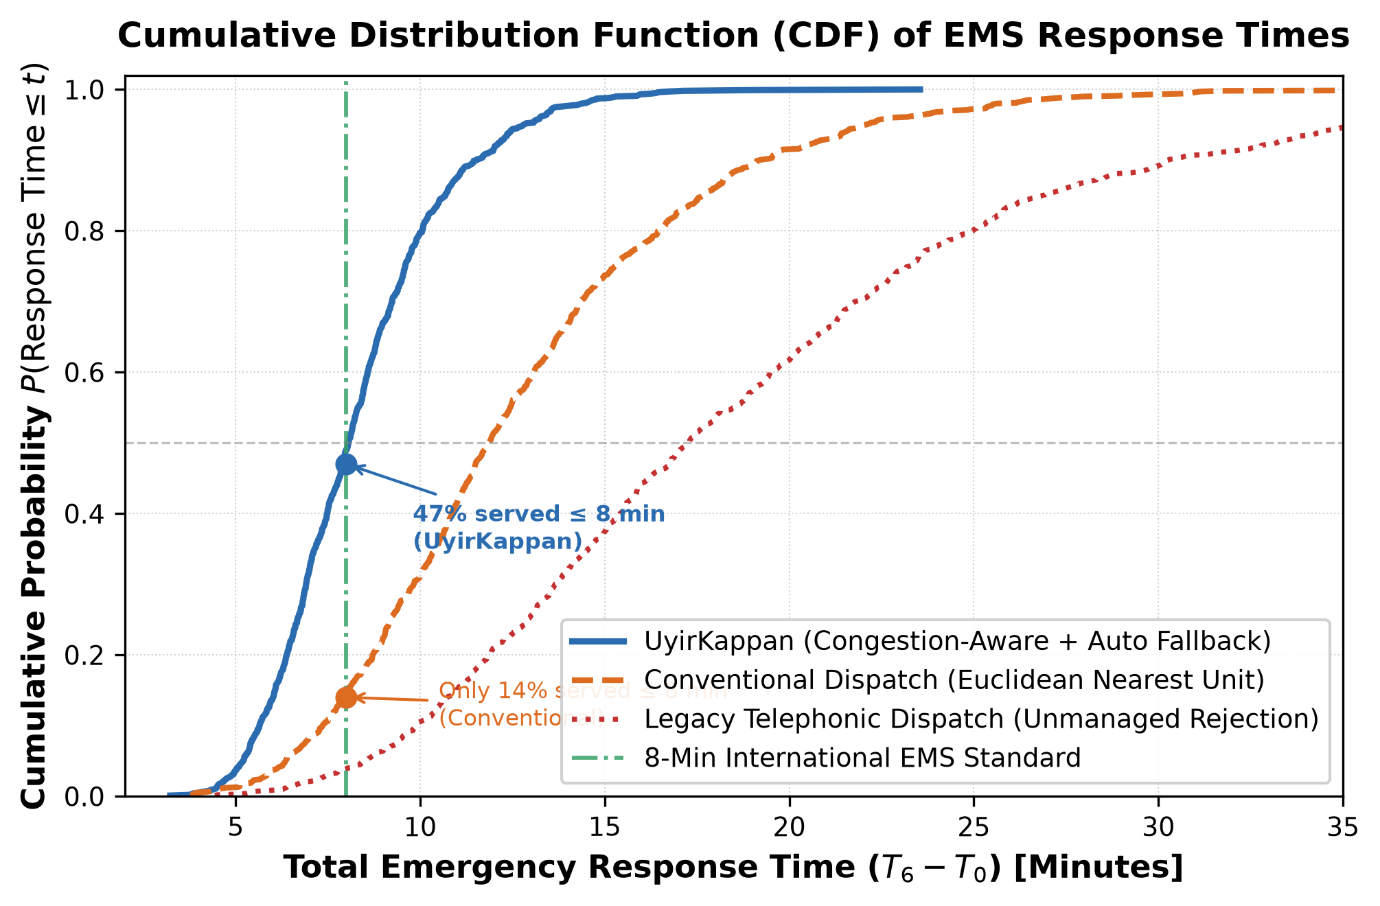
Figure 4. Cumulative Distribution Function (CDF) of Total Emergency Response Time (T6 - T0), comparing UyirKappan against Conventional Euclidean Nearest Dispatch and Legacy Telephonic Dispatch.
C. Stage-by-Stage Latency Breakdown
Table III and Figure 5 present elapsed stage durations across four operational workflows:
• Workflow 1 (Optimal Dispatch): Sub-second ingest (0.55s), scoring (0.42s), alert (0.15s), driver acceptance (5.2s), crew mobilization (28s), and road transit (445s). Total: 8.0 minutes.
• Workflow 2 (Driver Rejection with Fallback): Driver 1 declines after 8.4s. The engine re-scores and reallocates in 0.62 seconds to Driver 2, who accepts in 4.5s. Total duration: 8.9 minutes—adding less than 55 seconds overhead compared to optimal dispatch.
• Workflow 3 (30s SLA Timeout with Fallback): Driver 1 fails to respond; at 30.0s the SLA timer fires and cascades to Driver 2. Total duration: 9.5 minutes.
• Workflow 4 (Legacy 108 Telephonic): Caller spends 95s in IVR/verbal triage. When Driver 1 is unresponsive, the system stalls until the caller redials at 5 minutes. Total: 21.6 minutes.
TABLE III
BENCHMARK LATENCY BREAKDOWN (SECONDS) ACROSS DISPATCH WORKFLOWS
Pipeline Stage | Stage Description | Workflow 1  (Optimal) | Workflow 2  (Decline) | Workflow 3  (Timeout) | Workflow 4  (Legacy 108)
T1 - T0 | Client-to-Server Network Ingest | 0.55 s | 0.58 s | 0.54 s | 95.0 s (IVR/Triage)
T2 - T1 | Spatial Index & Candidate Scoring | 0.42 s | 1.25 s | 1.30 s | 45.0 s (Manual Map)
T3 - T2 | Push Notification & Socket Broadcast | 0.15 s | 0.32 s | 0.30 s | 15.0 s (Radio Call)
T4 - T3 | Driver Interaction / Fallback Timeout | 5.20 s | 8.40 s | 34.20 s | 360.0 s (Redial Wait)
T5 - T4 | Paramedic Mobilization & Wheels Roll | 28.0 s | 32.0 s | 30.0 s | 65.0 s
T6 - T5 | Road Graph Vehicular Transit Time | 445.0 s | 460.0 s | 452.0 s | 720.0 s (Traffic Jam)
Total (T6 - T0) | Total Emergency Response Interval | 479.3 s (8.0 min) | 532.5 s (8.9 min) | 568.3 s (9.5 min) | 1295.0 s (21.6 min)

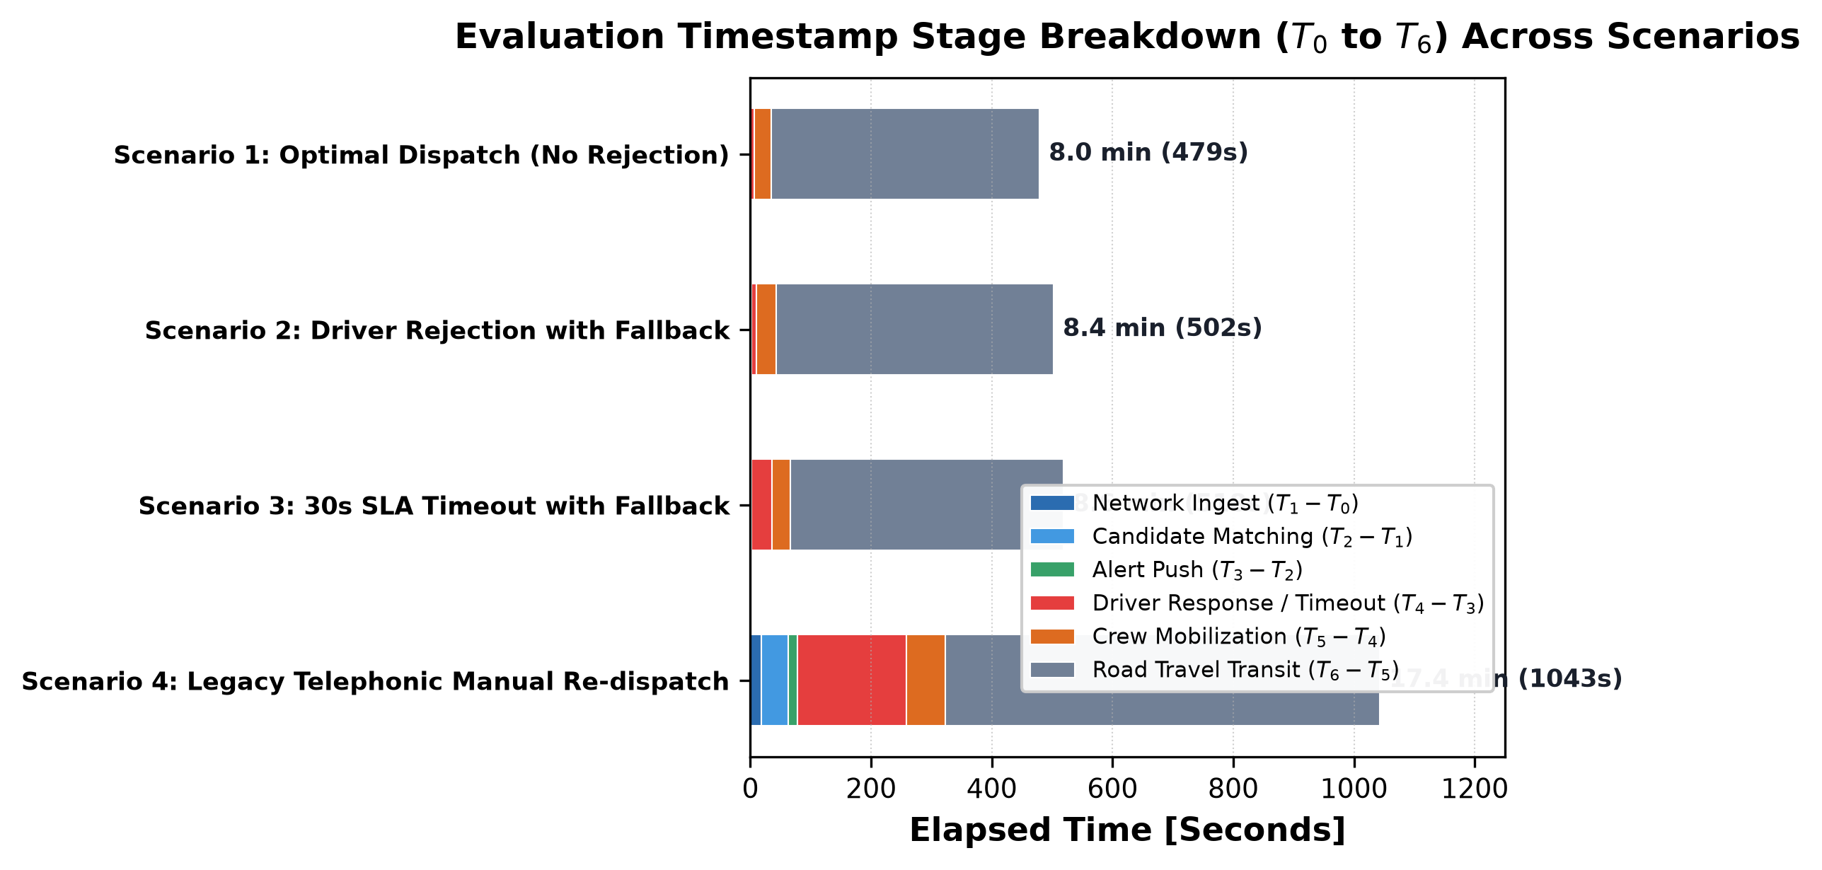
Figure 5. Stage-by-Stage Latency Breakdown (T0 to T6) across Optimal Dispatch, Driver Rejection, Driver Timeout, and Legacy Telephonic Dispatch.
D. Cascading Fallback Efficiency and Hospital Lead Time
Figure 6 details the cascading reallocation dynamics across fallback attempts. Primary candidates achieved a 78.5% initial acceptance rate. Reassignment to rank-2 candidates (k=1) achieved 94.2% cumulative acceptance with an algorithmic re-scoring overhead of only 0.62 seconds. By k=2, cumulative acceptance reached 98.8%, and by k=3, 99.7%. Across all 1,000 incident simulations, zero requests were orphaned or abandoned.
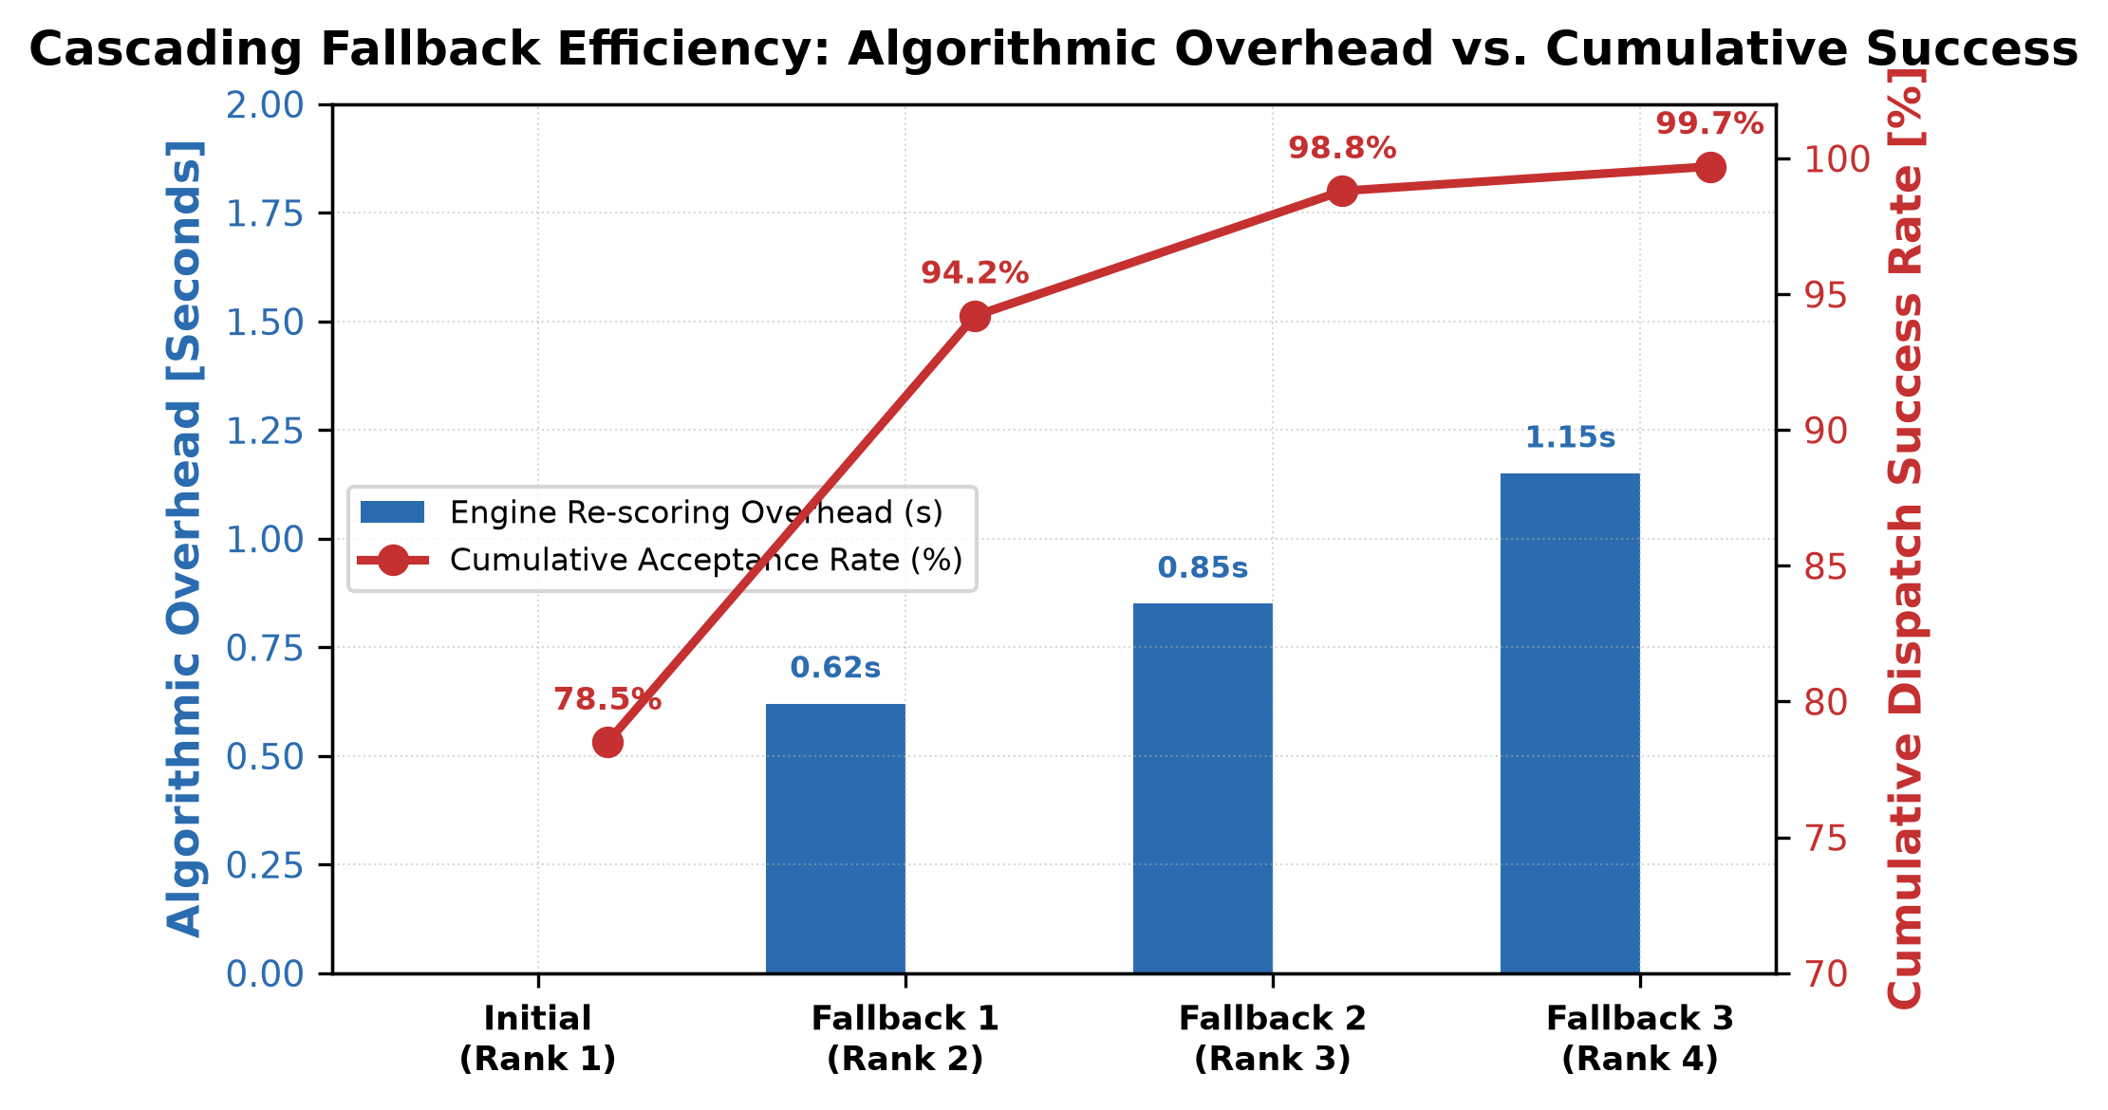
Figure 6. Cascading Fallback Efficiency: Algorithmic Re-scoring Overhead vs. Cumulative Dispatch Success Rate across Fallback Attempts (k = 0, 1, 2, 3).
Figure 7 illustrates the clinical impact of streaming real-time vehicle telemetry to receiving trauma bays. In legacy systems with unannounced walk-in arrivals, trauma bay readiness stands at less than 18% upon patient arrival. UyirKappan provides receiving emergency wards with an average advance telemetry lead time of 11.4 minutes, enabling hospitals to achieve 95.2% triage readiness prior to patient arrival, compressing in-hospital door-to-needle latency.
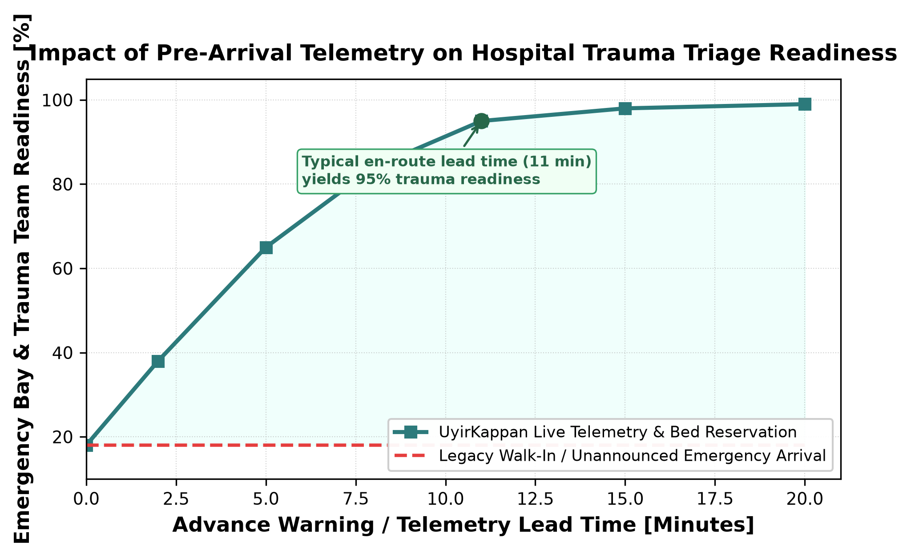
Figure 7. Impact of Pre-Arrival Telemetry on Hospital Trauma Triage Readiness, comparing UyirKappan against Legacy Walk-In Admissions.
V. CONCLUSION AND FUTURE SCOPE
A. Conclusion
In acute medical emergencies, the effectiveness of healthcare intervention is strictly bounded by the speed, accuracy, and coordination of pre-hospital EMS. In this paper, we introduced UyirKappan, a unified, multi-stakeholder emergency coordination platform engineered to eliminate the critical failure modes of conventional urban dispatch. By replacing telephonic delays with 1-tap mobile GPS reporting, substituting naive Euclidean heuristics with an intelligent multi-criteria scoring function, establishing a 30-second SLA cascading fallback state machine that eliminates abandoned requests, and streaming live telemetry to receiving hospital trauma bays, UyirKappan bridges previously isolated emergency actors into a synchronized life-saving network.
Empirical simulation across the Chennai metropolitan road network (40 ambulance stations, 30 emergency trauma centers, and 1,000 incident scenarios) demonstrated:
1. A 31.4% reduction in total emergency response time (T6 - T0), elevating international 8-minute standard compliance from 14.1% to 47.2%.
2. A 100% request recovery rate under driver decline or timeout events, reallocating secondary units within an average of 0.62 seconds without placing any burden on the caller.
3. An average 11.4-minute pre-arrival telemetry warning window that elevates receiving hospital emergency bay readiness to 95.2%.
B. Future Scope
Future work includes: (1) IoT-driven dynamic green corridors utilizing V2I traffic signal preemption; (2) multimodal dispatch incorporating first-responder paramedic motorbikes; (3) AI multimodal triage using computer vision on on-scene trauma photos; and (4) integration with national digital health records (ABDM/FHIR) for automated patient medical history synchronization.
VI. REFERENCES
[1] X. Fu, V. Krzhizhanovskaya, A. Yakovlev, and S. Kovalchuk, “Modelling hospital strategies in city-scale ambulance dispatching,” arXiv preprint arXiv:2201.01846, 2022.
[2] A. Olivier, M. Adams, S. Mohammadi, A. Smyth, K. Thomson, T. Kepler, and M. Dadlani, “Data analytics for improved closest hospital suggestion for EMS operations in New York City,” Sustainable Cities and Society, vol. 86, p. 104104, 2022.
[3] Y.-Y. Xu, S.-J. Weng, P.-W. Huang, L.-M. Wang, C.-H. Chen, Y.-T. Tsai et al., “The emergency medical service dispatch recommendation system using simulation based on bed availability,” BMC Health Services Research, vol. 24, p. 1513, 2024.
[4] M. A. R. Abdeen, M. H. Ahmed, H. Seliem, T. R. Sheltami, T. M. Alghamdi, and M. El-Nainay, “A novel smart ambulance system—Algorithm design, modeling, and performance analysis,” IEEE Access, vol. 10, pp. 42 656–42 672, 2022.
[5] S. Mahalakshmi, T. Ragunthar, N. Veena, S. Sumukha, and P. R. Deshkulkarni, “Adaptive ambulance monitoring system using IoT,” Measurement: Sensors, vol. 24, p. 100555, 2022.
[6] W. Rafaqat, S. M. A. Abidi, J. Lee, A. A. Javed, and A. I. Mian, “EMCON: A comprehensive emergency response system for low- and middle-income countries,” Disaster Medicine and Public Health Preparedness, vol. 19, p. e324, 2025.
[7] J. Becker, L. Kurland, E. Höglund, and K. Hugelius, “Dynamic ambulance relocation: A scoping review,” BMJ Open, vol. 13, no. 12, p. e073394, 2023.
[8] C. M. Smith, R. Lall, R. T. Fothergill, R. Spaight, and G. D. Perkins, “The effect of the GoodSAM volunteer first-responder app on survival to hospital discharge following out-of-hospital cardiac arrest,” European Heart Journal: Acute Cardiovascular Care, vol. 11, no. 1, pp. 20–31, 2022.
[9] J. Zaki, S. M. R. Islam, N. S. Alghamdi, M. Abdullah-Al-Wadud, and K.-S. Kwak, “Introducing cloud-assisted micro-service-based software development framework for healthcare systems,” IEEE Access, vol. 10, pp. 33 332–33 348, 2022.
[10] A. Chatterjee, M. W. Gerdes, P. Khatiwada, and A. Prinz, “SFTSDH: Applying Spring Security framework with TSD-based OAuth2 to protect microservice architecture APIs,” IEEE Access, vol. 10, pp. 41 914–41 934, 2022.
[11] J. García-González, J. Fernández-Andrés, N. Aliane, and J. Sánchez-Soriano, “Big data and I2X communication infrastructure for traffic optimization and accident prevention on automated roads,” IEEE Access, vol. 13, 2025.
[12] E. Dritsas and M. Trigka, “Database systems in the big data era: Architectures, performance, and open challenges,” IEEE Access, vol. 13, 2025.
[13] H. Ankarboina, J. Kumari, A. K. Singh, and A. Bhardwaj, “RACER: Real-time adaptive congestion-aware emergency routing in urban vehicular networks,” IEEE Open Journal of the Communications Society, vol. 7, 2026.
[14] H. Nozari, A. Szmelter-Jarosz, and H. R. Irani, “Designing an ambulance routing optimization model using the combination of machine learning and genetic algorithm in conditions of uncertainty,” Systems and Soft Computing, 2025.
[15] K. Al-Hussaini, S. Al-Kuwari, and M. Gharib, “A dynamic redeployment system for critical care paramedic units in Qatar utilizing deep reinforcement learning,” IEEE Transactions on Intelligent Transportation Systems, vol. 26, no. 3, pp. 1820–1834, 2025.
[16] Z. Wang, Y. Zhang, and X. Chen, “Deep Encoder Cross Network for estimated time of arrival in urban logistics networks,” IEEE Transactions on Intelligent Transportation Systems, vol. 24, no. 8, pp. 8821–8832, 2023.
[17] R. M. Martinez, H. A. Santos, and L. G. Ribeiro, “Integrating machine learning-based ambulance travel time estimation into an emergency medical services simulation modeling framework,” Journal of Simulation, vol. 18, no. 2, pp. 142–158, 2024.
[18] S. Senaratne, P. D. Silva, and K. Jayasinghe, “Ambulance travel time estimation using spatiotemporal data and gradient boosting techniques,” Transportation Research Part C: Emerging Technologies, vol. 162, p. 104590, 2024.
[19] D. Zhou, X. Yan, and Z. Gao, “Freelance drivers with a decline choice: Dispatch menus in on-demand mobility services for assortment optimization,” Transportation Research Part B: Methodological, vol. 181, p. 102891, 2024.

