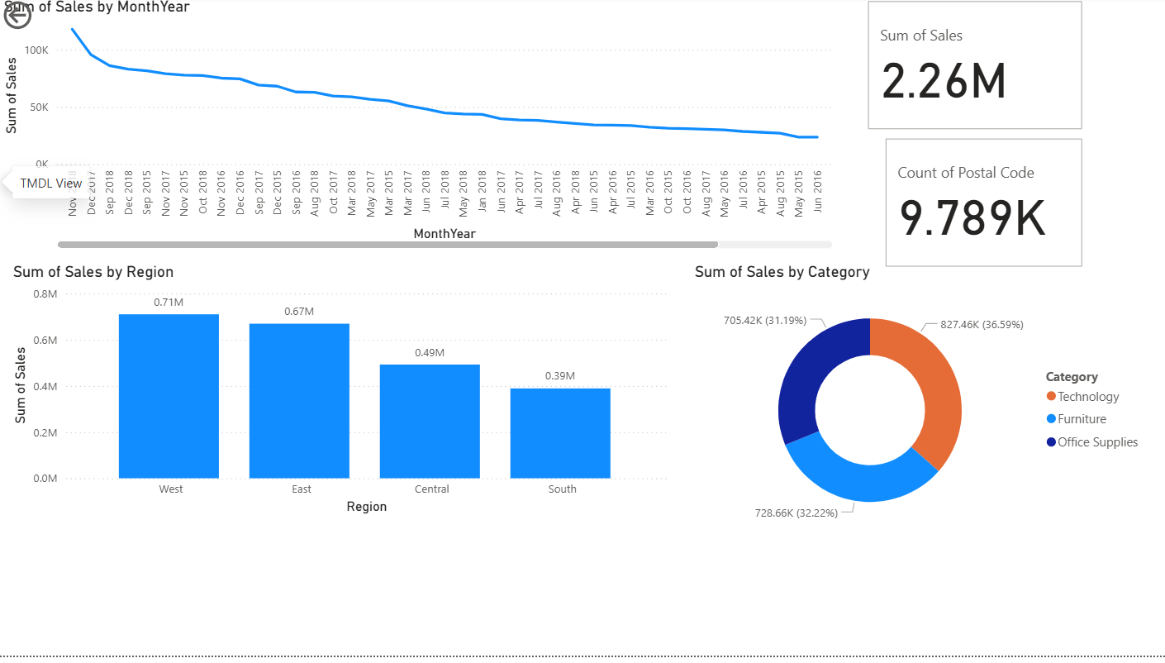

**🔹 Insight 1: Regional Performance**

The **West region** recorded the highest total sales among all regions, showing strong customer demand and effective distribution in that area.

**🔹 Insight 2: Category Contribution**

The **Technology category** contributed the most to overall revenue, while **Furniture** showed moderate sales but lower profit margins.

**🔹 Insight 3: Monthly Trend**

Sales showed a steady increase from **June to December**, peaking in **November**, indicating strong performance during the holiday season.