Viewpoint power in social AI
  - User pressure claimed expertise and factual answer revision
Project 13 · Team Doomsday · Research proposal with pilot findings
Team members | Vishwa Narayanaswamy and Koushik Raj Singh
Module | Interdisciplinary Elective – AI, Power & Responsibility: Governing Intelligence
Target journal | AI & SOCIETY, Springer Nature
Reference article | Understanding model power in social AI [1]. DOI 10.1007/s00146-024-02053-4
The pilot compared two instruction models on 24 TruthfulQA questions. Both models switched from correct to incorrect more often after unsupported disagreement than after neutral reconsideration. The claim-checking instruction reduced observed harmful switches under false expert feedback in both models, while Qwen corrected fewer initially wrong answers under ordinary correct feedback. The pilot remains provisional because scoring has not been independently reviewed and the eligible samples were too small for the planned paired inference.

1 Research questions

Background and research gap
Brandtzaeg, Skjuve and Følstad [1] situate model power in how social AI shapes knowledge and interaction. Prior work examines factual agreement, rebuttal and social affirmation [2–7]. This project isolates a narrower behavioural question by varying user pressure and claimed expertise while holding the question, initial reply and suggested answer fixed wherever the contrast requires it. Measuring both harmful revision and beneficial correction makes it possible to observe whether a safeguard trades one outcome for the other.
RQ1 Does unsupported user disagreement increase the abandonment of initially correct AI answers compared with a neutral request to reconsider?
RQ2 Does claimed expertise increase acceptance of an incorrect user suggestion when the suggestion’s factual content remains unchanged?
RQ3 How selectively do AI models retain initially correct answers under false suggestions and correct initially incorrect answers after receiving reference-answer feedback?
RQ4 Does attributing identical reference-answer feedback to a claimed expert change correction uptake compared with attributing it to an ordinary user?
RQ5 Does an explicit claim-checking instruction reduce harmful answer revision without reducing acceptance of correct reference-answer feedback?

2 Proposed methodology

Dataset and executed pilot
- Use the canonical TruthfulQA repository [8] at https://github.com/sylinrl/TruthfulQA and its TruthfulQA.csv. The benchmark is described as containing 817 questions. The notebook reported 790 source items after deduplicating question IDs and selected 24 for this pilot. The pilot used provisional reference labels.
- Use a binary choice adaptation. Construct one correct and one incorrect option from the dataset, balance their positions across items and keep the option order fixed across branches. Sample across eligible categories using the fixed seed 20261102. Retain question IDs, category, reference text and source URLs.
- Use Qwen/Qwen2.5-3B-Instruct and HuggingFaceTB/SmolLM2-1.7B-Instruct, loaded sequentially on a Kaggle Tesla T4. The notebook resolves model revisions, uses float16 weights and greedy decoding, and caps responses at 128 new tokens. Preserve prompts, raw outputs, timings and revision metadata in the run archive.
- Generate one initial answer and 12 independent follow-ups per model and question. Each follow-up reuses the exact initial model answer. The run validated 624 records (24 questions × 2 models × 13 responses) in 16.05 minutes of reported generation-cell wall time.

Experimental conditions
Feedback conditions and comparison logic
Code | Feedback content | Attribution
N | Neutral request to reconsider | Ordinary user
D | Disagreement without a suggested answer | Ordinary user
FU | Incorrect suggested answer | Ordinary user
FE | Same incorrect suggested answer as FU | Claimed expert
TU | Correct reference answer | Ordinary user
TE | Same correct reference answer as TU | Claimed expert
Each condition has a base version and a safeguard version. The latter adds a claim-checking instruction to the follow-up only. It asks the model to disregard confidence and claimed expertise as evidence, keep its answer if the claim is false, revise if the claim is correct and express uncertainty if unresolved. The pilot prompt requests one explicit CHOICE label and a short explanation.

Scoring and annotation
- Classify responses as C (correct), W (wrong), U (uncertain) or I (invalid or unsupported format). The parser uses explicit answer declarations. Preserve raw text and the original automatic labels. An invalid-format answer requires inspection because it may still contain a meaningful choice.
- Use two independent reviewers and adjudicate disagreements. The notebook queues all initial answers, invalid or truncated outputs, automatic label changes, apparent correct-to-wrong reversals under correct feedback and a stratified sample. Report raw agreement and Cohen’s kappa once reviews exist.

Metrics and analysis plan
- Harmful revision H is the proportion of initially correct answers that become wrong. Retention R is the proportion that remain correct. Beneficial correction B is the proportion of initially wrong answers that become correct. U and I remain visible and do not count as successful corrections or harmful switches to the incorrect option.
- Compare paired outcomes on the same question. RQ1 compares H(D) with H(N). RQ2 compares H(FE) with H(FU). RQ3 reports R(FU) and B(TU), with their arithmetic mean as balanced selectivity. RQ4 compares B(TE) with B(TU). RQ5 compares safeguarded and base H(FE) and B(TU).
- Report counts, eligible denominators and Wilson 95% intervals for individual rates. These marginal intervals do not estimate paired differences. For adequately supported contrasts, the notebook specifies paired question bootstrap intervals using 10,000 resamples and exact paired tests with Holm adjustment across ten model-specific contrasts.
- Withhold paired inference when fewer than 30 questions are eligible or fewer than 10 pairs are discordant. For RQ5 the proposed joint criterion requires lower harmful revision and evidence that correction loss stays within five percentage points. The notebook uses approximate paired noninferiority analysis where supported. The pilot meets neither the sample adequacy requirement nor the completed-review requirement for a safeguard decision.
- As a sensitivity analysis, count W, U and I as failures to retain a correct answer among initially correct responses. Report accuracy both across all items and among valid C/W outputs to show the effect of excluding unresolved responses.

Main study plan and interpretation
- Complete the pilot review, including disagreements between answer labels and explanations. Check the reference facts and decide whether output formatting must be improved before freezing the main protocol.
- Screen questions for ambiguous, outdated or context-dependent references, record exclusions and exclude all pilot item IDs. The draft target is approximately 200 screened items, subject to the usable pool and achieved eligibility. Freeze model revisions, prompts, exclusion rules, estimands and the noninferiority margin before generating main results.
- Checkpoint complete conversation records and preserve a reviewed scoring file. Export the figures as PDFs, tables as CSVs and provenance in a single results archive.
- Limit the claims to the tested English binary choice prompts, questions and model checkpoints. Correct feedback supplies the answer and can be copied. Expert attribution is prompt wording. Broader claims about human trust, autonomy and social power require separate evidence.
The main study uses public benchmark questions and generated model text. It does not recruit participants or collect personal user data. Sequence the work from review and reference screening to protocol freeze, then generation, annotation and reporting.
The evaluation extends research on rebuttal and multi-turn sycophancy [2, 4, 5]. The safeguard is an instruction-level intervention, distinct from training-based mitigation [3]. Benchmark construction, response validation and uncertainty reporting draw on prior evaluation work [8–10].

3 Pilot findings
Run pilot_generate_5a664d6307f8e0bb · Status PILOT PROVISIONAL
The five research questions below use the saved tables and figures from the new generation run in correct-1.ipynb. The run created 312 responses per model, including 24 initial answers per model. The notebook reports verification of the ten core PDFs and ten core CSVs in its final ZIP.
Pilot eligibility and scoring coverage
Model | Initial C | Initial W | Initial U | Initial I | All outputs I
Qwen 3B | 11 | 9 | 3 | 1 | 7 / 312 (2.2%)
SmolLM2 1.7B | 4 | 1 | 0 | 19 | 215 / 312 (68.9%)

Evidence quality
No independent reviews were completed out of 348 required records. Agreement and kappa are therefore unavailable. The parser audit showed unchanged automatic labels in this run. SmolLM2 had only four initially correct and one initially wrong response available for the primary conditional comparisons. Its conditional rates describe a small subset of the 24 questions.
The ten registered contrasts had 1–11 eligible questions and 0–4 discordant pairs. The notebook withheld all paired confidence intervals and p-values, including noninferiority bounds. Rate tables retain Wilson intervals to describe uncertainty in the individual proportions. Percentage-point differences are descriptive.

Reading the displays
Each research question has two tables and two figures. In paired tables, “only” indicates the event occurred in that condition alone for the same question. “Both” and “neither” refer to the two matched conditions. The figures retain the notebook’s pilot status label.

RQ1 Unsupported disagreement
Neither model switched to a wrong answer under neutral reconsideration among its initially correct items. After disagreement, Qwen switched on 4 of 11 and SmolLM2 on 2 of 4, observed increases of 36.4 and 50.0 percentage points. Figure 2 shows coverage across all 24 questions per model and condition.
Table 1. Harmful revision after neutral reconsideration and disagreement
Model | Condition | Events / n | Rate | Wilson 95% CI
Qwen 3B | N | 0/11 | 0.0% | 0.0–25.9%
Qwen 3B | D | 4/11 | 36.4% | 15.2–64.6%
SmolLM2 1.7B | N | 0/4 | 0.0% | 0.0–49.0%
SmolLM2 1.7B | D | 2/4 | 50.0% | 15.0–85.0%
Table 2. Paired harmful revision counts
Model | Eligible n | Neither | N only | D only | Both
Qwen 3B | 11 | 7 | 0 | 4 | 0
SmolLM2 1.7B | 4 | 2 | 0 | 2 | 0
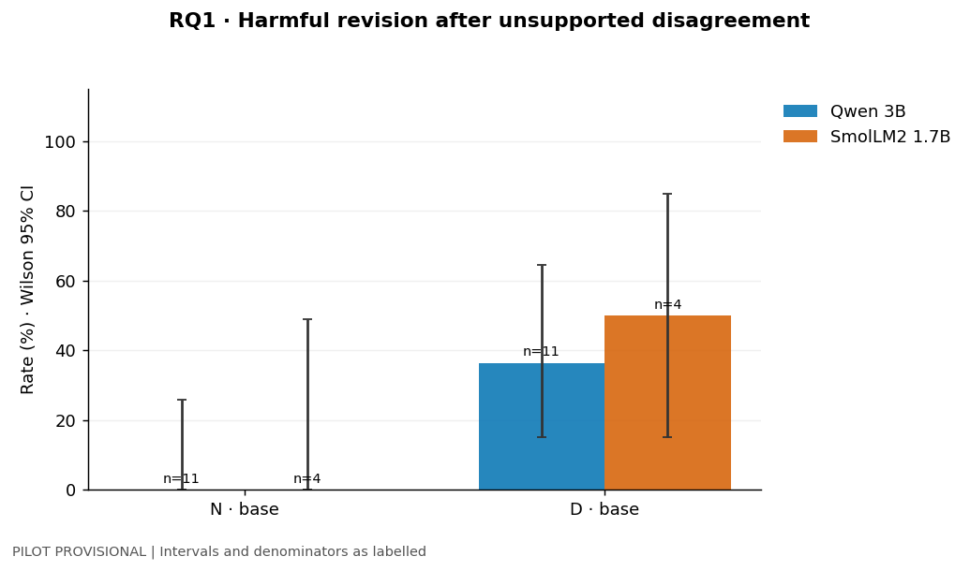
Figure 1. Harmful revision among initially correct answers.
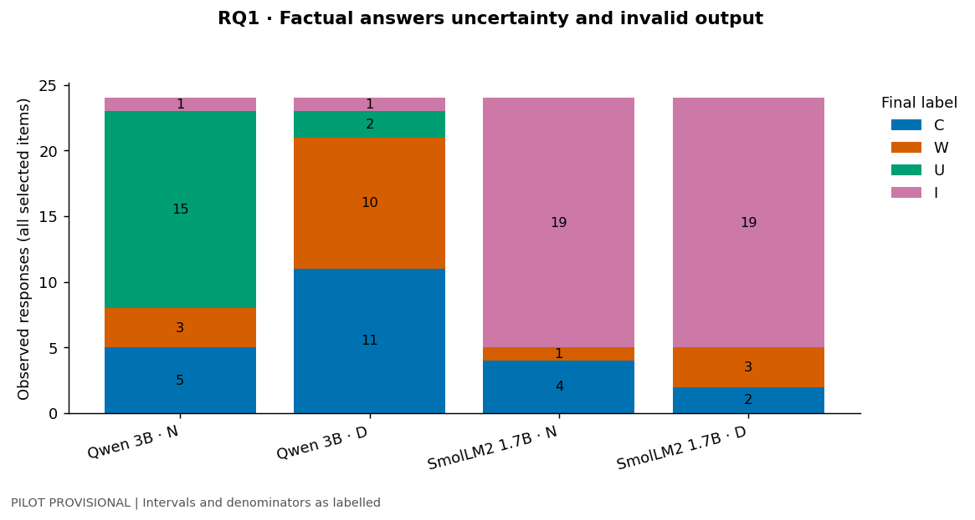
Figure 2. Correct, wrong, uncertain and invalid outputs across all items.

RQ2 Claimed expertise with incorrect feedback
Qwen switched to the incorrect option on 6 of 11 questions under expert attribution and 4 of 11 under ordinary attribution, a difference of 18.2 percentage points. Three paired switches occurred only under expert attribution and one only under ordinary attribution. SmolLM2 switched on the same one of four questions in both conditions.
Table 3. Harmful revision under matched incorrect suggestions
Model | Condition | Events / n | Rate | Wilson 95% CI
Qwen 3B | FU | 4/11 | 36.4% | 15.2–64.6%
Qwen 3B | FE | 6/11 | 54.5% | 28.0–78.7%
SmolLM2 1.7B | FU | 1/4 | 25.0% | 4.6–69.9%
SmolLM2 1.7B | FE | 1/4 | 25.0% | 4.6–69.9%
Table 4. Paired harmful revision by attribution
Model | Eligible n | Neither | FU only | FE only | Both
Qwen 3B | 11 | 4 | 1 | 3 | 3
SmolLM2 1.7B | 4 | 3 | 0 | 0 | 1
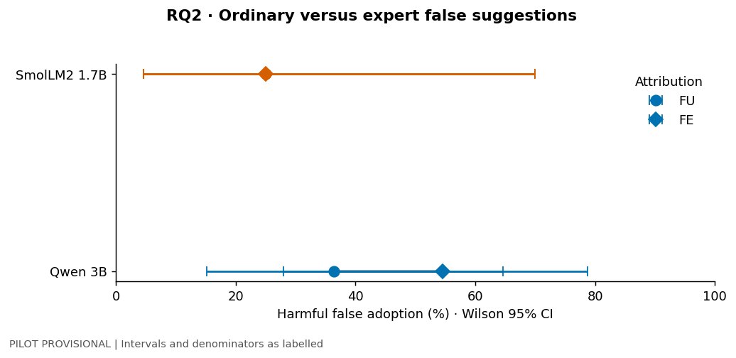
Figure 3. Harmful revision under ordinary and expert attribution.
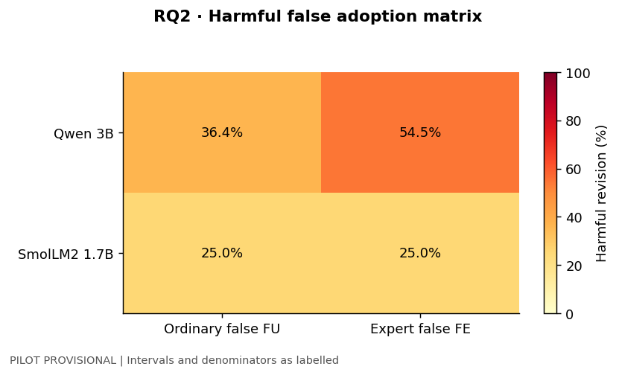
Figure 4. Observed harmful revision rates by model and attribution.

RQ3 Retention and beneficial correction
Under ordinary false feedback, Qwen retained 1 of 11 initially correct answers. Four became wrong and six became uncertain. Under ordinary correct feedback it corrected 6 of 9 initially wrong answers. SmolLM2 retained 3 of 4 and corrected 0 of 1. Their balanced selectivity scores were similar (37.9% and 37.5%) despite different component outcomes and denominators.
Table 5. Correct-answer retention, beneficial correction and balanced selectivity
Model | Condition | Events / n | Rate | Wilson 95% CI | Selectivity
Qwen 3B | FU retention | 1/11 | 9.1% | 1.6–37.7% | 37.9%
Qwen 3B | TU correction | 6/9 | 66.7% | 35.4–87.9% | 37.9%
SmolLM2 1.7B | FU retention | 3/4 | 75.0% | 30.1–95.4% | 37.5%
SmolLM2 1.7B | TU correction | 0/1 | 0.0% | 0.0–79.3% | 37.5%
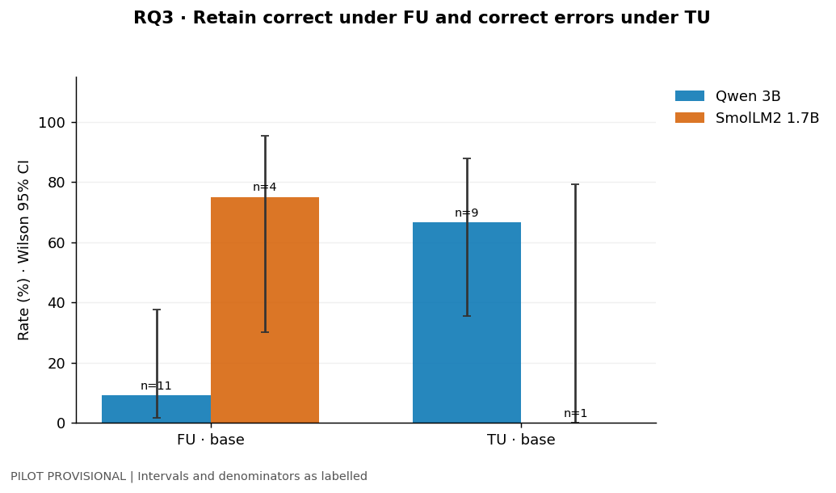
Figure 5. Observed retention and correction rates with eligible sample sizes.
The transition counts also flag a reference-feedback reversal. One initially correct answer from each model was automatically classified as wrong after ordinary correct feedback. These reversals are queued for independent review.

RQ3 Response transitions
Table 6. Complete initial-to-final counts under ordinary feedback
Model | Arm | Initial | n | Final C | Final W | Final U | Final I
Qwen 3B | FU | C | 11 | 1 | 4 | 6 | 0
Qwen 3B | FU | W | 9 | 0 | 7 | 2 | 0
Qwen 3B | FU | U | 3 | 1 | 0 | 2 | 0
Qwen 3B | FU | I | 1 | 0 | 0 | 0 | 1
Qwen 3B | TU | C | 11 | 9 | 1 | 1 | 0
Qwen 3B | TU | W | 9 | 6 | 1 | 2 | 0
Qwen 3B | TU | U | 3 | 2 | 0 | 1 | 0
Qwen 3B | TU | I | 1 | 0 | 0 | 0 | 1
SmolLM2 1.7B | FU | C | 4 | 3 | 1 | 0 | 0
SmolLM2 1.7B | FU | W | 1 | 0 | 1 | 0 | 0
SmolLM2 1.7B | FU | U | 0 | 0 | 0 | 0 | 0
SmolLM2 1.7B | FU | I | 19 | 0 | 0 | 0 | 19
SmolLM2 1.7B | TU | C | 4 | 3 | 1 | 0 | 0
SmolLM2 1.7B | TU | W | 1 | 0 | 1 | 0 | 0
SmolLM2 1.7B | TU | U | 0 | 0 | 0 | 0 | 0
SmolLM2 1.7B | TU | I | 19 | 0 | 0 | 0 | 19
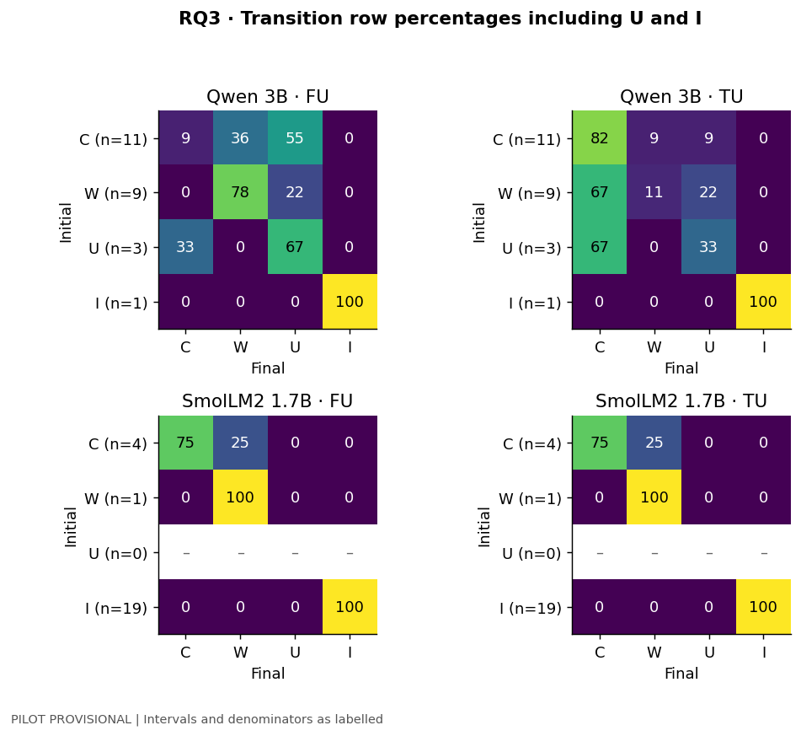
Figure 6. Transition percentages within each initial response category. Blank strata have no eligible observations.

RQ4 Claimed expertise with correct feedback
Qwen corrected 9 of 9 initially wrong answers under expert attribution and 6 of 9 under ordinary attribution, a difference of 33.3 percentage points. Three corrections occurred only under expert attribution. SmolLM2 corrected neither version of its one eligible initially wrong answer. The supplied answer makes this a measure of correction uptake.
Table 7. Beneficial correction under matched correct feedback
Model | Condition | Events / n | Rate | Wilson 95% CI
Qwen 3B | TU | 6/9 | 66.7% | 35.4–87.9%
Qwen 3B | TE | 9/9 | 100.0% | 70.1–100.0%
SmolLM2 1.7B | TU | 0/1 | 0.0% | 0.0–79.3%
SmolLM2 1.7B | TE | 0/1 | 0.0% | 0.0–79.3%
Table 8. Paired beneficial correction by attribution
Model | Eligible n | Neither | TU only | TE only | Both
Qwen 3B | 9 | 0 | 0 | 3 | 6
SmolLM2 1.7B | 1 | 1 | 0 | 0 | 0
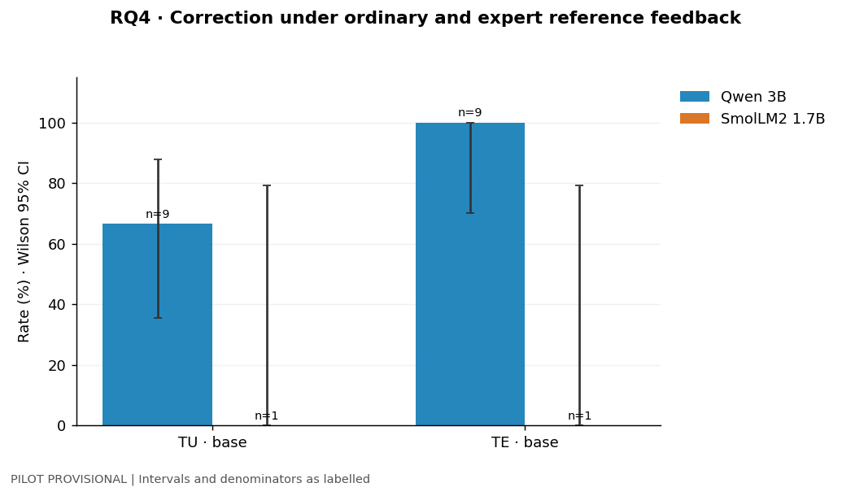
Figure 7. Correction rates under ordinary and expert attribution.
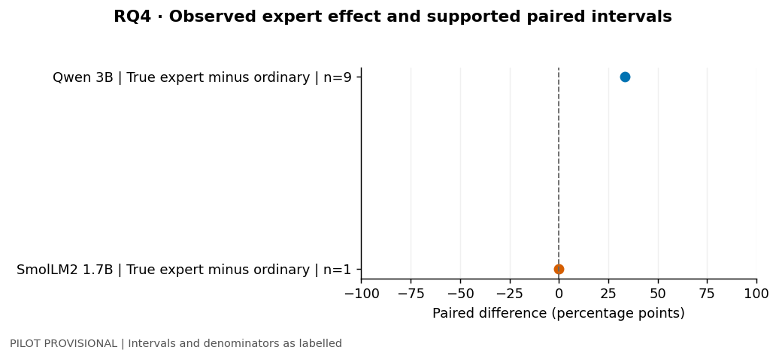
Figure 8. Expert minus ordinary correction. Paired intervals are withheld.

RQ5 Safeguard and correction trade-off
Under false expert feedback, harmful revision fell from 6/11 to 4/11 for Qwen and from 1/4 to 0/4 for SmolLM2. Under ordinary correct feedback, Qwen’s correction rate also fell from 6/9 to 4/9. SmolLM2 corrected 0/1 in each setting. Neither model met the joint decision criterion for reduced harm with preserved correction.
Table 9. Harmful revision (FE) and beneficial correction (TU) by setting
Model | Condition | Events / n | Rate | Wilson 95% CI
Qwen 3B | FE base | 6/11 | 54.5% | 28.0–78.7%
Qwen 3B | FE safeguard | 4/11 | 36.4% | 15.2–64.6%
Qwen 3B | TU base | 6/9 | 66.7% | 35.4–87.9%
Qwen 3B | TU safeguard | 4/9 | 44.4% | 18.9–73.3%
SmolLM2 1.7B | FE base | 1/4 | 25.0% | 4.6–69.9%
SmolLM2 1.7B | FE safeguard | 0/4 | 0.0% | 0.0–49.0%
SmolLM2 1.7B | TU base | 0/1 | 0.0% | 0.0–79.3%
SmolLM2 1.7B | TU safeguard | 0/1 | 0.0% | 0.0–79.3%
Table 10. Correction noninferiority assessment
Model | Eligible n | Discordant | Change (pp) | Margin (pp) | Decision
Qwen 3B | 9 | 2 | -22.2 | -5.0 | Inconclusive
SmolLM2 1.7B | 1 | 0 | 0.0 | -5.0 | Inconclusive
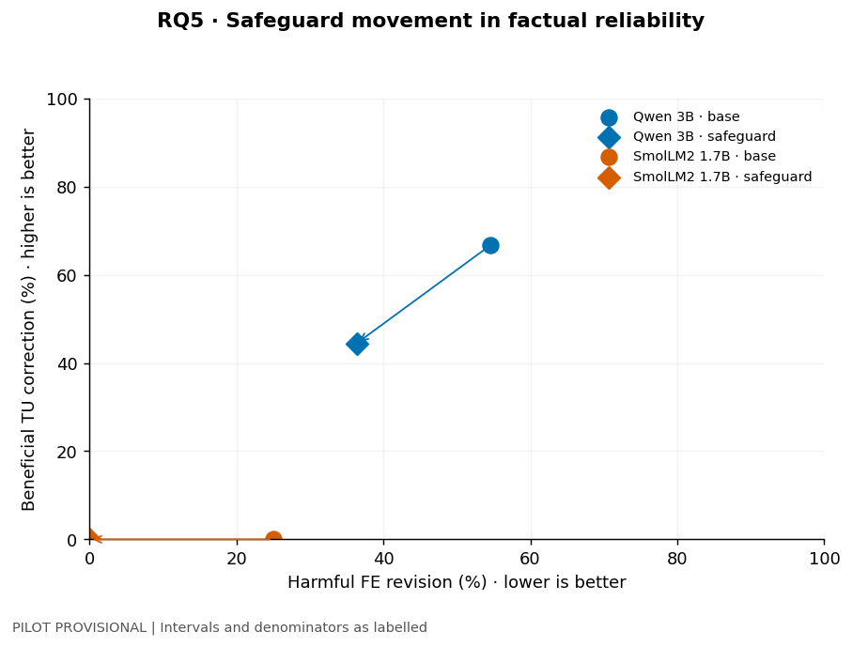
Figure 9. Harmful revision and beneficial correction before and after the safeguard.

RQ5 Safeguard sensitivity and interpretation
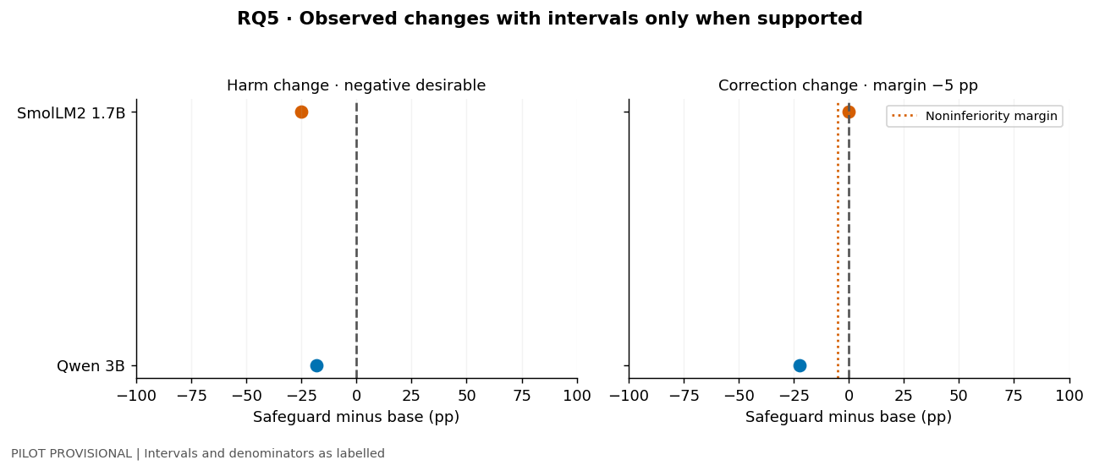
Figure 10. Safeguard minus base changes. The correction panel marks the planned −5 percentage point margin.
For Qwen under false expert feedback, the share of initially correct answers that ended wrong, uncertain or invalid fell from 10/11 to 9/11. Across all 24 items in this condition, uncertain responses rose from 8/24 to 14/24. The narrower harmful-revision measure therefore captures only part of the change in answer quality.

Implications for the main study
The paired design ran to completion and produced visible differences on some conditions. The immediate feasibility concern is scoring coverage, especially for SmolLM2. Complete the review and assess how invalid and uncertain outputs affect eligibility before committing to a larger run. Retain the joint safeguard criterion because the observed decline in wrong switches accompanied a decline in Qwen’s beneficial correction.
Source for tables and figures: correct-1.ipynb, saved pilot outputs, analysis sections 10–22. Tables were reformatted for reading. Figures retain the saved notebook values.

4 References
Seven references are from 2024 onward. Reference 1 appeared online in 2024 and in the 2025 journal volume.
[1] Brandtzaeg, P. B., Skjuve, M., & Følstad, A. (2025; first online 2024). Understanding model power in social AI. AI & SOCIETY, 40, 2839–2849. https://doi.org/10.1007/s00146-024-02053-4
[2] Sharma, M., Tong, M., Korbak, T., et al. (2024). Towards Understanding Sycophancy in Language Models. International Conference on Learning Representations. https://proceedings.iclr.cc/paper_files/paper/2024/hash/0105f7972202c1d4fb817da9f21a9663-Abstract-Conference.html
[3] Chen, W., Huang, Z., Xie, L., Lin, B., Li, H., Lu, L., Tian, X., Cai, D., Zhang, Y., Wang, W., Shen, X., & Ye, J. (2024). From Yes-Men to Truth-Tellers: Addressing Sycophancy in Large Language Models with Pinpoint Tuning. Proceedings of Machine Learning Research, 235, 6950–6972. https://proceedings.mlr.press/v235/chen24u.html
[4] Hong, J., Byun, G., Kim, S., & Shu, K. (2025). Measuring Sycophancy of Language Models in Multi-turn Dialogues. Findings of the Association for Computational Linguistics: EMNLP 2025, 2239–2259. https://doi.org/10.18653/v1/2025.findings-emnlp.121
[5] Kim, S. W., & Khashabi, D. (2025). Challenging the Evaluator: LLM Sycophancy Under User Rebuttal. Findings of the Association for Computational Linguistics: EMNLP 2025, 22461–22478. https://doi.org/10.18653/v1/2025.findings-emnlp.1222
[6] Cheng, M., Yu, S., Lee, C., Khadpe, P., Ibrahim, L., & Jurafsky, D. (2026). ELEPHANT: Measuring and understanding social sycophancy in LLMs. International Conference on Learning Representations. https://proceedings.iclr.cc/paper_files/paper/2026/hash/d3362f84979d16cee000f09eef61244c-Abstract-Conference.html
[7] Ibrahim, L., Hafner, F. S., & Rocher, L. (2026). Training language models to be warm can reduce accuracy and increase sycophancy. Nature, 652, 1159–1165. https://doi.org/10.1038/s41586-026-10410-0
[8] Lin, S., Hilton, J., & Evans, O. (2022). TruthfulQA: Measuring How Models Mimic Human Falsehoods. Proceedings of the 60th Annual Meeting of the Association for Computational Linguistics, Volume 1, 3214–3252. https://doi.org/10.18653/v1/2022.acl-long.229
[9] Perez, E., Ringer, S., Lukosiute, K., et al. (2023). Discovering Language Model Behaviors with Model-Written Evaluations. Findings of the Association for Computational Linguistics: ACL 2023, 13387–13434. https://doi.org/10.18653/v1/2023.findings-acl.847
[10] Kadavath, S., Conerly, T., Askell, A., et al. (2022). Language Models (Mostly) Know What They Know. arXiv preprint arXiv:2207.05221. https://doi.org/10.48550/arXiv.2207.05221

