In this challenge, we test your knowledge of using *if-else* conditional statements to automate decision-making processes. An if-else statement has the following logical flow:

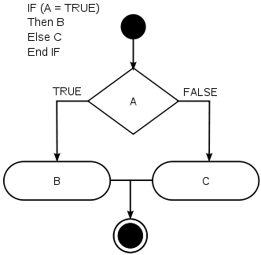

Source:[Wikipedia](https://en.wikipedia.org/wiki/Conditional_%28computer_programming%29)

**Task**  
Given an integer, , perform the following conditional actions:

* If  is odd, print Weird
* If  is even and in the inclusive range of  to , print Not Weird
* If  is even and in the inclusive range of  to , print Weird
* If  is even and greater than , print Not Weird

Complete the stub code provided in your editor to print whether or not  is weird.

**Input Format**

A single line containing a positive integer, .

**Constraints**

**Output Format**

Print Weird if the number is weird; otherwise, print Not Weird.

**Sample Input 0**

3

**Sample Output 0**

Weird

**Sample Input 1**

24

**Sample Output 1**

Not Weird

**Explanation**

*Sample Case 0:*   
 is odd and odd numbers are weird, so we print Weird.

*Sample Case 1:*   
 and  is even, so it isn't weird. Thus, we print Not Weird.