- https://nenow.in/north-east-news/guwahati-schools-healing-touch-special-needs-children.html (News article )
- https://www.facebook.com/share/r/1Eu9Zi2AiR/ (Talk show on World Disability Day by Doordarshan)
- https://www.facebook.com/share/v/16hBRGUWPX/ (Interview of Ashoka Sarma during observation of Autism Awareness Month at Projonmo.
- https://www.facebook.com/share/p/19S7Eyh9RQ/ (Interview of Ashoka Sarma during doctor’s visit from AIIMS.
- https://www.facebook.com/share/r/16d2eptC4X/ (Education Eminence Award by News18)

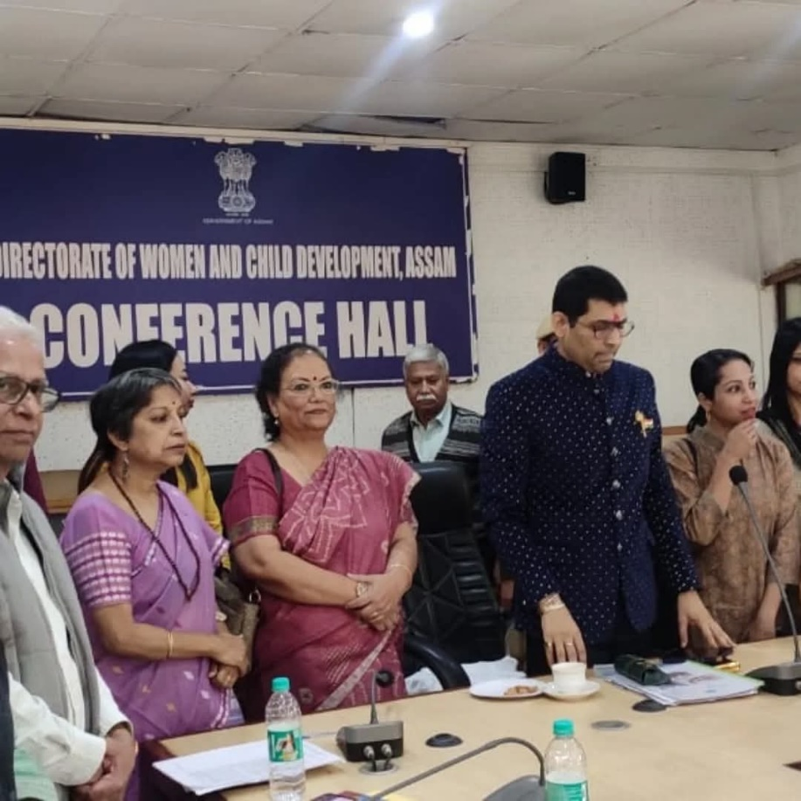
Invited by Directorate of Women and Child Development to represent the voices of ground-level practioners at a meeting chaired by Dr. Yogesh Dube (Special Monitor for Human Rights Commission).

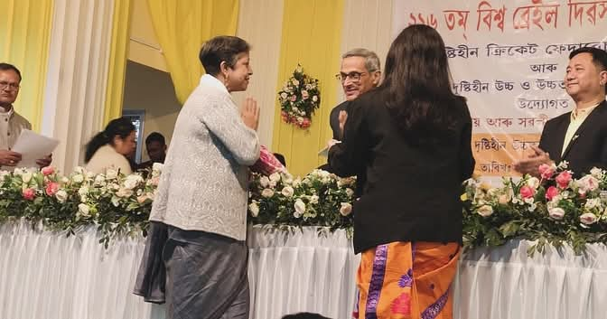
Felicitation by Department of Social Justice and Empowerment on Braille Day.

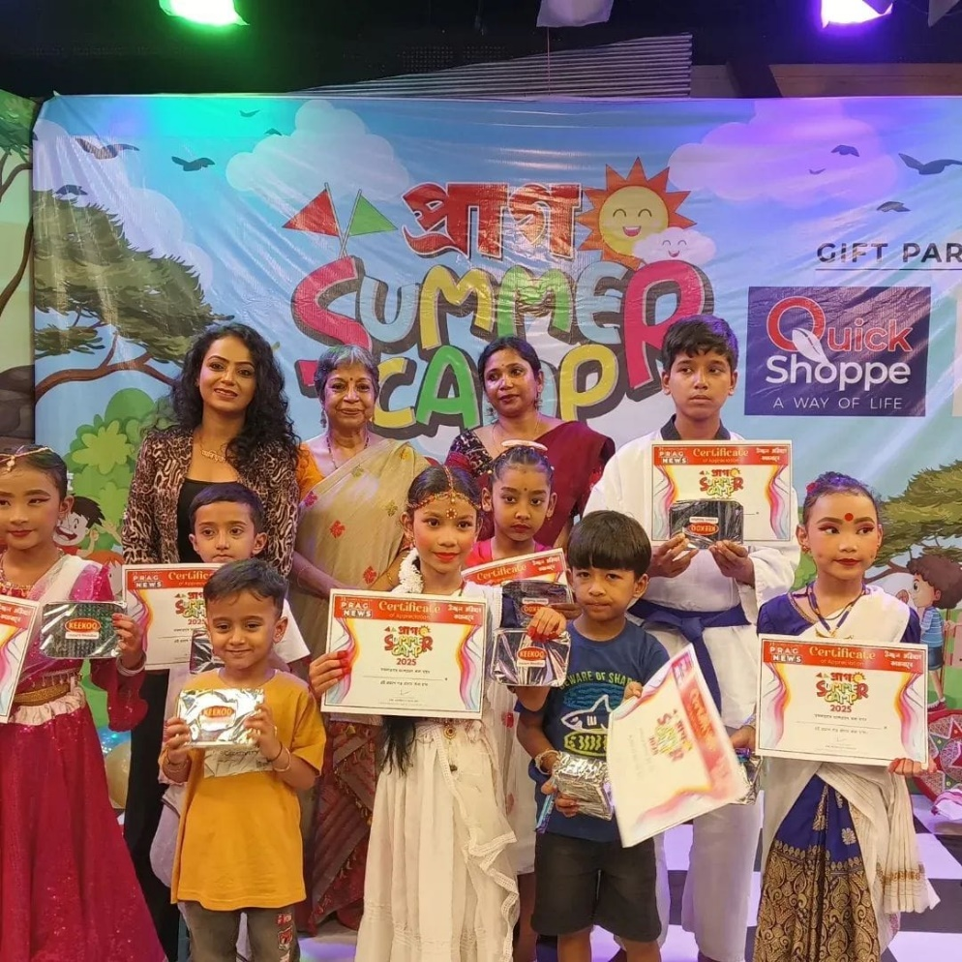
Prag News Summer Camp programme.

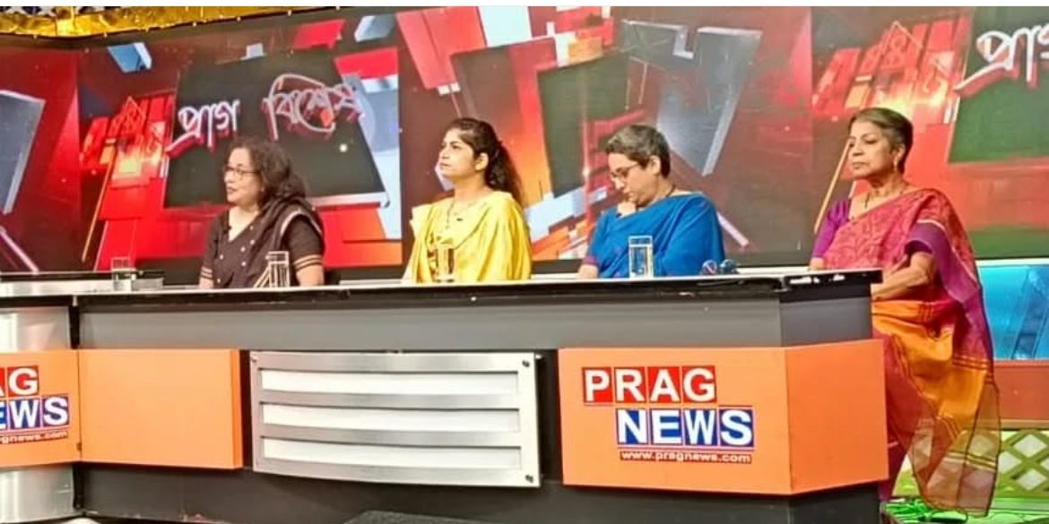
Prag News Talk Show.

