ABSTRACT
The project’s main objective is to enabling voting at elsewhere regardless of an individual’s current location through online mode providing a secured and user-friendly Voting System. The problem of e-voting is still critical in terms of safety and security. This is a robust system, which deals with the design and development of a web-based voting system.
Our system deals with online voting system that facilitates user(voter), candidate and administrator (who will be in charge to monitor voting) to participate in online voting. our online voting system is highly secured, and it has a simple and interactive user interface. The proposed online portal is secured and have unique security feature such as unique id generation that adds another layer of security (except login id and password) and the voter’s data are predefined in the database, which helps in authentication. It also creates and manages voting and an election detail as all the users must login by user name and password (as their date of birth) and click on candidates to register vote.
The voters and nominees are verified through OTP each and every time of their login. This system eliminates any intruders or duplicate logins.
The project Online Voting Software aims at making the voting process easy in any type of elections. Presently voting is performed using ballot paper and the counting is done manually, hence it consumes a lot of time. There can be possibility of invalid votes. All these make election a tedious task. In our proposed system voting and counting is done with the help of computer in Online. It saves time, avoid error in counting and there will be no invalid votes. It also avoids the process of physical touching or visiting any places and so in the time of pandemic too it will be more helpful to conduct elections. Without the wastage of time the citizen can vote the respective candidate. So, there is a need for Online Voting Systems.

CHAPTER 1

INTRODUCTION

This chapter starts with a high-level overview of the project. It then describes the specific aims and objectives of the project. Finally, it analyses the feasibility of the project and provides a feasibility report of the system.
  - Background of Study

In every democratic setting with persons of differing and inconsistent opinions, decisions must be made between several options. This happens in business environment, educational environment, social organizations, and mostly in governance. One of the ways of making such a decision is through voting. Voting is a formal process of expressing individual opinions for or against some motion. In the governance sector of many organizations this process is always used as a means of selecting or electing a leader. One of the key areas where voting is applied is in election. Election is the formal process of selecting a person for public office or of accepting or rejecting a political proposition by voting.

    - E-voting System Overview

The proposed online portal is secured and have unique security feature such as unique id generation that adds another layer of security (except login id and password) and the voter’s data are predefined in the database, which helps in authentication. It also creates and manages voting and an election detail as all the users must login by user name and password (as their date of birth) and click on candidates to register vote. The voters and nominees are verified through OTP each and every time of their login. This system eliminates any intruders or duplicate logins. In our proposed system voting and counting is done with the help of computer in Online. It saves time, avoid error in counting and there will be no invalid votes. It also avoids the process of physical touching or visiting any places and so in the time of pandemic too it will be more helpful to conduct elections. Without the wastage of time the citizen can vote the respective candidate. So, there is a need for Online Voting Systems.

  - Problem Statement

The present voting system applicable in the India electoral system has proved inefficient as the voters’ registration process is slow, the manual collation of results takes time and gives room for result manipulation, also the inaccessible nature of election venues which includes the long distances to be covered by voters’ to their registered location increases voters’ apathy towards the election processes, and finally the issues of ballot box snatching and damage and other election violence and issues associated with the traditional ballot paper voting all defiles the purpose of voting in election process as a formal process of expressing individual opinions for or against some motion.

  - Aim and Objectives

In the quest to design a successful system to tackle the issues stated in the problem statement, the aim and objectives of the project are outlined below.

    - Aim

The aim of this project is to design and implement a user-friendly real-time e-voting system.

1.3.2 Objectives

Project Objectives includes
- A detailed study of the election processes as it pertains to voting.
- Design and develop a software platform for voter registration, election voting, real-time election results collation and monitoring and mostly for voters’ remote access to elections.
- Design and develop an software system that incorporates OTP and personal information Authentication to the voters via e-mail.
- Design and develop an administration dashboard for the election administrators.
- Run simulations and compare the results of the designed e-voting system and other voting systems.

  - Significance of the Project

In view of the rapid development of computer technology in virtually all fields of operation and its use in relation to information management, the projects’ benefits are itemized as follows:

    - To the University

An e-voting system is beneficial to the university as:

- It will provide a means conduct a less stressful and fair elections at different levels (faculty, departments, school wide etc.) in the university.
- It will offer an in-depth knowledge of the practical approach to ICT education.
- It will serve as a hands-on application of theories taught in class as it relates to database, software and hardware development.
- As its’ database is based on a flexible database management system, student and staff details can easily be collected for easy access and monitoring.
- It will serve as a base for other works in the field of ICT in governance.

    - To the Society

The significance of an e-voting system to the society and mostly to Nigeria are itemized as follows:
- It will provide ECI (Election commission of India) with a means to conduct less costly and fair elections.
- The secure and flexible database management system safeguards data and information to account for credible elections.
- It will serve to reduce the workload in the process of conducting election.
- As it incorporates online voting individuals can vote from their convenience.
- It will enable ECI reduce the time wasted in collating and announcing election result.
- It will greatly reduce and eliminate disenfranchising electorates.
- It will serve to eliminate invalid votes, curb election violence as votes are counted immediately as they are cast.

  - Scope/Limitations of the Work

This project work is mainly designed to enable the Independent National Electoral Commission to use electronic device to capture voter’s information, and to allow voters to their cast votes easily and comfortably to promote a more credible election which is efficient and less costly. The dynamic nature of the elections application interface and database structure allows for different organizations set up and conduct basic elections too. Its online interface enables real-time election monitoring and result collation. Some of its major limitations are:

- It requires network access: Since the collection and sending of votes to the database requires an internet access which may not be readily available in some urban area would seem a limiting factor, though the local database and the printed vote can be used for counting until network is restored.

  - Project Outline

This project work on e-voting system is made up of five chapters: introduction, literature review, methodology and system design, systems implementation and result analysis, conclusion and recommendation.

In the chapter one of this project, the introduction which briefly explains voting and elections in general, is seen. It goes further to explain the background of an e-voting system, the aim and objectives of the e-voting system, its significance, scope, and constraints. It summaries by giving the project outline.

In the chapter two, a review of previous literature and technologies used for e-voting system was treated. We also see the different approaches to e-voting systems, their implementation, criticism with their literature reviews and noted the various gaps in the existing literatures.

In chapter three, we see the block diagram of the project work, different methodologies used in development stages, the different phases of the project work which include its research, design, display programming, testing. We extensively cover the requirements of the project designs and software incorporated in the work.

In chapter four, we talk about the steps taken and techniques used for the actual implementation of the project. We see tests carried out to ensure that the project is efficient and also display the result gotten and their significance. We also see the problems encountered and the techniques and solutions taken to overcome them or not.

And finally, we conclude the work and give notable recommendations for optimal operation of the product. Also, we provide suggestions for improvement, enhancement and optimization of our existing work. We also outline the major contribution to the body of knowledge in which our work has achieved

CHAPTER 2

LITERATURE REVIEW

This chapter discusses the different approaches to e-voting processes. After that, it explains the web application development tools and technologies used in this project.

2.1 Web Application Based System

A web-based system is an application that is accessed via HTTP. The term web-based is usually used to describe applications that run in a web browser. It can, though, also be used to describe applications that have a very small component of the solution loaded on the client’s PC. The host server for a web-based system could be a local server, or it could be accessed via the internet.
Web-based applications used to be very limited in functionality. However, advances in technology, security, and internet speeds have greatly increased the potential scope of web-based systems. Today, we have web-based business accounting systems, web-based CRM systems, a web-based Microsoft Office, and more. Web-based applications offer some significant advantages over native, client-based software. Here are just some of the benefits of web-based apps for business.

2.2 Web Application Development Technologies

This section is providing a brief description of the technologies used for this project.

    - Docker

Docker is an open platform for developing, shipping, and running applications. Docker enables you to separate your applications from your infrastructure so you can deliver software quickly. With Docker, you can manage your infrastructure in the same ways you manage your applications. By taking advantage of Docker’s methodologies for shipping, testing, and deploying code quickly, you can significantly reduce the delay between writing code and running it in production.

2.2.1.1 Docker Platform

Docker provides the ability to package and run an application in a loosely isolated environment called a container. The isolation and security allow you to run many containers simultaneously on a given host. Containers are lightweight and contain everything needed to run the application, so you do not need to rely on what is currently installed on the host. You can easily share containers while you work, and be sure that everyone you share with gets the same container that works in the same way.

Docker provides tooling and a platform to manage the lifecycle of your containers:
- Develop your application and its supporting components using containers.
- The container becomes the unit for distributing and testing your application.
- When you’re ready, deploy your application into your production environment, as a container or an orchestrated service. This works the same whether your production environment is a local data centre, a cloud provider, or a hybrid of the two.
2.2.1.2 Docker Architecture
Docker uses a client-server architecture. The Docker client talks to the Docker daemon, which does the heavy lifting of building, running, and distributing your Docker containers. The Docker client and daemon can run on the same system, or you can connect a Docker client to a remote Docker daemon. The Docker client and daemon communicate using a REST API, over UNIX sockets or a network interface. Another Docker client is Docker Compose, that lets you work with applications consisting of a set of containers.

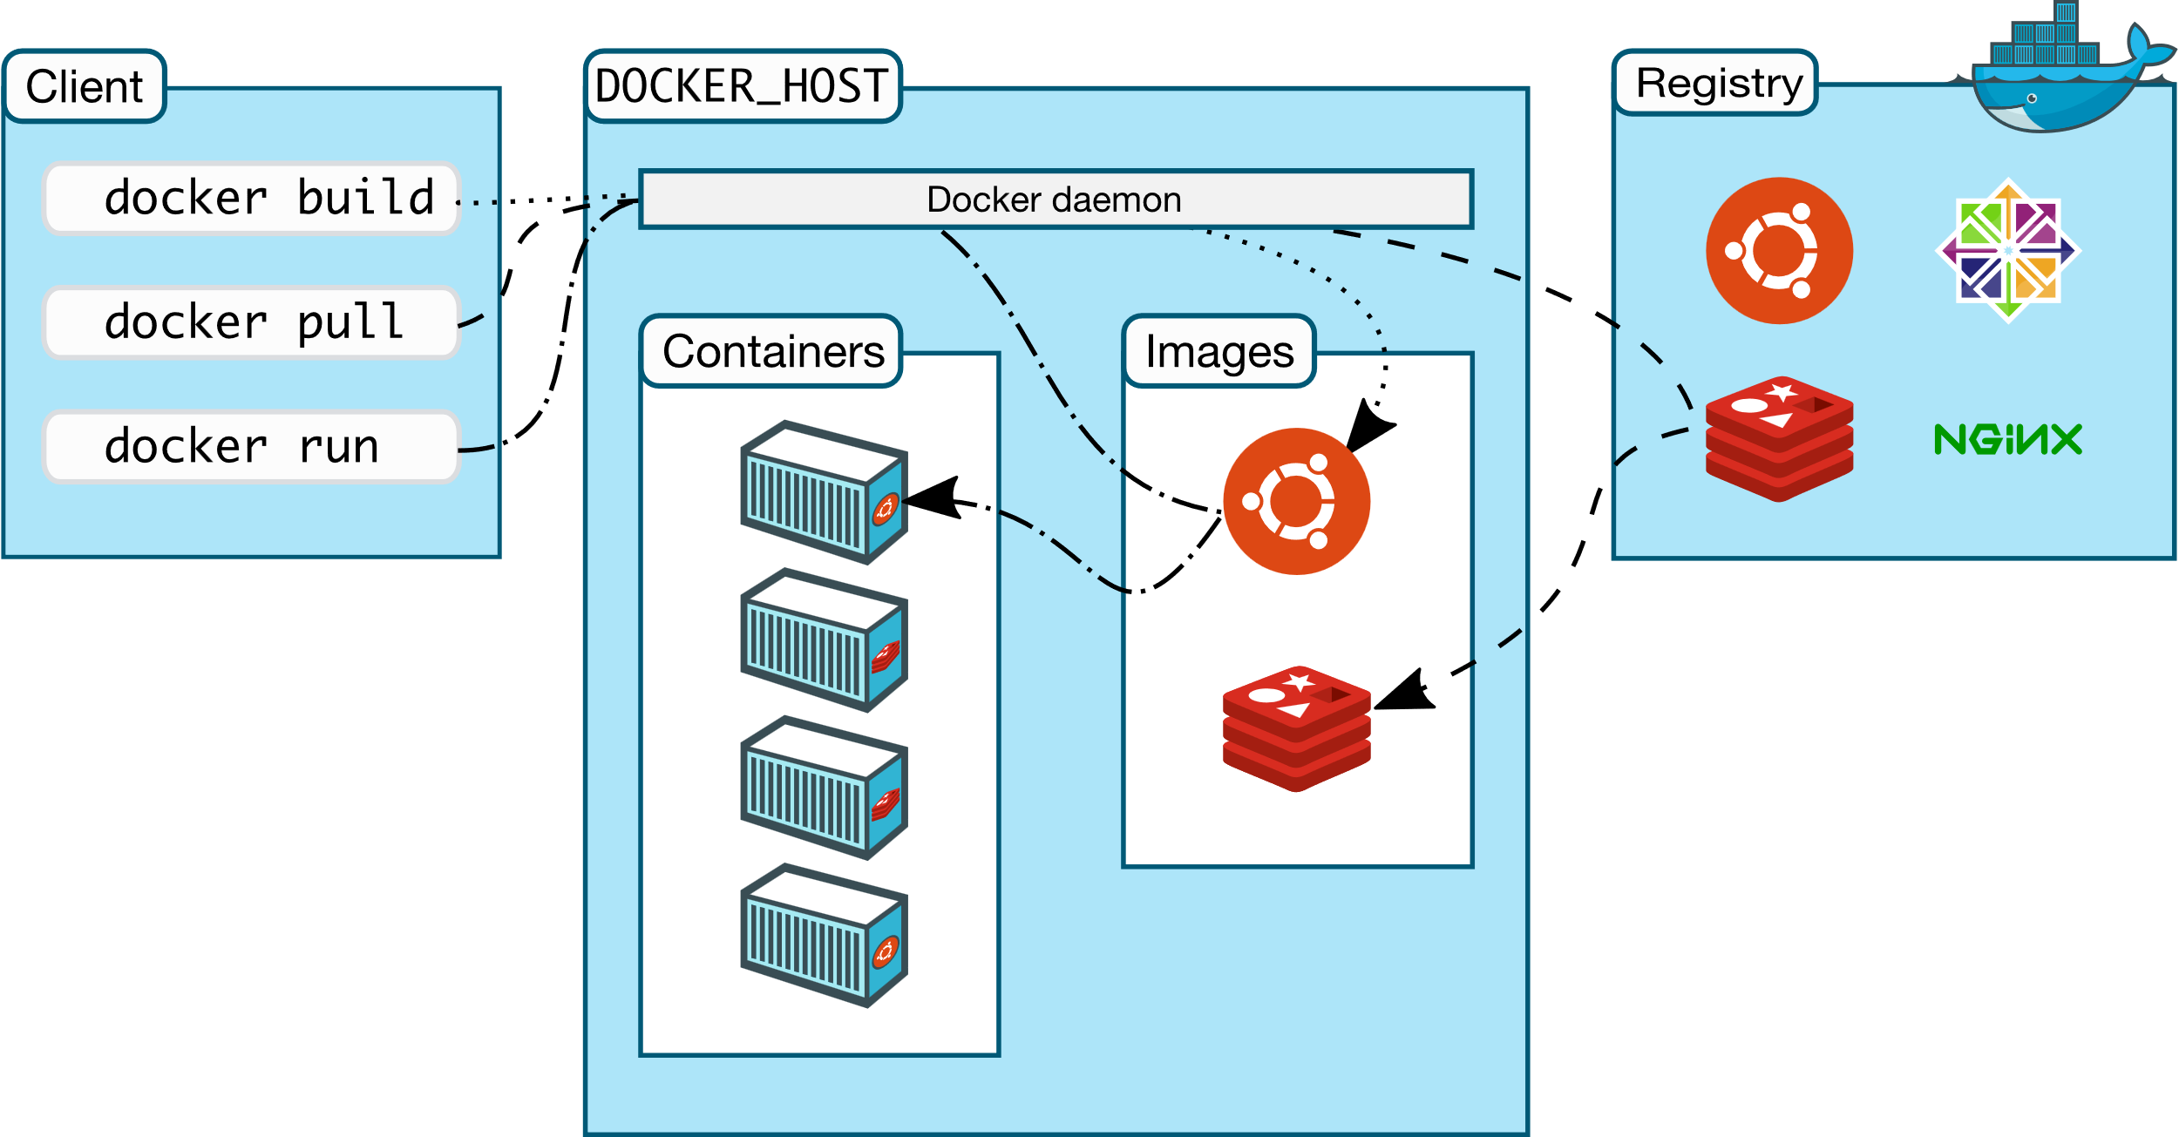

Figure 1: Docker architecture

2.2.2 MERN Stack

MERN Stack is a JavaScript Stack that is used for easier and faster
deployment of full-stack web application. MERN Stack comprises of 4 technologies namely: MongoDB, Express.js, React.js and Node.js. It is designed make the development process smoother and easier.

Each of these 4 powerful technologies provides an end-to-end framework for the developer to work in and each of these technologies play a big part in the development of web applications.

- MongoDB - Document Database.
- Express(.js) - Node.js web framework.
- React(.js) - client-side JavaScript framework.
- Node(.js) - The premier JavaScript web server
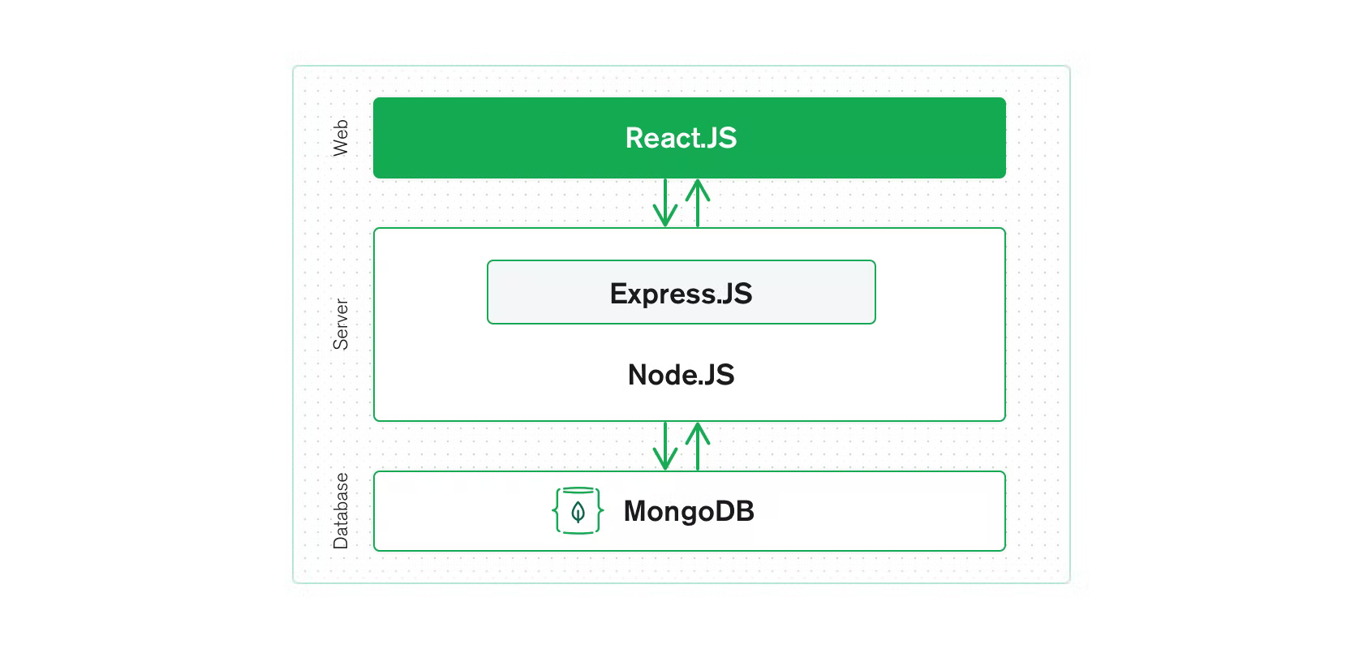

Figure 2: Illustrative diagram of the MERN stack

2.2.2.1 MongoDB

MongoDB is a NoSQL database where each record is a document comprising of key-value pairs that are similar to JSON (JavaScript Object Notation) objects. MongoDB is flexible and allows its users to create schema, databases, tables, etc. Documents that are identifiable by a primary key make up the basic unit of MongoDB. Once MongoDB is installed, users can make use of Mongo shell as well. Mongo shell provides a JavaScript interface through which the users can interact and carry out operations (e.g.: querying, updating records, deleting records).
MongoDB Atlas Cluster is a NoSQL Database-as-a-Service offering in the public cloud (available in Microsoft Azure, Google Cloud Platform, Amazon Web Services). This is a managed MongoDB service, and with just a few clicks, you can set up a working MongoDB cluster, accessible from your favourite web browser.
You don’t need to install any software on your workstation as you can connect to MongoDB directly from the web user interface as well as inspect, query, and visualize data.

Why use MongoDB?

- Fast – Being a document-oriented database, easy to index documents. Therefore, a faster response.
- Scalability – Large data can be handled by dividing it into several machines.
- Use of JavaScript – MongoDB uses JavaScript which is the biggest advantage.
- Schema Less – Any type of data in a separate document.
- Data stored in the form of JSON –
- Objects, Object Members, Arrays, Values, and Strings
- JSON syntax is very easy to use.
- JSON has a wide range of browser compatibility.
- Sharing Data: Data of any size and type (video, audio) can be shared easily.
- Simple Environment Setup – It’s really simple to set up MongoDB.
- Flexible Document Model – MongoDB supports document-model (tables, schemas, columns & SQL) which is faster and easier.

2.2.2.2 Express.js

Express is a Node.js framework. Rather than writing the code using Node.js and creating loads of Node modules, Express makes it simpler and easier to write the back-end code. Express helps in designing great web applications and APIs. Express supports many middleware’s which makes the code shorter and easier to write.

Why use Express?

- Asynchronous and Single-threaded.
- Efficient, fast & scalable
- Has the biggest community for Node.js
- Express promotes code reusability with its built-in router.
- Robust API
- Create a new folder to start your express project and type below command in the command prompt to initialize a package.json file. Accept the default settings and continue.

2.2.2.3 React.js

React is a JavaScript library that is used for building user interfaces. React is used for the development of single-page applications and mobile applications because of its ability to handle rapidly changing data. React allows users to code in JavaScript and create UI components.

Why use React?

- Virtual DOM – A virtual DOM object is a representation of a DOM object. Virtual DOM is actually a copy of the original DOM. Any modification in the web application causes the entire UI to re-render the virtual DOM. Then the difference between the original DOM and this virtual DOM is compared and the changes are made accordingly to the original DOM.
- JSX – Stands for JavaScript XML. It is an HTML/XML JavaScript Extension which is used in React. Makes it easier and simpler to write React components.
- Components – ReactJS supports Components. Components are the building blocks of UI wherein each component has a logic and contributes to the overall UI. These components also promote code reusability and make the overall web application easier to understand.
- High Performance – Features like Virtual DOM, JSX and Components makes it much faster than the rest of the frameworks out there.

2.2.2.4 Node.js

Node.js provides a JavaScript Environment which allows the user to run their code on the server (outside the browser). Node pack manager i.e., npm allows the user to choose from thousands of free packages (node modules) to download.

Why use Node.JS?

- Open-source JavaScript Runtime Environment
- Single threading – Follows a single-threaded model.
- Data Streaming
- Fast – Built on Google Chrome’s JavaScript Engine, Node.js has a fast code execution.
- Highly Scalable
- Initialize a Node.js application by typing running the below command in the command window. Accept the standard settings.

2.2.3 CSS Framework

2.2.3.1 Tailwind CSS

Tailwind CSS can be used to make websites in the fastest and the easiest way.
Tailwind CSS is basically a utility-first CSS framework for rapidly building custom user interfaces. It is a highly customizable, low-level CSS framework that gives you all of the building blocks you need to build bespoke designs without any annoying opinionated styles you have to fight to override.

The beauty of this thing called tailwind is it doesn’t impose design specification or how your site should look like, you simply bring tiny components together to construct a user interface that is unique. What Tailwind simply does is take a ‘raw’ CSS file, processes this CSS file over a configuration file, and produces an output.

Why Tailwind CSS

- Faster UI building process
- It is a utility-first CSS framework which means we can use utility classes to build custom designs without writing CSS as in traditional approach.

Advantages of Tailwind CSS

- No more silly names for CSS classes and Id’s.
- Minimum lines of Code in CSS file.
- We can customize the designs to make the components.
- Makes the website responsive.
- Makes the changes in the desired manner. CSS is global in nature and if make changes in the file the property is changed in all the HTML files linked to it. But with the help of Tailwind CSS, we can use utility classes and make local changes.

2.2.4 Front-end Library

2.2.4.1 Redux.js

Redux is an open-source JavaScript library for managing and centralizing application state. It is most commonly used with libraries such as React or Angular for building user interfaces. Similar to (and inspired by) Facebook's Flux architecture, it was created by Dan Abramov and Andrew Clark. Since mid-2016, the primary maintainers are Mark Erikson and Tim Dorr.

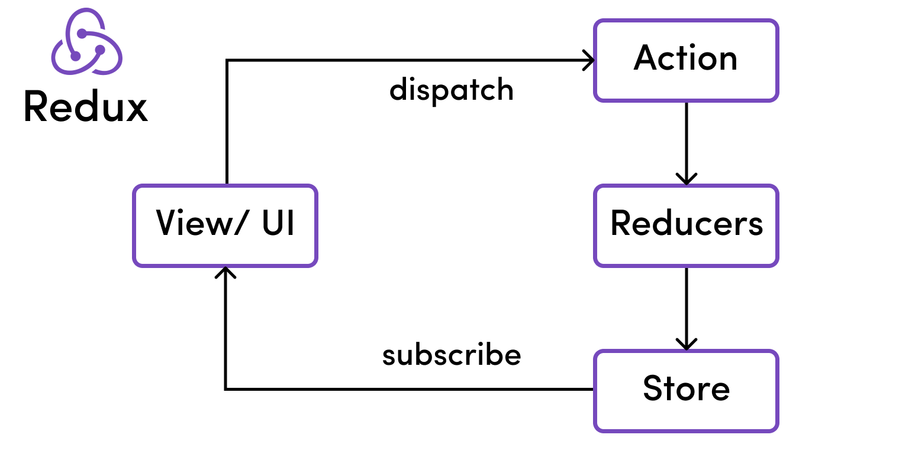

Figure 3: Core principles of Redux

Why use Redux?

When using Redux with React, states will no longer need to be lifted up. This makes it easier for you to trace which action causes any change.

As you can see in the example above, the component does not need to provide any state or method for its children components to share data among themselves. Everything is handled by Redux. This greatly simplifies the app and makes it easier to maintain.

2.2.5 Front-end Packages

Axios

Axios is a promised-based HTTP client for JavaScript. It has the ability to make HTTP requests from the browser and handle the transformation of request and response data.

Chart.js

Chart.js is a free, open-source JavaScript library for data visualization, which supports eight chart types: bar, line, area, pie (doughnut), bubble, radar, polar, and scatter. Chart.js renders in HTML5 canvas and is widely covered as one of the best data visualization libraries.
React-csv

Generate a CSV file from give data. This data can be an array of arrays, an array of literal objects, or strings.

React-icons

React-icons is a small library that helps you add icons (from all different icon libraries) to your React apps. It delivers the icons to your app as components so they’re easier to work with, and it lets you style them so they’re consistent with the overall style of your app.

2.2.6 Back-end Package

Bcrypt.js

The bcrypt hashing function allows us to build a password security platform that scales with computation power and always hashes every password with a salt.

Cloudinary

Clodinary is an end-to-end image and video management solution for website and mobile apps, covering everything from image and video uploads, storage, manipulations, optimizations to delivery.

CORS

Cross-Origin Resource Sharing (CORS) is an HTTP header-based mechanism that allows a server to indicate any origins (domain, scheme or port) other than its own from which a browser should permit loading resource. CORS also relies on mechanism by which browsers make a “pre-flight” request to the server hosting the cross-origin resource, in order to check that the server will permit the actual request. In the pre-flight, the browser sends headers that indicate the HTTP method and headers that will be used in the actual request.

EJS

EJS is a simple templating language that lets you generate HTML markup with plain JavaScript. No religiousness about how to organize things. No reinvention of iteration and control-flow. It’s just plain JavaScript.

JWT

JSON Web Token (JWT) is an open standard (RFC 7519) that defines a compact and self-contained for security transmitting information between parties as a JSON object. This information can be verified and trusted because it is digitally signed.
Multer

Multer is a node.js middleware for handling multipart/form-data, which is primarily used for uploading files. It is written on top of busboy for maximum efficiency.

Nodemailer

Nodemailer is a module for Node.js application to allow easy as cake email sending. The project got started back in 2010 when there was no sane option to send mail message, today it is the solution most Node.js users turn to by default. Npm install nodemailer.

CHAPTER THREE

METHODOLOGY AND SYSTEM DESIGN

