Abstract
The project is mainly aimed at providing a secured and user friendly Online Voting System. The problem of voting is still critical in terms of safety and security. This system deals with the design and development of a webbased voting system
Our paper deals with online voting system that facilitates user(voter), candidate and administrator (who will be in charge and will verify all the user and information) to participate in online voting. our online voting system is highly secured, and it has a simple and interactive user interface. The proposed online portal is secured and have unique security feature such as unique id generation that adds another layer of security (except login id and password) and gives admin the ability to verify the user information and to decide whether he is eligible to vote or not. It also creates and manages voting and an election detail as all the users must login by user name and password and click on candidates to register vote. Our system is also equipped with a chat bot that works as a support or guide to the voters, this helps the users in the voting process

The project “Online Election System” / “Online Voting Software” aims at making the voting process easy in any type of elections. Presently voting is performed using ballot paper and the counting is done manually, hence it consumes a lot of time. There can be possibility of invalid votes. All these make election a tedious task. In recent times in India, due to elections the second wave of COVID transmission also made huge loss of human lives. In our proposed system voting and counting is done with the help of computer in Online. It saves time, avoid error in counting and there will be no invalid votes. It makes the election process easy. It also avoids the process of physical touching or visiting any places and so in the time of pandemic too it will be more helpful to conduct elections. The system deals with the online voting and its details. Allows the user to vote for the candidate online. Can get the details of the candidate and voter as well. Without the wastage of time the citizen can vote the respective candidate. In present existing system we are using ballot paper and counting the number of votes, it takes the lot of time to for the existing process, to overcome the drawbacks in the existing system this particular system was proposed to mark our work much easier and to reduce wastage of time. And more over we doesn’t gets the accurate results in the present existing system. So there is a need for Online Voting Systems.

TECHNOLOGIES
MERN STACT DEVELOPMENT

What is the MERN stack?
MERN stands for MongoDB, Express, React, Node, after the four key technologies that make up the stack.
- MongoDB — document database
- Express(.js) — Node.js web framework
- React(.js) — a client-side JavaScript framework
- Node(.js) — the premier JavaScript web server
Express and Node make up the middle (application) tier. Express.js is a server-side web framework, and Node.js is the popular and powerful JavaScript server platform. Regardless of which variant you choose, ME(RVA)N is the ideal approach to working with JavaScript and JSON, all the way through.

How does the MERN stack work?
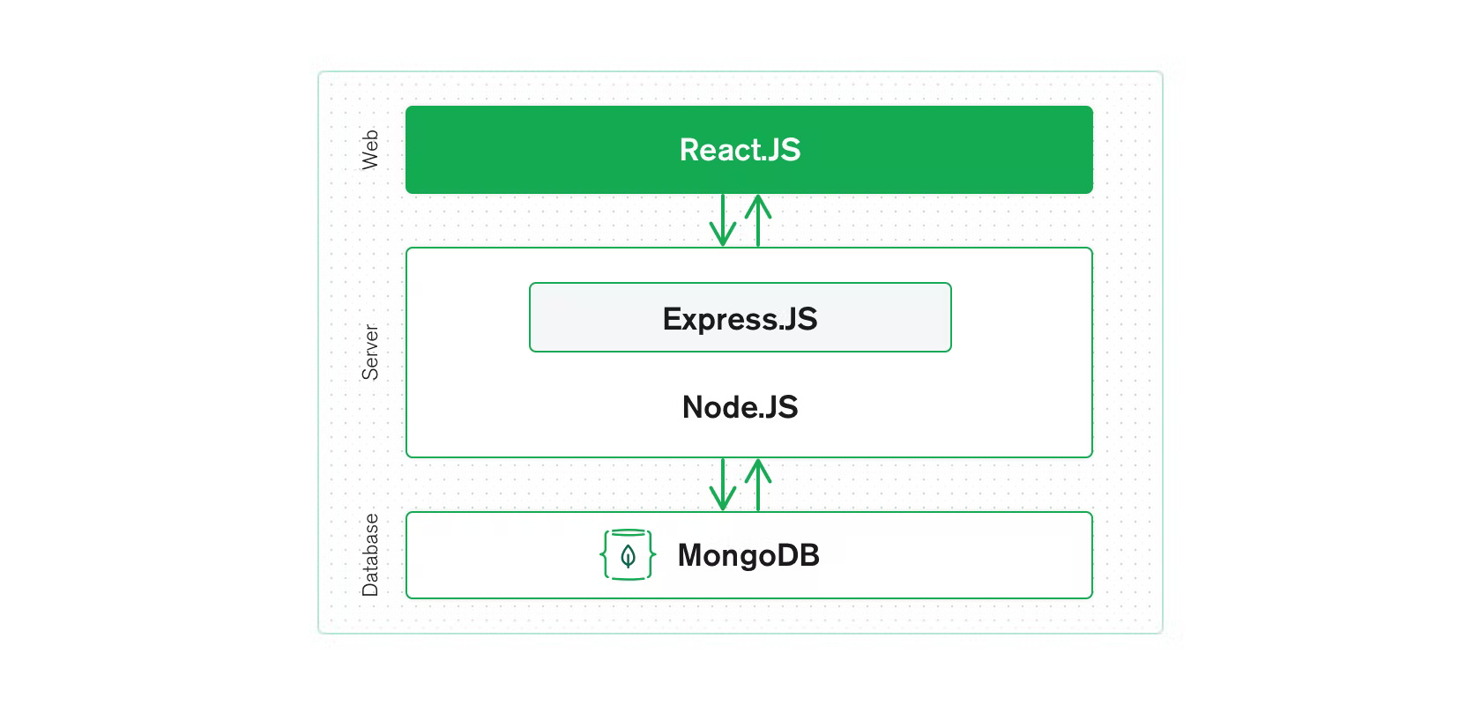
The MERN architecture allows you to easily construct a three-tier architecture (front end, back end, database) entirely using JavaScript and JSON.

React.js front end
The top tier of the MERN stack is React.js, the declarative JavaScript framework for creating dynamic client-side applications in HTML. React lets you build up complex interfaces through simple components, connect them to data on your back-end server, and render them as HTML.
React’s strong suit is handling stateful, data-driven interfaces with minimal code and minimal pain, and it has all the bells and whistles you’d expect from a modern web framework: great support for forms, error handling, events, lists, and more.

Express.js and Node.js server tier
The next level down is the Express.js server-side framework, running inside a Node.js server. Express.js bills itself as a “fast, unopinionated, minimalist web framework for Node.js,” and that is indeed exactly what it is. Express.js has powerful models for URL routing (matching an incoming URL with a server function), and handling HTTP requests and responses.
By making XML HTTP Requests (XHRs) or GETs or POSTs from your React.js front end, you can connect to Express.js functions that power your application. Those functions, in turn, use MongoDB’s Node.js drivers, either via callbacks or using promises, to access and update data in your MongoDB database.

MongoDB database tier
If your application stores any data (user profiles, content, comments, uploads, events, etc.), then you’re going to want a database that’s just as easy to work with as React, Express, and Node.
That’s where MongoDB comes in: JSON documents created in your React.js front end can be sent to the Express.js server, where they can be processed and (assuming they’re valid) stored directly in MongoDB for later retrieval. Again, if you’re building in the cloud, you’ll want to look at Atlas. If you’re looking to set up your own MERN stack, read on!

