**Amazon VPC(Virtual Private Cloud)**

**VPC:-**Amazon Virtual Private Cloud (Amazon VPC) enables you to launch AWS resources into a virtual network that you've defined.A VPC is a virtual private cloud that allows us to create a logical unit of the network where the hardware and resources are managed by the vendor, or the service provides. As users, we are responsible for the configuration and logical setup of the network.A VPC can only be defined within a single region, each VPC can have a number of subnets.

**A** [**VPC**](https://docs.aws.amazon.com/vpc/latest/userguide/configure-your-vpc.html) **is a virtual network that closely resembles a traditional network that you'd operate in your own data center.**

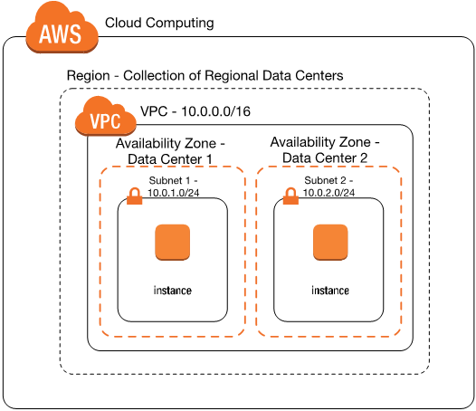

**Subnet:**-Subnets are used to provide granularity inside the VPC.

**After you create a VPC, you can add subnets.**

**Create VPC**

Open AWS Management Console

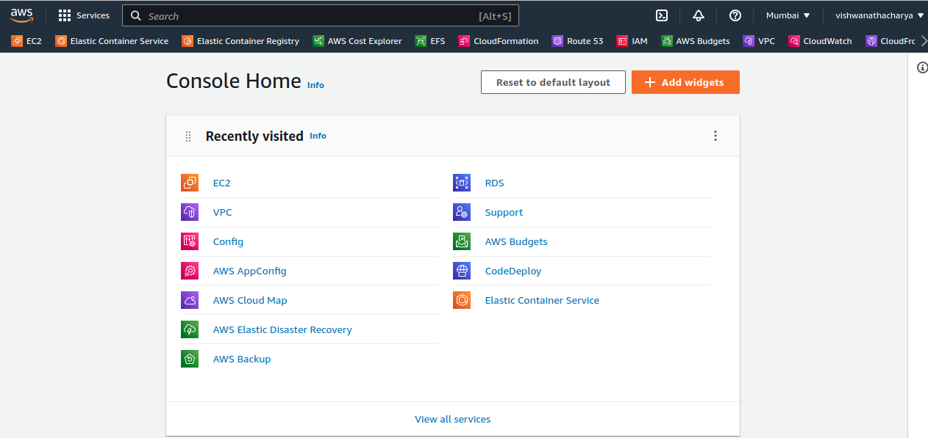

Search VPC Resource

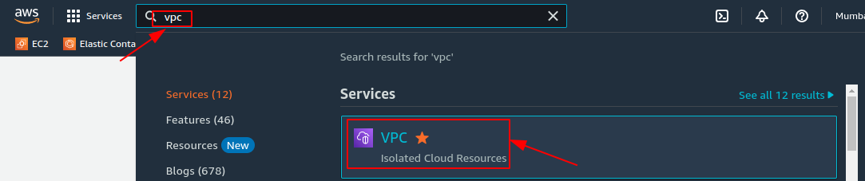

Open it

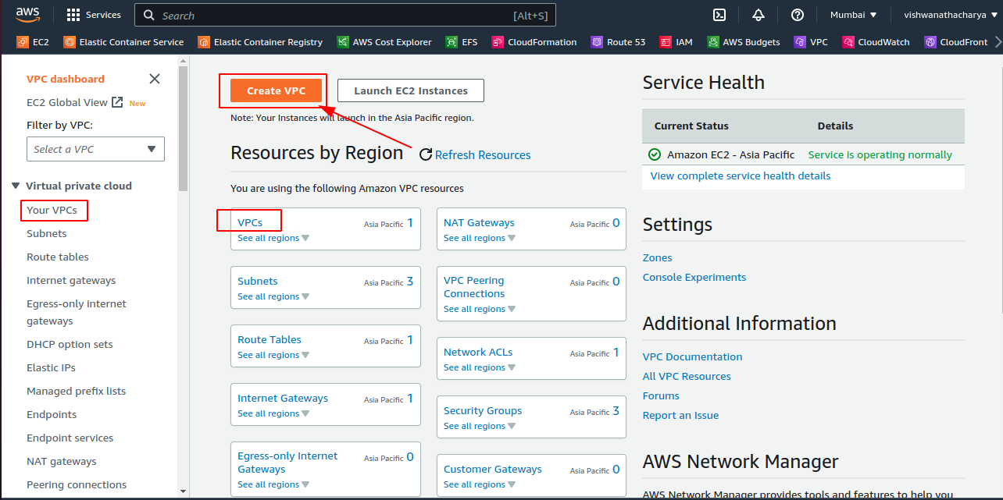

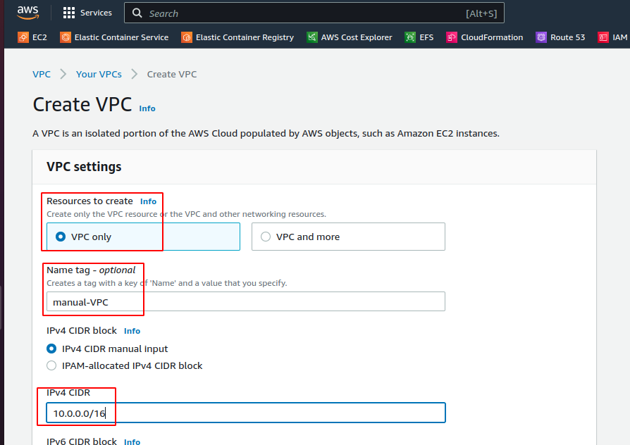

Ipv4 CIDR Classless Inter-Domain Routing (CIDR) block

10.0.0.0/16

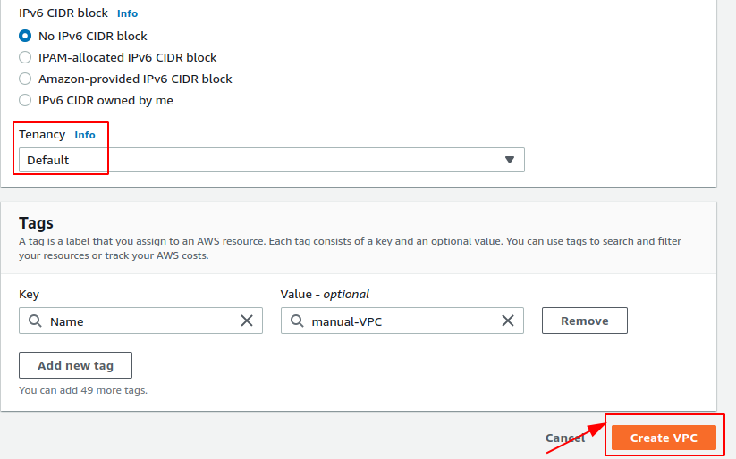

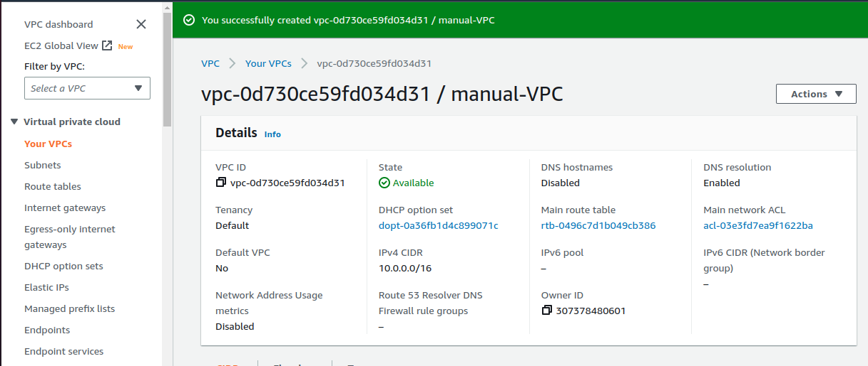

**Subnet:**-A [*subnet*](https://docs.aws.amazon.com/vpc/latest/userguide/configure-subnets.html) is a range of IP addresses in your VPC. A subnet must reside in a single Availability Zone. After you add subnets, you can deploy AWS resources in your VPC.

**Create Subnet**

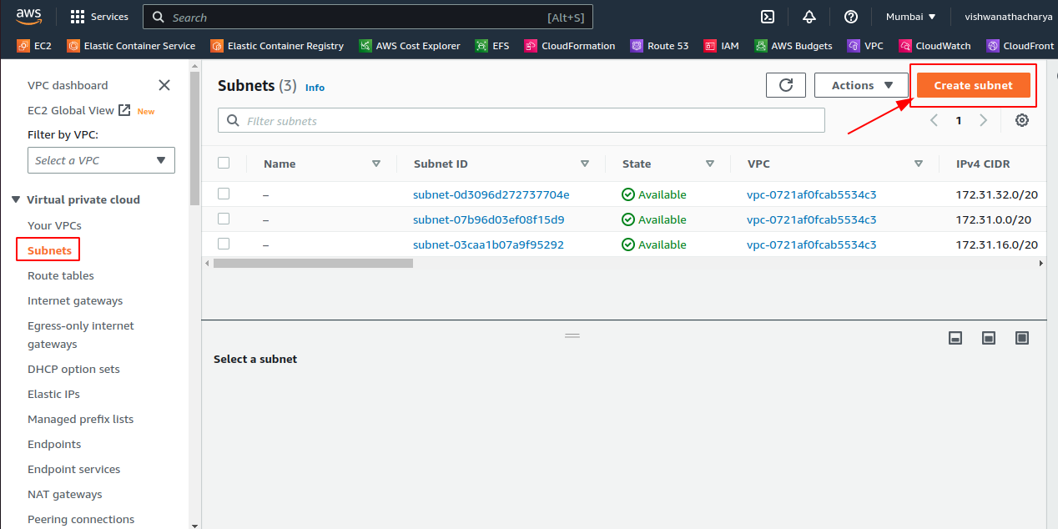

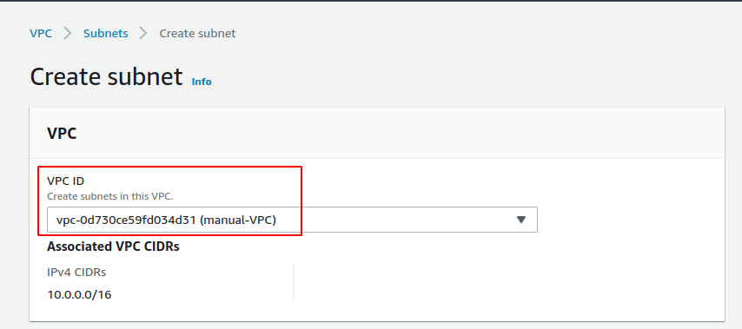

**Availability Zones** :-Availability Zones are distinct locations within an AWS Region that are engineered to be isolated from failures in other Availability Zones. They provide inexpensive, low-latency network connectivity to other Availability Zones in the same AWS Region.Each region is completely independent.

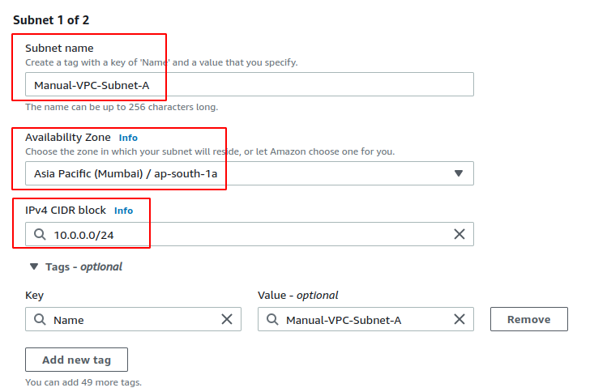

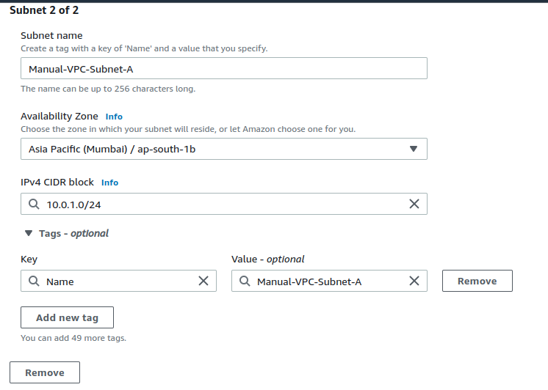

Click **Create Subnet**

**Internet Gateway:-**An internet gateway is a horizontally scaled, redundant, and highly available VPC component that allows communication between your VPC and the internet.

**Create Internet Gateway**

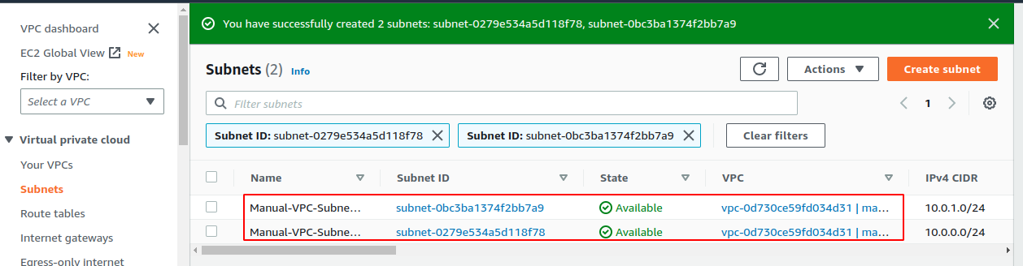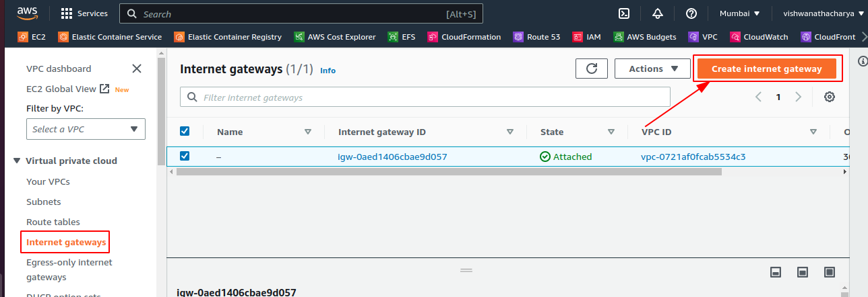

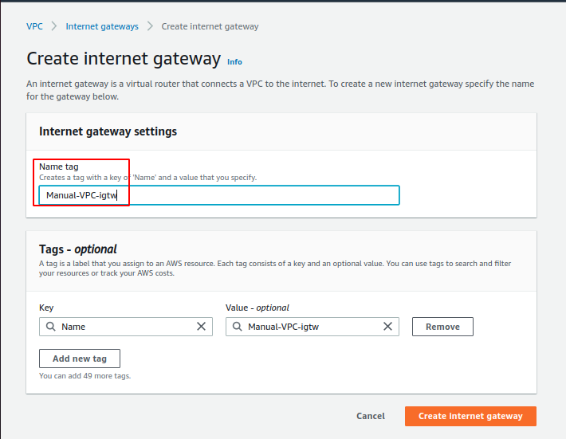

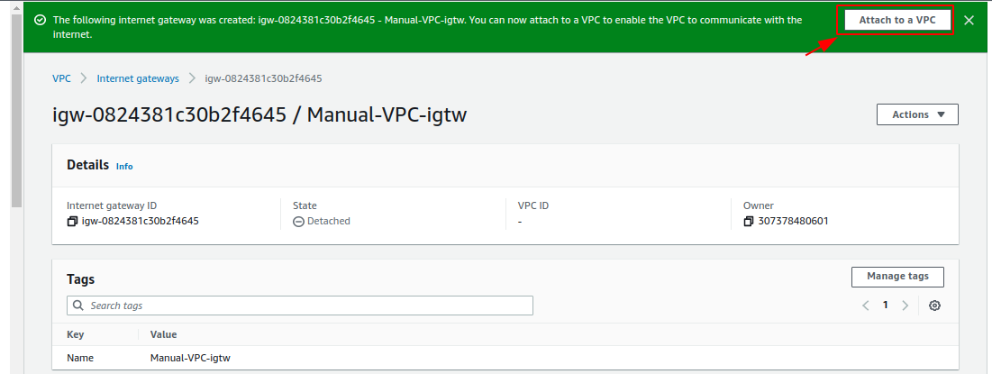

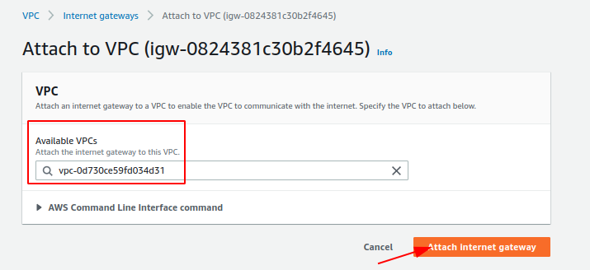

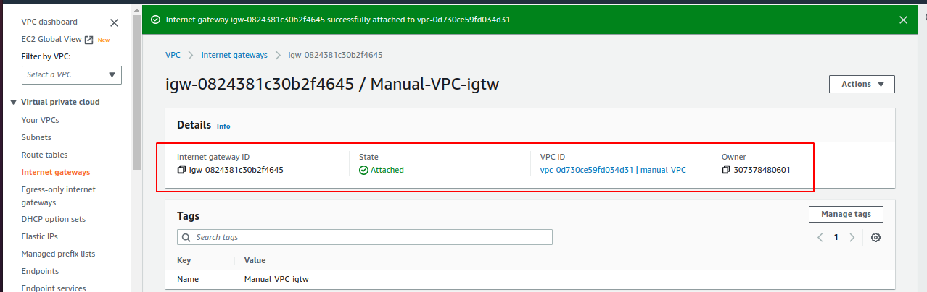

**Create Route Table**

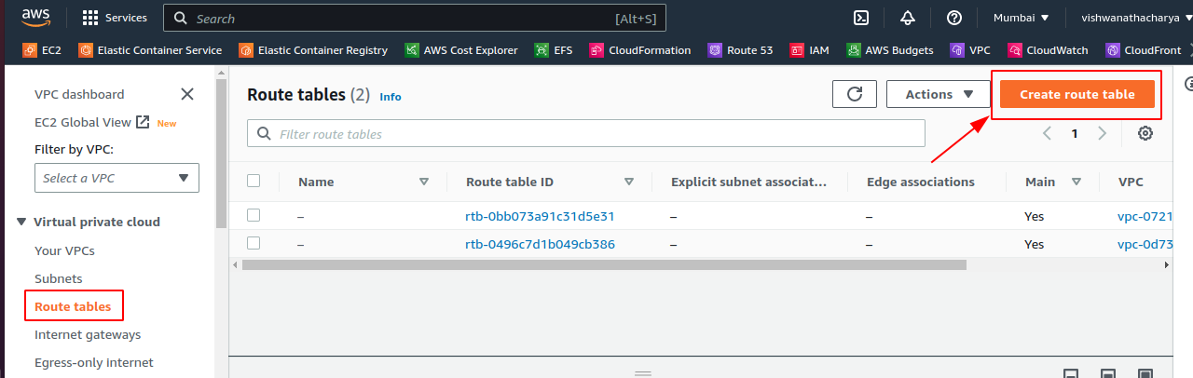

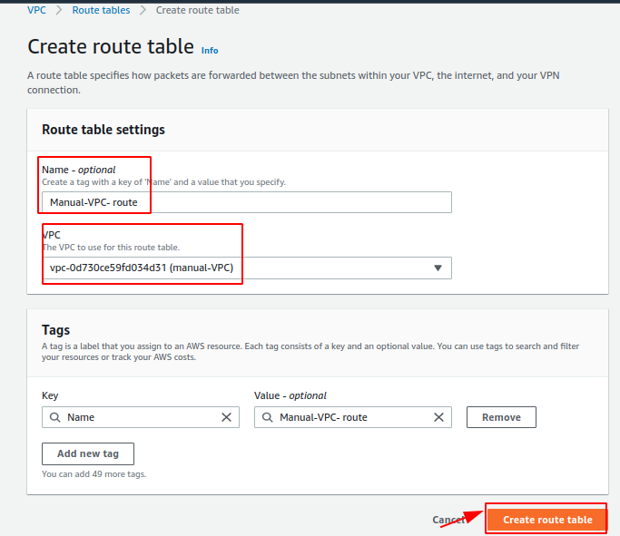

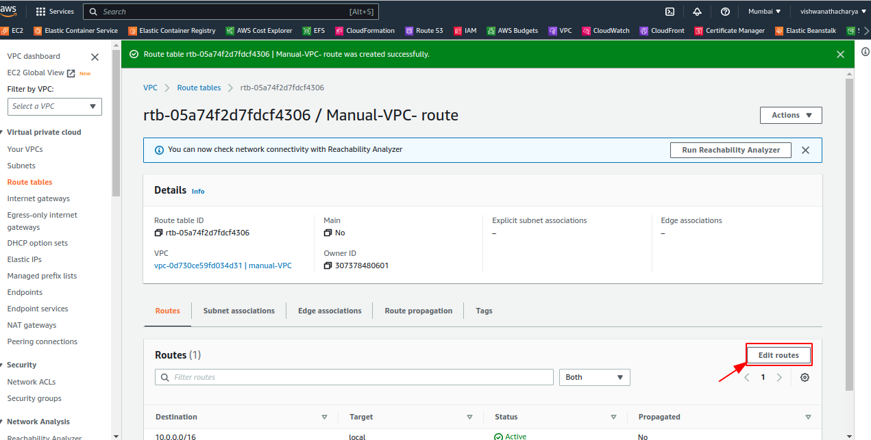

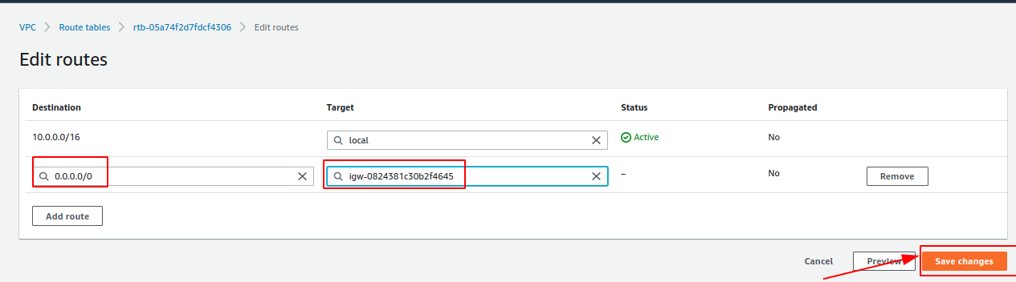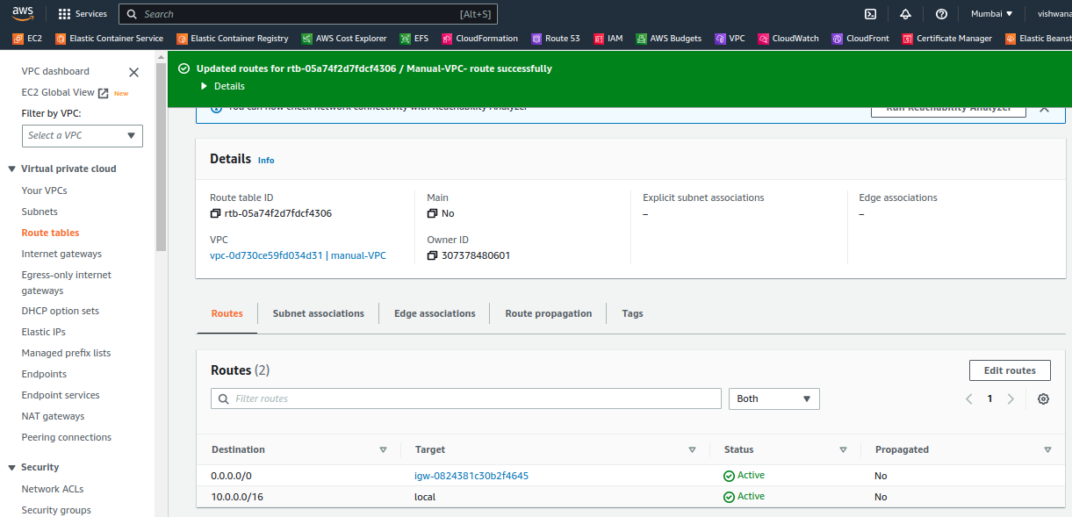

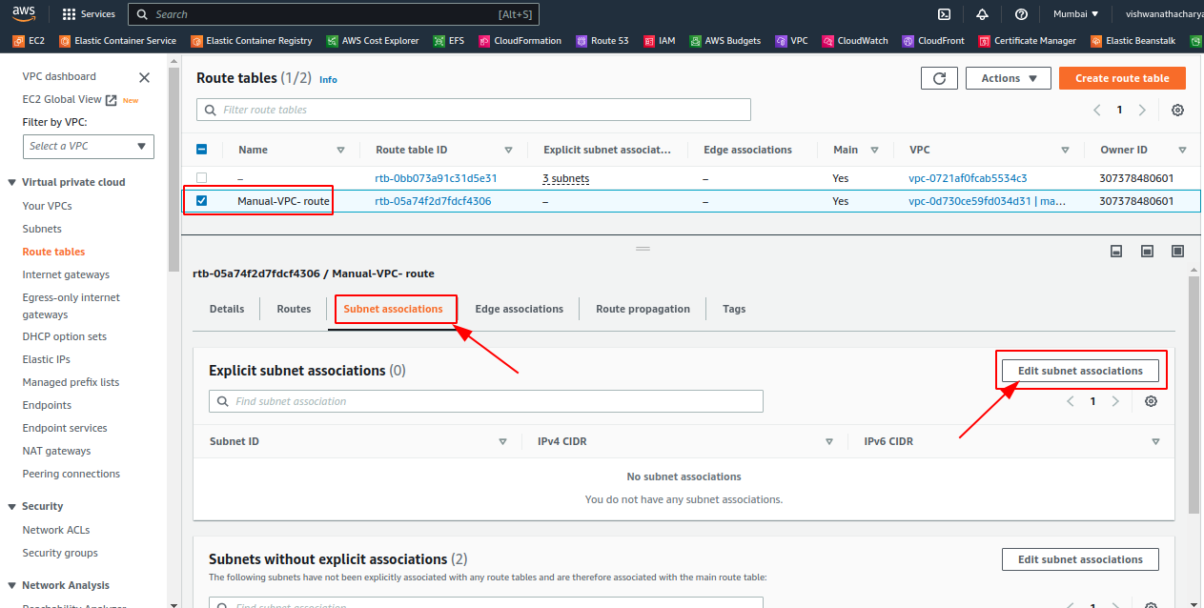

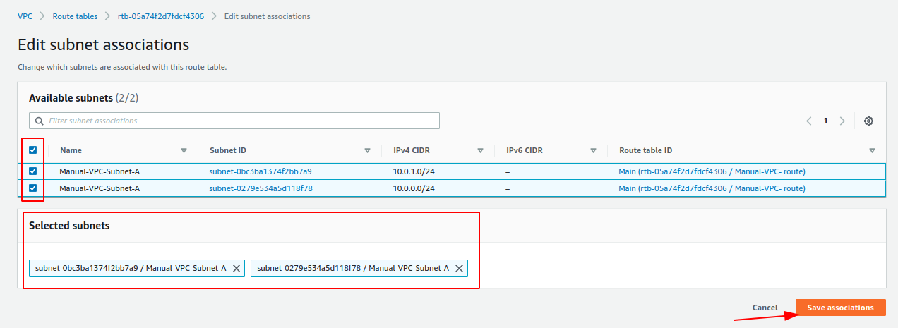

IF YOU USE DEFAULT VPC SG SO PLEASE OPEN PORT 22 FORT SSH

=======================================================================

**Create Private Subnet**

