Host Machine Details:

Operating System: Ubuntu 16.04.2 LTS

Memory: 24GB

CPU: Quad Core Intel Xeon

VM One Details (**CLI + Manager** Virtual Machine)

vCPUs: 2

**RAM: 4GB**

Storage: 40 GB

Operating System: CentOS Linux Release 7.4.1708 (Core)

Username: centos

IP: 192.168.122.165

Common Setup steps on **both the VMs**

Added the entry “**centos ALL=(ALL) NOPASSWD: ALL**” to the **/etc/sudoers** file

Setup steps on the **Single Virtual Machine**

1. Created PEM file for the Manager machine using the below steps (reference <https://www.therandombits.com/149/create-pem-file-for-your-linux-server/> )
   1. mkdir ~/cloudifykeys/
   2. ‘ssh-keygen’ and provided the ‘cloudify’ name when asked, skipped the passphrase
   3. ‘openssl rsa –in cloudify –outform pem > cloudify.pem’ to create a new PEM file
   4. ‘ssh-copy-id –i cloudify.pub centos@192.168.122.165
   5. ‘chmod 400 cloudify.pem’
2. Downloaded ‘**cloudify-cli-4.2ga.rpm**’ and installed it using command ‘**sudo rpm -i cloudify-cli-4.2ga.rpm’**
3. sudo yum install -y python-backports-ssl_match_hostname python-setuptools python-backports
4. Edited the file **/opt/cfy/cloudify-manager-blueprints/ simple-manager-blueprint-inputs.yaml** with the below entries
   1. ‘public_ip: 192.168.122.165’
   2. ‘private_ip: 192.168.122.165’
   3. ‘ssh_user: centos’
   4. ‘ssh_key_filename: ~/cloudifykeys/cloudify.pem’
5. Kicking off bootstrap from the **Single virtual machine**
6. cd to the **/opt/cfy/cloudify-manager-blueprints** directory and execute **cfy bootstrap simple-manager-blueprint.yaml -i simple-manager-blueprint-inputs.yaml**

End Result: SUCCESSFUL

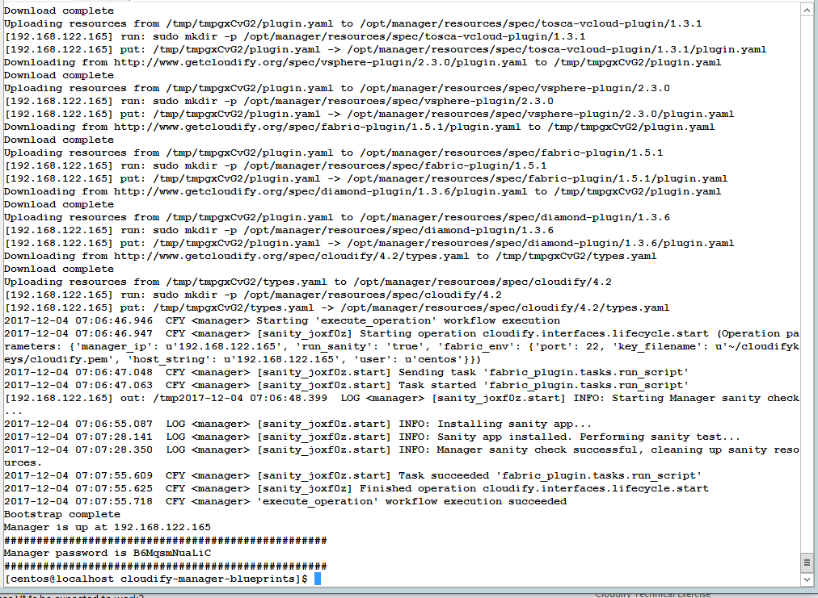

Creating blueprints

1. Created directory ~/cloudifyblueprints/helloworld and created the blueprint
2. cfy blueprints upload --validate ~/cloudifyblueprints/helloworld/helloworld.yaml
3. cfy deployments create -b helloworld -i helloworldinputs.yaml helloworld --skip-plugins-validation
4. cfy executions start execute_operation -d helloworld -p operation=cloudify.interfaces.lifecycle.configure;operation_kwargs={implementations=fabric.fabric_plugin.tasks.run_script;inputs={script_path=scripts/helloworld.sh,fabric_env={user=centos,port=22,key_filename=/tmp/keys/cloudify.pem,host_string=192.168.122.107}}}

Below ports were added using the command

1. sudo firewall-cmd --zone=public --add-port=5671/tcp –permanent
2. sudo firewall-cmd --zone=public --add-port=53333/tcp –permanent
3. sudo firewall-cmd --zone=public --add-port=53229/tcp –permanent
4. sudo firewall-cmd --zone=public --add-port=80/tcp –permanent
5. sudo firewall-cmd --reload