**Topics: Descriptive Statistics and Probability**

1. Look at the data given below. Plot the data, find the outliers and find out $μ, σ, σ^{2}$

|  |  |
| --- | --- |
| **Name of company** | **Measure X** |
| Allied Signal | 24.23% |
| Bankers Trust | 25.53% |
| General Mills | 25.41% |
| ITT Industries | 24.14% |
| J.P.Morgan & Co. | 29.62% |
| Lehman Brothers | 28.25% |
| Marriott | 25.81% |
| MCI | 24.39% |
| Merrill Lynch | 40.26% |
| Microsoft | 32.95% |
| Morgan Stanley | 91.36% |
| Sun Microsystems | 25.99% |
| Travelers | 39.42% |
| US Airways | 26.71% |
| Warner-Lambert | 35.00% |

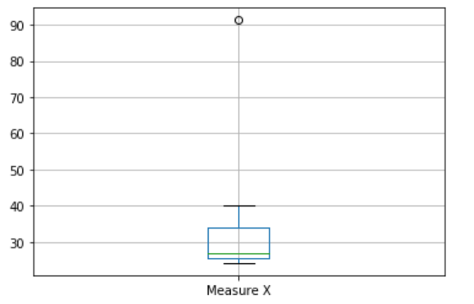

* + *Outliers: ‘Morgan Stanley’*
  + *Mean: 33.271333*
  + *Variance: 268.003505*
  + *Standard Deviation: 16.370813*



Answer the following three questions based on the box-plot above.

1. What is inter-quartile range of this dataset? (please approximate the numbers) In one line, explain what this value implies.

**Ans:** Q3-Q1 = 12 – 5 = 7

The IQR is used to measure how spread out the data points in a set are from the mean of the data set

1. What can we say about the skewness of this dataset?

**Ans:**  Right Skewed

1. If it was found that the data point with the value 25 is actually 2.5, how would the new box-plot be affected?

**Ans:** Then the outlier will not exist in the dataset



Answer the following three questions based on the histogram above.

1. Where would the mode of this dataset lie?

**Ans:**  Mode value will range between 4 to 8

1. Comment on the skewness of the dataset.

**Ans:** It is mostly Right-Skewed

1. Suppose that the above histogram and the box-plot in question 2 are plotted for the same dataset. Explain how these graphs complement each other in providing information about any dataset.

**Ans:** Two plots are useful when they are complemented with each other because

Mode can be observed in histogram and outliers can be found in boxplot.

1. AT&T was running commercials in 1990 aimed at luring back customers who had switched to one of the other long-distance phone service providers. One such commercial shows a businessman trying to reach Phoenix and mistakenly getting Fiji, where a half-naked native on a beach responds incomprehensibly in Polynesian. When asked about this advertisement, AT&T admitted that the portrayed incident did not actually take place but added that this was an enactment of something that “could happen.” Suppose that one in 200 long-distance telephone calls is misdirected. What is the probability that at least one in five attempted telephone calls reaches the wrong number? (Assume independence of attempts.)

**Ans:** probability that at least one in five attempted telephone calls reaches the wrong number = **0.02475**

1. Returns on a certain business venture, to the nearest $1,000, are known to follow the following probability distribution

|  |  |
| --- | --- |
| x | P(x) |
| -2,000 | 0.1 |
| -1,000 | 0.1 |
| 0 | 0.2 |
| 1000 | 0.2 |
| 2000 | 0.3 |
| 3000 | 0.1 |

1. What is the most likely monetary outcome of the business venture?

**Ans:** P (0.3) = 2000

1. Is the venture likely to be successful? Explain

**Ans:** P (0.6) > P (0.2). It will be successful

1. What is the long-term average earning of business ventures of this kind? Explain  
   **Ans:** Expected Value = P(x).x

0.1(-2000) + 0.1(-1000) + 0 + 0.2(2000) + 0.3(2000) + 0.1(3000) = **800**

1. What is the good measure of the risk involved in a venture of this kind? Compute this measure

**Variance** 2660000.0