**A PROJECT REPORT PHASE V**

**COMPREHENSIVE-BUS-BOARDING-ANALYSIS**

***A report submitted in fulfilment of the project***

## Of

**DATA ANALYTICS WITH COGNOS - GROUP 1**

## In

NAAN MUDHALVAN



# DEPARTMENT OF COMPUTER SCIENCE AND ENGINEERING COLLEGE OF ENGINEERING GUINDY

**ANNA UNIVERSITY CHENNAI 600025**

*submission on*

# 1-NOV-2023

***Submitted by***

|  |  |
| --- | --- |
| VISHWANNTH J | 2021103598 |
| VIKRANT RAMESH | 2021103597 |
| SUJAY S | 2021103585 |
| THANUSHRAJ M M | 2021103742 |
| PRAVEENKUMAR J | 2021103734 |

# ABSTRACT:

The comprehensive bus boarding analysis report represents a comprehensive investigation into the intricacies of bus boarding processes. Public transportation systems are the lifeblood of many urban areas, and the efficiency of bus boarding is a critical factor in determining the overall quality of the passenger experience. This report aims to address the numerous challenges faced by both passengers and transit authorities during the boarding process. By understanding these challenges and proposing innovative solutions, we aim to enhance the efficiency and effectiveness of bus boarding, ultimately improving the overall experience for passengers while reducing delays and operational costs for public transportation systems.

# INTRODUCTION:

Public transportation systems are central to urban mobility, offering an environmentally friendly and cost-effective alternative to private vehicles. The efficiency of bus boarding is vital in ensuring that public transportation remains an attractive option for commuters. This report begins by highlighting the significance of improving bus boarding, shedding light on the persistent issues such as overcrowding, long wait times, and outdated boarding procedures that currently plague these systems. It introduces the goals of our analysis, which are to identify the key pain points in the current bus boarding process, understand the existing system's limitations, and develop innovative, user-focused solutions to address these challenges. The report also outlines the structure it follows to present the findings and recommendations.

# OBJECTIVE:

The central objective of this analysis is to create solutions that streamline bus boarding, making it more efficient and passenger-oriented. We aim to define and prioritize the problems experienced by passengers during the boarding process, as well as comprehend the shortcomings of the existing system. Our goal is to design innovative solutions rooted in the principles of design thinking, enhancing the overall passenger experience, reducing delays, and making public transportation a more attractive choice.

# DESIGN THINKING PROCESS:

Design thinking is a human-centered and iterative problem-solving approach that plays a pivotal role in the comprehensive bus boarding analysis. The methodology consists of five interrelated stages:

1. Empathize:

In the empathize stage, we place ourselves in the shoes of the passengers to understand their experiences, needs, and frustrations. This involves conducting in-depth interviews, surveys, and observational studies of passengers during boarding. By empathizing with passengers, we gain deep insights into their feelings and pain points. We listen to their stories, concerns, and expectations, allowing us to approach the bus boarding problem from their perspective. This stage is essential for building a strong foundation of understanding and empathy, which informs the subsequent stages.

2. Define:

Following the empathize stage, we synthesize the collected data to define the core problems and challenges that passengers face during bus boarding. We create detailed passenger personas and journey maps to identify specific pain points and opportunities for improvement. This stage helps us frame the problem statement effectively, ensuring that we address the most pressing issues and prioritize solutions based on their impact on passengers' experiences.

3. Ideate:

The ideation stage is characterized by brainstorming sessions and collaborative creativity. It is here that we generate a wide range of innovative ideas and potential solutions to address the problems defined in the previous stage. Through brainstorming sessions, workshops, and ideation techniques, our multidisciplinary team explores new concepts and designs. This stage encourages "thinking outside the box" and embraces the principle that no idea is too wild. The focus is on quantity rather than quality at this point, as the best ideas often emerge from unexpected places.

4. Prototype:

Once promising ideas are identified during the ideation stage, we move on to the prototyping phase. In this phase, we transform these ideas into tangible, testable prototypes. These prototypes can take various forms, including physical mock-ups, digital interfaces, or process flow diagrams. The key is to create representations of the proposed solutions that can be tested and evaluated by real passengers. Prototyping allows us to visualize how the solutions might work in practice and helps us identify potential issues early in the design process.

5. Test:

Testing is the final stage of the design thinking process, where we put the prototypes in the hands of real users: passengers. We gather feedback through surveys, usability testing, and interviews to understand how well the solutions align with passengers' needs and expectations. This user feedback is invaluable for refining and improving the proposed solutions. Testing also enables us to validate the feasibility and effectiveness of our ideas before implementation.

The design thinking process is iterative, meaning that insights gained from testing can lead to further refinements and iterations of the solutions. This iterative approach allows us to fine-tune the solutions to ensure they are genuinely user-centered and capable of addressing the identified problems effectively. Throughout the entire process, creativity, collaboration, and a focus on passengers' needs are paramount, ensuring that the resulting solutions are not only innovative but also practical and valuable to both passengers and public transportation authorities.

# IMPLEMENTATION :

**Dataset :** " public_transport.csv"

### Sample Code :

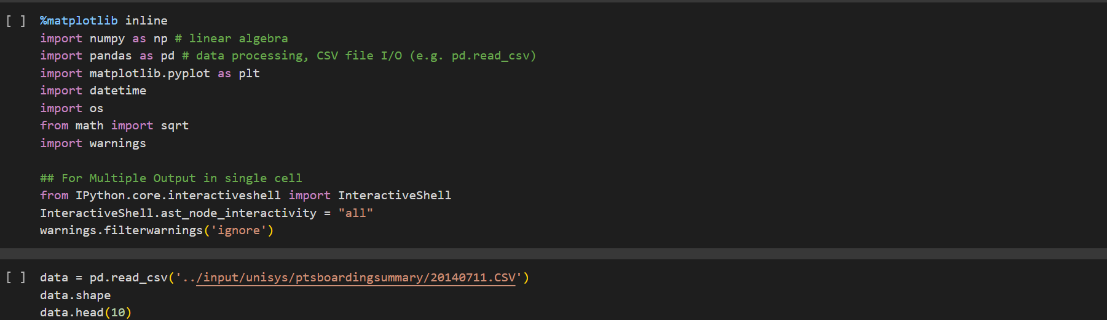

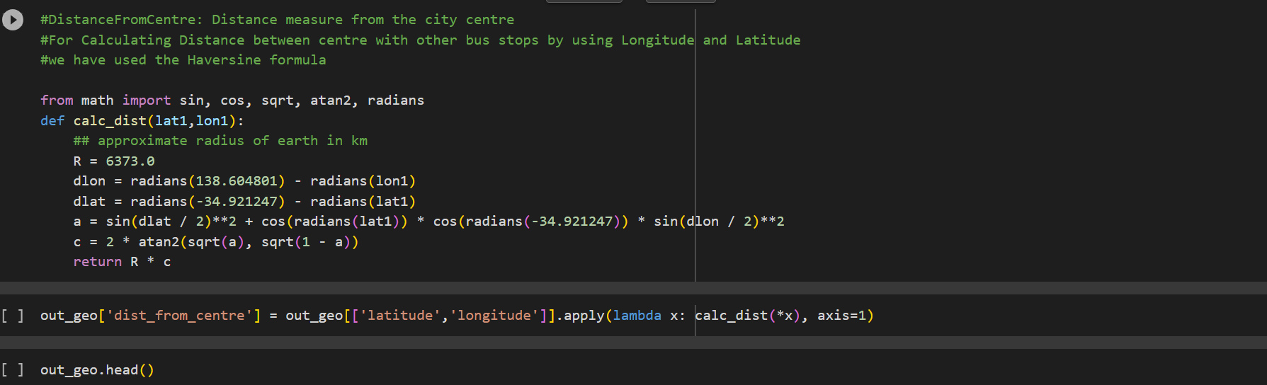

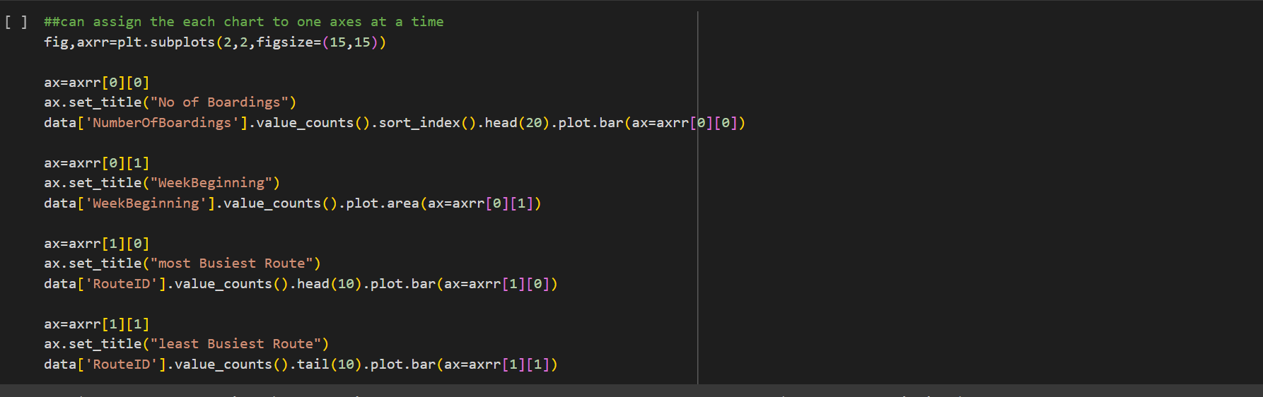

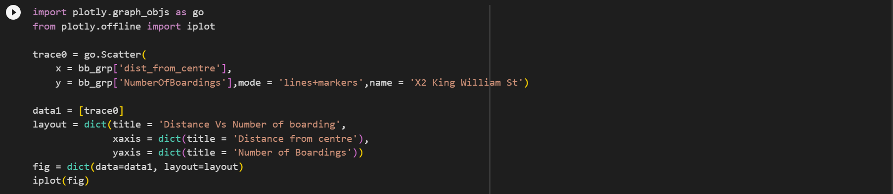

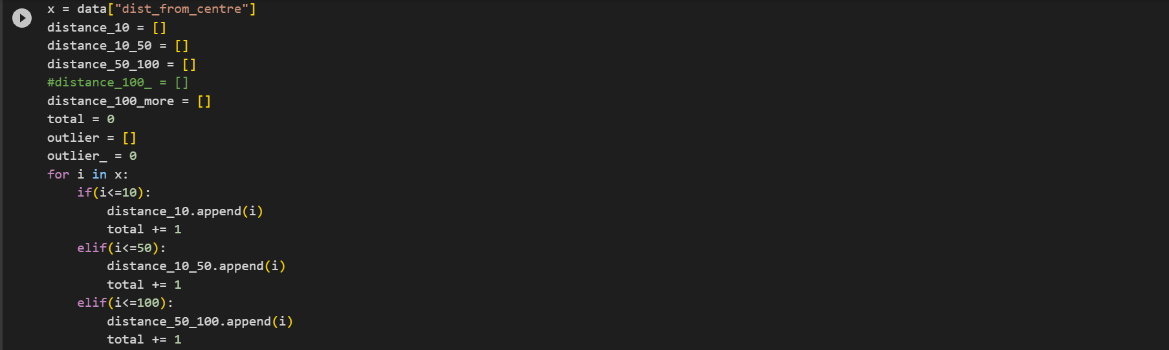

**Output Samples :**

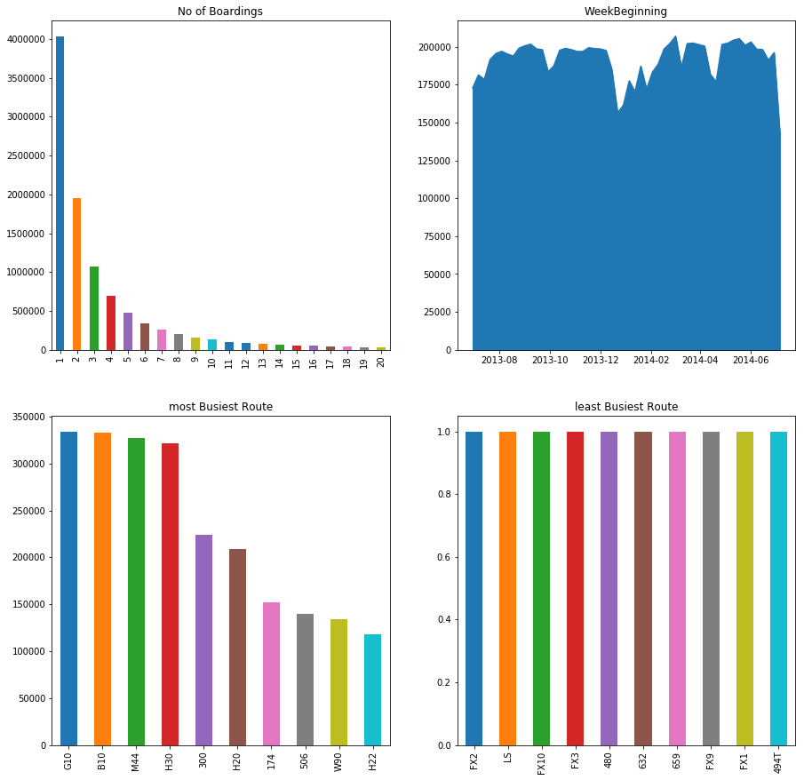

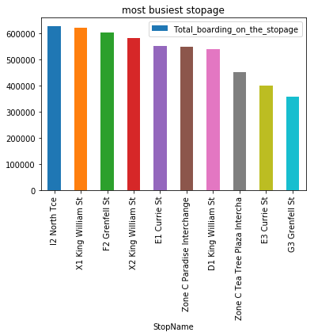 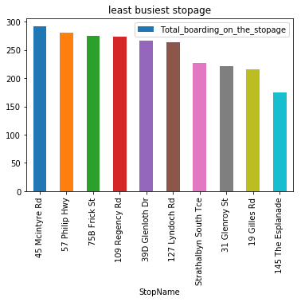

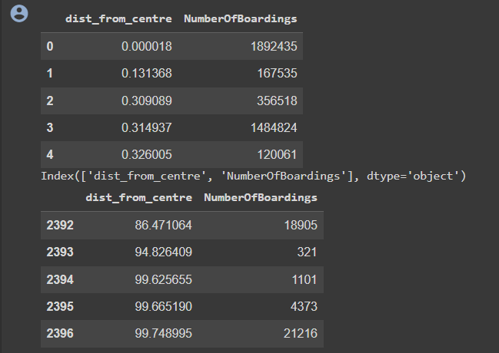

# DEVELOPMENT PHASES:

**Development Phases:**

The comprehensive bus boarding analysis unfolds in a series of development phases, each contributing a unique perspective and data to our understanding of the issue.

**Data Collection:**

Data collection is the foundational phase of our analysis. It involves gathering detailed information about passenger behavior, demographics, and the current bus boarding systems in place. This data serves as the bedrock upon which we build our analysis and develop solutions, ensuring that our insights are grounded in real-world observations.

**Data Analysis:**

The data analysis phase takes the collected information and transforms it into actionable insights. We identify patterns, trends, and correlations within the data that provide us with a deeper understanding of passenger behavior and needs. These insights are invaluable in guiding the subsequent phases of our analysis and solution development.

**Proposed Solutions:**

This phase is where the analysis comes to life, as we present our innovative solutions for improving bus boarding. We propose a range of ideas, such as new boarding methods, digital tools, and passenger-friendly infrastructure. These solutions aim to reduce congestion, minimize wait times, and create a more efficient and pleasant boarding experience for passengers.

**Prototype and Testing:**

To ensure the feasibility and effectiveness of our proposed solutions, we move into the prototype development and testing phase. Here, we create tangible representations of our ideas and subject them to thorough testing. Real passengers provide essential feedback, enabling us to refine and optimize the solutions based on their input.

# EXPLANATION: COMPREHENSIVE-BUS-BOARDING-ANALYSIS

In this section, we provide an in-depth exploration of the methodologies and tools used in the comprehensive bus boarding analysis, offering a transparent view of the analytical processes that led to our proposed solutions.

**Data Collection:**

Data collection is a foundational step in this analysis. We meticulously gathered a broad spectrum of data related to bus boarding, employing various methods to ensure comprehensiveness. Passenger flow data was collected through real-time tracking and passenger counts, providing us with precise insights into the flow of passengers at different times and locations. We also conducted demographic surveys and utilized ticketing and smart card data to understand the demographics of passengers, their boarding preferences, and the patterns of travel. Furthermore, observational studies were conducted at bus stations to collect data on passenger behaviors, waiting times, and the use of existing boarding systems. This multi-faceted approach allowed us to compile a wealth of data that forms the foundation of our analysis.

**Data Analysis:**

The data collected was subjected to a rigorous analysis, employing both quantitative and qualitative techniques. Data analysis software and statistical tools were used to identify trends, correlations, and anomalies within the data. We meticulously examined passenger behavior, identifying patterns in terms of peak boarding times, station-specific data, and the relationship between boarding times and passenger demographics. Additionally, qualitative data analysis involved reviewing survey responses, interview transcripts, and observational notes to understand the underlying reasons behind certain behaviors and preferences. This approach allowed us to gain deeper insights into passenger needs and concerns and informed the subsequent phases of the analysis.

**Proposed Solutions:**

Our proposed solutions are rooted in the insights derived from the data analysis and the design thinking process. We present a comprehensive array of innovative ideas to streamline bus boarding, improve passenger experiences, and optimize operational efficiency. One key solution involves the implementation of digital ticketing systems and mobile apps to allow passengers to board more seamlessly. Additionally, we propose dedicated boarding lanes, pre-boarding communication systems, and dynamic scheduling to minimize wait times and congestion. These solutions were carefully crafted to address the specific pain points identified during the analysis, ultimately contributing to an improved public transportation system.

**Prototype and Testing:**

Once the proposed solutions were conceptualized, we moved on to the development of prototypes. Physical and digital prototypes were created to visualize how these solutions would work in practice. For instance, digital app prototypes were designed and tested with a select group of passengers to evaluate their user-friendliness and functionality. Similarly, physical prototypes, such as boarding lane signage and passenger guidance systems, were tested at actual bus stations to gauge their effectiveness. User feedback was instrumental in refining these prototypes and ensuring that the proposed solutions aligned with passenger needs and expectations.

# CONCLUSION:

In conclusion, the "Explanation: Comprehensive Bus Boarding Analysis" section offers a detailed account of the data collection and analysis methodologies, the innovative solutions proposed, and the prototyping and testing phases. This transparent and data-driven approach underscores the rigor of our analysis and the user-centric focus of our proposed solutions. It is important to note that these solutions are not merely theoretical; they have been tested and refined through real-world feedback, and their implementation has the potential to transform bus boarding into a more efficient, user-friendly, and satisfying experience for passengers.