- Introduction
  - Structure of Report
This report is organized into multiple chapters, each addressing a specific aspect of quantum light sources with emphasis on weak coherent pulse sources (WCPS) and entangled photon sources based on spontaneous parametric down conversion (SPDC).
This report is designed to provide a systematic progression from fundamental concepts to detailed design considerations, experimental configurations, and current international research trends.

- Introduction
This section introduces a brief overview, objectives and motivation of the report. It provides a structural overview of each section covered in the report.

- Types of quantum light sources
This section is an overview of different types of quantum light sources (WCPS, entangles photon sources and heralded single photon sources). This section builds basic concept for quantum optical sources.

- 810 nm vs 1550 nm laser
Provides a comparison between 810 nm and 1550 nm wavelength. Discusses their suitability for free space and fiber, detection and why are we using 1550 nm.

- WCPS (Section 4-7)
Discusses weak coherent pulse sources. Working principles of WCPS, its photon statistics, key theoretical considerations like second order correlation and Poissonian distribution, design constraints are discussed in this.

- Entangles photon sources (Section 8-12)
These sections explain quantum entanglement, SPDC process, phase matching techniques, and design choices.

- Sagnac interferometer (Section 13)
This section explains what Sagnac interferometer is and its schematics for polarization entangled photon pairs

- Experimental set-ups (Section 14)
Explains various configurations based on PPKTP and PPLN crystals, including schematic descriptions.

- Experimental measurements for Entanglement (Section 15)
Gives numerical data for the previous discussed configurations like coincidence count, visibility

- International Scenario and Latest Trends on Entangled Photon Sources
(Section 16)
Reviews international research scenario, highlighting emerging trends and future directions in this field

Additional sections include abstract, objective, conclusion, bibliography, all intended to aid in navigation.

  - About the Report
This report presents a study of quantum light sources with particular emphasis on entangled photon sources generated through spontaneous parametric down conversion. Quantum light sources have an important role in quantum communication and information processing, where classical light sources fail to meet the nonclassical correlations.

The core objective of this report is to analyze the principles, design considerations, and practical implementation of WCPS and SPDC-based entangled photon sources (mainly for telecom wavelength of 1550 nm). This report explains various phase matching techniques, nonlinear crystal selection and trade-offs of each configuration involved in developing reliable quantum optical sources.

This report not only discusses the theoretical background and technological concepts involved but also provides detailed insights into experimental configurations, measurement techniques for entanglement verification, and real-world considerations for deploying quantum light sources in practical systems. By combining theoretical and experimental perspectives, this report aims to contribute toward the understanding and development of efficient and scalable quantum photonic sources.

- Types of quantum light source
Quantum light sources are essential components in quantum optics because they enable the generation of light which cannot be explained by classic laws of physics. The sources vary as per their application in quantum optics like quantum communication, quantum key distribution (QKD), quantum cryptography and many more. The most commonly used sources as follows:

  - Weak Coherent Sources
Weak coherent sources are obtained by reducing the intensity of a conventional laser so that, on average, less than one photon is present in each light pulse. However, the number of photons emitted in each pulse is random, thus, some pulses may contain no photons while others may contain more than one photon. Because of their simple design, high stability, and ease of implementation, weak coherent sources are widely used in practical quantum communication systems. Their main limitation is the possibility of multi-photon emission, which can reduce security in certain quantum protocols.
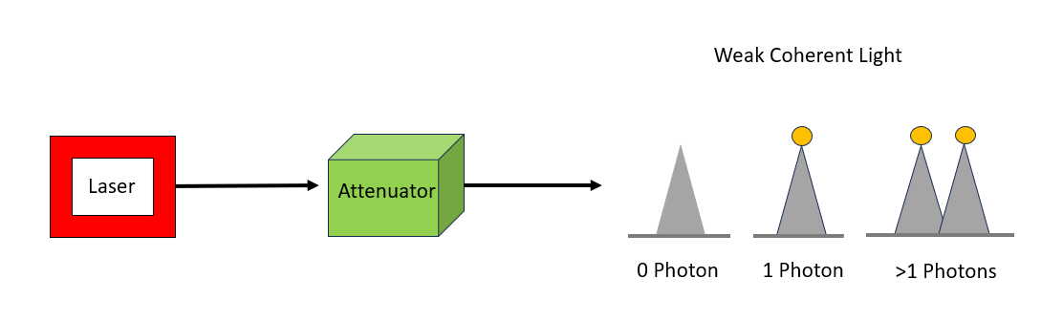
Figure 1: Schematic of weak coherent sources
  - Entangled Photon Sources
Entangled photon sources generate pairs of photons that are strongly correlated in their physical properties, such as polarization or time of arrival. Measuring one photon instantly determines the state and properties of its partner, regardless of the distance between them. These photon pairs are commonly produced using nonlinear optical processes like spontaneous parametric down-conversion or four-wave mixing. Entangled photons are crucial for advanced quantum applications, including tests of quantum nonlocality, quantum teleportation, and entanglement-based quantum key distribution.
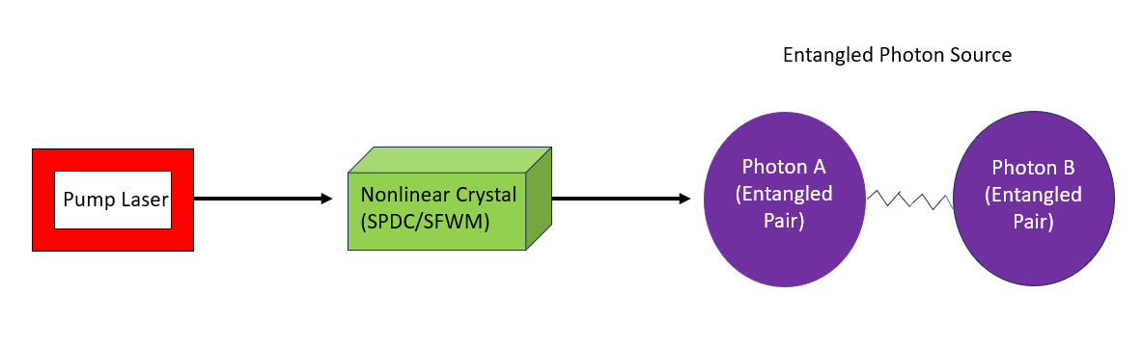
Figure 2: Showing schematic of EPS
  - Heralded Single Photon Sources
Heralded single-photon sources work by the principle of producing photon pairs, where the detection of one photon acts as a signal, or “herald,” indicating that the other photon is present. This method allows better control over single-photon generation compared to weak coherent sources. Although the generation is not perfectly deterministic, heralded sources significantly reduce the chances of producing multiple photons at the same time, making them suitable for applications that require high-quality single photons.

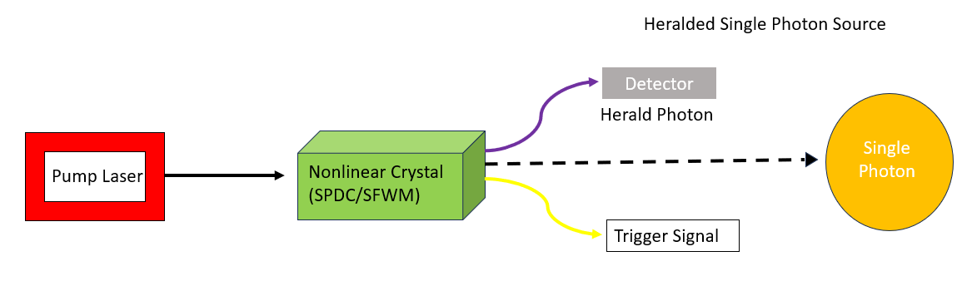
Figure 3: Showing schematic of Heralded Single Photon Sources

- 810 nm vs 1550 nm
In this section we will se a brief comparison between 810 nm and 1550 nm and conclude why we used 1550 nm for quantum entanglement.

810 nm | 1550 nm
They have 3 dB/km fiber loss. | They have 0.02 dB/km fiber loss.
810 nm use low noise Si APD detection. | 1550 nm requires InGaAs or SNSPDs which are more complex.
Detection efficiency is high. | Detection efficiency is low.
810 are more favorable for free space. | 1550 nm are more favorable for fiber.
810 nm can be operated in daylight but suffers higher solar background. | 1550 nm supports both daylight and nighttime operation with significantly lower background, higher eye safe launch powers.

  - Advantages of 1550 nm
- 810 nm can be operated in daylight but suffers higher solar background; 1550 nm supports both daylight and nighttime operation with significantly lower background, higher eye-safe launch powers.
- 1550 nm is the optimum wavelength for photons in long distance quantum
networks due to minimum fiber loss.
- 1550 nm is highly fiber integrable than 810 nm.
- 1550 nm has significantly lower fiber loss than 810 nm.

- WCPS

- Considerations for WCPS

- Design Considerations of WCPS

- General Steps to design WCPS

- Entangled photon source
Quantum entanglement is a physical phenomenon that the particles in a system are highly correlated such that the quantum state of each particle cannot be described independently from the state of the others, even if they are separated by a large distance. This property is considered as non-local correlation which had been tested in 2015. The nonlocal correlations of entangled systems play a central role in quantum technologies across domains as varied as communication, sensing and computation. Generating entangled states in a reliable and reproducible manner while pushing the limits of repetition rates and quality of entanglement can thus be considered a key prerequisite towards practical applications. Position, momentum, spin, and polarization are some typical physical quantities, which had been founded to be entangled in real systems.

Entangled photon sources are basic platforms for quantum optical experiments and quantum information processing tasks like quantum key distribution, quantum teleportation, photonic frequency conversion, and quantum computations.

Entangled photons are pairs of light particles (photons) that are created simultaneously and share a unique quantum relationship. When two photons are entangled, their properties become correlated in a way that has no equivalent in classical physics. This means measuring one photon's properties (like polarization or energy) instantly influences the state of the other photon, even if they are separated by large distances.

The increased prominence of quantum networks has led to growing interest in deployable high performance entangled photon-pair sources.

  - Polarization entangled photon
In most practical quantum applications, photons are entangled in their polarization states. Polarization refers to the orientation of the electromagnetic wave's oscillation.

A polarization entangled photon source is one of the most important entangled photon sources that have been studied for decades of years. The most successful method in generating polarization entangled photon pairs is based on the spontaneous parametric down-conversion process (SPDC) in nonlinear crystals. Generation of polarization entangled photons is done using different crystals with different experimental configurations. Polarization-entangled photons have been sent over vast distances(>190-km) via the standard telecom optical fiber network.
Two common Bell states (maximally entangled states) are:
•Both photons have the same polarization (H or V).
•Both photons have opposite polarizations.

$|{Φ⟩}^{+}=\frac{1}{\sqrt{2}}({{\left|H\right\rangle }_{s}\left|H\right\rangle }_{i}+{{\left|V\right\rangle }_{s}\left|V\right\rangle }_{i})$

Where H = Horizontal polarization, V = Vertical polarization
These states violate Bell's inequality, proving their inherent non-classical nature.

Polarization-entangled photon pairs are required for quantum key distribution and
communication, quantum computing and cryptography, teleportation, and metrology.

- Spontaneous Parametric Down Conversion
  - Introduction to SPDC
SPDC is a mechanism for producing entangled photons in nonlinear crystals. SPDC is one the most known techniques used for producing entangled photon pairs because: (1) it is easy to implement and experimentally simple, (2) it works for multiple wavelengths, 810 nm and 1550 nm are some examples, (3) it generates high quality entanglement.
One high energy pump photon enters a nonlinear crystal and it spontaneously splits into two lower energy photons called as Signal and Idler. This happens due to the nonlinear property of the crystal.
This process follows conservation of energy and momentum.
Energy conversion: $ω_{p}= ω_{s}+ ω_{i}$
Pump photon’s energy is exactly split between signal and idler. For degeneracy:${ ω_{s}=ω}_{i}=\frac{ω_{p}}{2}$
Momentum conversion: ${\vec{k}}_{p}= {\vec{k}}_{s}+ {\vec{k}}_{i}$
Can also be written as: $n_{p}ω_{p}=n_{i}ω_{i}+n_{s}ω_{s}$
In nonlinear optics, momentum conservation=phase matching. Phase matching is the condition under which the signal and idler are in phase with the pump wave throughout the crystal, therefore their probability amplitudes add constructively. Without phase matching the SPDC efficiency goes to zero. We use crystals (PPKTP, PPLN, etc) for phase matching.
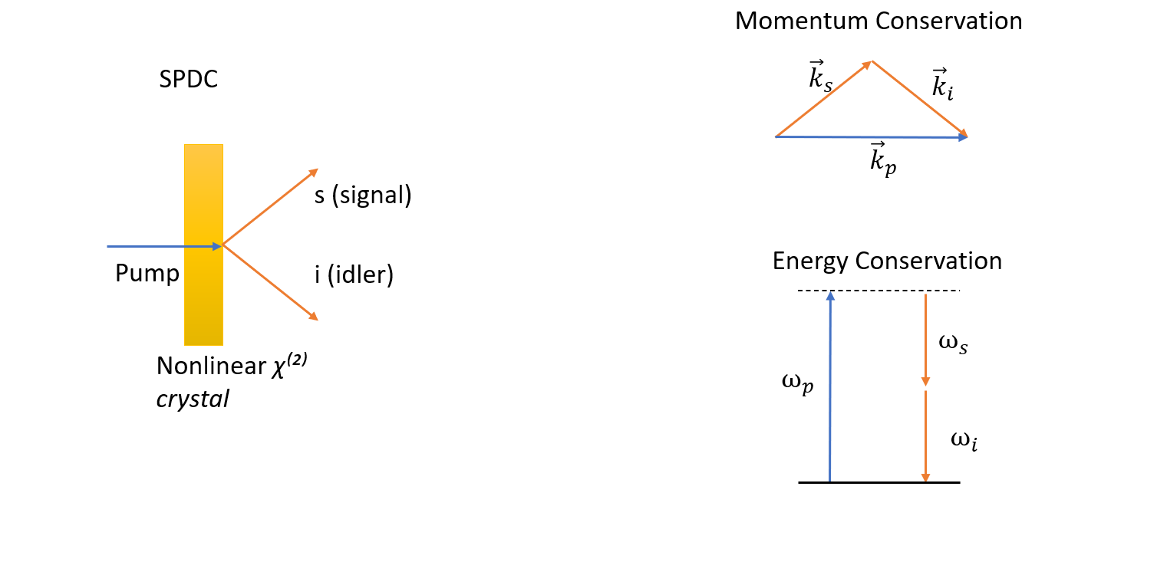
Figure 4: SPDC through a nonlinear crystal and momentum and energy conservation

  - Polarization
It is the orientation of the electric field vector of a light wave perpendicular to its direction of propagation.
Ordinary polarization (o): When electric field vector is perpendicular to the plane containing the propagation direction and the crystal’s optic axis.
Extraordinary polarization (e): When electric field vector lies in the plane containing the propagation direction and the crystal’s optic axis.

  - Bell State
A Bell state is a maximally entangled two-qubit quantum state. Bell states represent the strongest possible correlations allowed by quantum mechanics.
A bell state is a standard target states for EPS.
There are four bell states:
$|{Φ⟩}^{+}=\frac{1}{\sqrt{2}}({{\left|H\right\rangle }_{s}\left|H\right\rangle }_{i}+{{\left|V\right\rangle }_{s}\left|V\right\rangle }_{i})$
$|{Φ⟩}^{-}=\frac{1}{\sqrt{2}}({{\left|H\right\rangle }_{s}\left|H\right\rangle }_{i}-{{\left|V\right\rangle }_{s}\left|V\right\rangle }_{i})$
$|{Ψ⟩}^{+}=\frac{1}{\sqrt{2}}({{\left|H\right\rangle }_{s}\left|V\right\rangle }_{i}+{{\left|V\right\rangle }_{s}\left|H\right\rangle }_{i})$
$|{Ψ⟩}^{-}=\frac{1}{\sqrt{2}}({{\left|H\right\rangle }_{s}\left|V\right\rangle }_{i}-{{\left|V\right\rangle }_{s}\left|H\right\rangle }_{i})$
Where s represents signal photons and i represents idler photons obtained from spontaneous parametric down conservation.

  - Bell inequality and EPS Verification
In experiments, correlation alone is not enough to prove entanglement. Classical systems also show correlations, therefore in order to separate classical correlations from quantum entanglement, we need Bell inequality.

Bell inequality is a mathematical limit on the strength of correlations that any classical system can get. When correlations exceed this limit, the particles become entangled.
CHSH Bell inequality is most commonly used in entangled photon sources to prove entanglement. It defines a parameter S, such that:
$S≤2$ for classical systems. If S exceeds 2 them it shows quantum entanglement.
For an ideal Bell state: $S=2√2$. This is maximum possible violation and it shows strong entanglement.

  - Types of SPDC
    - Based on the polarization relationship of the interacting waves

Type 0: All three photons of pump, signal and idler share the same polarization.
$e→e+e$
Type 1: Signal and idler have same polarization and orthogonal polarization to the pump.
$e→o+o$
Type 2: Signal and idler have orthogonal polarizations.
$e→e+o$

    - Based on the frequency (or wavelength) relationship

Degenerate: Both signal and idler have same wavelength $ω_{s}= ω_{i}=\frac{ω_{p}}{2}$
Non degenerate: Signal and idler have different wavelength $ω_{s}≠ ω_{i}$

    - Base on momentum (wave vector) relationship

Collinear: Signal and idler photons propagate in the same direction as the pump beam.
Non collinear: Signal and idler photons propagate at angles with respect to the pump beam.

- Phase Matching Techniques

Phase matching is a condition in nonlinear processes like SPDC where the interacting waves stay in phase to each other as they propagate through a crystal so that they result in constructive interference.

Phase matching is important in order to satisfy the momentum conservation law. This condition is also called phase matching condition.
$${\vec{k}}_{p}= {\vec{k}}_{s}+ {\vec{k}}_{i}$$
If this condition is not satisfied, a phase mismatch builds up along the crystal, causing destructive interference and strongly reducing photon-pair generation.

  - Perfect Phase Matching
In SPDC:
$${\vec{k}}_{p}= {\vec{k}}_{s}+ {\vec{k}}_{i}$$
But normally $n_{p}≠n_{i}≠n_{s}$, this means that momentum does not balances.
Perfect phase matching is a solution to this.

Perfect phase matching uses the birefringence of nonlinear crystals (such as BBO) to exactly satisfy the momentum conservation condition.
Birefringence is the property of crystal in which light splits into components. Each component experiences different refractive index depending on polarization direction.

Perfect phase matching requires precise angular alignment called critical phase matching. Walk off effects are significant due to birefringence.
  - Quasi Phase Matching (QPM)
Instead of using birefringence, QPM changes the crystal itself (crystals like PPKTP are used). It uses periodic poling for changing the nonlinear properties of crystal.

Quasi-phase matching compensates phase mismatch by periodically reversing the sign of the nonlinear coefficient.
The internal axis of some crystals like PPKTP, PPLN can be reversed, this reversal flips the sign of the nonlinear coefficient $d_{eff}$.

When pump and signal + idler goes out of phase, SPDC output decreases (tending to 0).
When phase mismatch reaches 180°, the crystal domain flips.
$d_{eff}→-d_{eff}$
The crystal is periodically poled with period Λ, flipping the crystal axis every $Λ/2$.
Therefore, destructive interference becomes constructive again.

Poling period(Λ): Spatial period over which the crystal’s nonlinear coefficient reverses its sign for QPM.
The modified phase matching condition becomes:
$$Δk=k_{p}-k_{s}-k_{i}-k_{n}$$

  - Periodic Poling and Quasi Phase Matching
Instead of $Δk=k_{p}-k_{s}-k_{i}$, we periodically pole the crystal so that the crystal axis can
be flipped. This is done by flipping the sign of $d_{eff}$ so destructive interference turns to
constructive interference.
We include an extra grating vector $k_{n}$ such that $k_{n}=2πn​/Λ​$.
The momentum conservation now becomes $Δk=k_{p}-k_{s}-k_{i}-k_{n}$
Where:
For pump: $k_{p}=​2πn_{p}/λ_{p}$
For signal: $k_{s}=​2πn_{s}/λ_{s}$
For idler: $k_{i}=​2πn_{i}/λ_{i}$
And $k_{n}=​2πn/Λ(T)$

- Design considerations for SPDC sources
  - Bulk crystal vs Waveguides
At the 1550 nm telecom wavelength, entangled photon sources are produced using two distinctly different non-linear crystal implementations: bulk crystals and integrated waveguides.
Both generate entangled photons through spontaneous parametric down-conversion
(SPDC) within Sagnac interferometer configurations, but they differ fundamentally in their physical structure, integration method, and operational characteristics.

BULK CRYSTAL: A bulk crystal source consists of a solid, optically clear crystal block, placed directly inside a Sagnac interferometer loop. The crystal maintains its original bulk form with uniform dimensions throughout its length. The pump laser and resulting entangled photons propagate through this solid crystal material.
Bulk crystal at 1550nm remains the highest-performance platform for generating maximally entangled photons, achieving exceptional spectral brightness (>2.0 MHz/(mW.nm)) and fidelity (97.8%). However, it requires substantial free-space optical infrastructure and laboratory environments.

WAVEGUIDE: A waveguide source uses non-linear crystal not as a bulk crystal but as an integrated ridge waveguide-a narrow optical channel (typically 5-10 micrometers wide) inscribed or fabricated within a larger non-linear substrate. This waveguide is integrated directly into a fiber-coupled Sagnac interferometer loop.
Waveguide substrate at 1550nm trades some peak performance metrics for practical advantages: seamless fiber integration, multi-channel operation, compact design, and
proven long-distance distribution. It represents the mature choice for deploying quantum communication networks over existing telecom infrastructure.

The selection between bulk and waveguide depends entirely on application priorities: bulk crystal for highest-quality entanglement in research, and waveguide for practical, scalable quantum networks. Both employ Sagnac architectures that provide inherent stability and represent the state-of-the-art in 1550nm entangled photon generation.

  - Fiber based vs Free space

Both fiber-based and free-space sources generate entangled photon pairs through spontaneous parametric down-conversion (SPDC). The critical difference lies in how the photon generation occurs and how the generated photons are delivered to users: in a Sagnac interferometer configuration that provides inherent stability and efficient collection.

FREE-SPACE SOURCES:
A free-space source places a bulk crystal (typically 25-30 mm long) directly in open air or vacuum within a Sagnac interferometer architecture. The pump laser is focused into the crystal using free-space optics (mirrors and lenses), and the generated entangled photons propagate through open space before being collected and coupled into optical fibers.
1. Pump Delivery: A pump laser is directed into the crystal through free-space optics.
2. Entanglement Generation: Spontaneous parametric down-conversion splits pump photons into signal and idler pairs within the crystal.
3. Sagnac Configuration: The interferometer uses mirrors to create two counter-propagating paths. Both paths go through the same crystal, generating two types of entangled pairs that interfere at a 50/50 beam splitter, creating polarization entanglement.
4. Collection through Free Space: Generated photons are collected using lenses and filtered using dichroic mirrors before being coupled into optical fibers.

FIBER-BASED SOURCES:
A fiber-based PPKTP source integrates the non-linear crystal directly into a fiber-coupled Sagnac loop interferometer. The crystal is placed inside a fiber loop, with all light propagation occurring within optical fibers rather than in open space.
1. Pump Injection: Pump laser is coupled directly into the fiber loop using standard fiber couplers.
2. In-Fiber Generation: Non-linear crystal inside the fiber loop generates entangled photon pairs through SPDC.
3. Sagnac Architecture: Pump light circulates counter-clockwise and clockwise through the same crystal, generating two entangled pair states that interfere at a 50/50 fiber coupler, creating polarization entanglement.
4. Direct Fiber Output: Generated signal and idler photons exit directly into single-mode fibers-no free-space coupling optics needed.

- Considerations for SPDC for 1550

  - Nonlinear crystals
A nonlinear crystal is a material where the optical response to an applied electric field (from light) is not proportional to the field strength. In other words, inputting light at one frequency can produce light at different frequencies through interaction with the crystal.
The most important type for quantum applications is second-order nonlinearity, represented by χ⁽²⁾. This describes how strongly a material responds when two light waves interact within it.

Why Non-linear Crystals Are Essential?
Entangled photons cannot be created through linear processes. They require:
•Quantum interaction: The crystal must facilitate a process where two photons are created from one pump photon in a way that preserves quantum correlations.
•Specific material properties: The nonlinearity must be strong enough and located where the interacting photons can achieve efficient frequency conversion.
•Phase matching: The photons must maintain proper phase relationships throughout the crystal

    - PPKTP

KTP-KTiOPO₄ (Potassium Titanyl Phosphate): KTP is a ferroelectric nonlinear optical crystal that has become one of the most important materials in modern photonics.
Nonlinear crystals are fundamental materials that convert light frequency through quantum mechanical processes. KTP (Potassium Titanyl Phosphate) is one of the most important nonlinear crystals available today due to its exceptional properties. PPKTP (Periodically Poled KTP) emerged as a revolutionary advancement that overcomes natural limitations of bulk KTP through artificial periodic domain engineering.

CHALLENGE WITH KTP:
•In natural KTP, photons of different frequencies travel at different speeds.
•This creates a "phase mismatch" that prevents efficient frequency conversion at many wavelengths.
The Problem:
Both photons travel at different velocities v₁ and v₂ (v₁ ≠ v₂).
As they propagate, they accumulate different phases.
This leads to destructive interference, cancelling out the down-conversion signal.
This is where PPKTP comes in.

Instead of trying to match the phases naturally (which is impossible at certain wavelengths), quasi-phase-matching artificially creates periodic regions where the photons are "re-phased".
Periodic Poling: The fundamental idea is to reverse the crystal's nonlinearity periodically by poling (applying strong electric fields to flip the ferroelectric domains).
•In natural KTP, all domains point the same way, giving a nonlinear coefficient χ⁽²⁾.
•With periodic poling, we alternate the direction: +χ⁽²⁾, -χ⁽²⁾, +χ⁽²⁾, -χ⁽²⁾, etc.
•Each region contributes to the down-conversion process.
•The period Λ is carefully chosen so that contributions from each region add constructively.

THREE KEY NON-LINEAR PROCESSES:
1.Second Harmonic Generation (SHG): Two photons of frequency ω combine to create one photon at 2ω (doubled frequency).
2.Sum-Frequency Generation (SFG): Two different frequency photons combine: ω₁ + ω₂ → ω₃ (where ω₃ = ω₁ + ω₂).
3.Spontaneous Parametric Down Conversion (SPDC): One high-energy photon spontaneously converts into two lower-energy photons. This is the primary method for generating entangled photons.

    - Periodically Poled Lithium Niobate (PPLN)

PPLN is a nonlinear optical crystal of second order. It is used to convert light from one wavelength to another.

By periodically poled we mean that it is a second order crystal and the crystal domains are flipped periodically. This flipping gives rise to quasi phase matching (QPM).
PPLN is widely used for processes such as Spontaneous Parametric Down Conversion (SPDC), Second Harmonic Generation (SHG).

Properties of PPLN:
- Strong χ² nonlinearity: PPLN has large second order noncolinear coefficient (high brightness).
- Quasi Phase Matching (QPM): Periodic poling flips crystal domains which compensates for phase mismatch and results in constructive interference.
- PPLN is low loss for 1550 nm.
- PPLN can be integrated with fibers (Commercial use).

  - PPLN vs PPKTP
PPLN | PPKTP
Higher Nonlinear coefficient | Lower nonlinear coefficient
Better for 1550 nm wavelength (Telecom) | Better for 810 nm wavelength (Visible)
Higher SPDC brightness | Lower SPDC brightness
Broader bandwidth | Narrower bandwidth
Better fiber integration | Relatively lower fiber integration
Temperature sensitivity is higher | Temperature sensitivity is lower
Typically used with type 0 | Typically used with type I and type II

  - Why PPLN over PPKTP for 1550 nm
PPLN has higher nonlinear coefficient than PPKTP, is more fiber integrable (1550 nm is more fiber integrable).
Therefore, PPLN is preferred over PPKTP for 1550 nm entangled photon sources due to its significantly higher nonlinear coefficient, mature waveguide technology, robust quasi phase matching, and superior brightness.
- Sagnac Interferometer
Previously used setups for entangled source based on PPKTP involves Mach-Zehnder interferometer which was proposed by Marco Fiorentino in 2004.
However, those setups were limited by the phase stability. To overcome this challenge, a new setup as shown in figure 2. was proposed by Franco N. C. Wong in 2006 to pump the non-linear crystal in two opposite directions. This setup has been able to produce high entanglement quality while also permitting a high source brightness since this method uses collinear down-conversion and does not require phase stabilization.
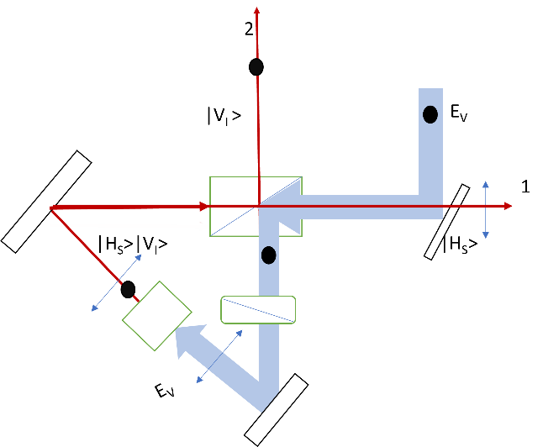
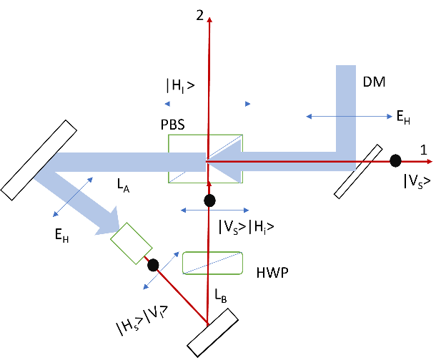
The core part is an isosceles right triangle in this Sagnac interferometer, and the crystal is placed in the middle of the base of the triangle. A pump photon propagates along the blue path, as it is reflected by a Dichroic mirror (this DM will transmit the idler and signal photons) as the figure 2 shows:

- (b)
Figure 5: A schematic of Sagnac interferometer: (a) H-polarized input
(b) V-polarized input

(a) For H-polarized pump |H⟩, the photon is transmitted in the PBS and go in the anti-clock path, the photon interacts with the crystal and generates H-polarized signal photon and V-polarized idler photon, the state can be written as |Hs⟩|Vi⟩ in the red path. After the mirror and the HWP, the state becomes |Vs⟩|Hi⟩. The H-polarized idler photon transmitted by the PBS and reaches path 2, while the V-polarized photon reflected by the PBS and reaches path 1, the final state is |Vs⟩1|Hi⟩2.
(b) For V-polarized pump |V⟩, the photon is reflected in the PBS and go in the clockwise path, the photon interacts with the crystal and generates H-polarized signal photon and V-polarized idler photon, the state can be written as |Hs⟩|Vi⟩ in the red path. After the mirror, the state becomes |Hs⟩|Vi⟩. The H-polarized idler photon transmitted by the PBS and reaches path 1, while the V-polarized photon reflected by the PBS and reaches path 2, the final state is |Hs⟩1|Vi⟩2.
The final output state is the superposition of (a) and (b), by controlling the ratio of
horizontal and vertical polarized pump photons, and rotating the HWP, we can produce the entangled superposition state.

CONTINUOUS-WAVE PUMPED SYSTEMS:
In CW systems, a steady laser beam (typically 532 nm green or 1064 nm infrared) continuously illuminates the nonlinear crystal. The parametric down-conversion process occurs continuously, producing a steady stream of entangled photon pairs.
PULSED PUMP SYSTEMS:
Pulsed systems use picosecond or femtosecond laser pulses to pump the nonlinear crystal [3]. Each pump pulse generates a brief burst of photon pairs. The temporal structure offers different advantages compared to CW pumping.

Both CW and pulsed Sagnac configurations generate high-quality 1550 nm polarization-entangled photons suitable for quantum communication. CW systems offer practical advantages for deployed networks with superior brightness and simplicity, while pulsed systems provide specialized capabilities for advanced research.
The Sagnac configuration's inherent phase stability—regardless of pump type—makes it the preferred choice for practical quantum networks requiring long-term reliability.

- Experimental set-ups

  - PPKTP based schematics
    - Setup
The experimental setup is shown in figure 3. We employ a 780 nm pulsed laser to pump the PPKTP crystal. The part A in the blue dotted box is made of a quarter-wave plate, a half-wave plate and a polarized beam splitter which transmits horizontally polarized photons and reflects the vertically polarized ones. The quarter-wave plate and the half-wave plate in part A are working for maximizing the transmittance of the PBS by adjusting them.
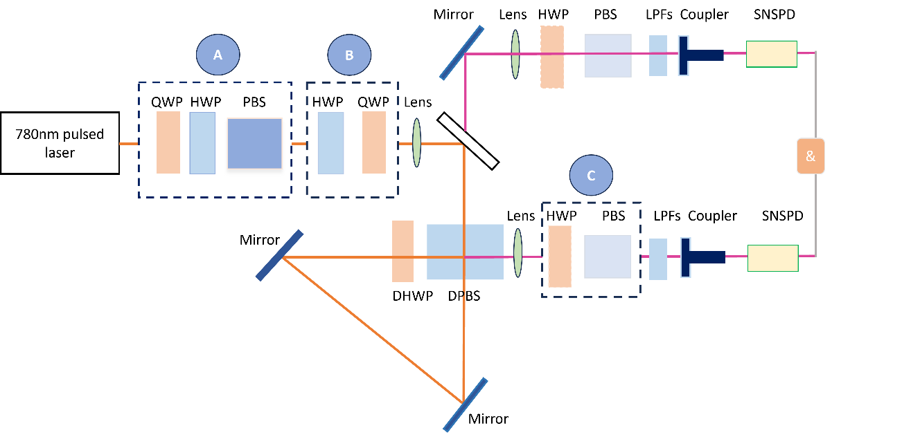
After part A, we have fully H-polarized pump light. The part B in the green dotted box is made of a half-wave plate and a quarter-wave plate. The H-polarized light is incident on the half-wave plate, the polarization direction is changed, and the light transmitted from the half-wave plate is then incident on the quarter-wave plate. When the polarization direction of the linearly polarized light is consistent with the fast axis or slow axis of the quarter-wave plate, the outgoing light is linearly polarized. In this condition the half-wave plate can be used to adjust the linear polarization direction. When the polarization direction is inconsistent with both the fast and slow axis, the outgoing light is elliptically polarized or circularly polarized. At this time, the quarter wave plate can be used to adjust the ellipticity and handedness. In conclusion, we can generate any polarized states based on the combination of a half-wave plate and a quarter-wave plate in part B.

Figure 6: A schematic of the setup of the entangled source
The light after part B is collimated by a f = 200 mm lens and reflected by a dichroic mirror (transmits the 780 nm light and reflects the 1560 nm light), and guided into the sagnac-loop. The sagnac-loop consists of a dual-wavelength polarized beam splitter (DPBS), a dual-wavelength half-wave plate (DHWP), two mirrors and a PPKTP crystal.
The sagnac-loop consists of a dual-wavelength polarized beam splitter (DPBS), a dual wavelength half-wave plate (DHWP), two mirrors and a PPKTP crystal. The PPKTP crystal is installed in a thermal control stage which shown in figure 3.1.The temperature is maintained to achieve a degenerate wavelength at 1560 nm.

Figure 6.1: The picture of PPKTP crystal installed in a thermal control stage

The PPKTP crystal was pumped simultaneously by clockwise (CW) and counterclockwise (CCW) laser pulses. The DHWP is set at 45 degrees to transform the V-polarized light into H-polarized in the CCW path. As a result, both the CW and CCW pulses are H-polarized as well as focused in the middle of the PPKTP crystal, and the down-converted photons are collimated by two f = 300 mm lenses to fiber couplers through a long pass filter.

To test the polarization correlation, we add the combination of a HWP and a PBS in the blue dotted box as part C. This part works as a polarizer. By setting the angles θ1 and θ2 in path 1 and path 2, we can perform a series of polarization correlation measurements.

14.1.2. Measurement
We employ the Single Quantum SNSPD (Superconducting Nanowire Single Photon Detector) with high detection efficiency of 76% and high timing resolution 30 picoseconds to measure the single photon counts in path 1 and path 2. With a 120 mW pump power for the PPKTP crystal, the single photon counts for each path is 500 kcps (kilo counts per second), the background counts have been subtracted.

14.1.3. Conclusion
In conclusion, we build a high brightness telecom band entangled photonic source with the Sagnac interferometer as the core part. The single path counts is approximately half-million per second, and the maximum generation rate of entangled photon pairs is 120k/s, which is 500 times higher than the previous entangled photon source that built by P. G. Evans at 2010 with a GVM-PPKTP crystal at telecom wavelength. The high single path counts and the high entangled photon pair counts indicate the high brightness.
The wavelength of the generated photons is centered at 1550nm telecom band which had been efficiently detected by 1550nm centered superconducting nanowire single photon detector (SNSPD).

14.1.4. Future Outlook
During the last two decades, quantum mechanism has been well studied experimentally in many experimental settings, includes entangled quantum pair generation, quantum key distribution, quantum dense coding, quantum teleportation, quantum walk and quantum machine learning based on the photonic systems.
We can perform the thermal control and the optimization of filter to both increase the bright- ness and purity of this source. Furthermore, the effort of building this sagnac interferometer-based source waves the way for compact waveguide-based entanglement source with PPLN crystal which can generate GHz photon pair rates.

  - PPLN based schematics
    - Polarization Entangled Photon Source based on PPLN Ridge Waveguide
While bulk PPLN crystals are widely used for polarization-entangled photon generation, integrated PPLN ridge waveguides offer significantly enhanced nonlinear interaction due to strong optical confinement. Ridge waveguides enable higher spectral brightness, improved fiber compatibility and compact source design, making them suitable for telecom-band quantum communication systems. Ridge waveguides can generate broadband, high-quality polarization-entangled photon pairs without requiring active stabilization, which is critical for large-scale quantum networks.

Why PPLN ridge waveguide
- The periodic poling enables quasi-phase matching (QPM), allowing efficient type-0 SPDC at telecom wavelengths.
- The ridge geometry ensures low propagation loss, strong χ² nonlinearity
- Efficient fiber coupling, which are difficult to achieve simultaneously in bulk crystals.
      - Setup
The experimental setup is shown in figure 4. A continuous laser of 775 nm wavelength is focused through pump, which passes through a polarization controller (rotates pump polarization to 45°) so that both loop directions produce balanced SPDC. Then the wave passes through a fiber integrable sagnac interferometer where FPBS (Fiber Polarization Beam Splitter) which splits the 775 nm beam into two counter propagating paths. The beam is then focused on a PPLN waveguide which performs type 0 SPDC:
$775 →1550+1550$
Then it converts one path’s polarization to match crystal orientation (90° twist)
SPDC in both directions generates:
Clockwise: ${|H}_{s}{H⟩}_{i}$
Anticlockwise: ${|V}_{s}{V⟩}_{i}$
There recombination causes entanglement.

This generates a bell state:
$${\left|Φ\right\rangle }^{+}=\frac{1}{\sqrt{2}}(|HH⟩+|VV⟩)$$

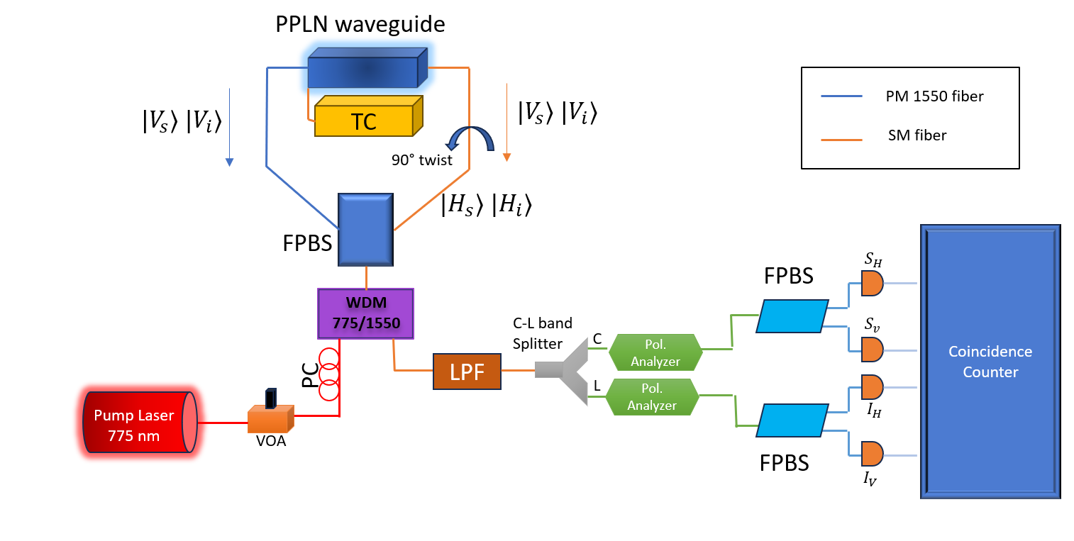
Figure 7: A schematic of the setup of the entangled sources using PPLN ridge waveguide

Further WDM (wavelength Division Multiplexer) and LDF (Long Pass Filter) rejects 775 nm pump so that only 1550 nm remain. The C-L band splitter splits the telecom band into C band (1520-1550 nm) and L band (1550-1580 nm) which are used to define the signal and idler.

Then each of the wave passes through the polarization analyzer where they pass through a Half Wave Plate (HWP) or a Quarter Wave Plate (QWP), then through a FPBS.

Two photon interference: Only HWP used (measures visibility).
Quantum State Tomography: Use HWP + QWP.

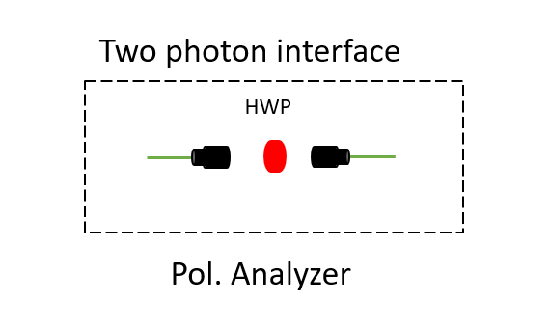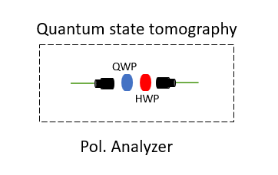
- (b)
Figure 8: Shows Polarization analyzer. (a) Two photon interface uses only HWP
- Quantum state tomography uses both QWP and HWP

Four SPADs (Single Photon Avalanche Photodetector) are used for detection. Then the correlation counter checks the correlations between signal and idler.

      - Measurement
A pump with 775 nm CW laser is focused on 4 cm PPLN ridge waveguide operated at ~36.5 °C. The spectral bandwidth is around 52 nm and the spectral brightness is $∼2×{10}^{8}$ pairs/s/mW/nm. Maximum CAR reaches about 1065 at 3.6 µW pump power.

The Bell CHSH parameter $S=2.49±0.017$, violating the classical bound. The tomography gives a raw fidelity of about 89.4%.

SPAD detectors with 10% efficiency, 5 μs dead time, and <1000 cps dark counts are employed. Coincidences are registered by a PicoHarp 300 time-tagger with 512 ps time-bin resolution.

    - Conclusion
This setup demonstrates a compact, fiber integrated broadband source of polarization entangled photon pairs at 1550 nm wavelength using CW pumped (type 0) PPLN ridge waveguide in a Sagnac configuration.

We get high spectral brightness, wide bandwidth. The nonclassical behavior is shown through Bell CHSH parameter S=2.49. Because the photons span in both C and L bands, the system is compatible with telecom infrastructure.

    - Future Outlook
The demonstrated fiber integrated entangled photon source opens several routes for practical quantum networking. Because the spectrum spans the telecom C-L bands with ~52 nm bandwidth, it can be used with WDM to support multiuser entanglement distribution.

The system fidelity can be increased by improving detector efficiency. Integrating superconducting nanowire detectors or low jitter timing modules would further improve coincidence rates and enable longer distance quantum communication.
Due to its broadband nature, this source is suitable for future reconfiguration of quantum networks, entanglement swapping.
Overall, this source is position to become scalable building block for long haul fiber-based quantum communication systems.

- International Scenario and Latest Trends on Entangled Photon Sources
Photon Sources
Contemporary developments have achieved remarkable milestones in polarization-entangled photon generation at telecommunications wavelengths. A recent breakthrough demonstrates a tunable, multi-channel polarization-entanglement source capable of generating 14 simultaneous wavelength-division-multiplexed (WDM) channels around 1550nm with raw fidelity values reaching 94% and Bell inequality violations exceeding 2.56. This multi-user capability represents a paradigm shift, enabling up to 40 user pairs to communicate simultaneously over standard metro-area fiber-optic infrastructure. Additionally, ultrabright fiber-coupled polarization-entangled sources based on bulk ppKTP crystals now achieve spectral brightness exceeding 2.0 MHz·mW⁻¹·nm⁻¹, with Bell-Clauser-Horne-Shimony-Holt values of 2.782±0.04 and state fidelities reaching 97.8%. Silicon photonic integration has also emerged as a competitive platform, producing polarization-entangled photon pairs with state-of-the-art brightness of 1.6×10⁷ pairs/s/GHz/mW² and visibility exceeding 96.6%.

International Scenarios-
1.) Metropolitan Fiber Networks: The primary focus is the 1550 nm (telecom C-band) because of its low loss in fiber. Commercial systems (e.g., from Quantum Computing Inc.) now offer "plug-and-play" EPS modules that can feed multi-user Quantum Key Distribution (QKD) networks across cities. Cities like London, Tokyo, and Singapore are using PPLN ridge waveguides and TFLN chips to generate millions of photon pairs per second. At 1550 nm, these sources integrate directly into existing "dark fiber" with minimal loss.
2.) Satellite-to-Ground Links: For space applications, bulk PPKTP is the international standard. Its ability to handle high power pump lasers without the "optical damage" seen in early waveguides makes it robust for trans-atmospheric communication.
3.) Quantum Memory Interfaces: A major trend is the Hybrid Scenario, where a source produces one photon at 1550 nm for fiber transmission and another at a non-degenerate wavelength (like 780 nm or 894 nm) to interface with local atomic quantum memories.

Latest Trends in Architecture-
- The Transition from Bulk to TFLN (Thin-Film Lithium Niobate)
The most significant trend is the adoption of TFLN.
Why: Unlike legacy "ridge" waveguides, TFLN offers sub-micron confinement. This boosts the efficiency of the spontaneous parametric down-conversion (SPDC) process by orders of magnitude, allowing for GHz-rate photon generation on a chip the size of a fingernail.
Breakthrough: The first commercial shipments of standalone PPLN-based sources using TFLN were confirmed in late 2025, moving the technology into the "Foundry" era.
- Dual-Section PPLN Waveguides
Instead of using external Sagnac interferometers to create entanglement, researchers are now
using Dual-Section PPLN. One section is poled for Type 0 (high brightness) and the second for Type-I, allowing for the direct generation of Bell states on a single straight waveguide.
Trend: "Self-entangling" chips that require no external polarization manipulation.
- PPKTP for Narrowband Stability
While PPLN is the brightest, PPKTP is trending for applications requiring "spectral purity."
Latest Result: 3-cm long Type-II PPKTP crystals are achieving record-high "Coincidences-to-Accidentals" Ratios (CAR > 1200) at 1550 nm, making them ideal for high-fidelity quantum teleportation.

Conclusion

Bibliography
[1] Entangled Photon-Pair Sources based on three-wave mixing in bulk crystals Ali Anwar, Chithrabhanu Perumangatt, Fabian Steinlechner, Thomas Jennewein, and Alexander Ling https://doi.org/10.1063/5.0023103
[2] CW-pumped telecom band polarization entangled photon pair generation in a Sagnac interferometer Yan Li, Zhi-Yuan Zhou, Dong-Sheng Ding, and Bao-Sen Shi https://doi.org/10.1364/OE.23.028792
[3] High-brightness fiber-coupled source of polarization-entangled photon pairs spanning the telecom C- and L-bands Vikash Kumar Yadav, Vivek Venkataraman, Joyee Ghosh https://doi.org/10.1016/j.optlastec.2024.110774
[4] C. Bruscino et al., “Entanglement based Spontaneous Parametric Down Conversion sources for Quantum Key Distribution applications,” International Conference on Transparent Optical Networks, Jul. 2024, doi: 10.1109/ICTON62926.2024.10647458.
[5] K. Park, J. W. Lee, D. h. Im, D. Kim, and Y. S. Ihn, “Ultrabright Fiber Coupled Polarization Entangled Photon Source with Spectral Brightness Surpassing 2.0MHzmW1nm1,” Wiley, May 2025, doi: https://doi.org/10.1002/adpr.202500024.
[6] V. K. Yadav, V. Venkataraman, and J. Ghosh, “Telecom source of tunable polarization-entanglement distribution up to 100-km for multi-user QKD over metro-area fiber-optic networks,” None, Jan. 2025, doi: https://doi.org/10.1063/5.0241324.
[7] X. Hua et al., “A bright polarization-entangled photon pair source based on silicon photonics integration,” APL Photonics, Jun. 2025, doi: 10.1063/5.0256768.
[8] Omshankar, et al. "Bright source of narrowband polarization-entangled photons from a thick type-II ppKIP crystal." https://doi.org/10.1364/0E.50s7372

