# 1#TASK DESCRIPTION

USE COPILOT TO GENERATE A IS_PRIME() PYTHON FUNCTION

EXPECTED OUTPUT:

FUNCTION TO CHECK PRIMALITY WITH CORRECT LOGIC

OUTPUT:

# 2#TASK DESCRIPTION

WRITE A COMMENT LINE #FUNCTION TO REVERSE A STRING AND USE COPILOT TO GENERATE THE FUNCTION.

EXPECTED OUTPUT:

AUTO COMPLETED REVERSE FUNCTION

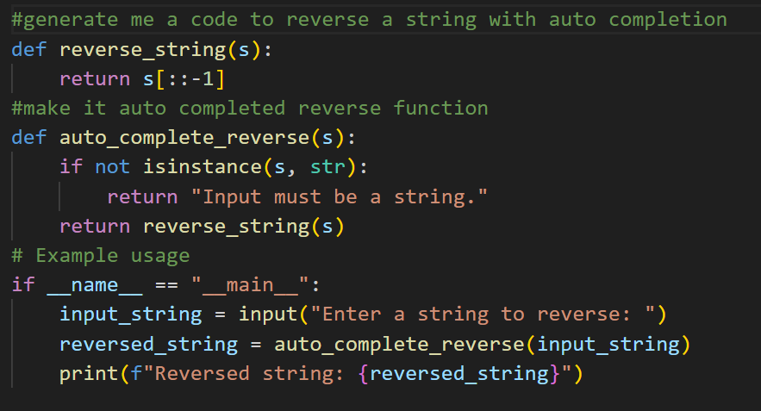

OUTPUT:

# 3#TASK DESCRIPTION

GENERATE BOTH RECURSIVE AND ITERATIVE VERSIONS OF A FACTORIAL FUNCTION COMMENTS

EXPECTED OUTPUT:

TWO WORKING FACTORIAL IMPLEMENTATIONS

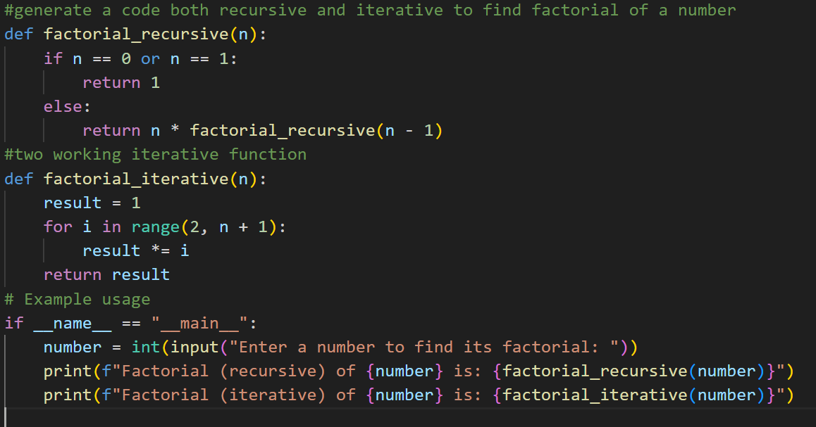

OUTPUT:

# 4#TASK DESCRIPTION

USE COPILOT TO FIND THE LARGEST NUMBER IN A LIST .ASSESS CODE QUALITY AND EFFICIENCY

EXPECTED OUTPUT:

A VALID FUNCTION WITH YOUR REVIEW

OUTPUT:

