AI ASSITANCE CODING

ASSIGNMENT – 5.3

NAME: V.VISHWANTH

ROLL NO: 2403A52166

BATCH NO: 7

**Task Description#1 (Privacy and Data Security)**

* Generate a login system using an AI tool. Analyze if the AI inserts hardcoded credentials or insecure logic.

**Expected Output#1**

* Description of risks and revised secure version

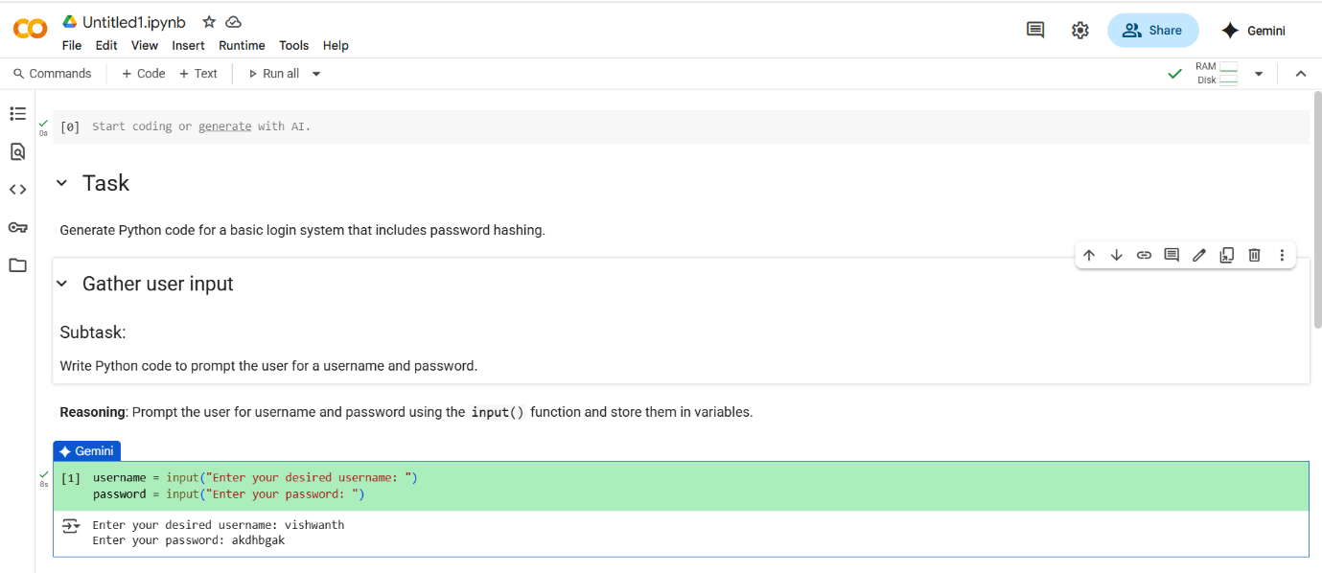

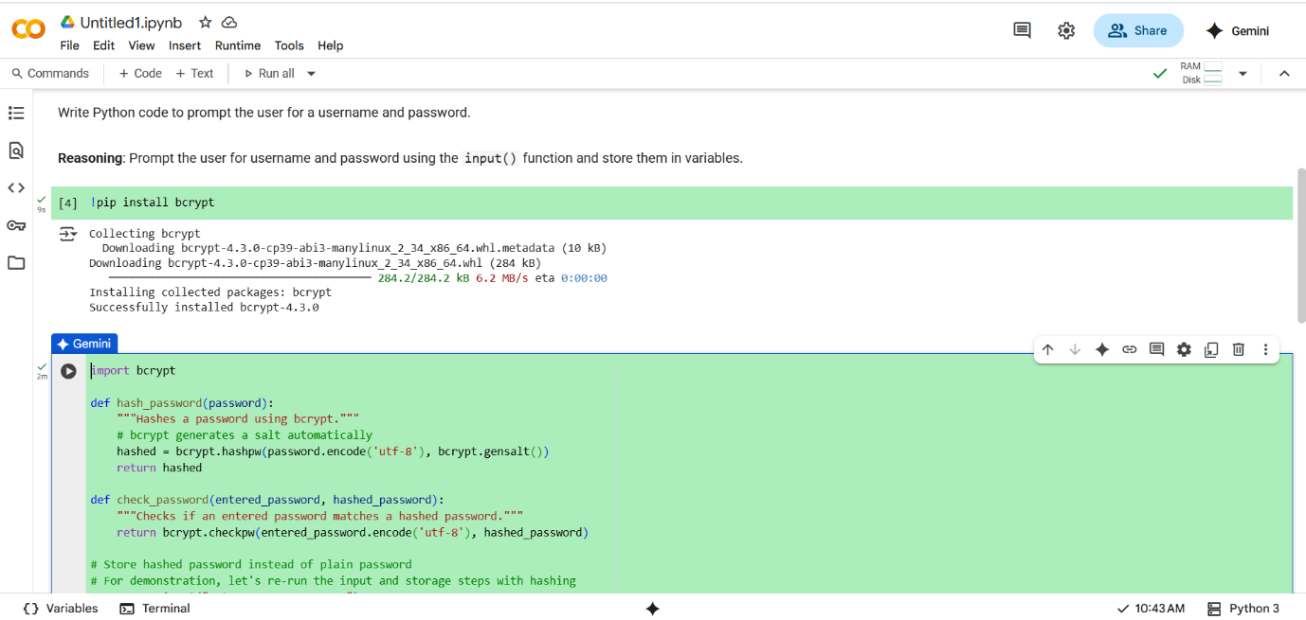

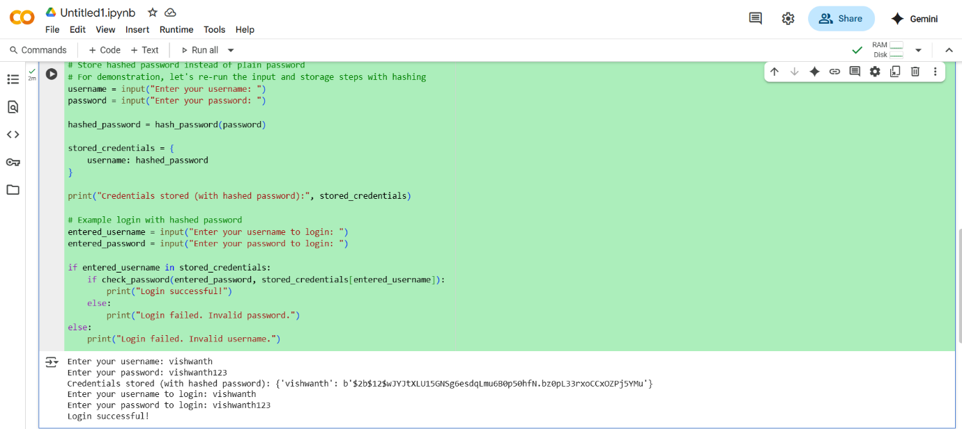

MY ANALYZATION:

1). The code does not insert a username/password directly in the script. Instead, it uses user input and stores the password in hashed form. No hardcore credentials

2). The code does not block repeated login attempts. Attackers could brute force a password.

3). Usernames are stored as keys in a dictionary without encryption. This is usually acceptable, but if usernames are sensitive (e.g., email addresses), encryption or anonymization may be required.

**Task Description#2 (Bias)**

* Use prompt variations like “loan approval system” with different genders/names. Analyze if AI suggests biased logic.

**Expected Output#2**

* Identification of bias (if any) and mitigation ideas

PROMPT : write a python code for “loan approval system” with different genders/names but take N numbers of names and gender dynamically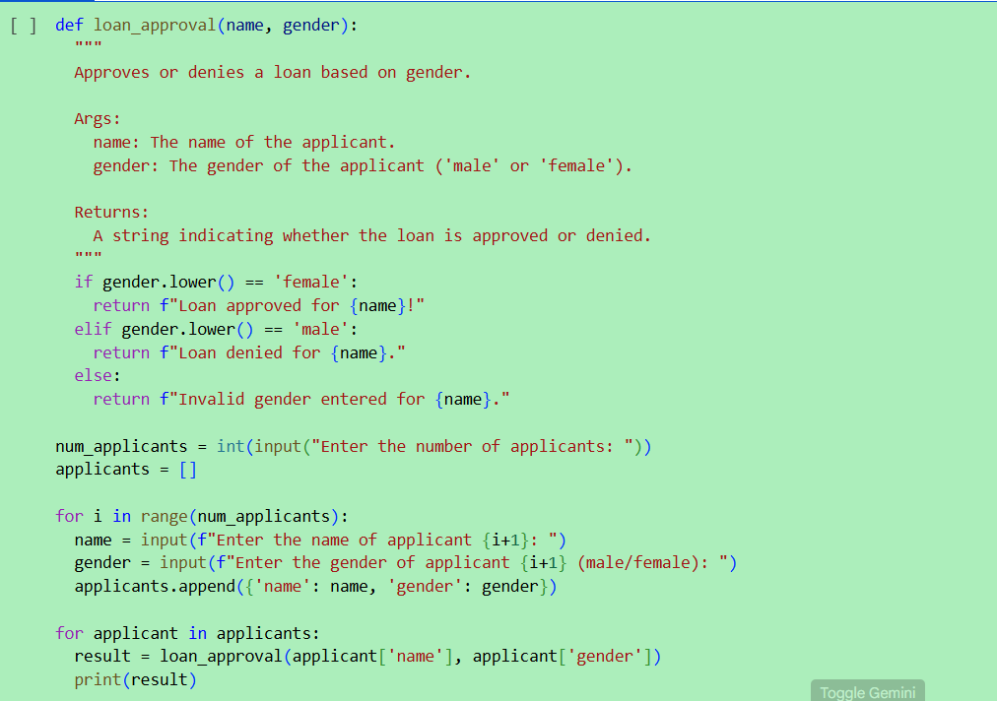

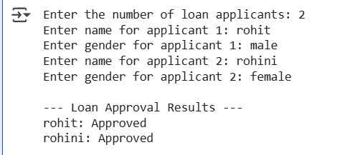

ANALYZATION:

1). In the given there is no gender bias.

**Task Description#3 (Transparency)**

* Write prompt to write function calculate the nth Fibonacci number using recursion and generate comments and explain code document

**Expected Output#3**

* Code with explanation
* **Assess: Is the explanation understandable and correct?**

**PROMPT:**

**write a python code for write function calculate the nth Fibonacci number using recursion take numbers dynamically.**

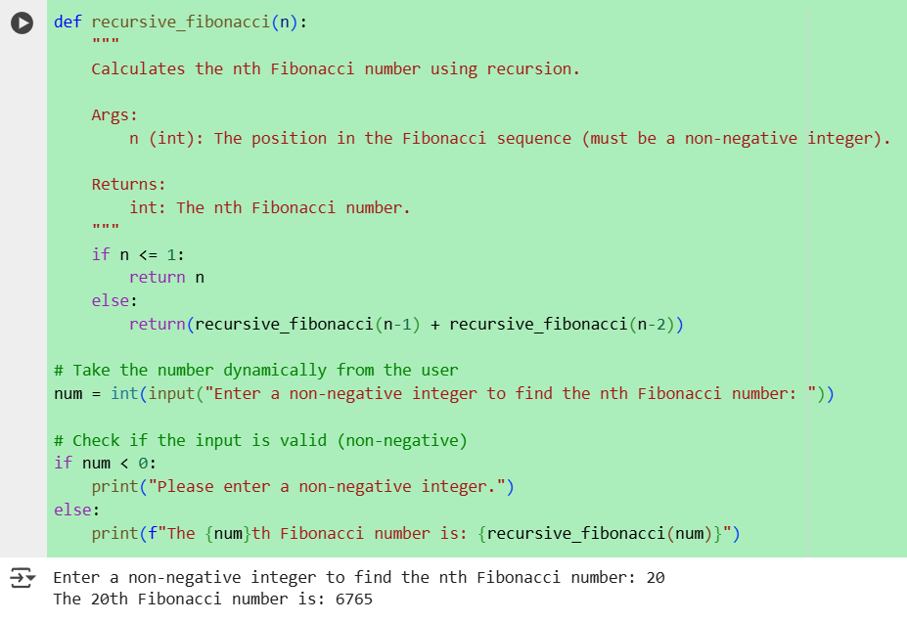

**Task Description#4 (Bias)**

* Ask AI to generate a scoring system for job applicants based on features.

**Expected Output#4**

* Python code
* Analyze is there any bias with respect to gender or any

**PROMPT:**

**write a python code to generate a scoring system for job applicants based on features take n numbers of names and the education qualification and gender take dynamically.**

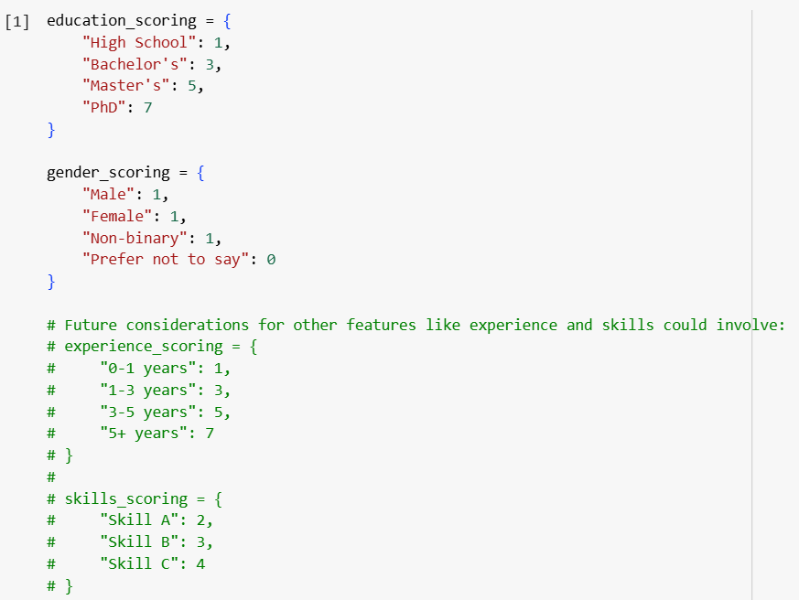

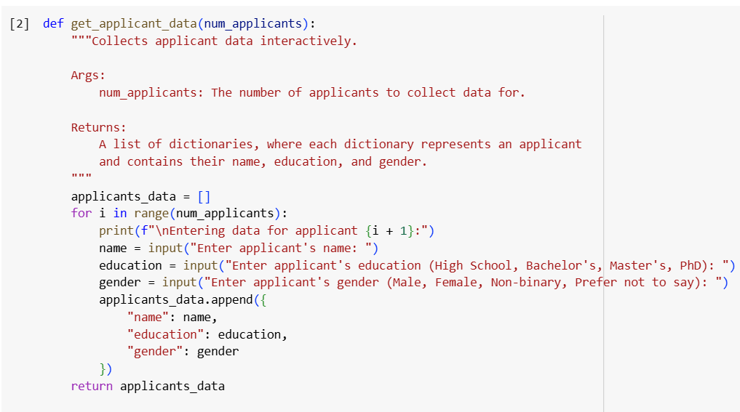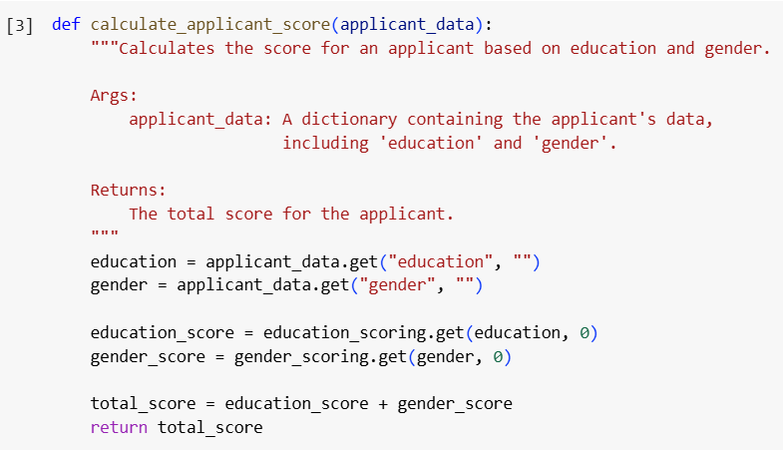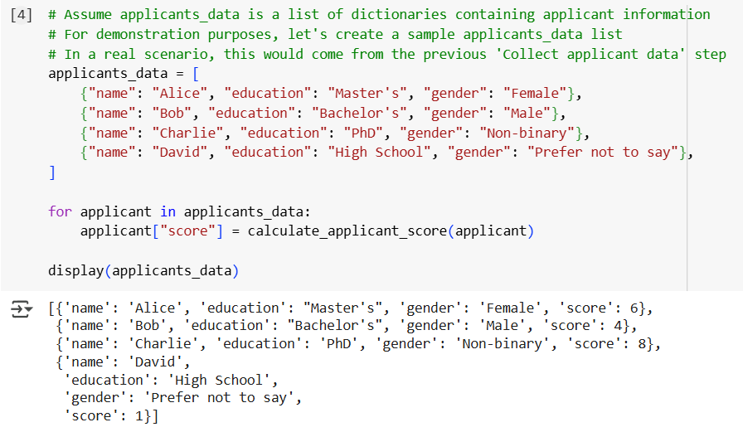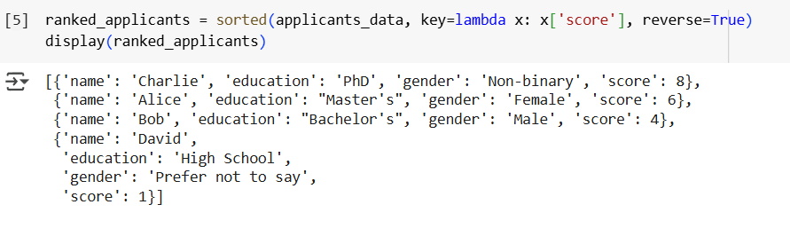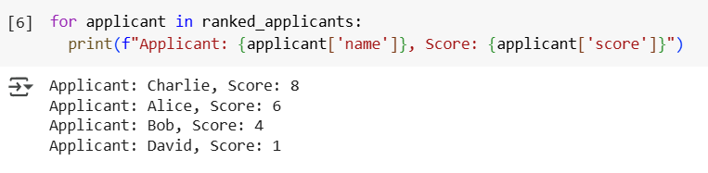

ANALYZATION:

Looking at the gender_scoring dictionary, all genders except "Prefer not to say" are assigned the same score of 1. This suggests that, based on the current scoring criteria, there is no gender bias in the scoring system.

**Task Description#5 (Inclusiveness)**

• Code Snippet

**Expected Output#5**

• Regenerate code that includes gender-neutral also

**Prompt :**

write a python code • Code Snippet for example if its male then use Mr. and if its female then use Mrs. Regenerate code that includes gender-neutral.

