AI ASSITANCE CODING

ASSIGNMENT – 5.4

NAME: V.VISHWANTH

ROLL NO: 2403A52166

BATCH NO: 7

Task Description #1:  
• Start a Python class named Student with attributes name, roll_number, and marks. Prompt  
GitHub Copilot to complete methods for displaying details and checking if marks are above  
average.  
Expected Outcome #1:  
• Completed class with Copilot-generated methods like display_details() and is_passed(),  
demonstrating use of if-else conditions

PROMPT: so give me a python code that should generate the marks of the student is above average or not. So first ask hoe many students are there in class and enter each students details like name, roll no, marks and also take what's the average marks and check each student marks are above or below the average marks.

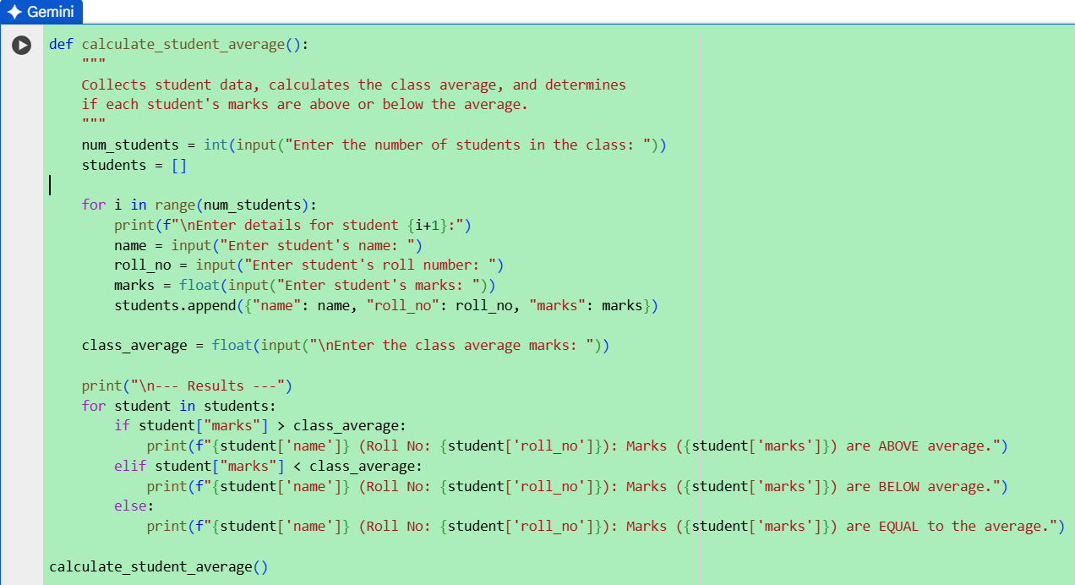

OUTPUT:

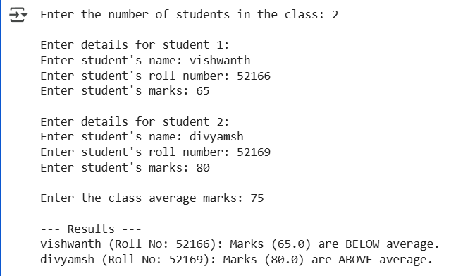

Task Description #2:  
• Write the first two lines of a for loop to iterate through a list of numbers. Use a comment  
prompt to let Copilot suggest how to calculate and print the square of even numbers only.  
Expected Outcome #2:  
• A complete loop generated by Copilot with conditional logic (if number % 2 == 0) and  
appropriate output

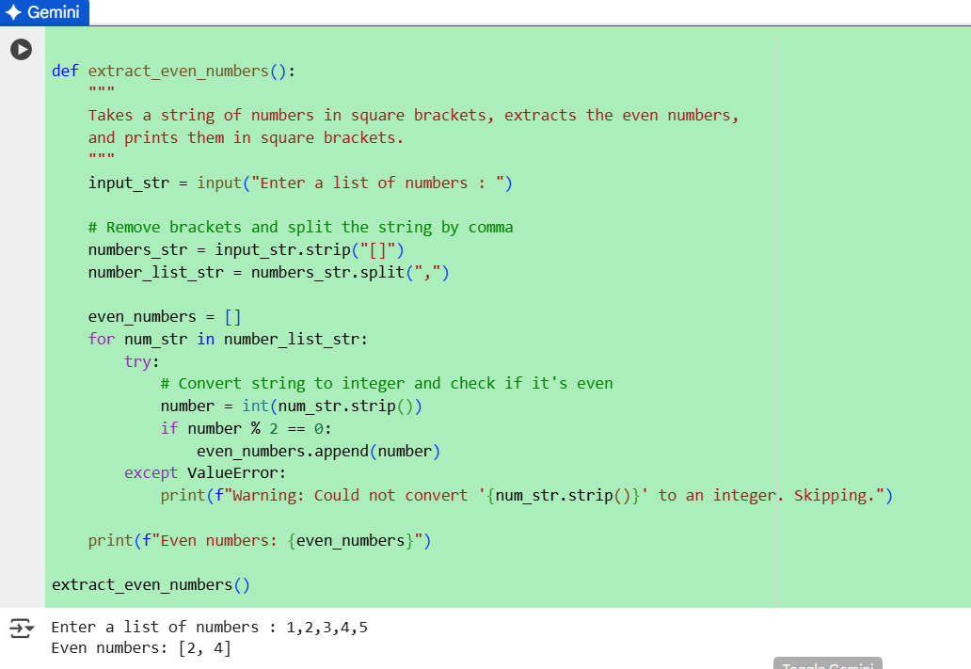

Comment:

So the AI used the modulo condition and I didn’t mention in the prompt directly instead I asked Indirectly which you can see in my prompt.

Task Description #3:  
• Create a class called BankAccount with attributes account_holder and balance. Use Copilot to  
complete methods for deposit(), withdraw(), and check for insufficient Expected Outcome #3:  
• Functional class with complete method definitions using if conditions and self attributes. Code  
should prevent overdrawing

PROMPT:

give me a python code that creates class called Bank Account with attributes for account holder and balance. Add methods to deposit money, withdraw money (with a check for insufficient balance), and ensure that withdrawals don’t allow overdrawing.

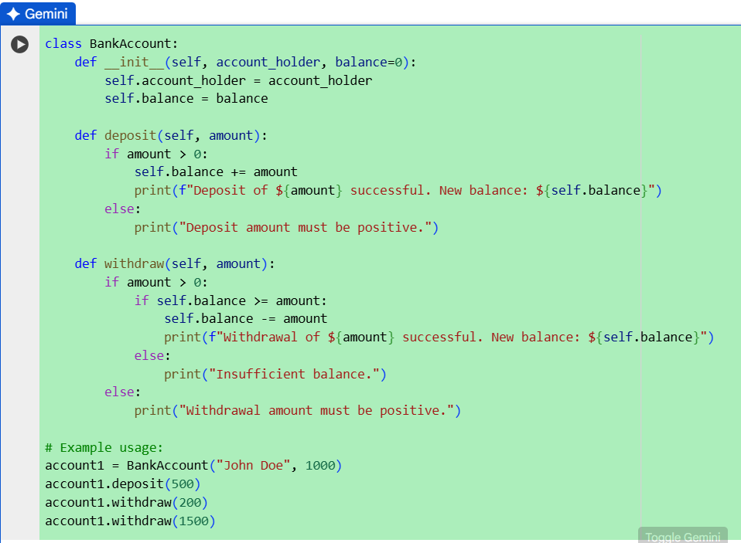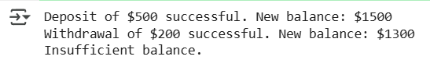

MY COMMENT:

The AI had given a code with appropriate use of self and if condition without mentioning it in my given prompt

Task Description #4:  
• Define a list of student dictionaries with keys name and score. Ask Copilot to write a while  
loop to print the names of students who scored more than 75.  
Expected Outcome #4:  
• A complete while loop generated by Copilot with proper condition checks and formatted

PROMPT:

I need a list of students with their names and scores, and then a while loop that prints only the names of students who scored more than 75. The loop should use conditions and give clear output."

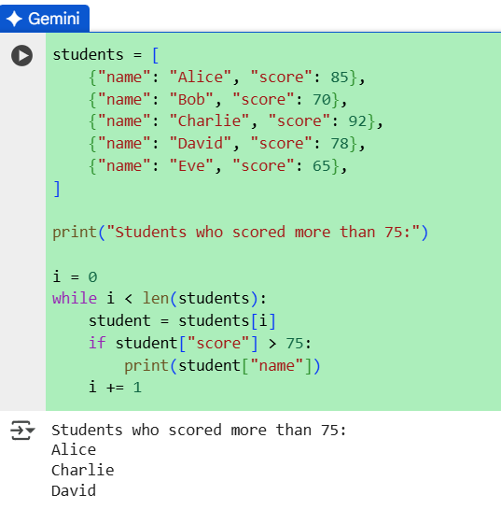

Task Description #5:  
• Begin writing a class ShoppingCart with an empty items list. Prompt Copilot to generate  
methods to add_item, remove_item, and use a loop to calculate the total bill using conditional  
discounts.  
Expected Outcome #5:  
• A fully implemented ShoppingCart class with Copilot-generated loops and if-else statements  
handling item management and discount logic

PROMPT:

I need a ShoppingCart class that starts with an empty list of items. It should have methods to add and remove items, and a method to calculate the total bill that should go after every bill