TASK-1 Labeled Diagram of a Desktop PC clearly marking the motherboard, CPU,GPU,RAM both HDD & SDD storge components?
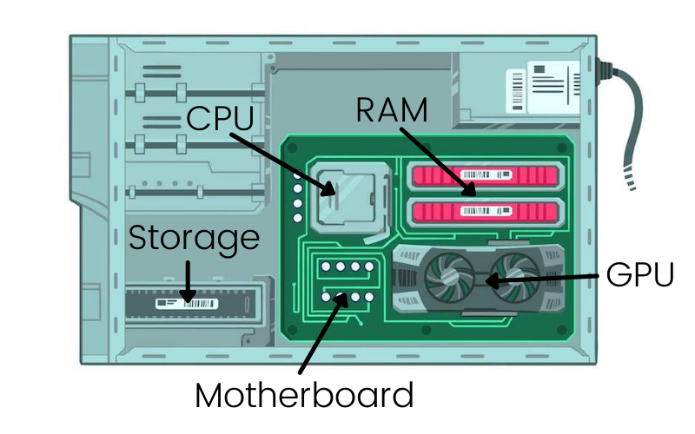

TASK-2 main difference between HDD and SDD storage in term of speed durability, and typical use case.<br><br><em><storage>hint:</strong> think about which one is faster which one is shock resistant and wher you would usally find each type(laptop, gaming PC, etc.).</em>?

Feature - HDD(hard disk drive) - SSD(solid state drive)
speed -slower mechanical read/write - significantly faster flash memory
speed usually 80-160MB/s.. chips reach speed usually from
500to7000MB/s..

Durability -vulnerable to physical shocks and - high durability with no moving parts
Drops because it uses moving marking it highly resistant to physical
mechanical parts.. impact and vibration..

Typical -Mass data storage, backup archives, - operating system drives gaming PCS
use causes large network server and budget desktop for faster loading times and modern
builds… laptops…
TASK-3 write a short explanation(2-3sentence each) describing the role of the CPU ,RAM, and GPU in running a game like PUBG or free fire on a PC?
- CPU(central processing unit):
The CPU handles the games underlying logic, artificial intelligence behavior,physics calculation and multiplayer networking data synchronization it essentially acts as the brain that directs the rest of the hardware on what happens in the game world frame-by-frame...
- RAM(random Access memory):
The RAM serves as a high-speed temporary storage workspace that holds active game asserts ,map textures, player data, and running scripts loaded from your storage this quick-access memory ensure that the CPU can retrieve crucial game data instantly, preventing micro-stutters during intense matches…
- GPU(graphics processing unit):
The GPU is dedicated entirely to rendering the actual visual imagery,3D environment geometry lighting effects shadow details, and texture onto your display screen.it ensure the game maintains a high, fluid frame rate(fps),allowing fast-paced shooters like PUBG to look sharp and play smoothly…

TASK-4 imagine you want to upgrade your PC to run the latest version of FIFA smoothly . list which hardware components you would consider and explain why for each?
- If we want to run latest version of FIFA smoothly you should consider upgrading the following components:

- GPU(graphics card):upgrading the GPU is the most critical factor for achieving fluid framerates and high visual fidelity in sports simulators like FIFA modern interaction of the game utilize advanced rendering engines featuring dense volumetric crowds, realistic grass field, and details players hair/skin physics, which severely tax graphics hardware.

- RAM: upgrading to at least 16GB or 32GB of RAM ensure that the system has enough memory overheard to handle large modern game assert footprints smoothly without relying on slow page file caching…

- SSD Storage: moving the game from an HDD to high-speed NVsMe SSD drastically cuts down matches loading times, eliminates cuts scene stuttering and ensure menu interfaces load instantly…

