**Vishwas Gandhi** 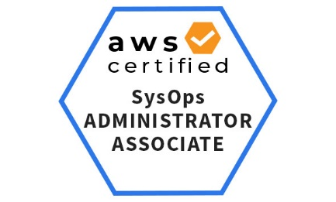

**Software Engineer II (AWS/DevOps) – CareerBuilder**

I am a DevOps enthusiast having 4 years of experience in IT industry. During this period I worked on many technologies and also got certified by AWS as AWS Certified Sysops Administrator - Associate.

I started my career with HCL as an Analyst and worked on NetBackup and HPDP then within a year I moved to AWS/DevOps operations team and got training on many DevOps tools such as - Jenkins, GIT, Ansible etc.

After that I took 3 months of profession training on DevOps from Opstree solutions Noida and got certified from Opstree. I also did Freelancing for 5 months as a DevOps Specialist. In this period I also worked on micro services based project.

I also worked with 3 pillar Global as a DevOps professional and enhanced my skills by working in a team as well as an individual.

Recently, I joined CareerBuilder as Software Engineer II in DevOps/AWS role and started working on cost optimization of all AWS accounts