List of reasons/constraints to justify the choice of DBMS.[RDBMS]

* Our data is -
  + structured
  + Tables had fixed rows and columns
* Data retrieval is simple in RDBMS compared to nosql

DBMS ASSIGNMENT 2

5TH SEM SECTION I

PES1UG19CS579 PES1UG19CS548 PES1UG19CS534

VISHWAS R UTHPAL P T R SUDHARSHAN

* Our data in database changes frequently so it would have been difficult if we had used nosql.
* RDBMS is best suited for complex queries.
* RDBMS focuses on vertical scaling .

Relational Table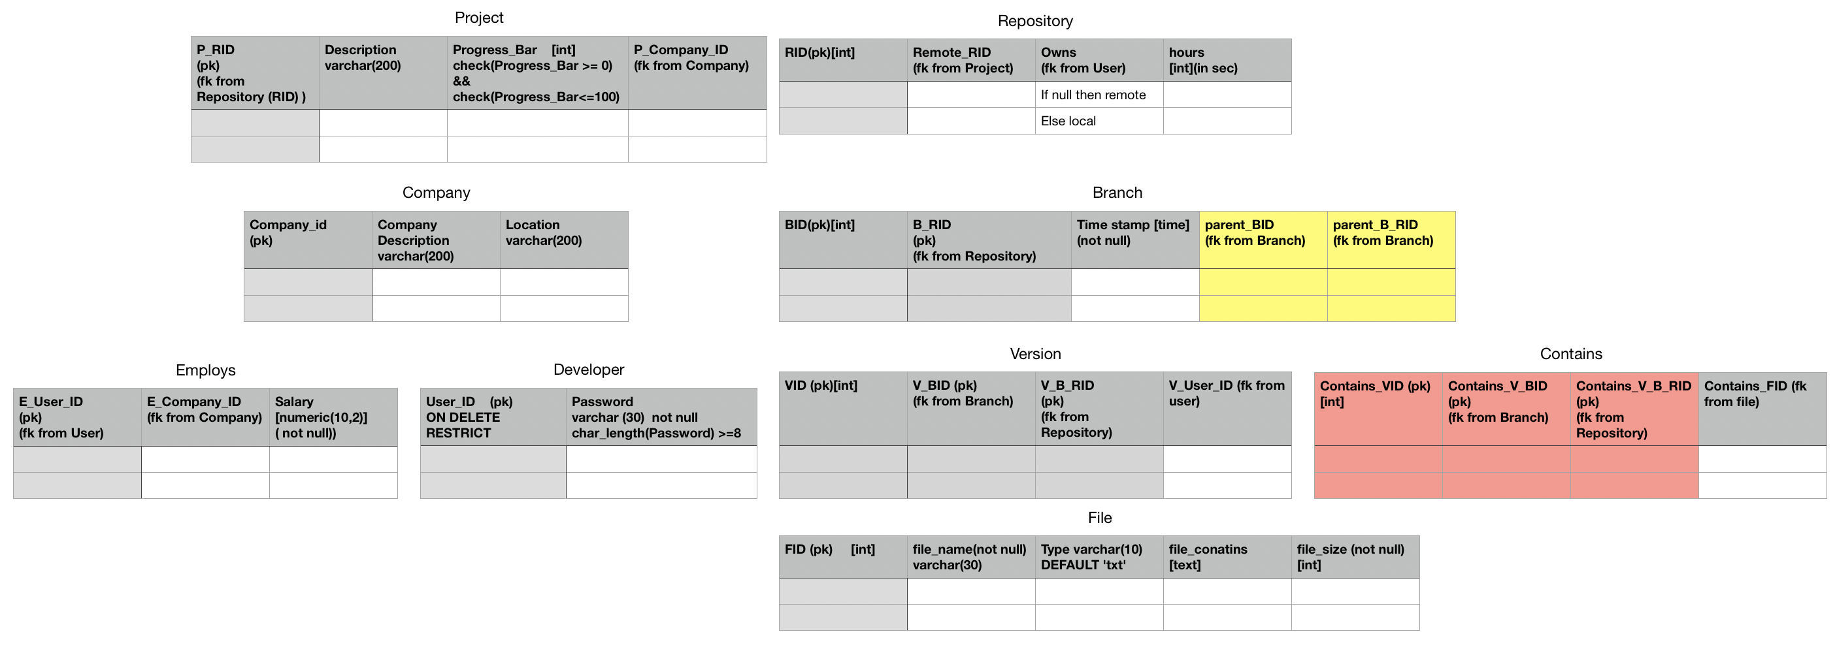

createstatements.sql

drop database github;

create database github;

\c github

create table Project(

P_RID int,

Description varchar(200),

Progress_Bar int,

P_Company_ID int,

PRIMARY KEY (P_RID));

create table Repository(

RID int,

Remote_RID int not null,

Owns int,

Hours int,

PRIMARY KEY (RID));

create table Company(

Company_ID int ,

Company_Description varchar(200),

Location varchar(200),\

PRIMARY KEY (Company_ID));

create table Branch(

BID int,

B_RID int,

Timestamp time not null,

parent_BID int,

parent_B_RID int,

PRIMARY KEY(BID,B_RID));

create table Employs(

E_user_ID int,

E_Company_ID int,

Salary numeric(10,2) not null,

PRIMARY KEY(E_user_ID));

create table Developer(

User_ID int,

Password varchar(30) not null,

PRIMARY KEY (User_ID));

create table Version(

VID int,

V_BID int,

V_B_RID int,

V_User_ID int,

PRIMARY KEY (VID,V_BID,V_B_RID));

create table Contains(

Contains_VID int,

Contains_V_BID int,

Contains_V_B_RID int,

COntains_FID int,

PRIMARY KEY (Contains_VID,Contains_V_BID,Contains_V_B_RID));

create table File(

FID int,

file_name varchar(30) not null,

type varchar(10),

file_contains text,

file_size int not null,

PRIMARY KEY(FID)

);

constriants.sql

\c github

ALTER TABLE Project add constraint p_fk1 FOREIGN KEY (P_RID) REFERENCES Repository(RID) on DELETE SET NULL;

ALTER TABLE Project add constraint p_fk2 FOREIGN KEY (P_Company_ID) REFERENCES Company(Company_ID) on DELETE CASCADE;

ALTER TABLE Project add CHECK (Progress_Bar>=0);

ALTER TABLE Project add CHECK (Progress_Bar<=100);

ALTER TABLE Repository add constraint r_fk1 FOREIGN KEY (Remote_RID) REFERENCES Project(P_RID) on delete cascade;

ALTER TABLE Repository add constraint r_fk2 FOREIGN KEY (Owns) REFERENCES Developer(User_ID) on delete set null;

ALTER TABLE Repository add CHECK (hours>=0);

ALTER TABLE Branch add constraint b_fk1 FOREIGN KEY (B_RID) REFERENCES Repository(RID);

ALTER TABLE Branch add constraint b_fk2 FOREIGN KEY (parent_BID,parent_B_RID) REFERENCES Branch(BID,B_RID);

ALTER TABLE Employs add constraint e_fk1 FOREIGN KEY (E_user_ID) REFERENCES Developer(User_ID) on DELETE CASCADE;

ALTER TABLE Employs add constraint e_fk2 FOREIGN KEY (E_Company_ID) REFERENCES Company(Company_ID) on DELETE CASCADE;

ALTER TABLE Developer add CHECK (LENGTH(Password)>=8);

ALTER TABLE Version add constraint v_fk1 FOREIGN KEY (V_BID,V_B_RID) REFERENCES Branch(BID,B_RID);

ALTER TABLE Version add constraint v_fk2 FOREIGN KEY (V_User_ID) REFERENCES Developer(User_ID) ON DELETE SET NULL;

ALTER TABLE Contains add constraint c_fk1 FOREIGN KEY (Contains_VID,Contains_V_BID,Contains_V_B_RID) REFERENCES Version(VID,V_BID,V_B_RID);

ALTER TABLE Contains add constraint c_fk2 FOREIGN KEY (Contains_FID) REFERENCES File(FID);

ALTER TABLE File ALTER COLUMN type SET DEFAULT '.txt';



Contribution of each member

Designing DATABASE for GitHub is complex as it involved understanding GitHub in detail .

We regularly had team meetings almost every week though Microsoft Teams and finalised the entities and operations in our DBMS

We together made lot of sketches like about how a repository should look and how we perform operations like pull push merge etc…

PES1UG19CS579 VISHWAS R

Converted ER diagram to Relational Schema and defined constraints.

PES1UG19CS548 UTHPAL P

Wrote the DLL statements

PES1UG19CS534 T R SUDHARSHAN

Inserting data to the database