**VISVESVARAYA TECHNOLOGICAL UNIVERSITY**

**“JnanaSangama”, Belgaum -590014, Karnataka.**



## LAB REPORT

**on**

OBJECT ORIENTED JAVA PROGRAMMING

***Submitted by***

## VISHWAS G C (1BM21CS244)

***in partial fulfillment for the award of the degree of***

**BACHELOR OF ENGINEERING**

***in***

## COMPUTER SCIENCE AND ENGINEERING



**B.M.S. COLLEGE OF ENGINEERING**

**(Autonomous Institution under VTU)**

## BENGALURU-560019 Oct 2022-Feb 2023

**B. M. S. College of Engineering,**

**Bull Temple Road, Bangalore 560019**

(Affiliated To Visvesvaraya Technological University, Belgaum)

**Department of Computer Science and Engineering**



**CERTIFICATE**

This is to certify that the Lab work entitled “**OBJECT ORIENTED JAVA PROGRAMMING**” carried out by **VISHWAS (1BM21CS244),**who is bonafide student of **B. M. S. College of Engineering.** It is in partial fulfillment for the award of **Bachelor of Engineering in Computer Science and Engineering** of the Visvesvaraya Technological University, Belgaum during the year 2022-23. The Lab report has been approved as it satisfies the academic requirements in respect of **Object-Oriented Java Programming Lab - (22CS3PCOOJ)** work prescribed for the said degree.

**BASAVARAJ JAKKALI DR. JYOTHI S NAYAK**

Associate Professor Professor and Head

Department of CSE Department of CSE

BMSCE, Bengaluru BMSCE, Bengaluru

# Index Sheet

|  |  |  |
| --- | --- | --- |
| **Sl.**  **No.** | **Experiment Title** | **Page No.** |
| 1 | Develop a Java program that prints all real solutions to the quadratic equation ax2+bx+c = 0. Read in a, b, c and use the quadratic formula. If the discriminate b2-4ac is negative, display a message stating that there are no real solutions. | 1 |
| 2 | Develop a Java program to create a class Student with members usn, name, an array credits and an array mark. Include methods to accept and display details and a method to calculate SGPA of a student. | 3 |
| 3 | Create a class Book which contains four members: name, author, price, num_pages. Include a constructor to set the values for the members.  Include methods to set and get the details of the objects. Include a toString() method that could display the complete details of the book. Develop a Java program to create n book objects. | 7 |
| 4 | Develop a Java program to create an abstract class named Shape that contains two integers and an empty method named printArea( ). Provide three classes named Rectangle, Triangle and Circle such that each one of the classes extends the class Shape. Each one of the classes contain only the method printArea( ) that prints the area of the given shape. | 10 |
| 5 | Develop a Java program to create a class Bank that maintains two kinds of account for its customers, one called savings account and the other current account. The savings account provides compound interest and withdrawal facilities but no cheque book facility. The current account provides cheque book facility but no interest. Current account holders should also maintain a minimum balance and if the balance falls below this level, a service charge is imposed.  Create a class Account that stores customer name, account number and type of account. From this derive the classes Cur-acct and Sav-acct to make them more specific to their requirements. Include the necessary methods in order to achieve the following tasks:   1. Accept deposit from customer and update the balance. 2. Display the balance. 3. Compute and deposit interest 4. Permit withdrawal and update the balance   Check for the minimum balance, impose penalty if necessary and update the balance. | 13 |

|  |  |  |
| --- | --- | --- |
| 6 | Write a program that creates a user interface to perform integer divisions. The user enters two numbers in the text fields, Num1 and Num2. The division of Num1 and Num2 is displayed in the Result field when the Divide button is clicked. If Num1 or Num2 were not an integer, the program would throw a NumberFormatException. If Num2 were Zero, the program would throw an Arithmetic Exception Display the exception in a message dialog box. | 23 |
| 7 | Write a program that demonstrates handling of exceptions in inheritance tree. Create a base class called “Father” and derived class called “Son” which extends the base class. In Father class, implement a constructor which takes the age and throws the exception WrongAge( ) when the input age<0. In Son class, implement a constructor that cases both father and son’s age and throws an exception if son’s age is >=father’s age. | 27 |
| 8 | Write a program which creates two threads, one thread displaying “BMS College of Engineering” once every ten seconds and another displaying “CSE” once every two seconds. | 30 |
| 9 | Write a program that creates a user interface to perform integer divisions. The user enters two numbers in the text fields, Num1 and Num2. The division of Num1 and Num2 is displayed in the Result field when the Divide button is clicked. If Num1 or Num2 were not an integer, the program would throw a NumberFormatException. If Num2 were Zero, the program would throw an Arithmetic Exception Display the exception in a message dialog box. | 32 |
| 10 | Create a package CIE which has two classes- Student and Internals. The class Personal has members like usn, name, sem. The class internals have an array that stores the internal marks scored in five courses of the current semester of the student. Create another package SEE which has the class External which is a derived class of Student. This class has an array that stores the SEE marks scored in five courses of the current semester of the student. Import the two packages in a file that declares the final marks of n students in all five courses. | 36 |
| 11 | Demonstrate Inter process Communication and deadlock | 40 |

**Program 1:**

**Develop a Java program that prints all real solutions to the quadratic equation ax2+bx+c = 0. Read in a, b, c and use the quadratic formula. If the discriminate b2-4ac is negative, display a message stating that there are no real solutions.**

import java.util.Scanner; import java.lang.Math;

class Quadratic {

public static void main (String args[]){ Scanner s =new Scanner (System.in);

System.out.println("Enter the values of a, b and c"); double a= s.nextInt();

double b= s.nextInt(); double c= s.nextInt();

//Discriminant is D double D=b*b-4*a*c; double r1, rt2; if(D>0){

System.out.println("Roots are real and Unique"); r1= -b+Math.sqrt(D)/(2*a);

r2= -b-Math.sqrt(D)/(2*a);

System.out.println("Root1= "+r1+" AND "+"Root2= "+r2);

}

else if(D==0) {

System.out.println("Roots are real and equal"); r1=r2=-b/(2*a); System.out.println("Root1=Root2= "+r1);

}

else {

System.out.println("There are no real solutions"); double realpart=-b/(2*a);

double imagpart=Math.sqrt(-D)/(2*a);

System.out.println("Root1= "+realpart+" + "+imagpart+"i"+" AND "+"Root2= "+realpart+" - "+imagpart+"i");

}

}

}

**OUTPUT:**

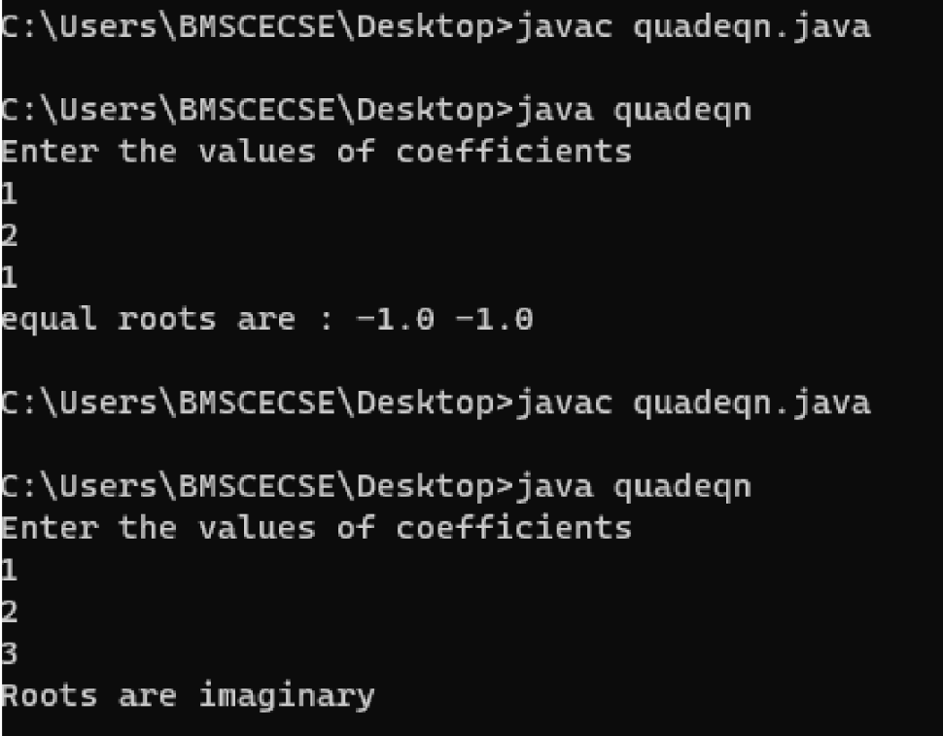

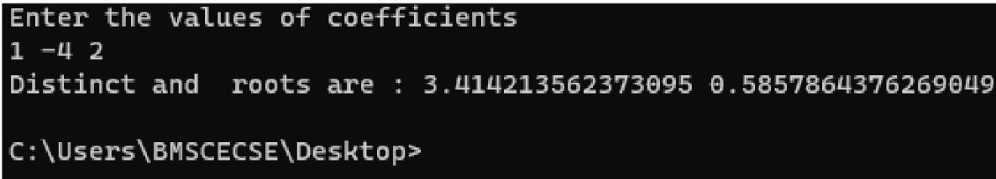

**Program 2:**

**Develop a Java program to create a class Student with members usn, name, an array credits and an array mark. Include methods to accept and display details and a method to calculate SGPA of a student.**

import java.util.Scanner; class Student {

String name,USN;

int marks[] = new int[10]; int credits[] = new int[10]; double SGPA=0;

int n;

Scanner s=new Scanner(System.in);

void Input(){

System.out.println();

System.out.print("Enter name of the student: "); name=s.nextLine();

System.out.print("Enter USN: "); USN=s.nextLine();

System.out.print("Enter the number of courses: "); n=s.nextInt();

for(int i=0;i<n;i++){

System.out.println();

System.out.println("Enter the credits of subject "+(i+1)); credits[i]=s.nextInt();

System.out.println("Enter the marks of subject "+(i+1)); marks[i]=s.nextInt();

}

}

void Display(){

System.out.println(); System.out.println("NAME :"+name); System.out.println("USN: "+USN); System.out.println("SGPA is "+SGPA);

}

void CalcSGPA(){

double grade=0, totalcred=0; int i;

for(i=0;i<n;i++){

totalcred=totalcred+credits[i];

}

for(i=0;i<n;i++){

if(marks[i]>=90)

{

grade+=credits[i]*10;

}

else if(marks[i]>=80)

{

grade+=credits[i]*9;

}

else if(marks[i]>=70)

{

grade+=credits[i]*8;

}

else if(marks[i]>=60)

{

grade+=credits[i]*7;

}

else if(marks[i]>=50)

{

grade+=credits[i]*6;

}

else if(marks[i]>=40)

{

}

else{

}

}

grade+=credits[i]*5;

grade=0;

SGPA=grade/totalcred;

}

}

class SGPA{

public static void main(String args[]){

Student st= new Student();

st.Input(); st.CalcSGPA(); st.Display();

}

}

## OUTPUT:

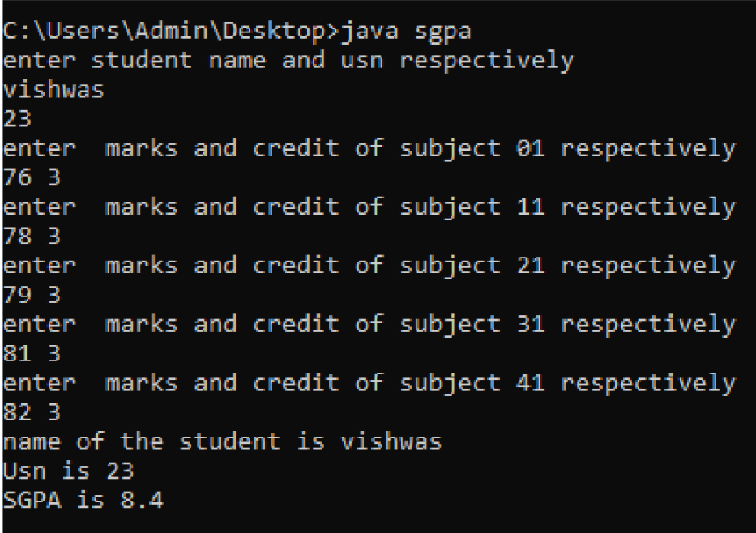

**Program 3:**

**Create a class Book which contains four members: name, author, price, num_pages. Include a constructor to set the values for the members. Include methods to set and get the details of the objects. Include a toString() method that could display the complete details of the book. Develop a Java program to create n book objects.**

import java.util.*; class Book{

String name,author; int price,num_pages;

Book(){

name=""; author=""; price=0; num_pages=0;

}

void setnget(String n, String a, int p, int nop){ name=n;

author=a; price=p; num_pages=nop;

}

public String toString(){

String s="";

s+="Name: "+name+"\nAuthor: "+author+"\nPrice: "+price+"\nNo. of pages:

"+num_pages;

}

}

return s;

class BookInfo{

public static void main(String args[]){ Scanner sc=new Scanner(System.in);

System.out.println("Enter the number of books: "); int num=sc.nextInt();

Book b[]=new Book[num];

for(int i=0;i<num;i++){ b[i]=new Book();

}

for(int i=0;i<num;i++)

{

System.out.println(); System.out.println("Book "+(i+1)); sc.nextLine();

System.out.print("Enter the name of the Book: "); String n=sc.nextLine();

System.out.print("Enter the name of the Author: "); String a=sc.nextLine();

System.out.print("Enter the price of the Book: "); int p=sc.nextInt();

System.out.print("Enter number of pages there in the Book: "); int nop=sc.nextInt();

b[i].setnget(n,a,p,nop);

}

for(int i=0;i<num;i++)

{

System.out.println(); System.out.println("Details of book :"+(i+1));

System.out.println(b[i]);

}

}

}

## OUTPUT:

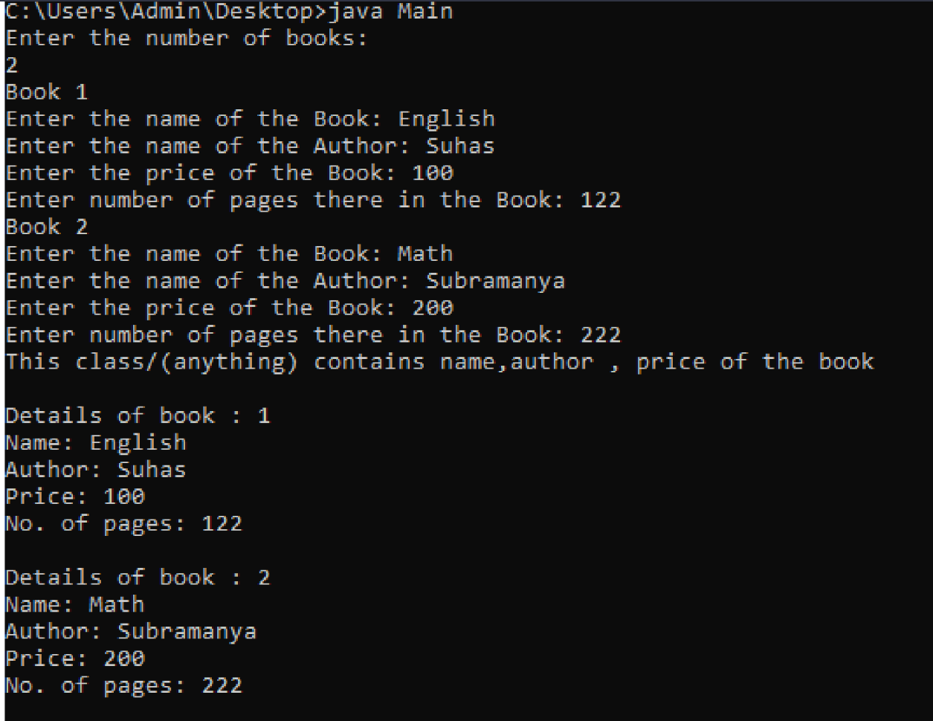

**Program 4:**

**Develop a Java program to create an abstract class named Shape that contains two integers and an empty method named printArea( ). Provide three classes named Rectangle, Triangle and Circle such that each one of the classes extends the class Shape. Each one of the classes contain only the method printArea( ) that prints the area of the given shape.**

import java.util.*; abstract class Shape{

int a,b;

Shape(int x, int y){ a=x;

b=y;

}

abstract double printArea();

}

class Rectangle extends Shape{ Rectangle(int length,int breadth){

super(length,breadth);

}

double printArea(){

return a*b;

}

}

class Triangle extends Shape{ Triangle(int length, int height){

super(length,height);

}

double printArea(){

return 0.5*a*b;

}

}

class Circle extends Shape{ Circle(int r){

super(r,r);

}

double printArea(){

return Math.PI*a*b;

}

}

class AREA{

public static void main(String args[]){

Rectangle R=new Rectangle(10,20); Triangle T=new Triangle(15,30); Circle C=new Circle(5);

Shape s; s=R;

System.out.println("Area of the Rectangle : " +s.printArea()); s=T;

System.out.println("Area of the Triangle : " +s.printArea());

s=C;

System.out.println("Area of the Circle : " +s.printArea());

}

}

# OUTPUT:

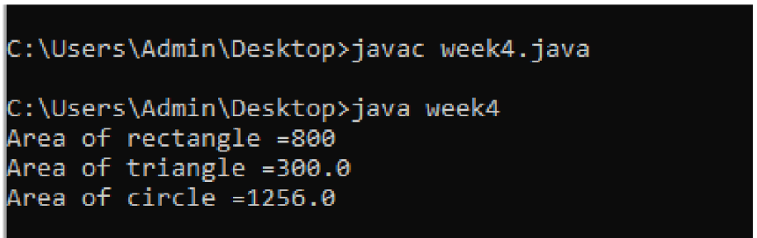

**Program 5:**

**Develop a Java program to create a class Bank that maintains two kinds of account for its customers, one called savings account and the other current account. The savings account provides compound interest and withdrawal facilities but no cheque book facility. The current account provides cheque book facility but no interest. Current account holders should also maintain a minimum balance and if the balance falls below this level, a service charge is imposed.**

**Create a class Account that stores customer name, account number and type of account. From this derive the classes Cur-acct and Sav-acct to make them more specific to their requirements. Include the necessary methods in order to achieve the following tasks:**

1. **Accept deposit from customer and update the balance.**
2. **Display the balance.**
3. **Compute and deposit interest**
4. **Permit withdrawal and update the balance**

**Check for the minimum balance, impose penalty if necessary and update the balance.**

import java.util.*;

class account{

String ac_name;

int ac_no;

account(String s,int ac){

ac_name=s;ac_no=ac;

}

}

class sav_act extends account{

Scanner sc=new Scanner(System.in);

double sum=0;

sav_act(String s,int ac){

super(s,ac);

}

void deposit(){

System.out.println("ENTER AMOUNT");

double am=sc.nextInt();

sum+=am;

return;

}

void balance(){

System.out.println("BALANCE AMOUNT IS "+sum);

return;

}

double interest(){

return sum*0.08;

}

void withdraw(){

System.out.println("ENTER THE AMOUNT");

double am=sc.nextInt();

sum-=am;

return;

}

}

class cur_act extends account{

cur_act(String s,int ac){

super(s,ac);

}

Scanner sc=new Scanner(System.in);

double sum1=0;

void deposit(){

System.out.println("ENTER AMOUNT");

double am=sc.nextInt();

sum1+=am;

return;

}

void balance(){

System.out.println("BALANCE AMOUNT IS "+sum1);

return;

}

void withdraw(){

System.out.println("ENTER THE AMOUNT");

double am=sc.nextInt();

sum1-=am;

return;

}

}

class bank_week5{

public static void main(String args[]){

Scanner sc=new Scanner(System.in);

int flag=1;

System.out.println("ENTER NAME AND ACCOUNT NUMBER");

String ac_name=sc.next();

int ac_no=sc.nextInt();

sav_act sa=new sav_act(ac_name,ac_no);

cur_act cu=new cur_act(ac_name,ac_no);

while(flag==1){

System.out.println("1.DEPOSIT AMOUNT"+"\n"+"2.DISPLAY BALANCE"+"\n"+"3.SHOW INTEREST"+"\n"+"4.WITHDRAW"+"\n"+"5.DETAILS"+"\n"+"6.exit");

int ch=sc.nextInt();

switch(ch){

case 1:

System.out.println("1.DEPOSIT AMOUNT IN SAVING ACCOUNT 2.DEPOSIT AMOUNT IN CURRENT ACCOUNT");

int x=sc.nextInt();

if(x==1) sa.deposit();

if(x==2) cu.deposit();

break;

case 2:

System.out.println("1.BALANCE AMOUNT IN SAVING ACCOUNT 2.BALANCE AMOUNT IN CURRENT ACCOUNT");

int y=sc.nextInt();

if(y==1) sa.balance();

if(y==2) cu.balance();

break;

case 3:

System.out.println("INTEREST AMOUNT IS "+sa.interest());

break;

case 4:

System.out.println("1.WITHDRAW USING CASH 2.WITHDRAW USING CHEQUE");

int z=sc.nextInt();

if(z==1) sa.withdraw();

if(z==2) cu.withdraw();

break;

case 5:

System.out.println("ACCOUNT DETAILS ARE "+sa.ac_name+" and "+sa.ac_no);

break;

case 6:

flag=0;

break;

default: System.out.println("INVALID INPUTS");

}

}

}

}

**OUTPUT:**

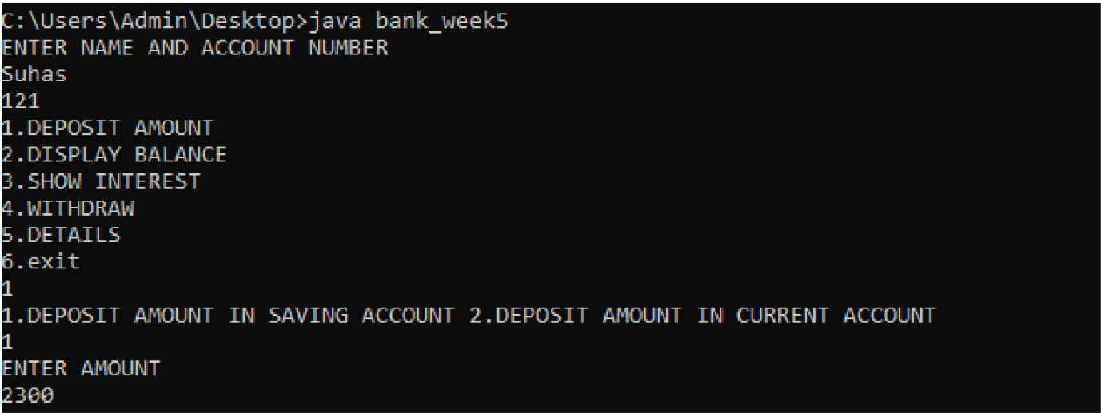

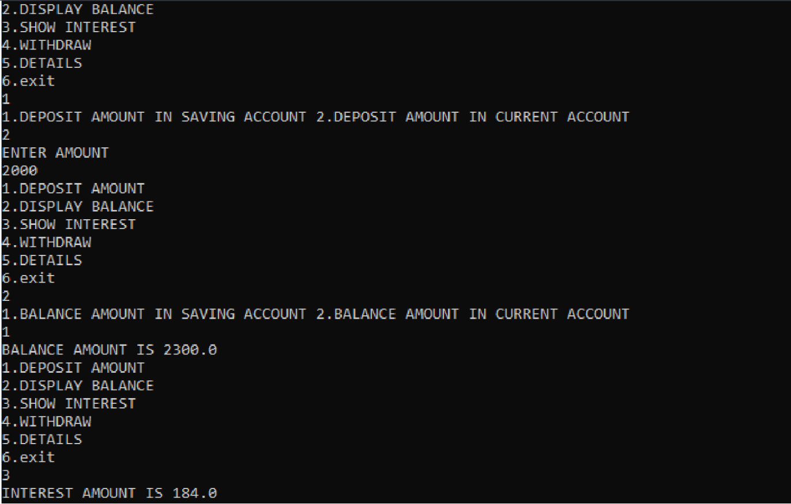

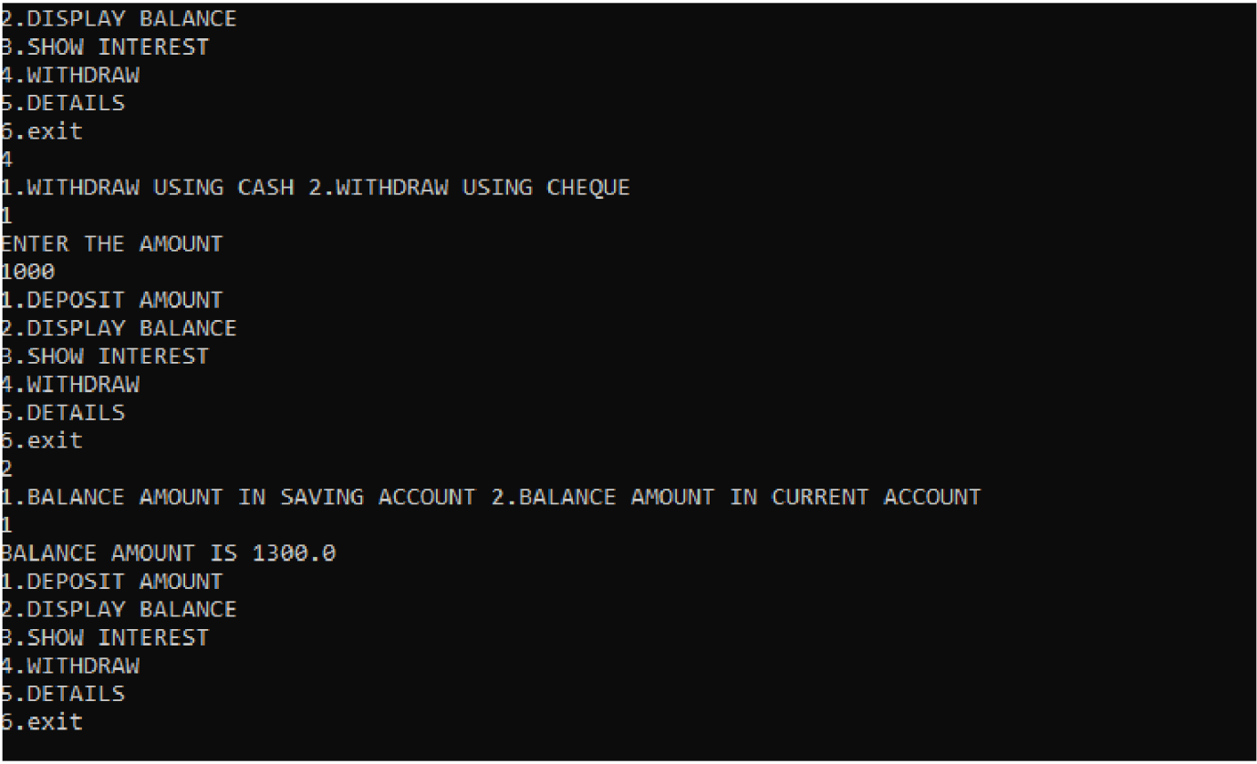

**Program 6:**

**Write a program that creates a user interface to perform integer divisions. The user enters two numbers in the text fields, Num1 and Num2. The division of Num1 and Num2 is displayed in the Result field when the Divide button is clicked. If Num1 or Num2 were not an integer, the program would throw a NumberFormatException. If Num2 were Zero, the program would throw an Arithmetic Exception Display the exception in a message dialog box.**

import javax.swing.*; import java.awt.*;

import java.awt.event.ActionEvent; import java.awt.event.ActionListener;

class IntegerDivisionUI { private JFrame frame;

private JTextField num1Field; private JTextField num2Field; private JTextField resultField; private JButton divideButton;

public IntegerDivisionUI() { initUI();

}

private void initUI() {

frame = new JFrame("Integer Division"); frame.setLayout(new GridLayout(4, 2, 10, 10)); frame.setDefaultCloseOperation(JFrame.EXIT_ON_CLOSE);

JLabel num1Label = new JLabel("Num1:"); JLabel num2Label = new JLabel("Num2:"); JLabel resultLabel = new JLabel("Result:");

num1Field = new JTextField(10); num2Field = new JTextField(10); resultField = new JTextField(10); resultField.setEditable(false);

divideButton = new JButton("Divide"); divideButton.addActionListener(new ActionListener() {

@Override

public void actionPerformed(ActionEvent e) { try {

int num1 = Integer.parseInt(num1Field.getText()); int num2 = Integer.parseInt(num2Field.getText());

if (num2 == 0) {

throw new ArithmeticException("Division by zero");

}

int result = num1 / num2; resultField.setText(String.valueOf(result));

} catch (NumberFormatException ex) {

JOptionPane.showMessageDialog(frame, "Invalid input: not an integer", "Error", JOptionPane.ERROR_MESSAGE);

} catch (ArithmeticException ex) { JOptionPane.showMessageDialog(frame, ex.getMessage(), "Error",

JOptionPane.ERROR_MESSAGE);

}

}

});

frame.add(num1Label);

frame.add(num1Field); frame.add(num2Label); frame.add(num2Field); frame.add(resultLabel); frame.add(resultField); frame.add(new JLabel()); frame.add(divideButton);

frame.pack(); frame.setVisible(true);

}

public static void main(String[] args) { SwingUtilities.invokeLater(new Runnable() {

@Override

public void run() {

new IntegerDivisionUI();

}

});

}

}

**OUTPUT:**

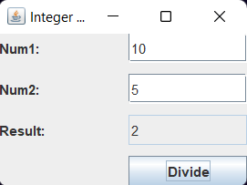

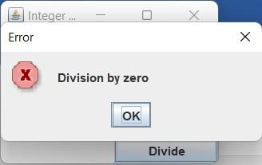

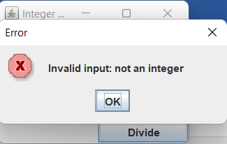

**Program 7:**

**Write a program that demonstrates handling of exceptions in inheritance tree. Create a base class called “Father” and derived class called “Son” which extends the base class. In Father class, implement a constructor which takes the age and throws the exception WrongAge( ) when the input age<0. In Son class, implement a constructor that cases both father and son’s age and throws an exception if son’s age is >=father’s age.**

**import java.lang.*;**

**import java.util.Scanner;**

**class WrongAge extends Exception**

**{**

**private String detail;**

**WrongAge(String a)**

**{**

**detail=a;**

**}**

**public String toString()**

**{**

**return("WrongAge Exception ["+detail+ "]");**

**}**

**}**

**class Father {**

**int f_age;**

**Father(int a) throws Exception**

**{**

**f_age=a;**

**if(f_age<0)**

**{**

**throw new WrongAge("Father's age is negative");**

**}**

**}**

**void display()**

**{**

**System.out.println("Father's age: "+f_age);**

**}**

**}**

**class Son extends Father**

**{**

**int s_age;**

**Son(int ag,int f) throws Exception**

**{**

**super(f);**

**s_age=ag;**

**if(s_age<0)**

**{**

**throw new WrongAge("Son's age is negative");**

**}**

**if(s_age>=f_age)**

**{**

**throw new WrongAge("Son's age greater than father's age");**

**}**

**}**

**void display()**

**{**

**System.out.println("Son's age: "+s_age+" Father's age: "+f_age);**

**}**

**}**

**class program7**

**{**

**public static void main(String args[]) throws Exception**

**{**

**int ch,f,s;**

**Scanner sc= new Scanner(System.in);**

**try**

**{**

**while(true){**

**System.out.println("1.Check Father\n2.Check Son and Father's age\n3.Exit\nEnter your choice");**

**ch=sc.nextInt();**

**switch(ch)**

**{**

**case 1:**

**System.out.println("Enter father's age");**

**f=sc.nextInt();**

**Father f1=new Father(f);**

**f1.display();**

**break;**

**case 2:**

**System.out.println("Enter son and father's age");**

**s=sc.nextInt();**

**f=sc.nextInt();**

**Son s1=new Son(s,f);**

**s1.display();**

**break;**

**case 3:**

**System.exit(0);**

**default:**

**System.out.println("Invalid choice");**

**}**

**}**

**}**

**catch(WrongAge e)**

**{**

**System.out.println("Exception: "+e);**

**}**

**}**

**}**

## OUTPUT:

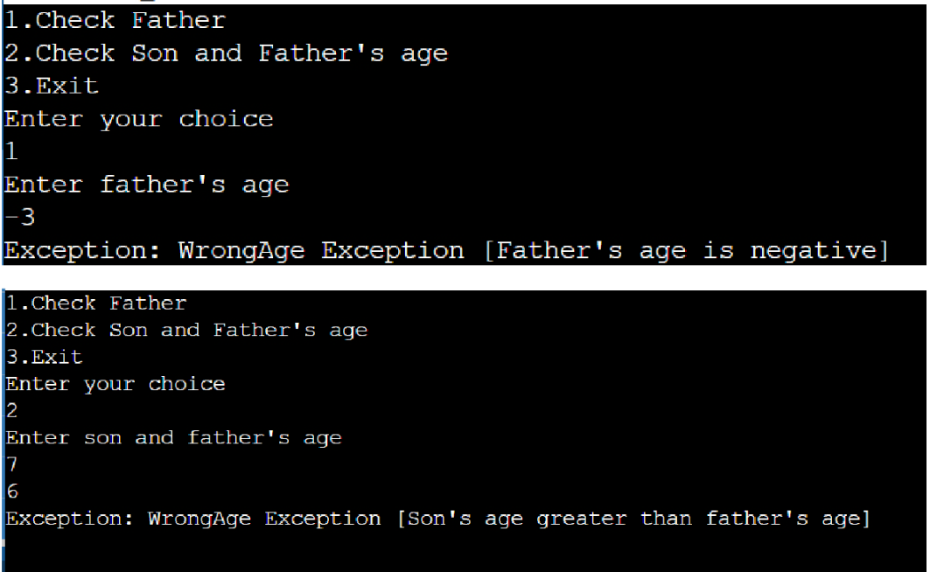

**Program 8:**

**Write a program which creates two threads, one thread displaying “BMS College of Engineering” once every ten seconds and another displaying “CSE” once every two seconds.**

class BMSCE extends Thread { public void run() {

try {

for (int i = 5; i > 0; i--) {

System.out.println("BMS College Of Engineering"); Thread.sleep(10000);

}

} catch (InterruptedException e) { System.out.println("Interrupted");

}

}

}

class CSE extends Thread { public void run() {

try {

for (int i = 5; i > 0; i--) { System.out.println("CSE"); Thread.sleep(2000);

}

} catch (InterruptedException e) { System.out.println("Interrupted");

}

}

}

class ThreadDemo {

public static void main(String args[]) { new BMSCE().start();

new CSE().start();

}

}

## OUTPUT:

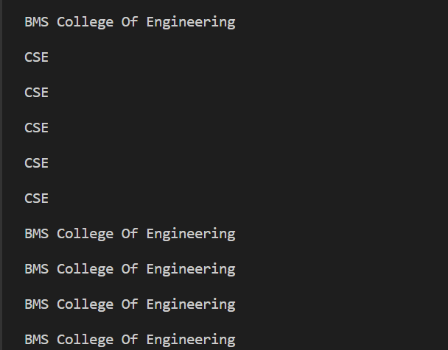

**Program 9:**

**Write a program that creates a user interface to perform integer divisions. The user enters two numbers in the text fields, Num1 and Num2. The division of Num1 and Num2 is displayed in the Result field when the Divide button is clicked. If Num1 or Num2 were not an integer, the program would throw a NumberFormatException. If Num2 were Zero, the program would throw an Arithmetic Exception Display the exception in a message dialog box.**

import javax.swing.*; import java.awt.*;

import java.awt.event.ActionEvent; import java.awt.event.ActionListener;

class IntegerDivisionUI { private JFrame frame;

private JTextField num1Field; private JTextField num2Field; private JTextField resultField; private JButton divideButton;

public IntegerDivisionUI() { initUI();

}

private void initUI() {

frame = new JFrame("Integer Division"); frame.setLayout(new GridLayout(4, 2, 10, 10)); frame.setDefaultCloseOperation(JFrame.EXIT_ON_CLOSE);

JLabel num1Label = new JLabel("Num1:"); JLabel num2Label = new JLabel("Num2:"); JLabel resultLabel = new JLabel("Result:");

num1Field = new JTextField(10); num2Field = new JTextField(10); resultField = new JTextField(10); resultField.setEditable(false);

divideButton = new JButton("Divide"); divideButton.addActionListener(new ActionListener() {

@Override

public void actionPerformed(ActionEvent e) { try {

int num1 = Integer.parseInt(num1Field.getText()); int num2 = Integer.parseInt(num2Field.getText());

if (num2 == 0) {

throw new ArithmeticException("Division by zero");

}

int result = num1 / num2; resultField.setText(String.valueOf(result));

} catch (NumberFormatException ex) {

JOptionPane.showMessageDialog(frame, "Invalid input: not an integer", "Error", JOptionPane.ERROR_MESSAGE);

} catch (ArithmeticException ex) { JOptionPane.showMessageDialog(frame, ex.getMessage(), "Error",

JOptionPane.ERROR_MESSAGE);

}

}

});

frame.add(num1Label);

frame.add(num1Field); frame.add(num2Label); frame.add(num2Field); frame.add(resultLabel); frame.add(resultField); frame.add(new JLabel()); frame.add(divideButton);

frame.pack(); frame.setVisible(true);

}

public static void main(String[] args) { SwingUtilities.invokeLater(new Runnable() {

@Override

public void run() {

new IntegerDivisionUI();

}

});

}

}

## OUTPUT:







**Program 10:**

**Create a package CIE which has two classes- Student and Internals. The class Personal has members like usn, name, sem. The class internals has an array that stores the internal marks scored in five courses of the current semester of the student. Create another package SEE which has the class External which is a derived class of Student. This class has an array that stores the SEE marks scored in five courses of the current semester of the student. Import the two packages in a file that declares the final marks of n students in all five courses.**

package cie;

public class Internals {

public int internal[]=new int[5];

}

package cie;

public class Student {

public String name; public int usn; public int sem;

}

package see;

import cie.Internals;

public class External extends Internals { public int external[]=new int[5];

}

import java.util.Scanner; import cie.Student; import see.External; public class Marks {

public static void main(String[] args) { int n;

Scanner sc=new Scanner(System.in); System.out.println("enter number of students");

n=sc.nextInt();

External student[]=new External[n]; Student details[]=new Student[n]; int final_marks[][]=new int[n][5]; for(int i=0;i<n;i++)

{student[i]=new External();

details[i]=new Student();

order");

System.out.println("Enter Student usn and System.out.println(“sem respectively"); details[i].usn=sc.nextInt();

details[i].sem=sc.nextInt();

System.out.println("Enter Internal marks of 5 subject in respective

for(int j=0;j<5;j++)

{

student[i].internal[j]=sc.nextInt();

}

order");

System.out.println("Enter external marks of 5 subject in respective

for(int k=0;k<5;k++)

{

student[i].external[k]=sc.nextInt();

}

}

for(int i=0;i<n;i++)

{

for(int j=0;j<5;j++) final_marks[i][j]=student[i].internal[j]+(int)(student[i].external[j]/2);

}

for(int i=0;i<n;i++)

{

//System.out.println("Name: "+details[i].name); System.out.println("USN: "+details[i].usn); System.out.println("Sem: "+details[i].sem); System.out.println("Marks of the student is"); for(int j=0;j<5;j++)

{

System.out.println(final_marks[i][j]);

}

}

}

}

## OUTPUT:

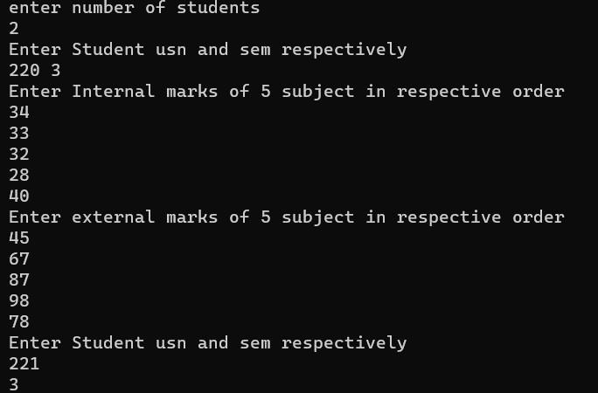

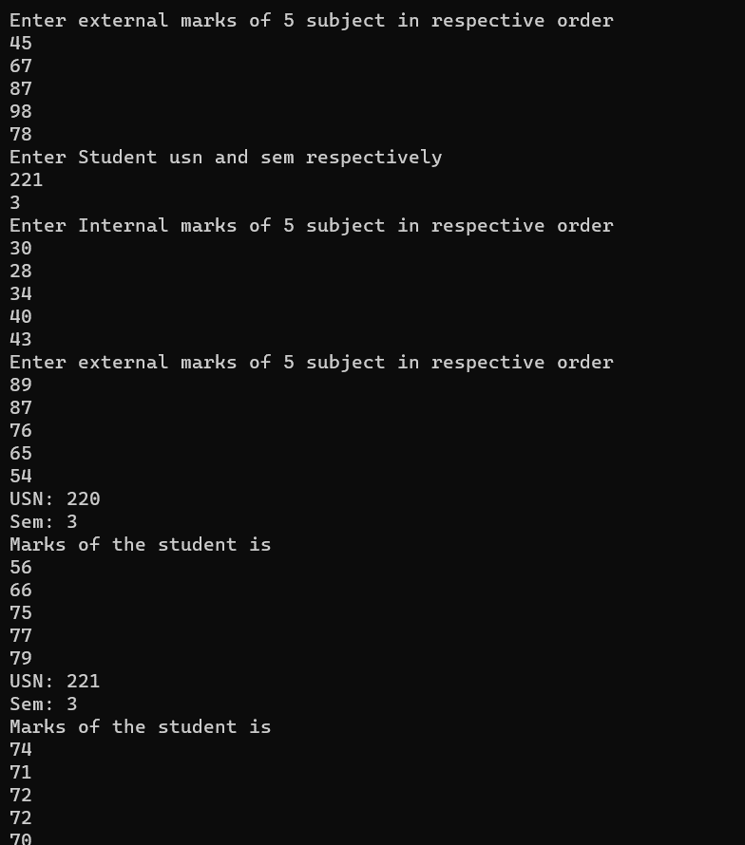

**Program 11:**

**Demonstrate Inter process Communication and deadlock.**

class printer{

String str; printer()

{

str="";

}

synchronized void print(String str)

{

System.out.print("["+str); try {

Thread.sleep(1000);

}catch(InterruptedException e)

{

System.out.println("Erroroccured")

}

try {

} catch (InterruptedException e) {

// TODO Auto-generated catch block e.printStackTrace();

}

}

}

class SampleThread implements Runnable

{

String msg; printer pt; Thread t;

public SampleThread(printer pr,String message)

{

pt=pr; msg=message; t=new Thread(this); t.start();

}

@Override

public void run() {

// TODO Auto-generated method stub pt.print(msg);

}

}

public class InterThread {

public static void main(String[] args) { printer pt=new printer();

SampleThread s1=new SampleThread(pt,"HELLO"); SampleThread s2=new SampleThread(pt,"CSE"); SampleThread s3=new SampleThread(pt,"WORLD"); SampleThread s4=new SampleThread(pt,"BMS");

try {

s1.t.join();

s2.t.join();

s3.t.join();

s4.t.join();

} catch (InterruptedException e) {

// TODO Auto-generated catch block e.printStackTrace();

}

}

}

## OUTPUT:

