A REPORT

**ON**

**NUMERICAL ANALYSIS OF MICROFLUIDIC DEVICES FOR LAB-ON-CHIP APPLICATIONS**

BY

Name(s) of the ID.No.(s)

Student(s)

**VISHWAS VASUKI GAUTAM 2019A3PS0443H**

Samarth Agarwal 2019A3PS0418G

AT

CSIR-CEERI Pilani

A Practice School-I Station of

**BIRLA INSTITUTE OF TECHNOLOGY & SCIENCE, PILANI**

**(July, 2021)**

**A REPORT**

**ON**

**NUMERICAL ANALYSIS OF MICROFLUIDIC DEVICES FOR LAB-ON-CHIP**

**APPLICATIONS**

BY

Name(s) of the ID.No.(s) Discipline(s)

Student(s)

**VISHWAS VASUKI GAUTAM 2019A3PS0443H EEE**

Samarth Agarwal 2019A3PS0418G EEE

Prepared in partial fulfilment of the Practice School-I Course Nos.

BITS C221/BITS C231/BITS C241

AT

CSIR-CEERI Pilani

A Practice School-I Station of

**BIRLA INSTITUTE OF TECHNOLOGY & SCIENCE, PILANI**

**(July, 2021)**

**ACKNOWLEDGEMENTS**

I’m extremely grateful toBITS Pilani to have given me this opportunity to work with the best stations to enhance my knowledge. I’d like to acknowledge the assistance and support of my mentor Dr. Vijay Chatterjee and my faculty Dr. Pankaj Arora.

Lastly, I would like to express my deepest appreciation to my parents, without whom none of this would be possible.

**BIRLA INSTITUTE OF TECHNOLOGY AND SCIENCE PILANI**

**(RAJASTHAN)**

**Practice School Division**

**Station**: ………CSIR-CEERI………………**Centre** ...PILANI.............…………………..

**Duration** .........2 months……………**Date of Start**.......31st May..........…………………

**Date of Submission**....20thJuly............……………………………………………………

**Title of the Project**: NUMERICAL ANALYSIS OF MICROFLUIDIC DEVICES FOR LAB-ON-CHIP APPLICATIONS

**Name(s)/ID(s)/Discipline(s):** VISHWAS VASUKI GAUTAM –2019A3PS0443H–EEE

**Name(s) and designation(s) of the expert(s):** Dr. Vijay Chatterjee

**Name(s) of the PS Faculty:** Dr. Pankaj Arora

**Key Words:** Microfluidic device, lab-on-chip, viscometer, micro pump, micro chamber

**Project Areas:** Electronics

**Abstract:**

To design and simulate a Microfluidic device for quality control. The device will consist of a micro-pump, micro-chamber, and micro-channel. The basic working principle is that the micro-chamber will contain the fluid for testing, and the micro-pump will pump the fluid through the micro-channel. Due to the difference in viscosities of the pure and impure fluid, the fluids traverse the micro-channel at two different periods. This will allow us to differentiate the impurities from the pure fluid.

Vishwas Vasuki Gautam

|  |  |  |  |
| --- | --- | --- | --- |
|  | Signature(s) of Student(s)  20th June 2021 |  | Signature of PS Faculty |

**TABLE OF CONTENTS**

|  |  |  |  |
| --- | --- | --- | --- |
| **Sr. No.** |  | **Content** | **Page No.** |
| 1. | Cover |  | 1 |
| 2. | Title Page |  | 2 |
| 3. | Acknowledgements |  | 3 |
| 4. | Abstract Sheet |  | 4 |
| 5. | Table of contents |  | 5 |
| 6. | Introduction |  | 6 |
| 7. | Basic Working Principle |  | 6, 7 |
| 8. | Microfluidic Devices |  | 7, 8, 9 |
| 9. | Microfluidic Viscometer |  | 10, 11, 12, 13, 14 |
| 10. | References |  | 15 |

**INTRODUCTION**

Microfluidics is a domain of fluid mechanics referring to the control, behavior, and manipulation of fluids that are constrained to a small size. Due to small volumes of fluids in use, the surface forces dominate over the volumetric forces. Microfluidics is a vast field that involves physics, chemistry, biology, engineering, etc. Due to the micro-scale behavior of fluids, some interesting and sometimes unintuitive properties appear. In particular, the Reynolds number can become very low. A key consequence is co-flowing fluids do not necessarily mix in the traditional sense, as the flow becomes laminar rather than turbulent.

A microfluidic device is an electronic device that takes advantage of this micro-scale behavior of fluids to perform a particular task. These microfluidic devices are millimeterscale, often etching grooves called microchannels on materials such as PDMS, glass, silicon, etc. In addition, they have microvalves, micro pumps, micro-heaters, and several other miniature devices to perform the intended task.

Lab-On-Chip is a microfluidic device that incorporates one or several laboratory functions on a single chip. This achieves high levels of automation and throughput at a very small scale.

Our project involves all of the background details mentioned above. It incorporates the design of a microfluidic device for quality control and impurity detection in fluids.

We chose a microfluidic device for this application because we don’t need large volumes of fluid for testing. It’s not feasible to use large volumes of blood or plasma for testing. Hence a microfluidic device works best as it uses less than a milliliter of fluid for testing. In addition to this, the compact size of the devices allows several operations to take place simultaneously, and extensive experiments can be brought down to a very closely packed unit. This shortens the time of the experiment too.

**BASIC WORKING PRINCIPLE OF THE DEVICE**

The device works on the principle that different viscosities of fluids travel at different velocities. So, if a pure fluid X takes t time to traverse a distance in a micro-channel. Then the same fluid X with an impurity traverses the micro-channel at a time greater/lesser than t due to a change in viscosity caused by the contaminant.

To give a brief overview of the design of the device. The device comprises three components, a micro-chamber to store the fluid, micro-channel for the fluid to traverse through, and a micropump to pump the fluid through the micro-channel.

Consider that a pure fluid is filled in the micro-chamber in the first test case, and the micropump pumps the fluid through a distance of the micro-channel. This operation takes a particular time. These readings are noted down. In the second test case, the adulterated fluid is filled in the micro-chamber, and a similar procedure is undertaken. It can be seen that the obtained timings aren’t the same due to the difference in their viscosities. From this result, we can systematically deduce the impurities and all other relevant details..

A simple illustrative diagram is given below:

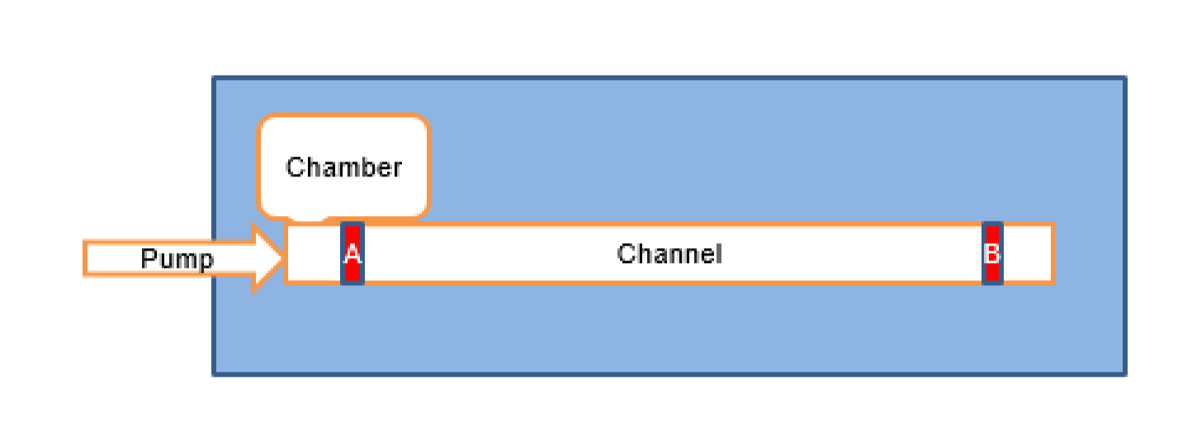

**MICROFLUIDIC DEVICES**

**Literature Review**

The first two weeks of Practise school - I was spent on understanding the problem statement by reading and skimming through papers.

I read papers on numerical analysis of microfluidic device components such as micro-mixers, micro-chambers, micro-channels, micro-heaters, etc. These devices were modelled and simulated in COMSOL Multiphysics. Fluid flow patterns, concentration distribution and velocity field were observed by using simulation software.

For example, a paper had implemented a micro-mixer and micro-chamber components of microfluidic devices. A micro-mixer is a component of a microfluidic device that allows the stabilized mixing of fluids from several inlets and a micro-chamber is a component of a microfluidic device that allows uniform filling of the fluid. We plan on implementing the microchamber for our application as well.

The image is a 3D cross-section of the three inlets, one outlet micro-mixer. The channels are etched using PDMS. The boundary conditions and the fluid properties have been specified in the paper according to their requirements.

For the three inputs of inlet concentration, two inlets were high concentration; 2 mol/m^3 and one low inlet concentration; 1 mol/m^3. It was interesting to see that the mixing occurs

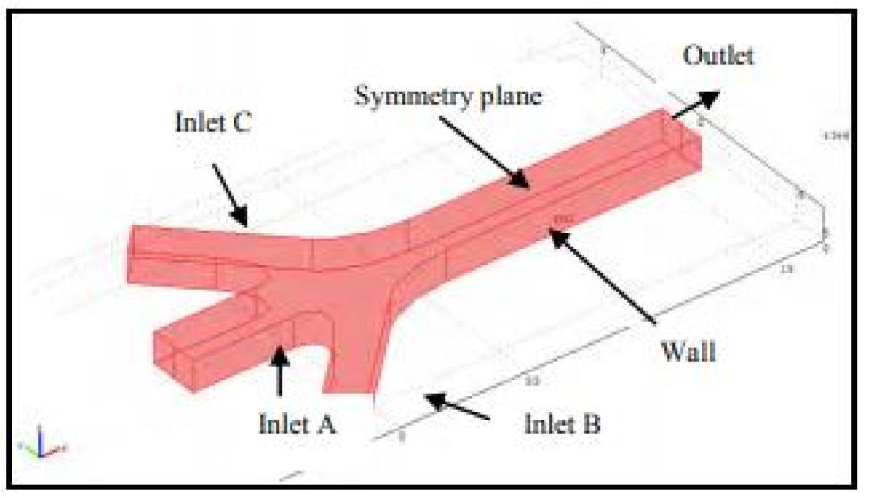at a concentration of 1.3 mol/m^3 and an arc length of 0.12µm, according to the results in the paper.

The image to the left shows a single inlet single outlet micro-chamber designed for a uniform filling of fluids. Similar to the micro-mixer, the boundary conditions, fluid properties were well defined.

They deduced some interesting results based of the simulation study in COMSOL

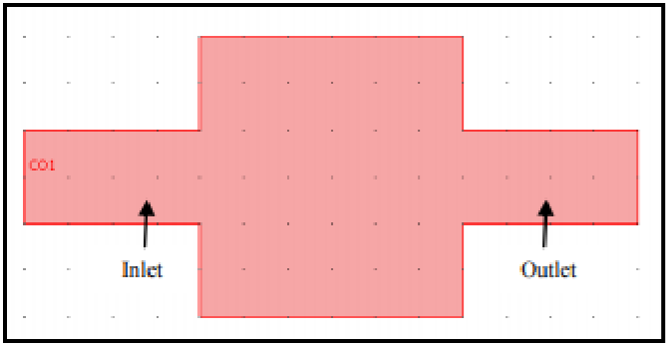Multiphysics.

Concentration distribution

Velocity distribution

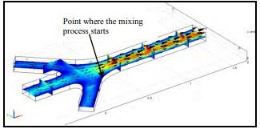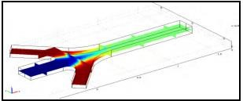

The mixing occurred around 60%-70% at the junctions before the liquids flow through the main microchannel. The highest concentration of fluid was set at 2.00 mol/m^3, and the low concentration is set at 1.00 mol/m^3. The mixing stabilized after reach 1.3 mol/m^3.

Another interesting paper fabricated, modeled, and tested a thin film Au/Ti micro-heater. Pyrex bulk substrate was used to fabricate the device, and a finite element-based model was employed to decipher the performance. Though it wasn’t directly related to our project, it was

an interesting read.

Images of the modelled micro

-

heater

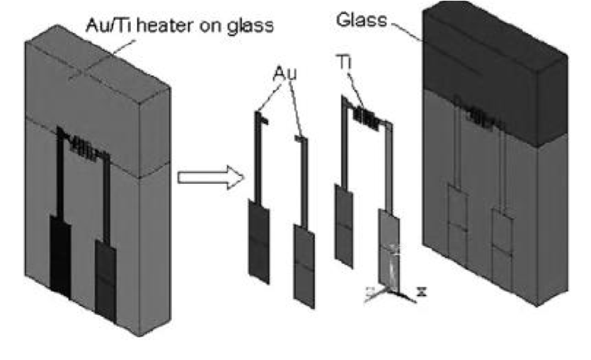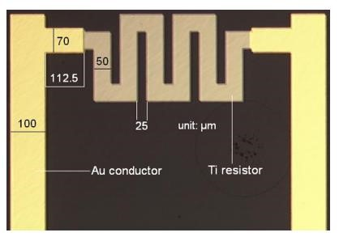

In the literature review process, I came across several review papers that gave a comprehensive overview of the applications of different microfluidics in different fields. For example, it covered clinical analysis, blood sampling, DNA analysis, quality control, food analysis, cellonomics, fluid mixing, petroleum testing, etc. It was fascinating to see the wide range of applications and how different devices suit different applications.

In the last part of the literature review, I read papers on the different numerical analysis techniques that helped in modeling microfluidic devices. This gave me a general overview of numerical techniques and tools such as finite element (FE), finite volume (FV), boundary element, etc. These techniques differ from each other, and by choosing a particular technique, we can extract the equations that we require for modeling the device.

**Introduction to modelling and simulation of microfluidic devices in COMSOL**

I designed a simple microfluidic device for capillary-driven two-phase laminar flow of air and water. It was a single-inlet-single-outlet 2D asymmetric model comprising two rectangles and a moving boundary. I defined the necessary fluid properties like wettability, surface tension, adhesive forces, etc.

|  |  |  |
| --- | --- | --- |
| |  | | --- | | B |      |  | | --- | | A | |

The model is of the device is given in the image below. The inlet is illustrated with ‘A,’ and the outlet is ‘B.

’

A time-dependent study was performed, keeping pressure and velocity in mind.

The velocity and pressure profiles after the time of simulation have exceeded given below.

The velocity profile

The

pressure

pro

file

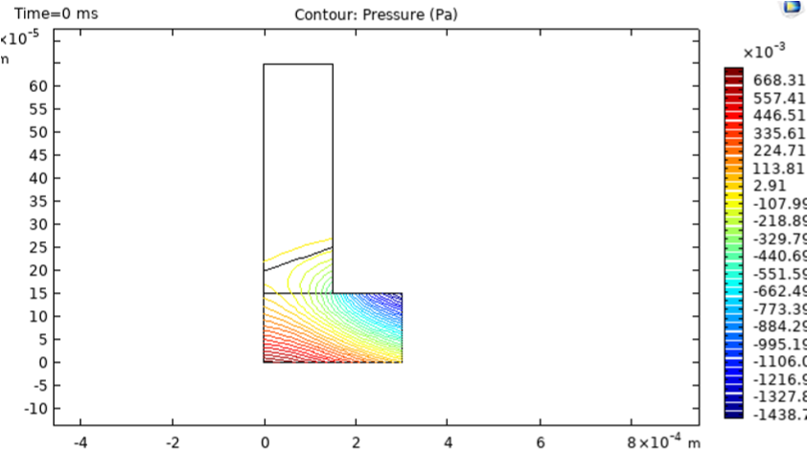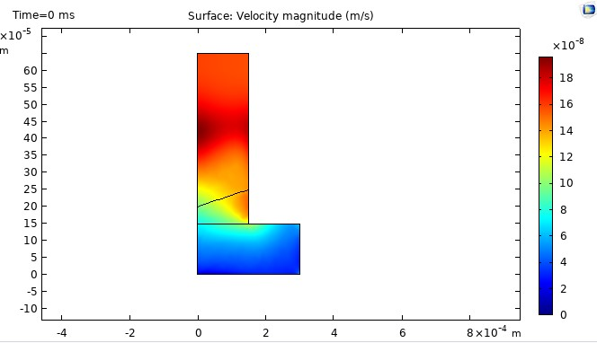

**MICROFLUIDIC VISCOMETER**

We now delve into the specifics of the project. Trying to learn, model, and simulate the viscometer keeping the basic working principle mentioned above in mind.

**Literature Review:**

Read papers on microfluidic viscometers. The articles included the different types of viscometer, the various applications, the different dimensional parameters, etc.

To summarise:

* *Different applications and opportunities in microfluidic viscometers*

1. *Adulteration:* The more inferior quality adulterated fluid can be differentiated from the pure fluid.
2. *Biomedical diagnostics*: Many human body fluids may be differentiated based on the viscosity of the body fluid. This helps us in medical applications. For example, Diabetes can be monitored by comparing the deviation in the viscosity of the blood serum with the typical person.

* *Different flow approaches associated with microfluidic viscometers*

1. *Pressure-driven flow:* Pressure-driven flow is supported by the ‘no-slip boundary condition, whereby at the walls of the microchannel, the velocity of the fluid needs to be zero.
2. *Electro Osmotic flow*: Electroosmotic flow is an alternative for the pressure-driven flow. The velocity across every point in the microchannel can become constant, and a plug-like flow can be achieved.
3. *Capillary Flow*: Capillary flow is the flow of the fluid without any interference of the external forces in a small space with the least opposition for the flow.

* *Dimension parameters associated with microfluidic viscometers*

1. *Knudsen’s number:*Knudsen’s number helps in deciding whether the designed fluid dynamics model is a continuum or not.
2. *Reynold’s number:*A number that decides whether the fluid flow is laminar or turbulent.
3. *Co-laminar flow*
4. *Peclet’s number*: Peclet’s number is a dimensionless number that gives information on the heat or the mass transfer in the model.
5. *Schmidt Number*: Schmidt number is given by the diffusion of the momentum of the fluid and mass of fluid’s diffusion
6. *Rayleigh Number*: Rayleigh number gives information on the natural or the free convection in the buoyancy-driven flow.

And few other parameters

* *Different working principles of microfluidic viscometers*:

1. Electro-mechanical methods: In this approach, change in the viscosity can be measured by measuring the mechanical response by converting it to the electrical response by integrating various mechanical and electronic components.

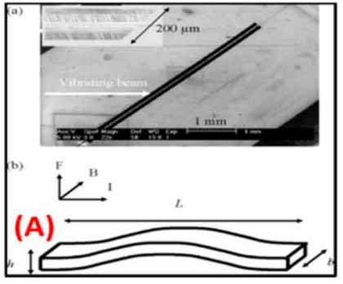The image to the left depicts an electromechanical microfluidic viscometer that uses electricity and magnetism to result in a functional Lorentz force F and uses this methodology to identify the viscosity.

1. *Optical methods:* Using optical methods to measure the viscosity of the fluid in the microchannel.

The image below shows a combination of optical and electromechanical viscosity measurement microfluidic device.

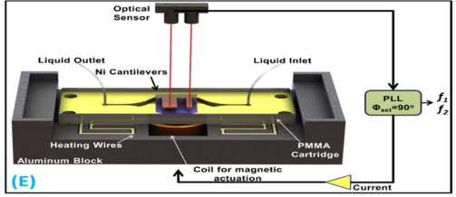

1. *Paper-based analytical devices*: Paper based devices do not generally need power, unlike the electromechanical and optical methods.

The image below shows a paper based microfluidic viscometer.

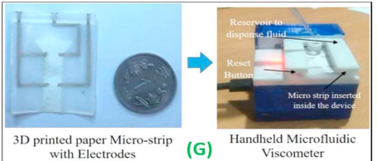

**Simulation & Design of micro pump and a microchannel:**

A micropump was designed to increase the velocity of fluids whose viscosity is high. This device allows a uniform increase in surface flow. The design was a simple nozzle-based device that increased the fluid velocity at the expense of pressure and area.

The design of the 2D micropump comprises a 100umx100um rectangle, truncated triangle, and microchannel of 40umx300um, as shown in the figure below.

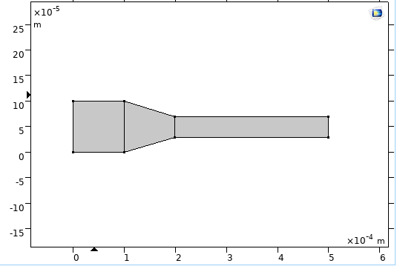

The material and fluid properties were specified in COMSOL for laminar flow. The inlet, outlet, and walls of the device were added to the software. The appropriate study parameters were set. The fluid used for simulation purposes was water. A pressure-driven flow approach where the velocity of the fluid at the boundary was zero.

The results of the simulations show that the surface flow velocity increased by up to 3 times.

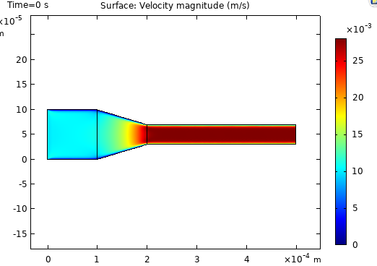The surface flow velocity profile and the pressure contours are given below. 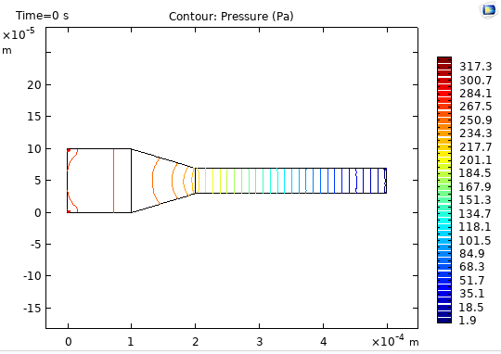

**Approach to finding the contaminants in the fluid:**

It is pretty clear that the viscosity of the fluid changes when a contaminant is added. For this analysis, let us consider the viscosities of hydrophobic room temperature ionic liquids in dissolved water. The data for viscosity vs. water content for three hydrophobic room-temperature ionic liquids show that their viscosities are strongly dependent on the amount of dissolved water. Table 1 in paper 8 shows the necessary data.

We now need to understand the relation between viscosity, laminar flow, and velocity.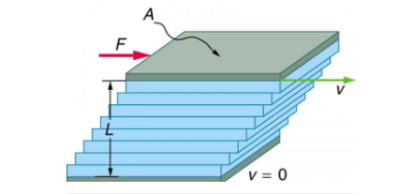

A force F is required to keep the top plate in Figure 3 moving at a constant velocity v, and experiments have shown that this force depends on four factors. First, F is directly proportional to v (until the speed is so high that turbulence occurs—then a much larger force is needed, and it has a more complicated dependence on v). Second, F is proportional to the area A of the plate. This relationship seems reasonable, since A is directly proportional to the amount of fluid being moved. Third, F is inversely proportional to the distance between the plates L. This relationship is also reasonable; L is like a lever arm, and the greater the lever arm, the less force that is needed. Fourth, F is directly proportional to the coefficient of viscosity, η. The greater the viscosity, the greater the force required. These dependencies are combined into the equation:

Re-arranging, we get,

This gives us an inverse relationship between viscosity and velocity of the fluid, i.e.

Using the above relations and the length of the microchannel, we can determine the time taken for two different fluids to traverse the same distance.

We now use the first two columns of table 1 in paper 8 for the ionic liquid [C4mim][Tf2N] to calculate the difference in time taken to traverse the same distance of the microchannel.

*(Assuming all other constants remain the same and the force is assumed to be approximately the same value)*

This difference of almost 1 second allows us to differentiate the two fluids. To get a clearer result a longer channel or a better micropump can be employed.

Extrapolating the same analysis to different viscosities we get the following graph:

**REFERENCES**

1. U. Hashim, P. N. A. Diyana and T. Adam, "Numerical simulation of Microfluidic devices," 2012 10th IEEE International Conference on Semiconductor Electronics (ICSE), 2012, pp. 26-29, doi: 10.1109/SMElec.2012.6417083.
2. K.L. Zhang, S.K. Chou, S.S. Ang, Fabrication, modeling and testing of a thin film Au/Ti microheater, International Journal of Thermal Sciences, Volume 46, Issue 6, 2007, Pages 580-588, ISSN 1290-0729, https://doi.org/10.1016/j.ijthermalsci.2006.08.002.

(https://www.sciencedirect.com/science/article/pii/S1290072906001505)

1. Crevillén AG, Hervás M, López MA, González MC, Escarpa A. Real sample analysis on microfluidic devices. Talanta. 2007 Dec 15;74(3):342-57. doi: 10.1016/j.talanta.2007.10.019. Epub 2007 Oct 18. PMID: 18371648.
2. David Erickson, Dongqing Li, Integrated microfluidic devices, Analytica Chimica Acta, Volume 507, Issue 1, 2004, Pages 11-26, ISSN 0003-2670, https://doi.org/10.1016/j.aca.2003.09.019.

(https://www.sciencedirect.com/science/article/pii/S0003267003012261)

1. Helene Andersson, Albert van den Berg, Microfluidic devices for cellomics: a review,

Sensors and Actuators B: Chemical, Volume 92, Issue 3, 2003, Pages 315-325, ISSN

0925-4005, https://doi.org/10.1016/S0925-4005(03)00266-1.

(https://www.sciencedirect.com/science/article/pii/S0925400503002661)

1. Erickson, D. Towards numerical prototyping of labs-on-chip: modeling for integrated microfluidic devices. Microfluid Nanofluid 1, 301–318 (2005). https://doi.org/10.1007/s10404-005-0041-z
2. 10.1088/2631−8695/abfd47, https://doi.org/10.1088/2631−8695/abfd47, 2021, may, IOP Publishing, 3, 2, 022003, SB Puneeth and Madhusudan B Kulkarni and Sanket Goel, Microfluidic viscometers for biochemical and biomedical applications: A review, Engineering Research Express
3. The effect of dissolved water on the viscosities of hydrophobic room-temperature ionic liquids, Widegren, Jason A., Laesecke, Arno, Magee, Joseph W., 2005, 1610, 1612, Chemical Communications, PB - The Royal Society of Chemistry, 1359-7345, 10.1039/B417348A, 10.1039/B417348A, <http://dx.doi.org/10.1039/B417348A>

_________________________________________________________________________