Assignment 3 – Cloud Functions

DS 561 – Cloud Computing

Vishwas Bhaktavatsala

U74206902

[vishwasb@bu.edu](mailto:vishwasb@bu.edu)

GitHub Url: <https://github.com/vishwas21/DS561-vishwas-assignments>

Steps to run the First app locally:

1. Download the code from the above link.
2. Install all the python dependencies using the command python pip3 install -r requirements.txt.
3. We can run the python code using the command functions-framework-python --target ds561_fileRequest_http --debug
4. Now this function can be tested using the browser using the link <http://localhost:8080>

Steps to run the Second App:

1. Download the code if you have not already downloaded using the git clone command
2. Install all the python dependencies using the command python pip3 install -r requirements.txt.
3. Run the Consumer Code using the command – python3 consumerApp.py

Commands used to deploy the Cloud Function:

gcloud functions deploy ds561-python-http-server \

--gen2 \

--runtime=python311 \

--region=us-central1 \

--source=. \

--entry-point=ds561_fileRequest_http \

--trigger-http \

--allow-unauthenticated \

--memory=256MB \

--max-instances=83

Command to describe the Cloud function which was just deployed:

gcloud functions describe ds561-python-http-server \

--region us-central1

Output:

buildConfig:

build: projects/776935284294/locations/us-central1/builds/2f374b1b-59d1-4ca5-a2d6-a0297a26c471

dockerRegistry: ARTIFACT_REGISTRY

entryPoint: ds561_fileRequest_http

runtime: python311

source:

storageSource:

bucket: gcf-v2-sources-776935284294-us-central1

generation: '1696977664596551'

object: ds561-python-http-server/function-source.zip

sourceProvenance:

resolvedStorageSource:

bucket: gcf-v2-sources-776935284294-us-central1

generation: '1696977664596551'

object: ds561-python-http-server/function-source.zip

environment: GEN_2

labels:

deployment-tool: cli-gcloud

name: projects/ds561-visb-assignment/locations/us-central1/functions/ds561-python-http-server

serviceConfig:

allTrafficOnLatestRevision: true

availableCpu: '0.1666'

availableMemory: 256M

ingressSettings: ALLOW_ALL

maxInstanceCount: 83

maxInstanceRequestConcurrency: 1

revision: ds561-python-http-server-00001-cot

service: projects/ds561-visb-assignment/locations/us-central1/services/ds561-python-http-server

serviceAccountEmail: 776935284294-compute@developer.gserviceaccount.com

timeoutSeconds: 60

uri: https://ds561-python-http-server-gbzbgqktlq-uc.a.run.app

state: ACTIVE

updateTime: '2023-10-10T22:42:28.557170555Z'

url: https://us-central1-ds561-visb-assignment.cloudfunctions.net/ds561-python-http-server

Command used to run the http_client.py:

python3 http_client.py -d ds561-python-http-server-gbzbgqktlq-uc.a.run.app -b /ds561-python-http-server/ds561_fileRequest_http -i 10000 -n 200 -v -w none

Screenshots:

After running the http_client.py code - Logs

Browser Call – GET Request

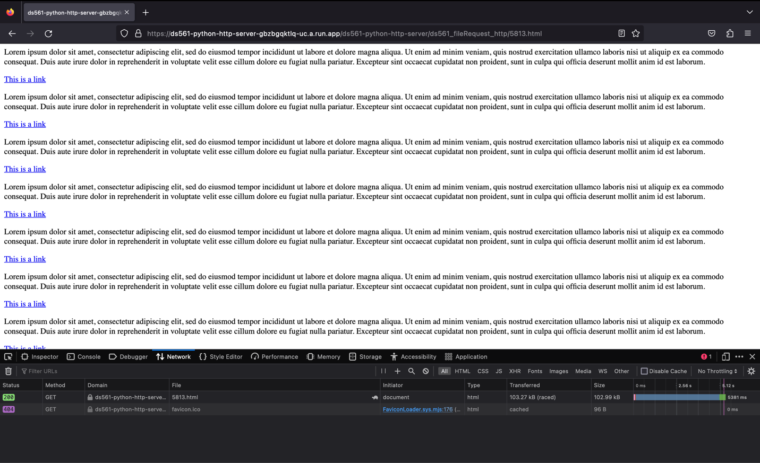

Browser Call – POST Request

Curl Command – GET Method

Second App - Output

