Module Name: Defect Reporting
Test Case ID: st_05
Tester Name: Narigara Vishwas (Enrollment No: 2504030100054)
Webpage URL: https://www.saucedemo.com/

TC 001:-login page
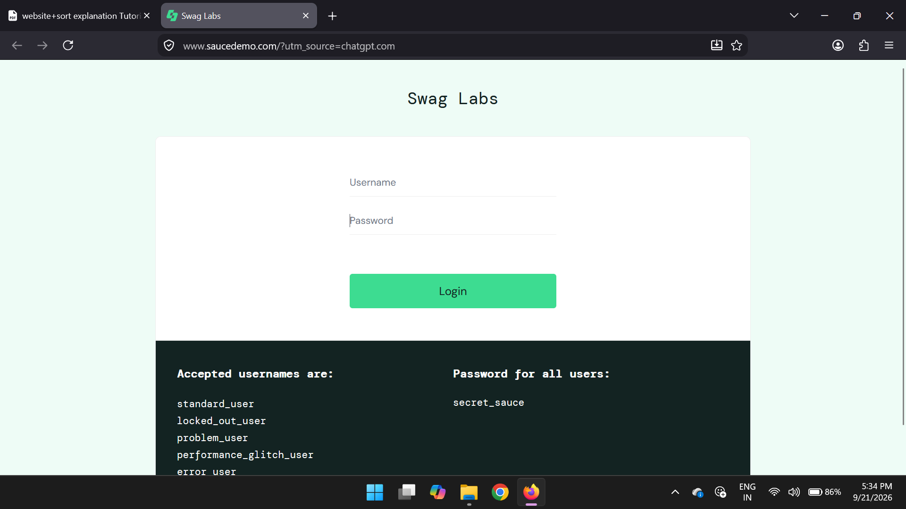
TC 002:-invalid username/password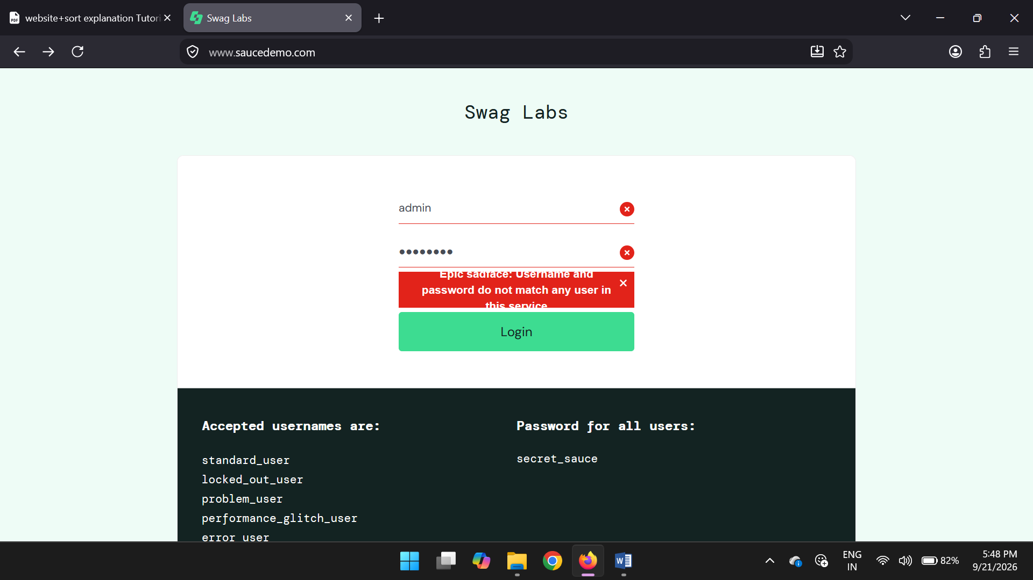

TC 003:-homepage
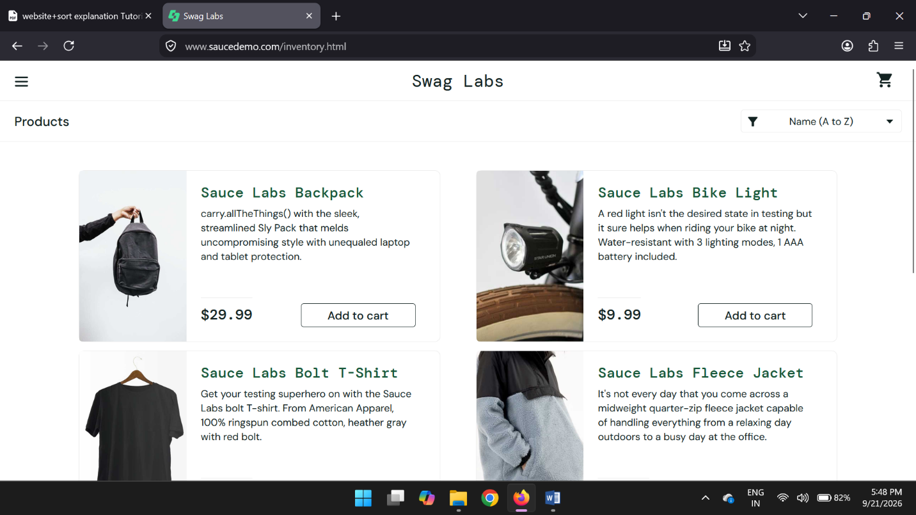
TC 004:-product displayed
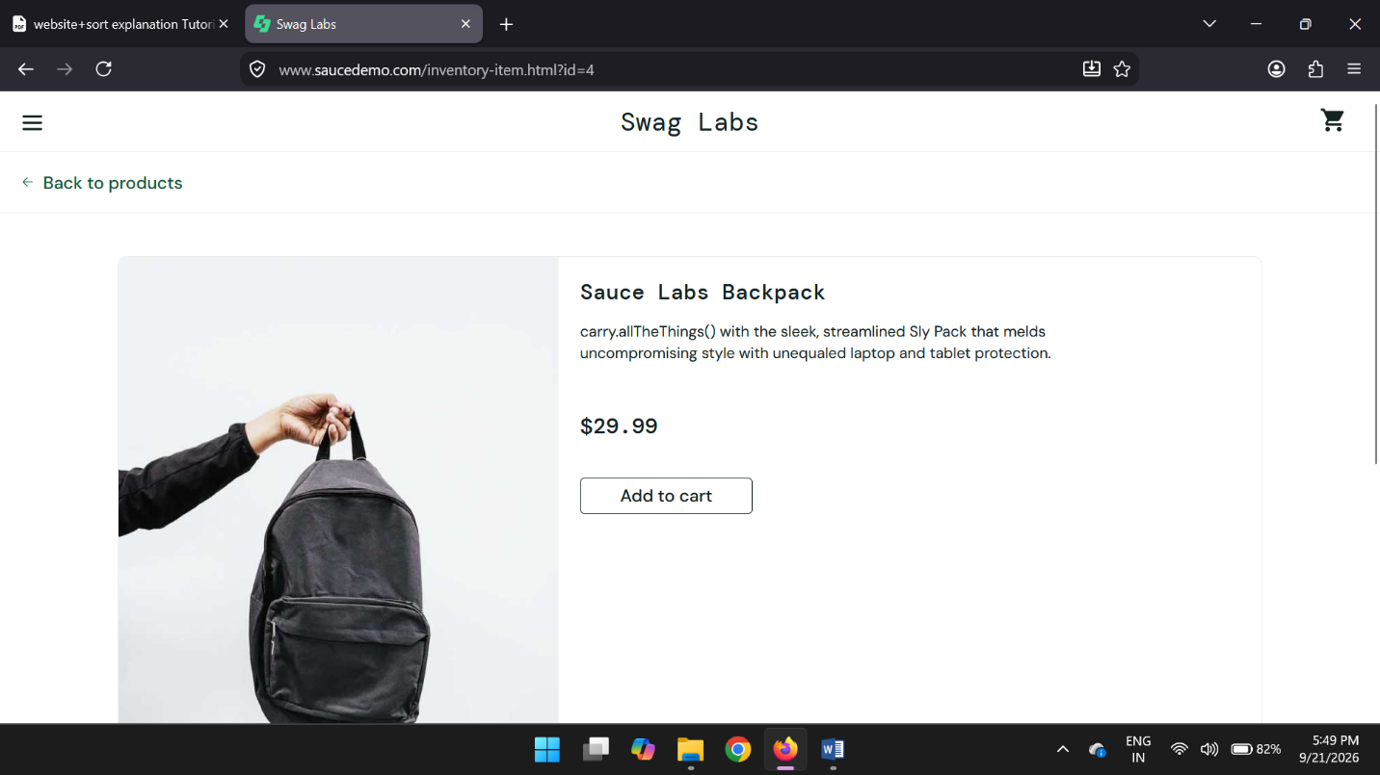

TC005:-product add to cart
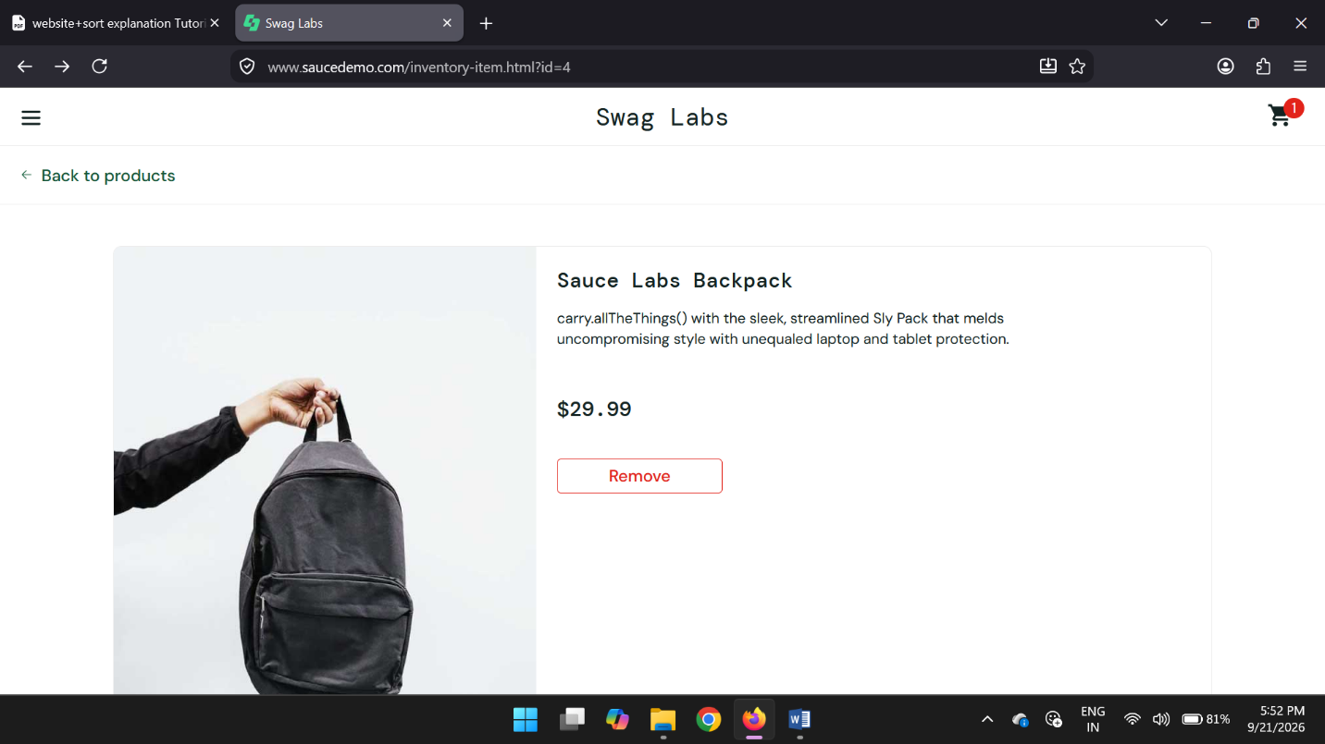
TC 006:-view cart
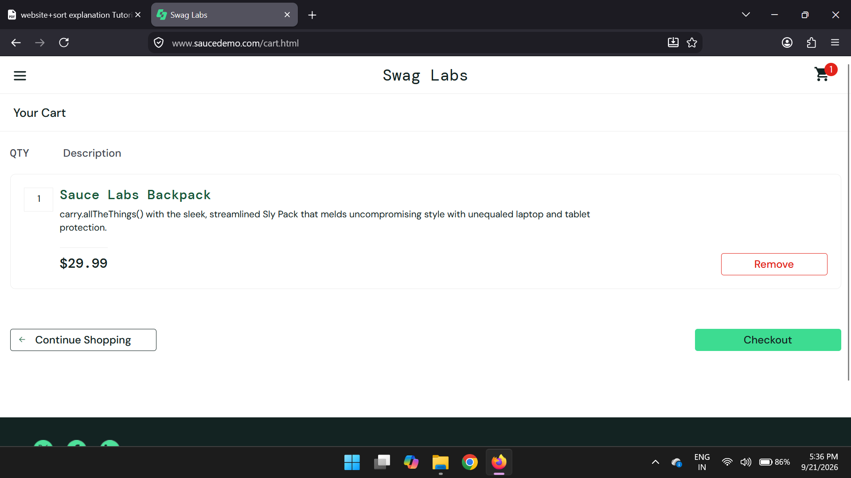

TC 007:-remove item from cart
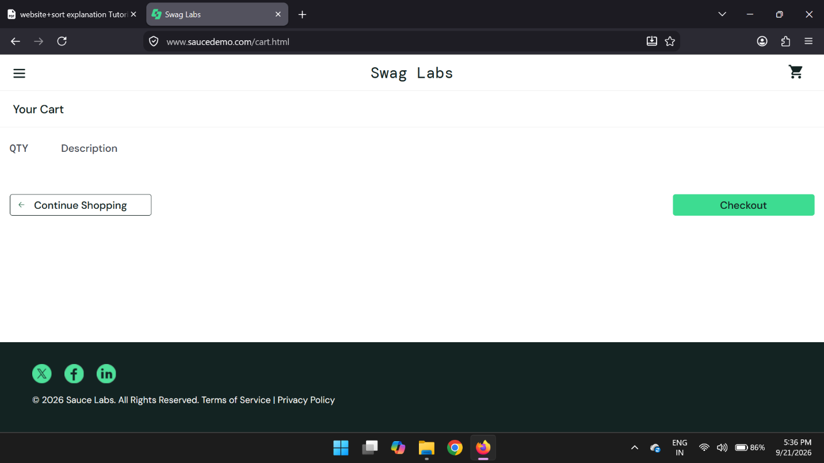
TC 008:-checkout
