Module Name: AI-Assisted Software Testing
Test Case ID: st_12
Tester Name: Narigara Vishwas (Enrollment No: 2504030100054)
Webpage URL: https://www.automationexercise.com/

TC LOGIN 01:- Open login page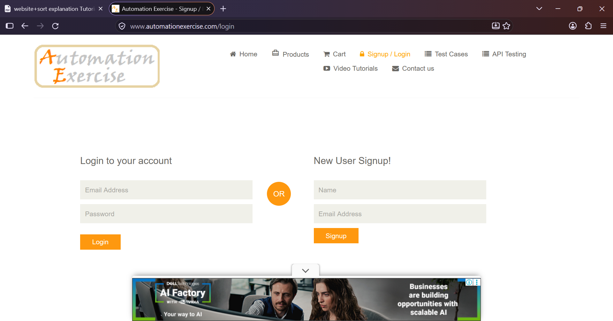
TC LOGIN 02:- Login with valid credentials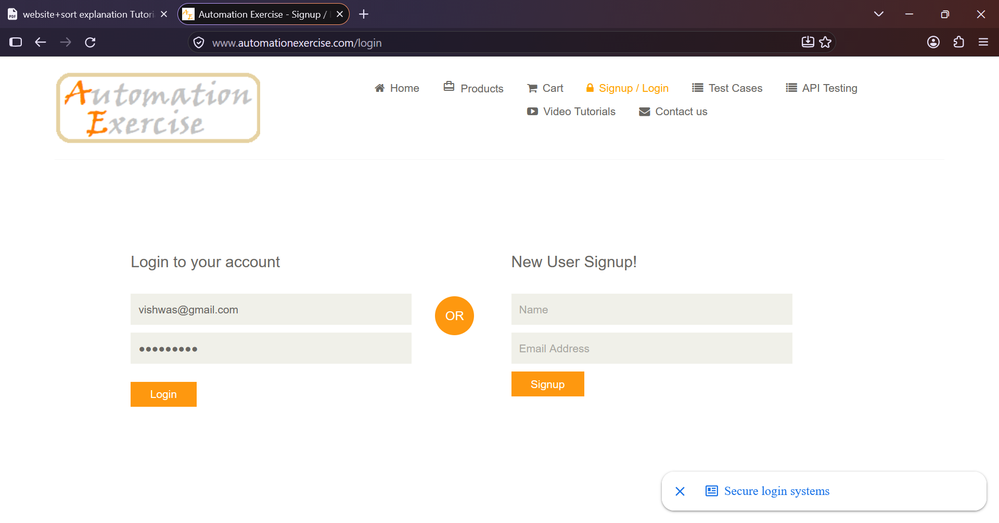
TC LOGIN 03:- Login with incorrect password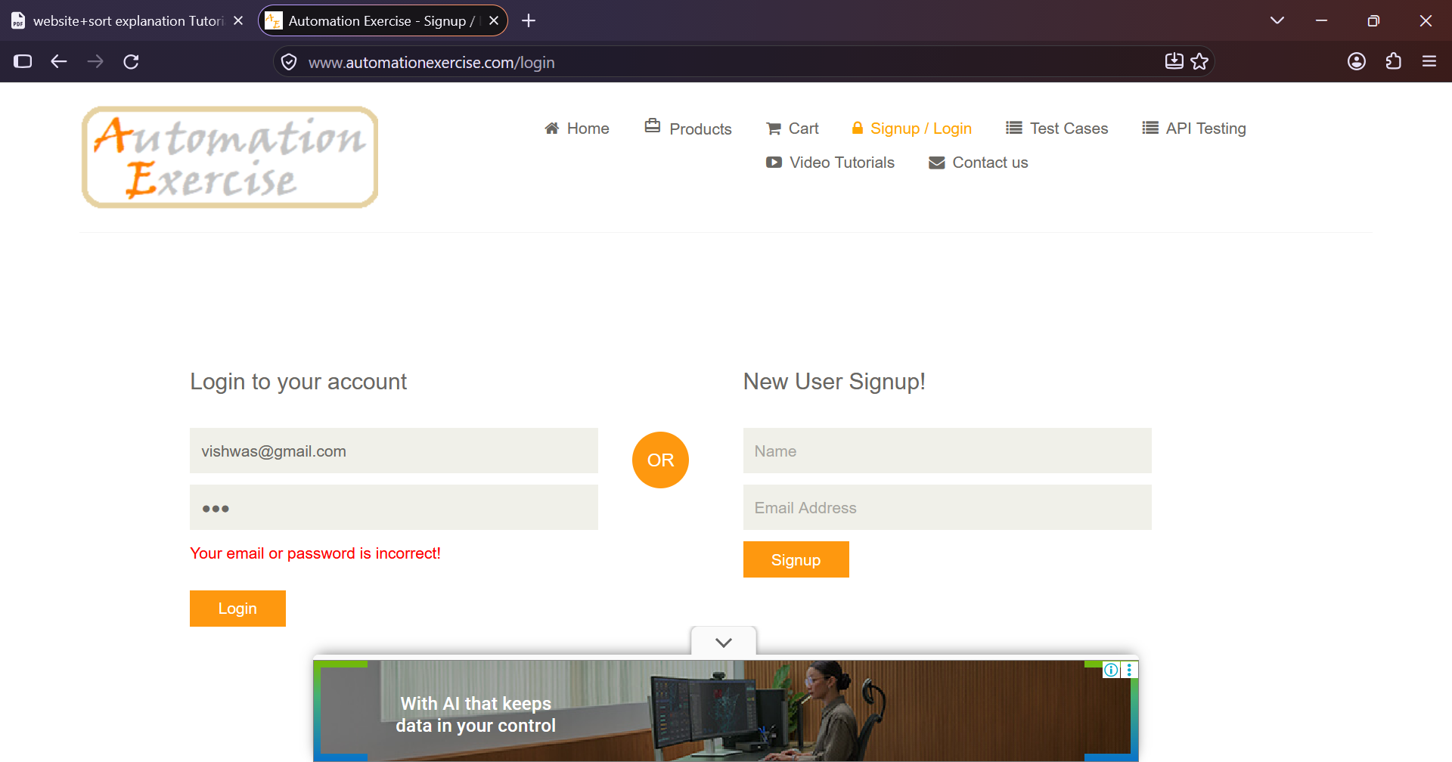
TC LOGIN 04:- Submit with both fields empty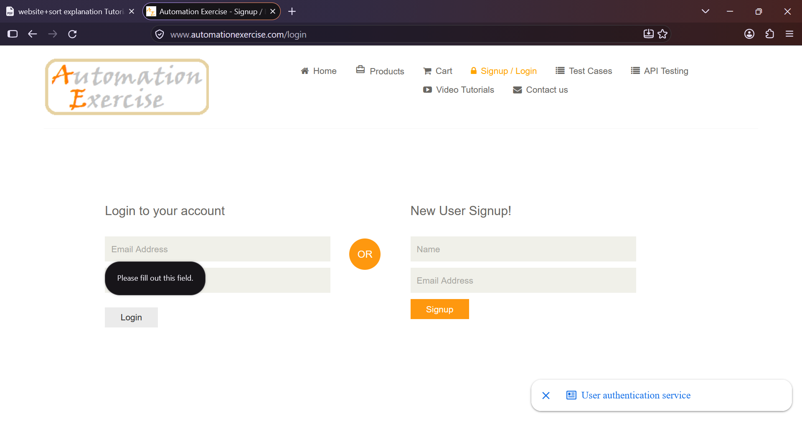
TC LOGIN 05:- Submit with email empty
TC LOGIN 06:- Submit with password empty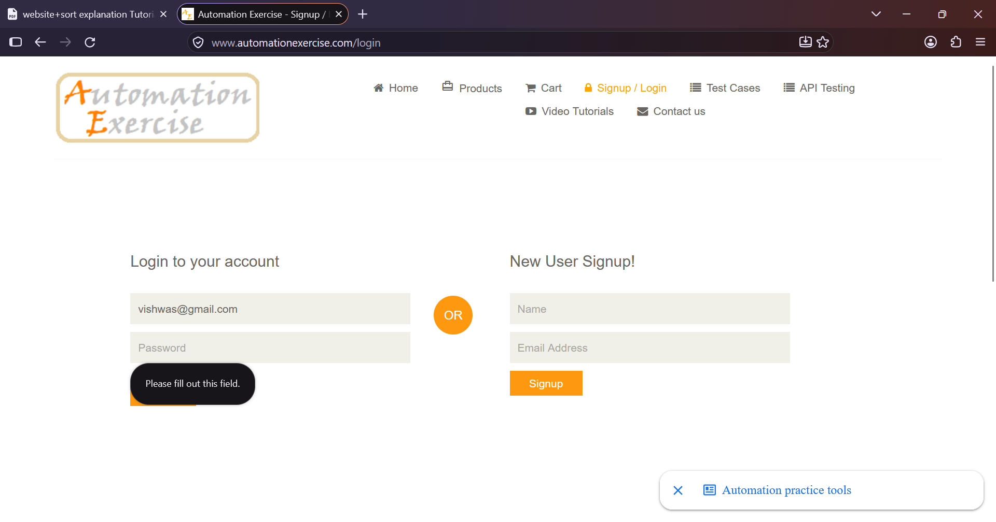
TC LOGIN 07:- Logout after successful login

