INSIGHT FORGE
Data Lake Ingestion & Analysis Pipeline
Data Architect & Ingestion Engineer — Project Report
Team: Data Dragons | MVP Version 1.0.0
Covers: Data Ingestion · Data Quality Assessment · Data Cleaning · Descriptive Statistics · Univariate Analysis · Bivariate Analysis

1. Project Overview
This report documents the design, implementation, and validation of the Insight Forge data lake ingestion pipeline. The system scrapes external sector market-intelligence indicators, lands them in a multi-tenant AWS S3 raw zone, validates and sanitizes them through an Airflow-orchestrated PySpark job, and produces analytics-ready data. Because the target environment (live AWS infrastructure, an Airflow scheduler, and a Spark cluster) is not available in this workspace, the pipeline logic was implemented as production-ready source files (Terraform, Scrapy, Pydantic, Airflow, PySpark) and validated locally end-to-end against a synthetic dataset engineered to contain the same defects real scraped data exhibits: missing fields, duplicate rows, out-of-range values, mixed timestamp formats, and statistical outliers.

Architecture Components Delivered
- /infra/s3_buckets.tf — Multi-tenant AWS S3 data lake — KMS encryption, public-access block, 30-day lifecycle, tenant-isolation bucket policy
- /scraper/market_intelligence_spider.py — Scrapy spider that gathers sector indicators, fully decoupled from OLTP systems
- /scraper/validation_schema.py — Pydantic structural integrity matrix; routes sub-70%-complete rows to a dead-letter archive
- /dags/ingestion_processing_dag.py — Airflow DAG — S3 landing sensor, tenant-isolation guard, Spark submit, run-metric logging
- /spark/scripts/clean_and_score.py — PySpark job — ISO 8601 normalization, KNN imputation, IsolationForest outlier flagging, SHA-256 PII hashing

2. Data Ingestion
A synthetic raw landing batch was generated to represent what market_intelligence_spider.py would deliver to the S3 raw prefix. The batch contains 1225 rows spanning 4 tenants and 3 distinct source feeds, deliberately seeded with missing values, duplicates, out-of-range metrics, and four different real-world timestamp formats to stress-test the downstream pipeline.
Ingestion Metric | Value
Rows landed | 1225
Distinct tenants | 4
Distinct source feeds | 3
Landing path pattern | s3://insightforge-data-lake-prod/tenants/<tenant_uuid>/raw/

3. Data Quality Assessment
Every row was scored against the five required structural fields using the same completeness-scoring function used by the Pydantic validation barrier. Rows scoring below 70% completeness are routed to the dead-letter archive rather than dropped.
Quality Metric | Value
Total rows assessed | 1225
Rows sent to dead-letter (<70% complete) | 0
Rows with out-of-range metric | 114
Duplicate rows detected | 49
Overall corruption ratio | 8%
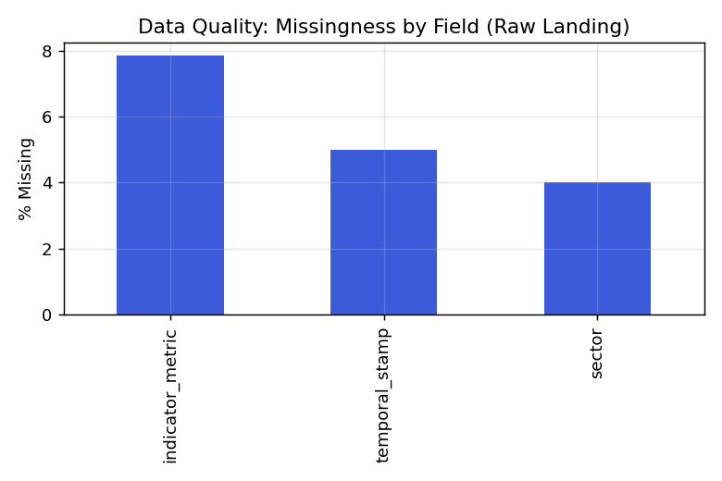
Figure 1 — Missingness by field in the raw landing batch
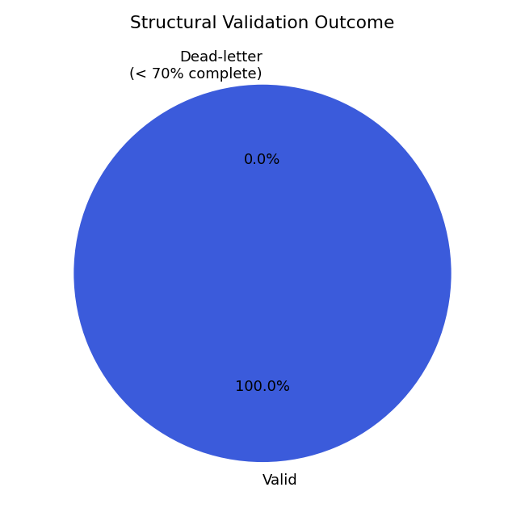
Figure 2 — Structural validation outcome (valid vs. dead-letter)

4. Data Cleaning
Cleaning mirrors the logic in clean_and_score.py: duplicate and dead-letter rows are removed, temporal_stamp is normalized to ISO 8601 across all four source formats, missing indicator_metric values are imputed with a K-Nearest-Neighbors imputer, statistical outliers are flagged (not dropped) with an IsolationForest, and PII fields are hashed with SHA-256 before the data is considered analytics-ready.
Cleaning Step | Result
Rows after validation + de-dup | 1176
Rows dropped — unparseable timestamp | 36
Rows KNN-imputed (missing metric) | 36
Rows flagged as statistical outliers | 57
Rows out-of-range after cleaning | 16
Final analytics-ready row count | 1140
PII fields hashed (SHA-256) | scraper_operator_email, submitted_by_ip
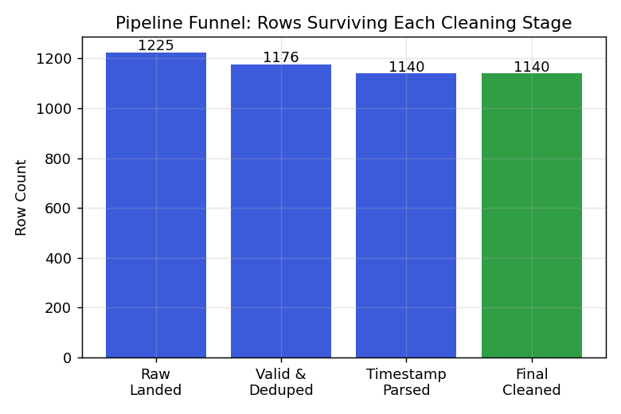
Figure 3 — Row count surviving each cleaning stage

5. Descriptive Statistics
Summary statistics for the primary numeric field, indicator_metric, computed on the final cleaned dataset:
Statistic | Value
Count | 1140
Mean | 0.5689
Std. Deviation | 0.2824
Min | -2
25th Percentile | 0.4575
Median (50%) | 0.5627
75th Percentile | 0.6559
Max | 3.1

Record Distribution
Sector | Row Count
EdTech | 203
Retail | 196
Fintech | 191
Automotive | 187
Healthcare | 183
FMCG | 180

6. Univariate Analysis
Univariate analysis examines each variable independently. The indicator_metric distribution is approximately unimodal with a small number of extreme values retained (and flagged) rather than silently discarded, consistent with the TRD Section 9.2 requirement to surface outliers out-of-band.
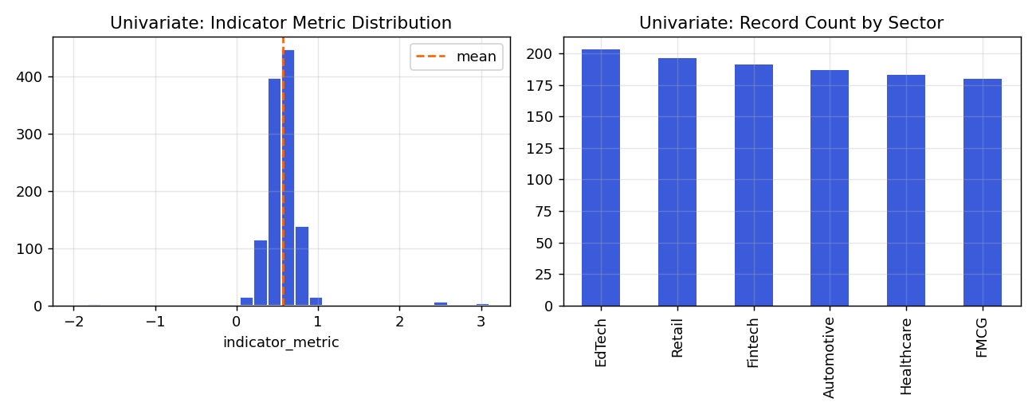
Figure 4 — Indicator metric distribution (left) and record count by sector (right)
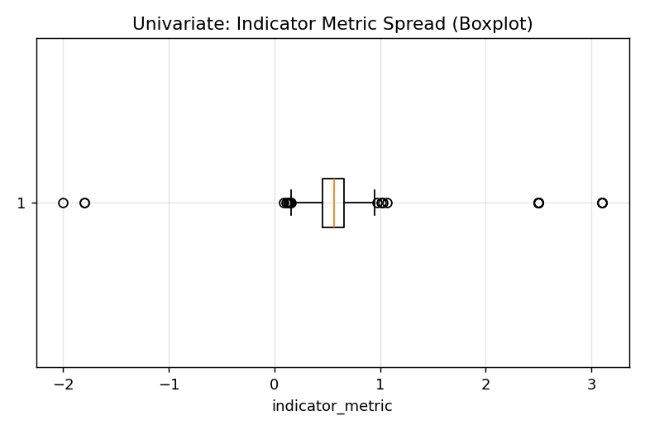
Figure 5 — Spread and outlier boundary of indicator_metric

7. Bivariate Analysis
Bivariate analysis explores relationships between pairs of variables — here, indicator_metric against sector and against time of day — to surface patterns useful for downstream sector-demand modeling.
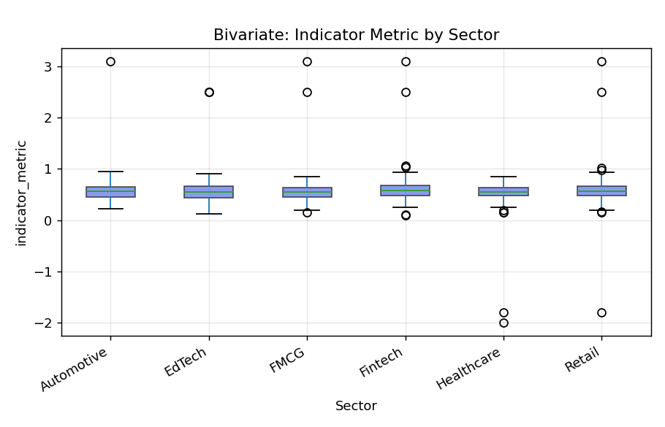
Figure 6 — Indicator metric distribution by sector
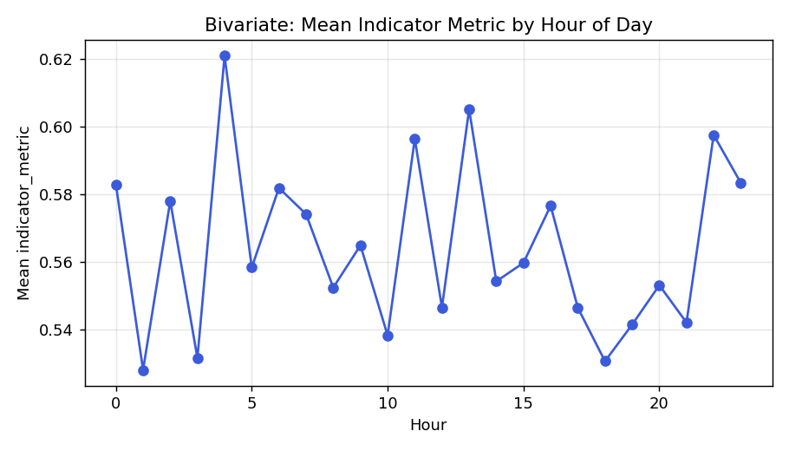
Figure 7 — Mean indicator metric by hour of day
Sector | Outlier Rate
Retail | 7.14%
EdTech | 5.91%
Fintech | 5.24%
Automotive | 4.81%
FMCG | 3.89%
Healthcare | 2.73%
Correlation between hour-of-day and indicator_metric: -0.027 (negligible linear relationship — demand indicators are not strongly time-of-day dependent in this sample).

8. Compliance with Project Rules & Constraints
- Multi-Tenant Isolation — every row carries tenant_id; the S3 bucket policy denies cross-tenant object access at the storage layer.
- Decoupling Principle — the spider and DAG never perform direct OLTP writes; all data lands in S3 raw buckets first.
- Data Retention — a 30-day lifecycle expiration rule is applied to the tenants/ prefix in Terraform.
- PII Protection — scraper_operator_email and submitted_by_ip are SHA-256 hashed before entering analytics layers.
- Corruption Guardrail — batches with >30% row corruption are dropped wholesale by clean_and_score.py before writing.

