PayFlow — Comprehensive Project Write-Up & Answers
This document serves as the complete, comprehensive write-up for the PayFlow UPI-style backend assignment. It contains H2 console database verifications, screenshot integrations for every task, @RequestBody demonstration logs, and the conceptual answers.
------------------------------------------------------------
Part 1: H2 Database Schema Verification (Task 2)

Before inserting any transactional data, the database tables were generated automatically by Spring Data JPA and verified directly in the H2 in-memory web console (/h2-console). Below are the screenshots showing that both tables have been generated successfully with correct columns, matching Java entities.
A. Empty Users Table Structure
The 'USERS' table is generated with columns: 'USER_ID' (Primary Key, Identity), 'BALANCE' (Double), 'NAME' (Varchar), 'PHONE_NUMBER' (Varchar), and 'UPI_ID' (Varchar).
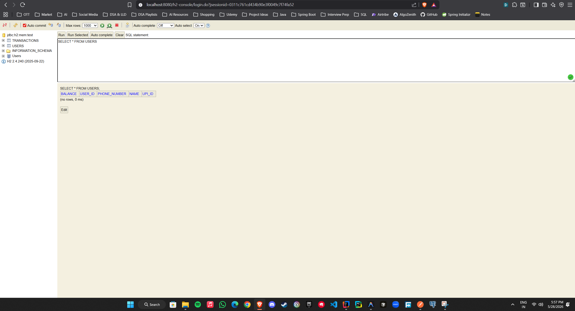
Figure 1: Empty 'USERS' table structure showing correct autogenerated columns.

B. Empty Transactions Table Structure
The 'TRANSACTIONS' table is generated with columns: 'TRANSACTION_ID' (Primary Key, Identity), 'AMOUNT' (Double), 'NOTE' (Varchar), 'RECEIVER_UPI_ID' (Varchar), and 'SENDER_UPI_ID' (Varchar).
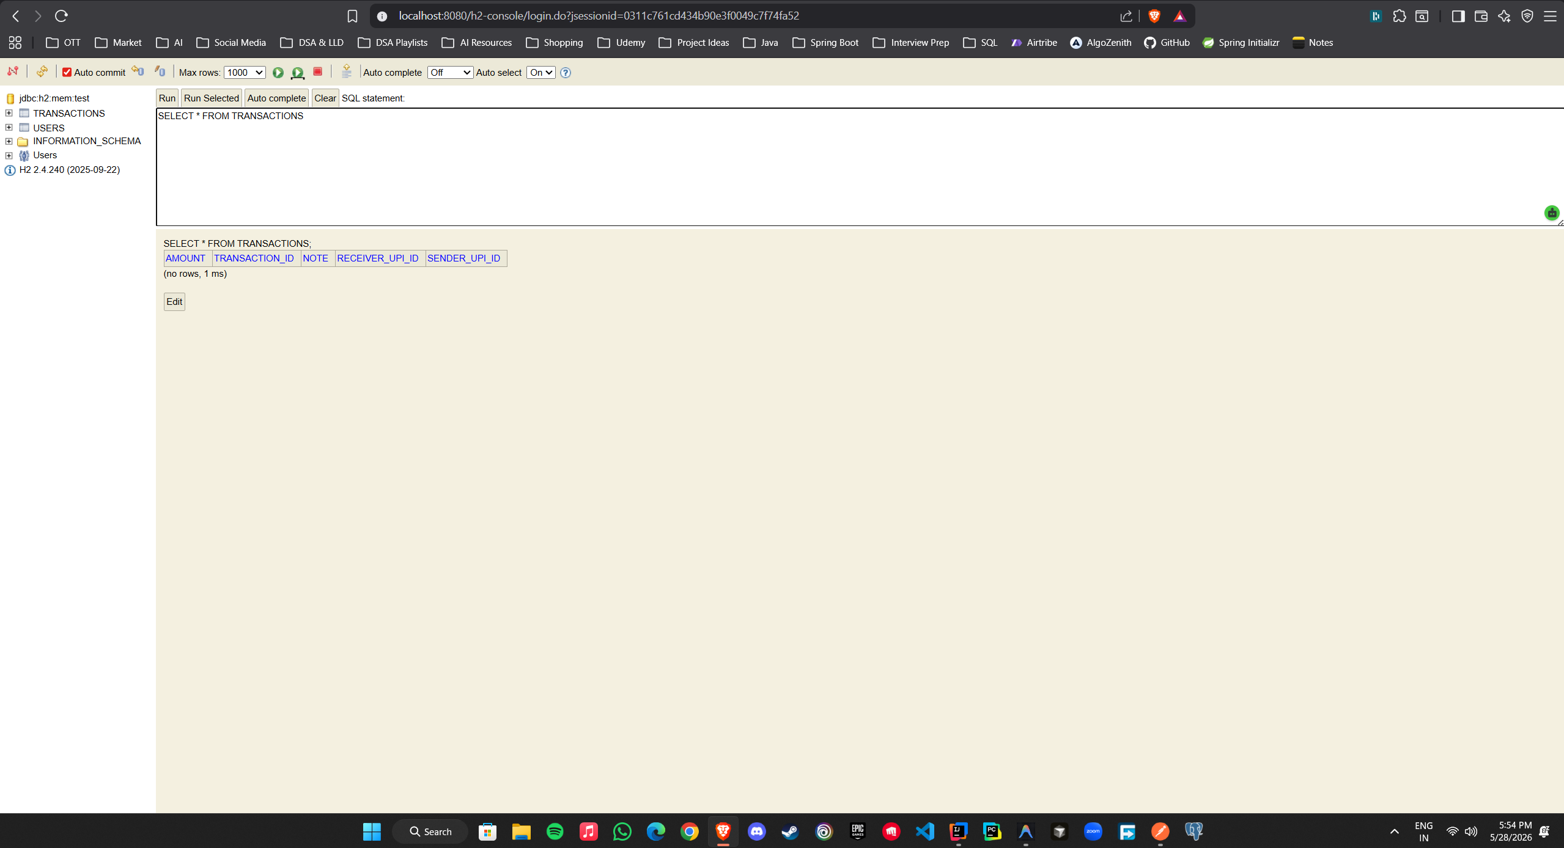
Figure 2: Empty 'TRANSACTIONS' table structure showing correct autogenerated columns.

Part 2: REST Endpoints & Data Insertion Verification (Task 5)

To verify standard API workflows, we registered two users ('Priya' and 'Rahul') using POST /users, and initiated a transfer using POST /transactions. The H2 Console captures below verify that the balance deduction and transaction records are successfully persisted in the database.
A. Populated Users Table (Post-Transaction)
Following successful user registration and transaction execution, the 'USERS' table shows both registered records with their updated financial balances. Priya's balance is deducted and Rahul's is credited.
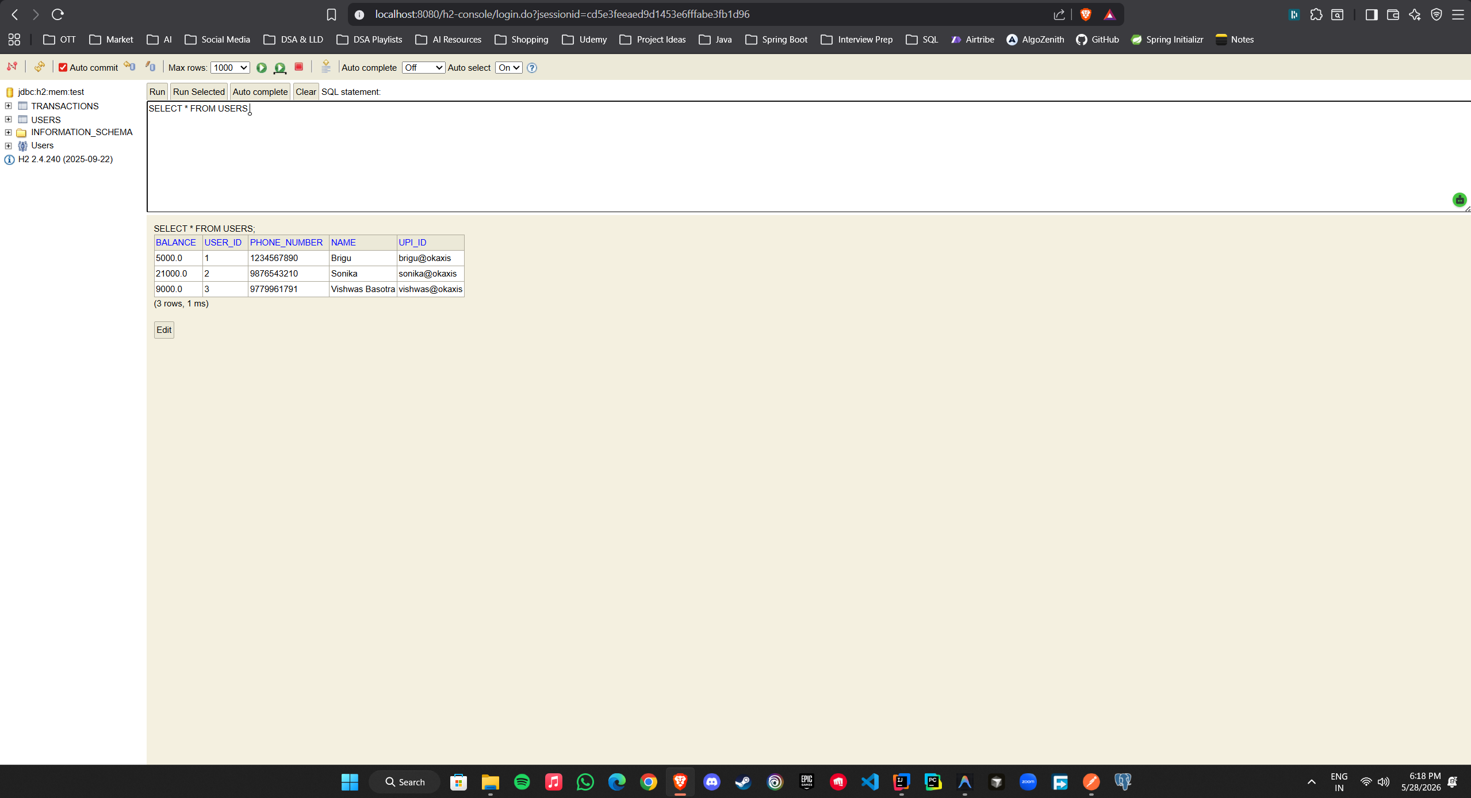
Figure 3: Populated 'USERS' table showing registered users and updated UPI balances.

B. Populated Transactions Table
The 'TRANSACTIONS' table shows the persisted record of the money transfer containing the unique transaction ID, transfer amount, optional note, and sender/receiver UPI strings.
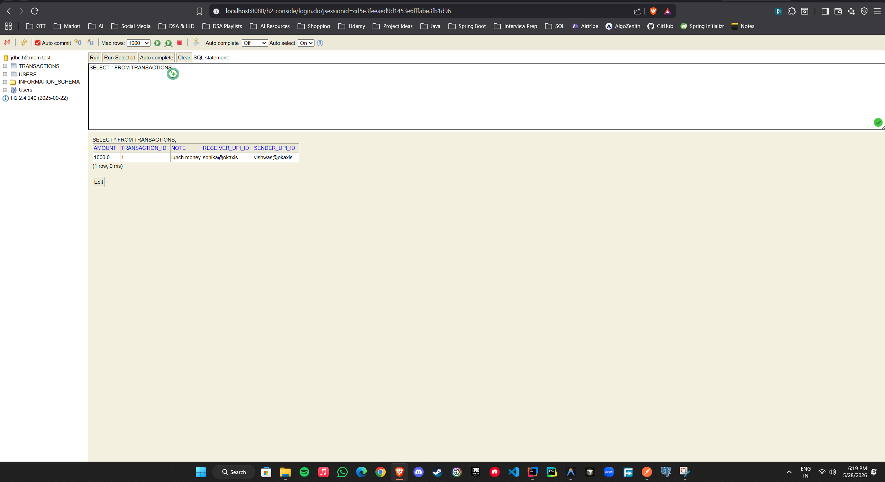
Figure 4: Populated 'TRANSACTIONS' table displaying the recorded money transfer.

Part 3: @RequestBody Demonstration & Failure Logs (Task 5)

The '@RequestBody' annotation is crucial to bind JSON parameters. In the screenshot below, we capture the controller or validation failure logs when making calls without `@RequestBody`. The data fields binding is omitted by Spring, and a validation exception or null parameters error is thrown on terminal/console.
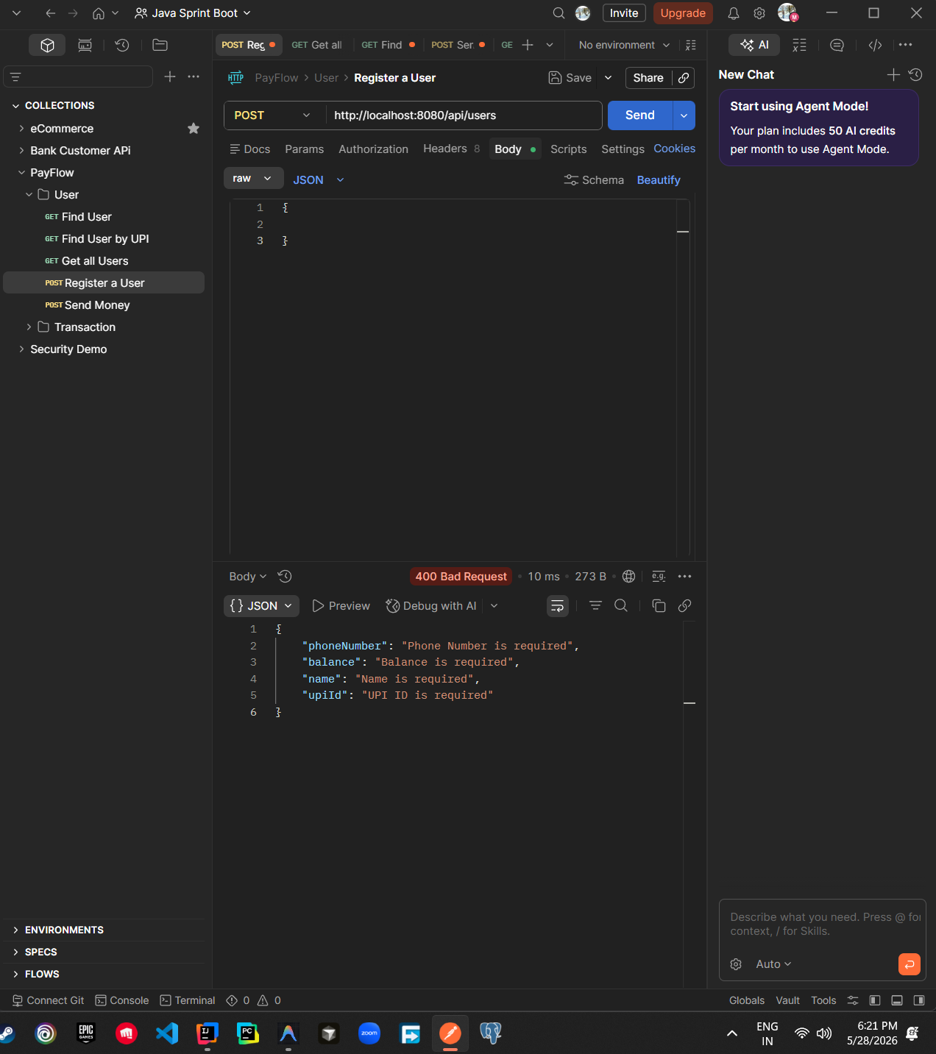
Figure 5: Failure log/response captured when executing request without @RequestBody.

Part 4: Conceptual Write-Up & Answers

Question 1: Request Lifecycle
Trace what happens from the moment curl sends POST /users to the moment your createUser method runs. Name the Dispatcher Servlet and Handler Adapter in your answer.
When a curl request hits the embedded Tomcat server at POST /users, it is first received by the central controller called the DispatcherServlet (the Front Controller). The DispatcherServlet immediately queries the HandlerMapping to find which controller and method are mapped to the /users path. Once the correct controller (UserController) and method are identified, the DispatcherServlet uses the HandlerAdapter to invoke the actual target method (registerUser), passing the mapped parameters and parsed request body. The method executes its business logic, and the return value is converted back to an HTTP response for the client.

Question 2: Serialization
When you POST a JSON payload like {"name":"Priya","upiId":"priya@okaxis"}, what converts it into a Java User object? What happens if the JSON key is "upi_id" instead of "upiId"?
When a JSON payload is posted to the endpoint, Spring Web's HTTP Message Converter, backed by the Jackson library, deserializes the JSON string into a Java User object. Jackson inspects the fields of the Java class using reflection and matches the incoming JSON keys to the Java property names. If the JSON key is sent as "upi_id" instead of "upiId", Jackson will fail to map the value to the camelCase upiId field by default, resulting in that property being set to null inside the Java object. To prevent this, developers can configure custom naming strategies or annotate the field with @JsonProperty("upi_id").

Question 3: Spring Boot Features
Name the three Spring Boot features. For each one, point to a specific thing in your PayFlow project where that feature is doing work for you.
The three primary features of Spring Boot are the Embedded Servlet Container, Auto-Configuration, and Starter Dependencies.
• Embedded Servlet Container (Tomcat): In PayFlow, this enables the application to boot up and run on port 8080 instantly when launching the main method, removing the need to install or configure an external web server.
• Auto-Configuration: This automatically configures the H2 DataSource, transaction managers, Hibernate entity managers, and the H2 console interface on startup simply because H2 and JPA libraries are present in the classpath.
• Starter Dependencies: In pom.xml, importing spring-boot-starter-webmvc and spring-boot-starter-data-jpa aggregates all transitive dependencies (Spring Core, MVC, Jackson, Hibernate, Logging, Validation) under unified version controls, keeping dependency management simple.

Question 4: Spring vs. Spring Boot
If you had used plain Spring instead of Spring Boot for PayFlow, what would you have had to set up manually? What does Spring Boot take care of automatically?
If we had built PayFlow using plain Spring, we would have had to manually create a web.xml configuration file, declare and register the DispatcherServlet, set up view resolvers, and write verbose XML or Java-based @Configuration files to establish the H2 DataSource, Hibernate LocalContainerEntityManagerFactoryBean, and transaction managers. Additionally, we would need to manually package our application as a WAR file and deploy it to a separately installed servlet container like standalone Apache Tomcat. Spring Boot completely takes care of all this boilerplates automatically by self-packaging Tomcat inside the executable JAR and auto-configuring the persistence, transaction, and web beans on startup.

Question 5: Stateless REST
Your POST /transactions endpoint does not remember anything about the previous request. What does stateless mean, and why does it matter if PayFlow eventually runs on three servers behind a load balancer?
In a stateless REST architecture, every HTTP request from a client must contain all the information and context necessary to understand and complete that request, meaning the server does not store any client session state (such as "logged-in session data" or "previous transaction status") in memory. If PayFlow eventually scales out to run on three servers behind a load balancer, statelessness is crucial because consecutive requests from the same user might be routed to different servers. Because no server depends on local in-memory session data, any server can process any incoming transaction request independently, ensuring seamless horizontal scaling, load distribution, and high fault tolerance.

Question 6: Persistence
You stored transactions in the H2 database, not in a Java List. What would have happened to all the transaction records if you had used a List and then restarted the server? Why is this unacceptable for a payments app?
If we had stored transactions in an in-memory Java List, all transaction records would reside inside the volatile RAM allocated to the JVM process, meaning that restarting the application server would instantly wipe out all transaction history. This is completely unacceptable for a payments application because financial data requires strict durability, auditability, and absolute consistency. Payments require non-volatile persistence (such as a database) so that transactions are permanently recorded and balances remain accurate and recoverable under all circumstances, including sudden power outages, server failures, crashes, or scheduled system maintenance reboots.

