**Heart Rate detection from Photoplethysmography**

**using Fast Fourier Transform**

21MAT211

Mathematics for Intelligent Systems-4

A PROJECT REPORT

***Submitted by*** *Team 20*

**BL.EN.U4AIE21119**  **Simhadri Tanya**

**BL.EN.U4AIE21121 Srinidhi Kannan**

**BL.EN.U4AIE21144 Vishwash Sharma**

***In partial fulfillment for the award of the degree***

***Of***

**BACHELOR OF TECHNOLOGY**

**IN**

**ARTIFICIAL INTELLIGENCE ENGINEERING**



AMRITA SCHOOL OF ENGINEERING, BANGALORE

AMRITA VISHWA VIDYAPEETHAM

BANGALORE - 560035

June 2023

**INDEX**

1. Abstract..........................................................................(3)
2. Introduction..................................................................(4-5)
3. Literature Survey.........................................................(6-7)
4. Implementation..........................................................(8-13)

1. Result.........................................................................(14-16)
2. Conclusion..................................................................(17)
3. Future Scope................................................................(17)
4. References…………………………………………(18)
5. **ABSTRACT**

Proposed method for detecting heart rate by fast Fourier transform (FFT) and heart rate variability (HRV) analysis techniques combined with photoplethysmography (PPG) signal. The PPG signal is first obtained using a photoplethysmograph sensor that measures changes in blood volume. These signals undergo preprocessing steps, including drift removal and frequency filtering, to remove noise and artifacts. Next, use the FFT algorithm to convert the preprocessed PPG signal from the time domain to the frequency domain. This allows the identification of the most common frequencies associated with the heartbeat. The peak frequency corresponding to the heartbeat is determined by finding the maximum in the FFT spectrum or using a peak detection algorithm. Once the maximum value is determined, it can be multiplied by 60 to convert to heart rate because heart rate is usually expressed in beats per minute. In addition, HRV analysis was performed by subtracting the R-R interval, which represents the mean time between consecutive heartbeats. To measure heart rate variability, calculate the HRV metrics such as mean RR duration, standard deviation of RR duration, root mean difference between consecutive RR, and pNN50. The plan combines FFT analysis and HRV metrics to provide a better understanding of the characteristics of the heartbeat. It provides a non-invasive and easy-to-use method for measuring heart rate via PPG signals, making it suitable for applications in portable devices, remote monitor monitoring, and assessment of cardiovascular health. This method contributes to the advancement of heart rate measurement and facilitates the early diagnosis of heart disease.

1. **INTRODUCTION**

Heart rate monitoring is an essential part of cardiovascular care, providing important information about the patient and the body. Photoplethysmography (PPG) is a widely used non-invasive technique to measure changes in blood volume in tissues, most commonly in the fingers or ears. The PPG signal captures the pulsatile nature of blood flow, allowing heart rate to be measured.

In recent years, signal processing techniques such as Fast Fourier Transform (FFT) and Heart Rate Variability (HRV) analysis have been used to improve the accuracy of heart rate measurements. FFT is a widely used technique that converts a time-domain signal to its frequency-domain representation and reveals the spectral components of the signal.By applying FFT to the PPG signal, the critical frequency corresponding to the heartbeat will be determined.

HRV focuses on analyzing short-term changes in heart rate. These changes are influenced by the autonomic nervous system and provide important information about heart health, stress levels and general health. HRV analysis involves the calculation of several time- and frequency-related parameters, including the mean RR interval, the standard deviation of the RR interval (SDNN), the principal difference parameter constant (RMSSD), and the power band.

Heart rate detection of PPG signals can be improved by combining FFT and HRV analysis.FFT provides primarily an initial estimate of heart rate, while HRV analysis provides a more comprehensive assessment of heart rate variability and heart function. This integration allows for more accurate heart rate measurements and can be used in a variety of applications such as remote patient monitoring, exercise tracking and stress measurement.

In this study, we investigated the effectiveness of heart rate detection from photoplethysmography signals using fast Fourier transform and HRV analysis. We evaluate the performance of these methods in terms of accuracy, stability, and sensitivity to physical differences. The findings of this study contribute to the advancement of heart rate monitoring and provide insight into the use of PPG signals to assess heart disease.

1. **LITERATURE SURVEY**

**3.1 Paper 1**

**Analysis of Cardiac Frequency on Photoplethysmograph (PPG) Synthesis for Detecting Heart Rate Using Fast Fourier Transform (FFT)**

**Ratna Aisuwarya, Computer Engineering Department, Faculty of Information Technology, Andalas University, Padang, Indonesia. Hendrick, Electrical Engineering Department, Padang State Polytechnics, Padang, Indonesia.Meitiza, Computer Engineering Department, Faculty of Information Technology, Andalas University, Padang, Indonesia. International Conference on Electrical Engineering and Computer Science (ICECOS) 2019.**

This paper focuses on analysis of Cardiac Frequency and the application of the Fast Fourier Transform for Detecting Heart Rate.

The research utilizes the Wireless Body Network (System) which consists of Pulse sensor, bluetooth, a computer and a graphical viewer. The output of the pulse sensor is a photoplethysmograph (PPG) signal.

Analysis of cardiac frequency through the obtained PPG signal is done by Fast Fourier Transform (FFT). These frequencies are obatined from the spectrum of PPG signal.

The PPG signal obtained first undergoes normalization, so that the signal is seen and understood easily. This makes the Fast Fourier Transform more effective.

Through the spectrum, we can obtain the heart rate data pattern and hence, distinguish between healthy heart rate and abnormal heart rate.

This paper talks categorizes the data only into 2 states: normal and abnormal states. It doesn’t talk about any specific diseases.

**3.1 Paper 2**

**Heart Rate Variability Analysis of Ischemic and Heart Rate Related ST-segment Deviation Episodes Based on Time-frequency Method. WANG Xing, XU Liang, SUN Zhongwei, YANG Zibin, PENG Yi. Institute of Basic Medical Sciences, Chinese Academy of Medical Sciences, School of Basic Medicine, Peking Union Medical College, Beijing 100005, China.**

**Proceedings of NFSI & ICFBI 2007. Hangzhou, China, October 12-14, 2007**

The variation or fluctuations in time between 2 heartbeats is known as Hear Rate Variability.

* They have performed the time and frequency analysis of Heart Rate Variability(HRV). Analysis of heart rate variability (HRV) is one of the most popular non-invasive techniques used for evaluating cardiac autonomic control.
* HRV can change based on stress levels, physical activity, etc.
* R-R interval is used as basis to calculate the various parameters of HRV during the time-frequency analysis.
* Using the HRV analysis results, several coronary heart diseases can be diagnosed.

In this paper, they have considered ST segment deviation as the parameter for classification of heart diseases.

1. **IMPLEMENTATION**

**1. Making a PPG signal Using MATLAB**

% Sample PPG signal

fs = 1000; % Sampling rate (Hz)

t = 0:1/fs:5;

% Simulated PPG signal with noise

ppg = sin(2*pi*1.5*t) + sin(2*pi*2.5*t) + 0.8*randn(size(t));

Time vector , which is for 5 seconds which is saved in a list and used to run the function. The terms add Guassian noise to the signal, uses standard normalization distribution where mean is 0 and standard deviation is 1.Size(t) ensures the noise vector has same size as 't'.  
The sin components represents the Physiological pulsatic signal.

plot(t,ppg)

xlabel("time")

ylabel("PPG value")

title("PPG signal")

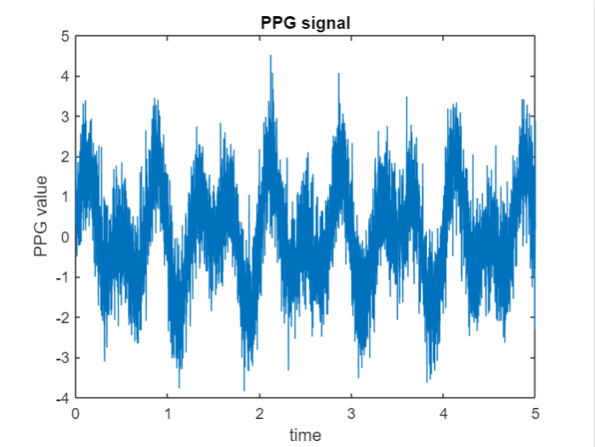

**2. Apply FFT to the Signal**

fft_ppg = abs(fft(ppg));

fprintf("Amplitude Spectrum ")

fft_ppg

freq = (0:length(fft_ppg)-1)*(fs/length(fft_ppg));

fprintf("Frequency Specturm ")

freq

compute the fft of the ppg signal and takes the absolute value of each frequency component to obtain the amplitude spectrum.

Calculates FFT of signal and stores the abs value of the resulting complex numbers in the variable fft_ppg contains the magnitude of the frequency component of the PPG signal.

**3. Plotting the Frequency Spectrum**

% Plot the frequency spectrum

figure;

plot(freq, fft_ppg);

xlabel('Frequency (Hz)');

ylabel('Amplitude');

title('FFT Spectrum of PPG Signal');

**4.Frequency Analysis using FFT signal and find the peak frequency to find the heartbeat.**

% Find the peak frequency

[~, max_idx] = max(fft_ppg);

peak_freq = freq(max_idx);

peak_freq

% Convert peak frequency to heart rate

heart_rate = peak_freq * 60;

% Display heart rate

fprintf('Estimated heart rate: %.2f bpm\n', heart_rate);

Generate a vector of indices ranging from 0 to length of fft_ppg-1This corresponds to the frequency bins of the FFT output.

Scales the indices to the corresponding frequencies values.

Final step to calculate the heart beat .Find the peak of FFT and multipy it with 60(seconds) to find the heart bpm.

**5.Using PPG image to find the heart Beat**

clf

image = imread("C:/Users/sharm/OneDrive/Desktop/Maths/ppg.jpg");

% Extract the PPG signal

ppg_signal = mean(image, 2);

ppg_signal=reshape(ppg_signal,[],1)

% Detect peaks

[peaks, locations] = findpeaks(ppg_signal);

sampling_rate=10;

fft_result = fft(ppg_signal);

% Calculate heart rate

time_between_peaks = diff(locations);

heart_rate = 60 / mean(time_between_peaks);

% Plotting the results

t = 1:length(ppg_signal); % Assuming a time-based PPG signal

time_in_seconds = t / sampling_rate; % Convert to time in seconds

plot(time_in_seconds, ppg_signal);

hold on;

plot(locations / sampling_rate, peaks, 'ro');

xlabel('Time (s)');

ylabel('PPG Amplitude');

title('PPG Signal with Detected Peaks');

Using Imread function to read the PPG signal and trying to resize and filter the images for better results. We need to extract the mean values of the Frequency from the PPG Image and reshape the frequency structure.

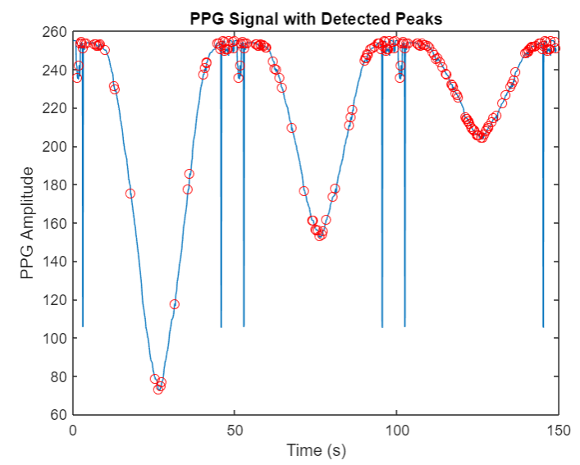

After Reshaping and Extracting mean values we need to detect the peaks from the ppg signal these peaks are used as a point for the fast fourier transformation.

Once we have extracted the frequency , we apply FFT to the points and plot it against the time and frequency , this plot is then used to find the heart beat of the person.

**6.Applying HRV analysis to the PPG signal**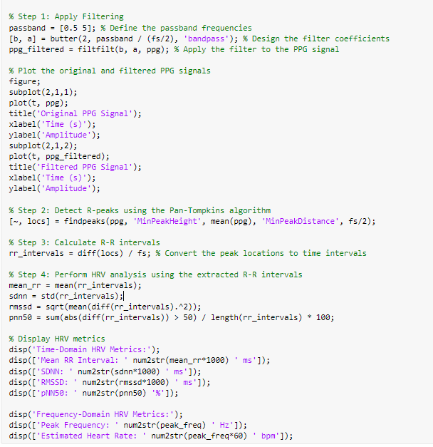

First, create an analog PPG signal with added noise. A band-pass filter is then applied to the signal to eliminate unwanted frequencies and improve the pulse output. Plot the filter signal to see the effect of the filter operation.

The Pan-Tompkins algorithm is then used to determine the R peak representing the corresponding heart rate. The algorithm shows the position of the R-peak relative to the size of the R-peak's features.The detected R peaks are used to calculate the R-R interval, which represents the mean time between consecutive heartbeats.

During the R-R acquisition, various heart rate variables (HRV) can be calculated. These measurements provide information about changes in heart rate and show the activity of the nervous system. HRV measurements include the mean RR interval (mean time between consecutive R peaks), the standard deviation of the RR interval (a beat-to-beat match measure), the central mean difference of the sequential RR (a short-term measure). variability) and the percentage of RR difference (measure of heart rate change) between intervals longer than 50 ms.

Finally introduces a time domain HRV metric that provides a quantitative measure of heart rate characteristics.The algorithm combines signal processing, R peak detection and HRV analysis to extract key heart rate information from the PPG signal.

1. **Result**

**5.1 Generating Photoplethysmograph Using Matlab**



**Fig: PPG graph**

**5.2 Generating the FFT implementation on this Graph**

**Fig: FFT implementation on PPG**

**5.3 Plotting the Peak Frequency Image from the PPG image**

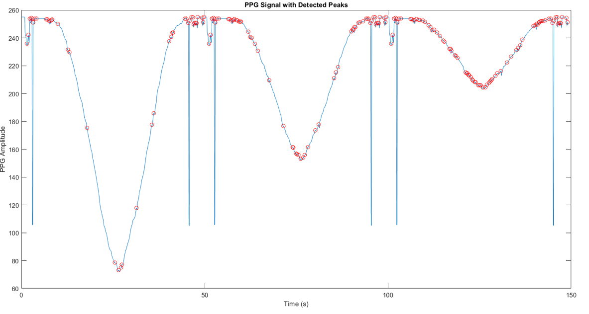

**Fig : Plot the Peak Frequency**

**5.4 FFT on PPG signal**

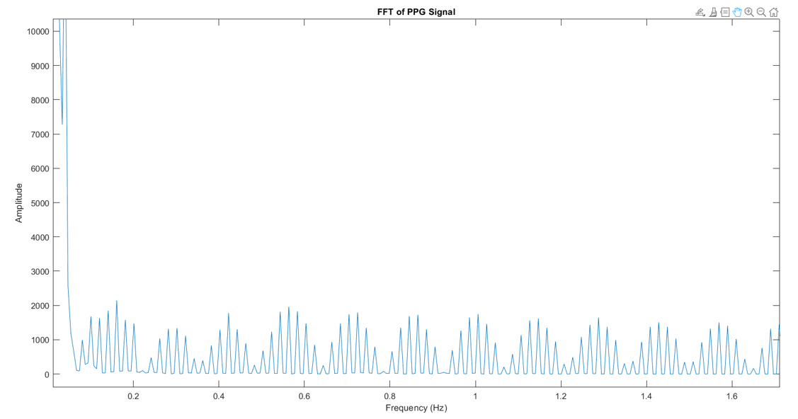

**Fig: FFT on PPG signal**

**5.5 Filtered PPG Signal**

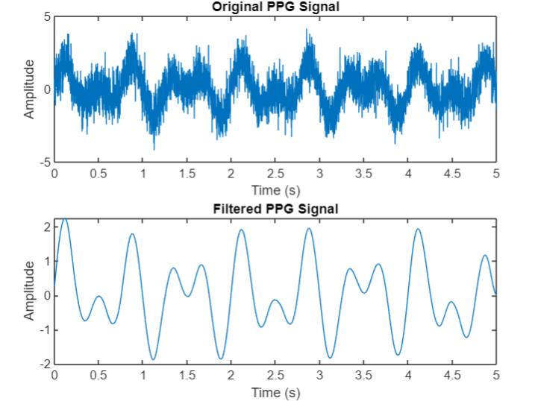

**Figure: original PPG signal vs Filtered PPG signal**

**5.6 HRV analysis**

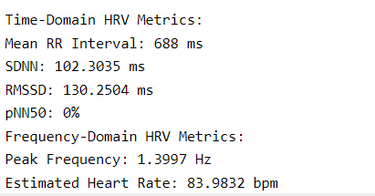

1. **Conclusion**

In conclusion we successfully implemented Matlab to generate photoplethysmography signal and conducted Fast Fourier Transfrom (FFT) to find out the heart beat of person.

We used matlab which has the capabilities of signal processing enable us to help us make an accurate PPG signal with some added Anomalies.

By simulating this Signal within the matlab environment, we could simulate the environment of making a PPG signal and Applying Fourier Transform to it.

From the FFT output we find out the periodic changes in blood volume to find the heartbeat.

By successfully identifying the peak frequency in the FFT spectrum, we were able to precisely determine the hearbeat frequency this information is used for many application in the medical field.

To combine we used Matlab to generate implement and try the different test cases which we can find in real life to determine heartbeat in real life .

This will help us Significantly in the Field of Healthcare to do analysis of the paitents and take care of the paitents by treating them timely and with all precautions.

1. **Future Scope**

We can enhance the signal processing techniques to get better and precise outputs. We can include techniques such as Kalman Filtering to increase the signal quality.

Adding Machine Learning and Deep learning concepts to get to know about the previous state and new state of the Human Heart can be used to diagnose disease.

Multi-modal Signal fusion can be done by combining it with other types of physiological signals such as SPO2, Stress level to give better heart beat rate.

1. **References**

* R. Aisuwarya, H. Hendrick and M. Meitiza, "Analysis of Cardiac Frequency on Photoplethysmograph (PPG) Synthesis for Detecting Heart Rate Using Fast Fourier Transform (FFT)," 2019 International Conference on Electrical Engineering and Computer Science (ICECOS), Batam, Indonesia, 2019, pp. 391-395, doi: 10.1109/ICECOS47637.2019.8984512.
* W. Xing, X. Liang, S. Zhongwei, Y. Zibin and P. Yi, "Heart Rate Variability Analysis of Ischemic and Heart Rate Related ST-segment Deviation Episodes Based on Time-frequency Method," 2007 Joint Meeting of the 6th International Symposium on Noninvasive Functional Source Imaging of the Brain and Heart and the International Conference on Functional Biomedical Imaging, Hangzhou, China, 2007, pp. 162-164, doi: 10.1109/NFSI-ICFBI.2007.4387715.