**Experiment: 1**

Aim: track engagement with home page and other site content.

Track engagement with home page and other site is content in a similar web tools use for it.

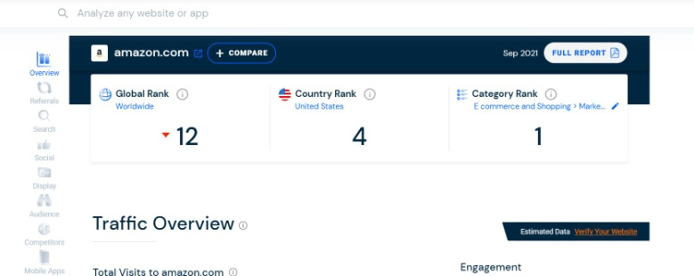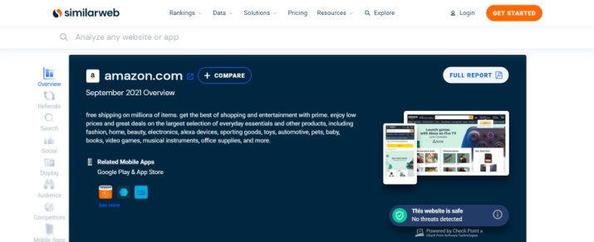  
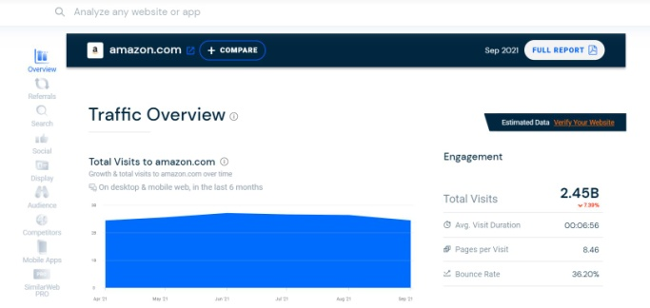 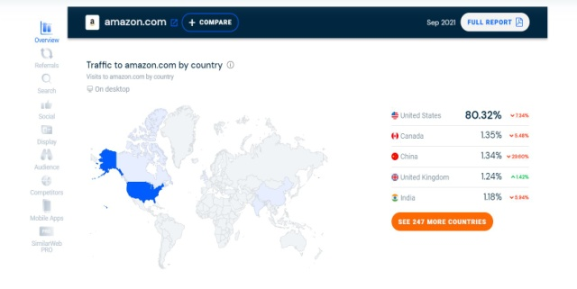

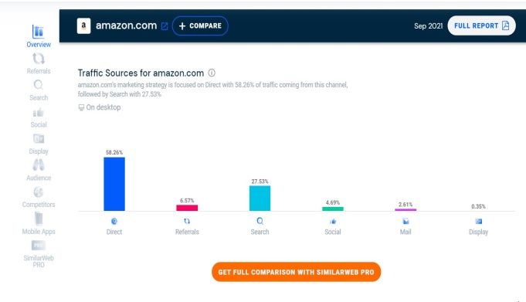 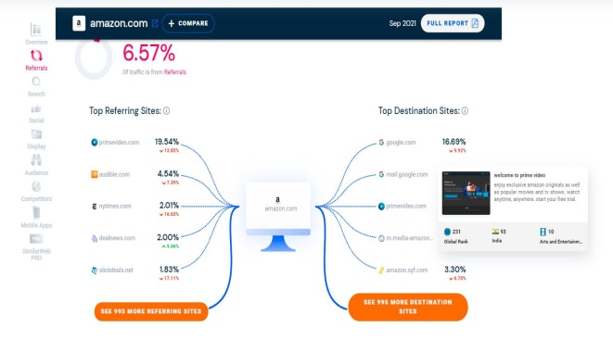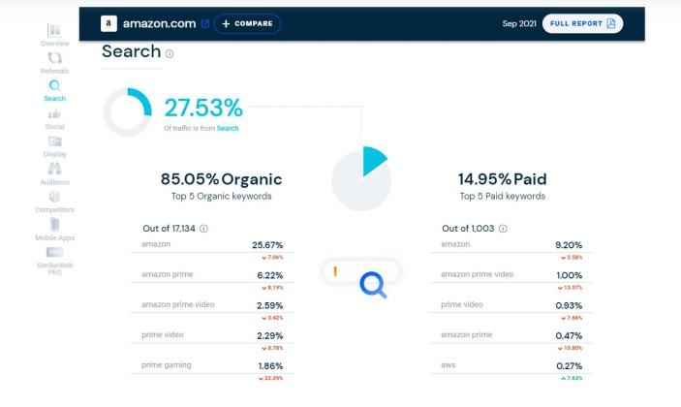 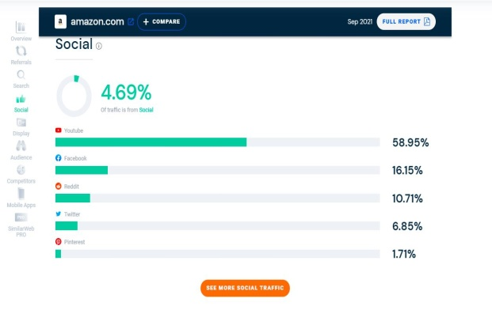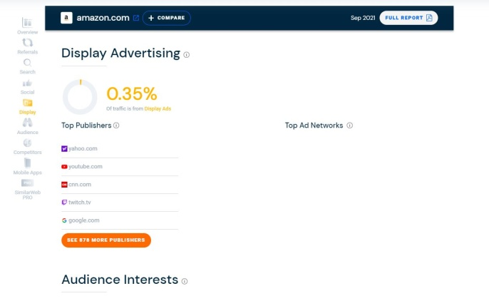 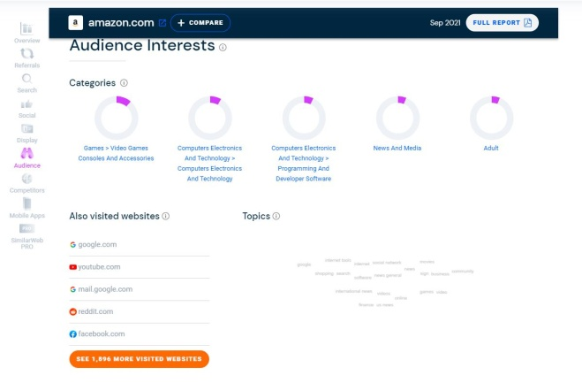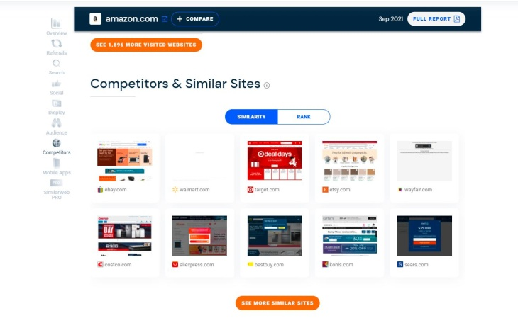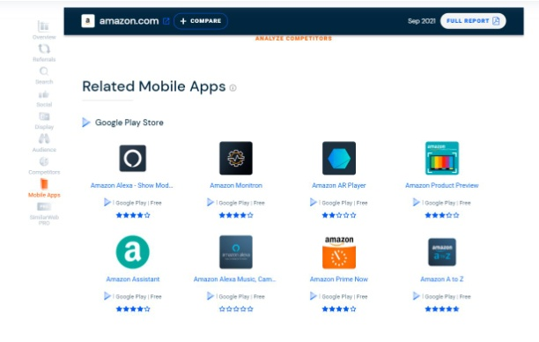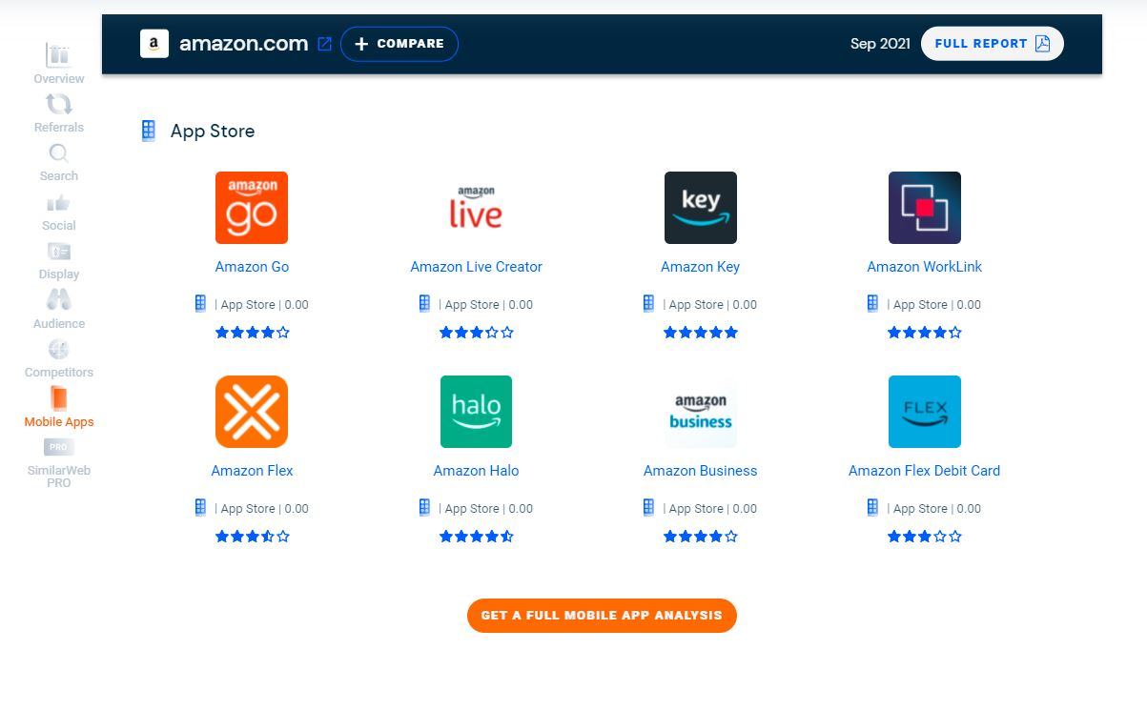

**Conclusion:**

In this experiment we learn track home page or other site use similaweb.com tools .

**Experiment: 2**

**Aim: Measure the time taken to load home page and other pages.**

Page load time plays a decisive role in determining website ranking. A website that loads faster is bound to rank well and gain significant growth in organic traffic.

**Key Metrics for checking website load time:**

* TTFB: Time to First Byte(TTFB) represents the time taken by a web or mobile browser to receive the first byte of response from the server after it requests a specific URL.
* Page load time: Represents the time taken to completely display the content of a specific page.
* Response Time: Represents the time taken to fully receive the first response from the server.
* DOM Processing Time: Represents the time required to parse the HTML into a DOM and retrieve or execute scripts.

There are so many tools to check the load time of webpage. Here we are going to use Google PageSpeed Insights.

Steps to check the loading time:

1. Visit Google PageSpeed Insights.
2. Enter the URL of the website.
3. Click on the Analyze button.

Here, we are going to measure the loading time of [WWW.spec.edu.in](http://WWW.spec.edu.in) website.

**OUTPUT:**

Here we got the output for desktop platform:

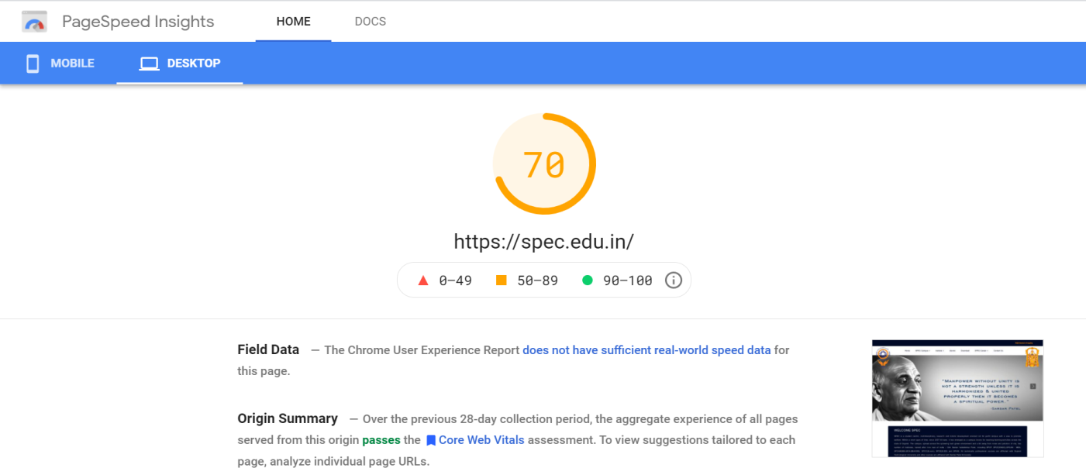

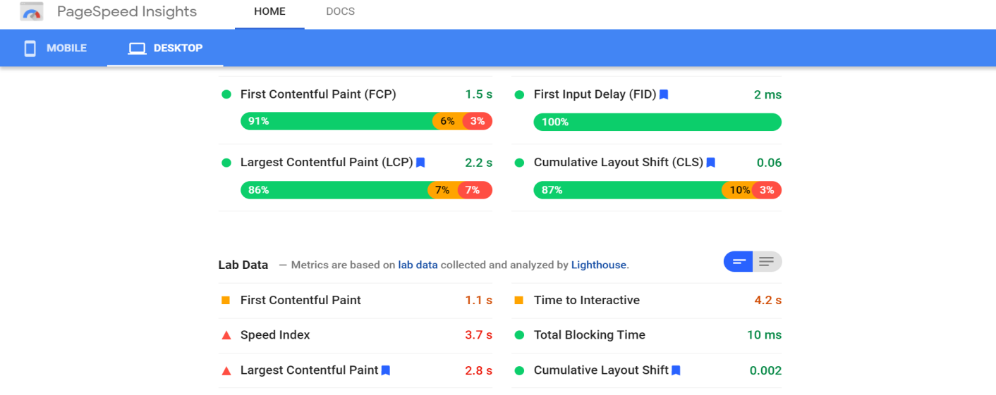



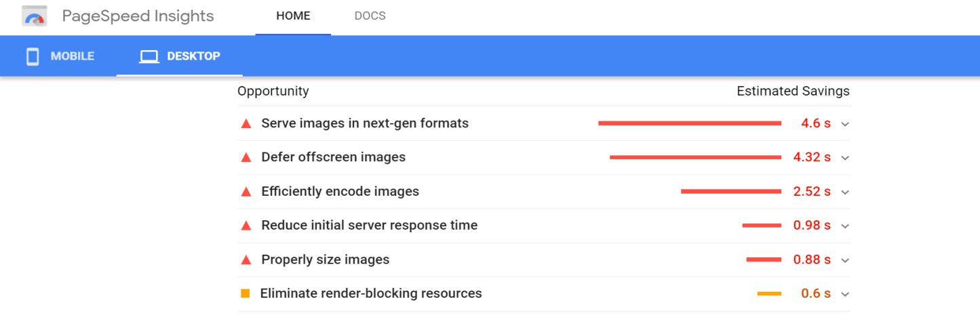

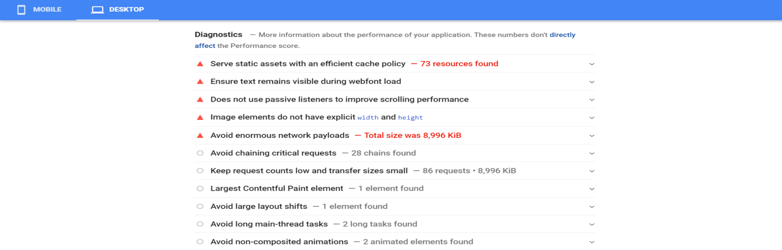

Now we have the output for same website for mobile:

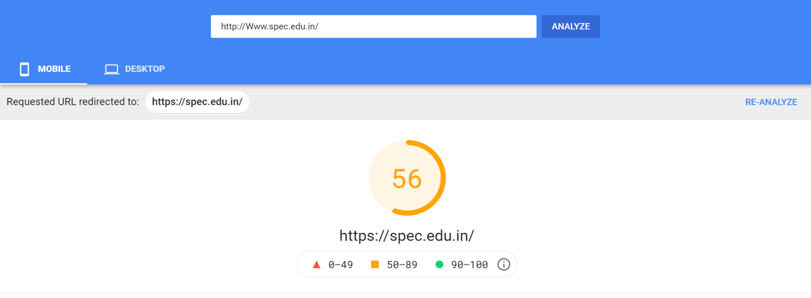

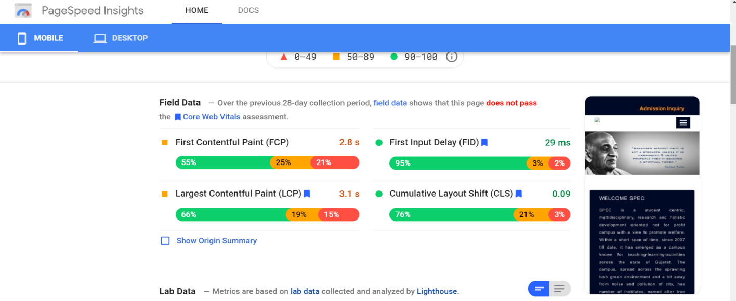

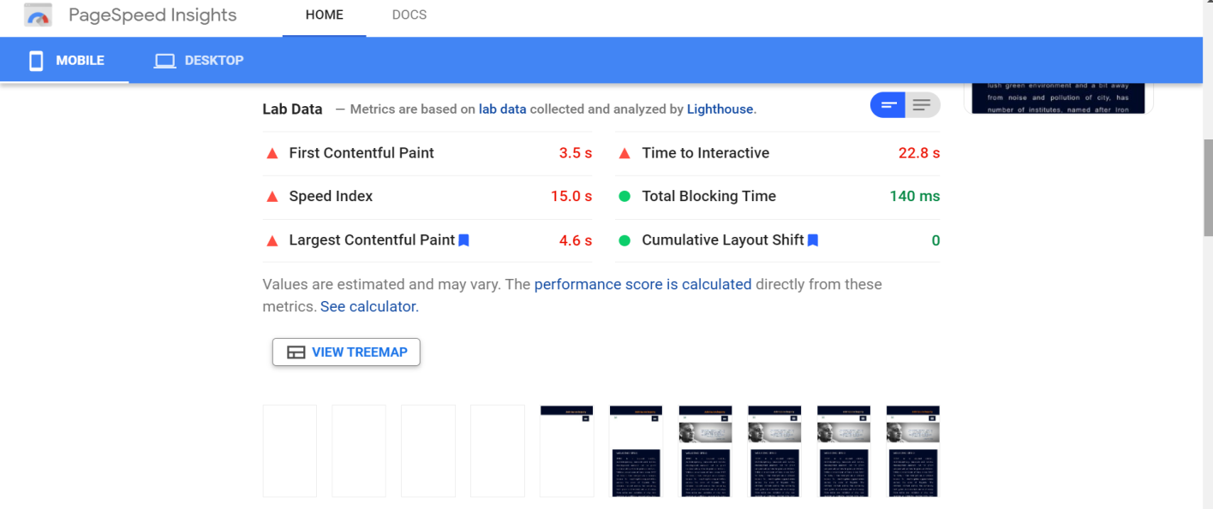

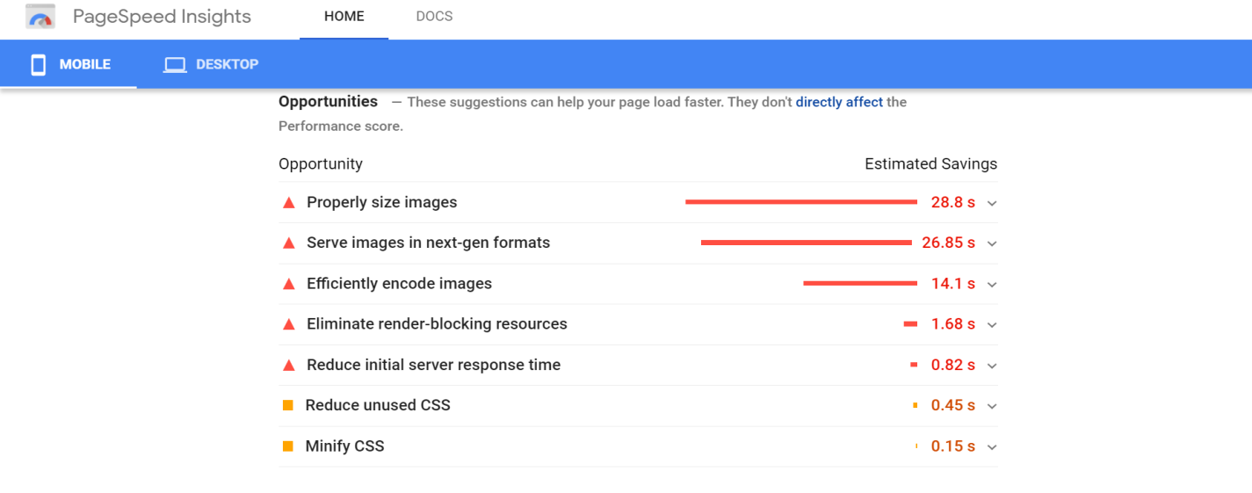

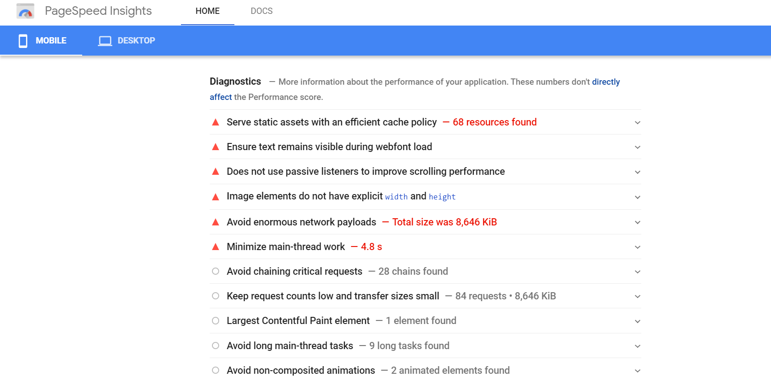

**Conclusion:**

In this experiment we learned about the page load time and perform practical to find the page load time for website as well as through this experiment we came to know about how the components of the webpage load and how much time are taken to load them.