Practical – 6

Aim: Build your keyword list (a list or spreadsheet of attainable, relevant keywords), write content around those keywords and track performance and rankings.

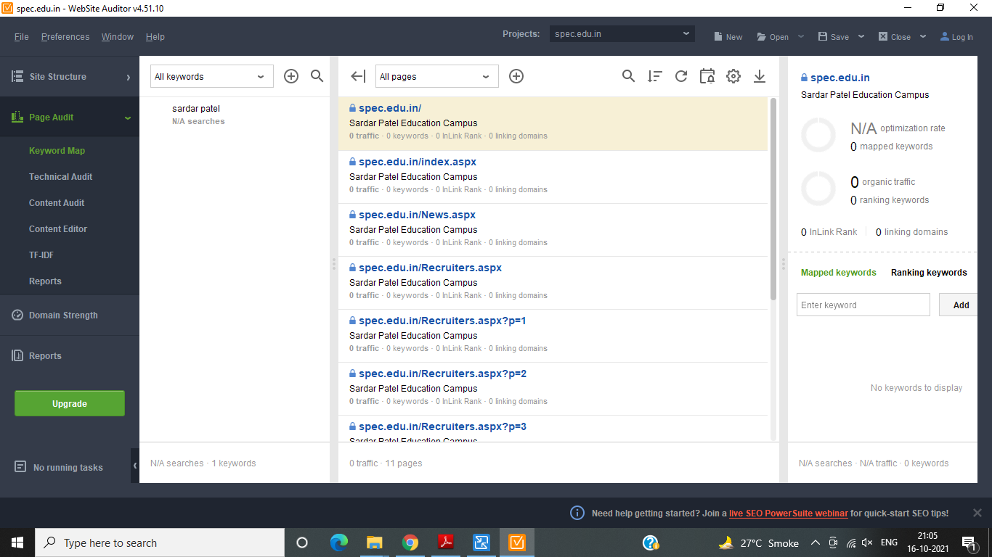

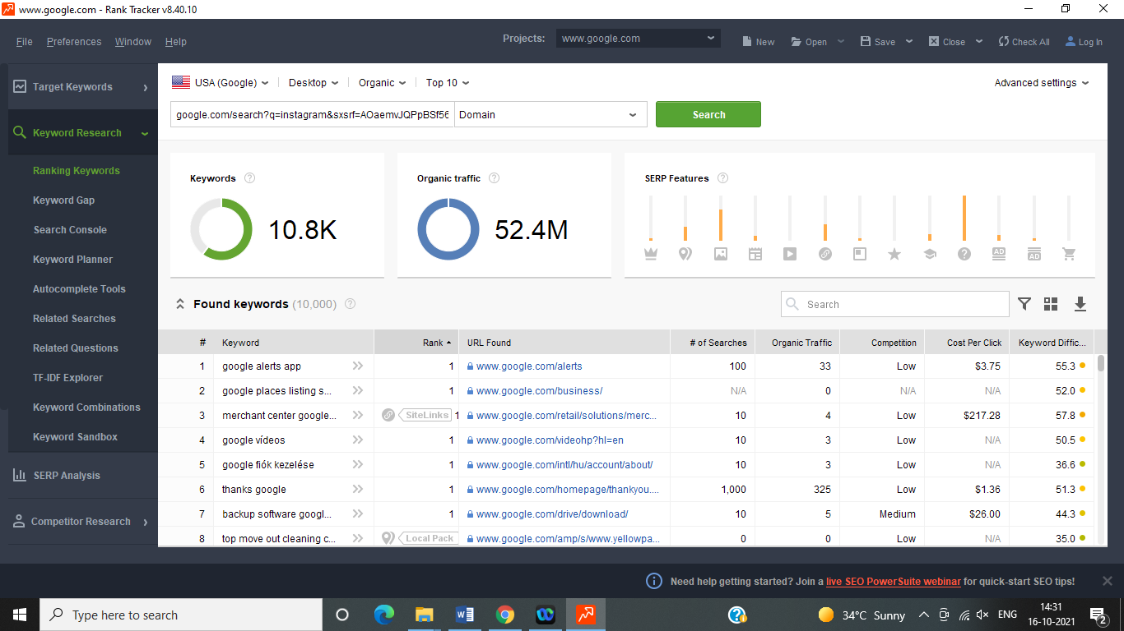

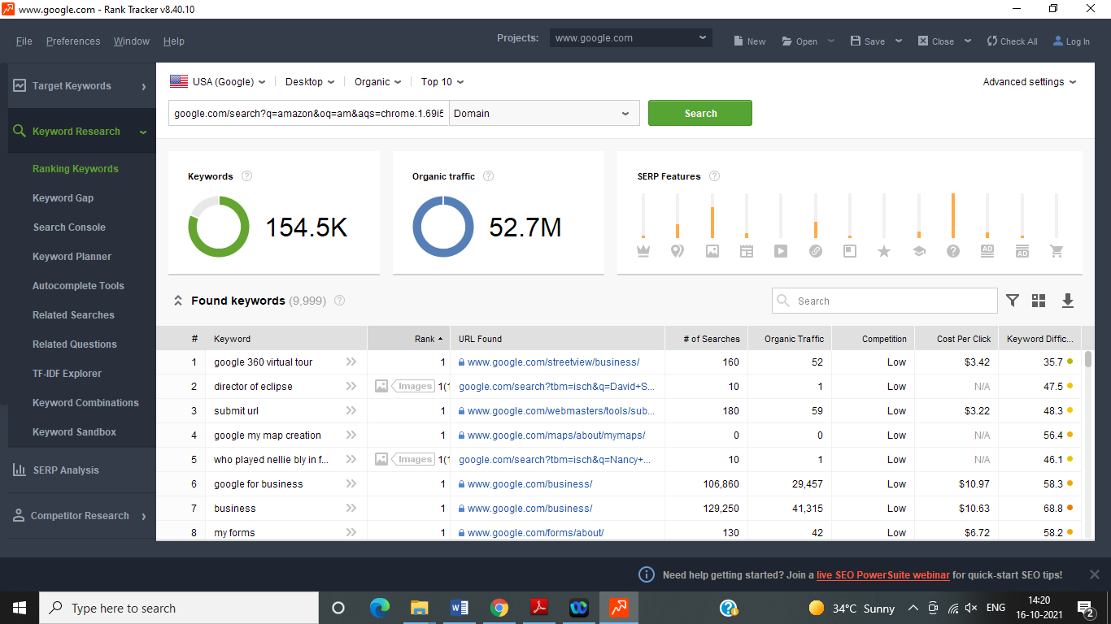

Conclusion: in this experiment we are learn how to search key word we are used for search keyword power shoot tools.