Multipath propagation

In wireless media, signals propagate using three principles, which are reflection, scattering, and diffraction.

* **Reflection** occurs when the signal encounters a large solid surface, whose size is much larger than the wavelength of the signal, e.g., a solid wall.
* **Diffraction** occurs when the signal encounters an edge or a corner, whose size is larger than the wavelength of the signal, e.g., an edge of a wall.
* **Scattering** occurs when the signal encounters small objects of size smaller than the wavelength of the signal.

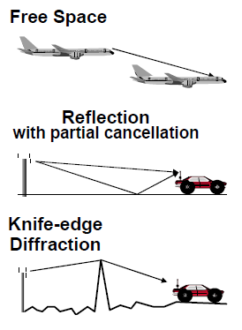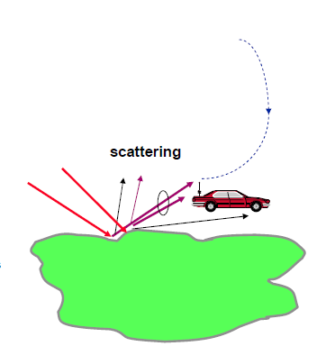

**Shadowing**

Shadowing is the **effect that the received signal power fluctuates due to objects obstructing the propagation path between transmitter and receiver**.

Also see in PPT for details of shadowing.

**Empirical formula for path loss**

An empirical formula for propagation loss is derived from Okumura's report in order to put his propagation prediction method to computational use. The propagation loss in an urban area is presented in a simple form: **A + B log 10 R**, where A and B are frequency and antenna height functions and R is the distance.

Based on the experimental results, a novel empirical path-loss model with two important parameters (Tx-Rx distance and carrier frequency) is proposed by using linear regression. Specifically, the path-loss model **describes the statistical characteristics for parameters**.

