ABOUT US
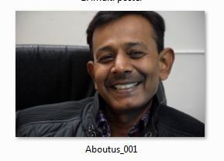 | A leading Jewellery manufacturer, wholesaler and exporter from Jaipur-India, established in 2013. Founded by Prakash Singh (owner) - a passionate jeweller, with a vast experience of over 21 years in Gems and jewellery. His vision for innovation and high quality coupled with the usage of sophisticated and modern technology propelled him in starting his own venture. The continual works from Indian and International market are a testament of his vision in action in a short span of time.
Our main business is in manufacturing jewellery for the clients who are into designing and selling. We provide our clients a comfort of their own manufacturing unit, they come here, they work with us as a team, providing a conducive environment for collaboration. We give our clients special technology support and ideas whenever required. We also provide customized designing support to ease the work. Our manufacturing unit is well managed from initial designing stage to packaging and shipping | 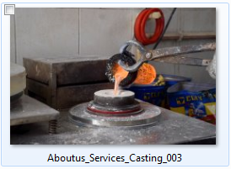
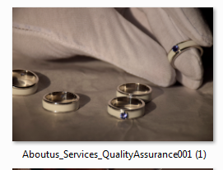 | We have well-equipped jewellery manufacturing plant. We have plating plants, laser soldering machine, laser marking machine along with best casting machine plant. We have 150 skilled artisans and trained staff who work hard to make sure the performance is always at par! The plant is equipped in working on all materials - brass, silver, gold, etc both studded and plain. We also take pride in on-time delivery without the compromise in quality.
Our factory is spacious following all the norms for security and safety of workers. We work for the growth of workers and clients both so as we grow. Our clients are back-bone so is our artisans and staff.  We always look forward to love long-lasting association | 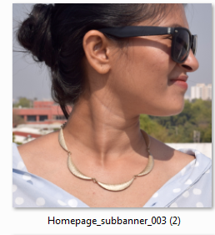
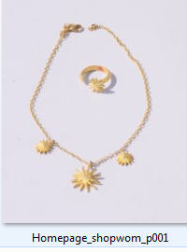 | Brand name PGJ  Quality  On Time delivery  Authenity  Price competitive  Handling with care

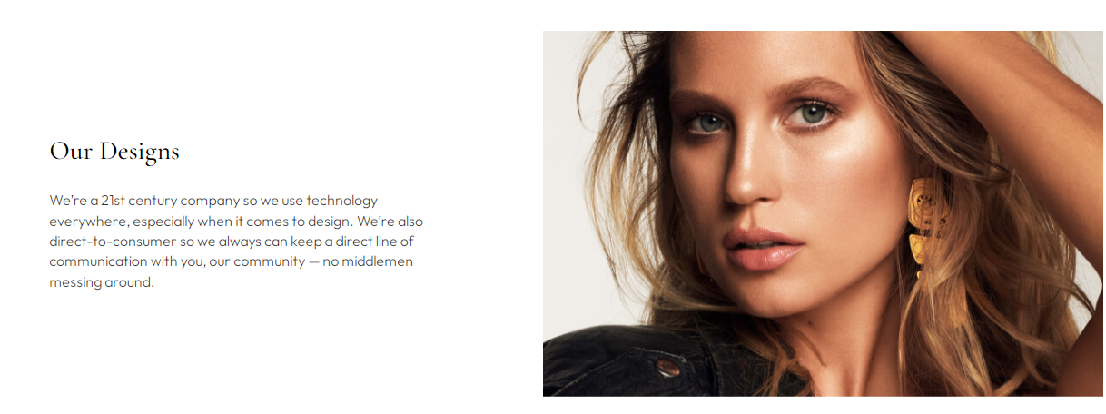
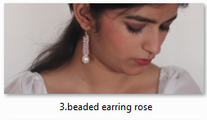



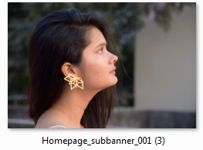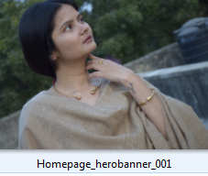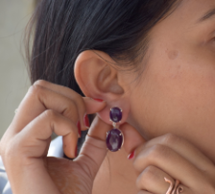
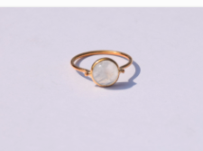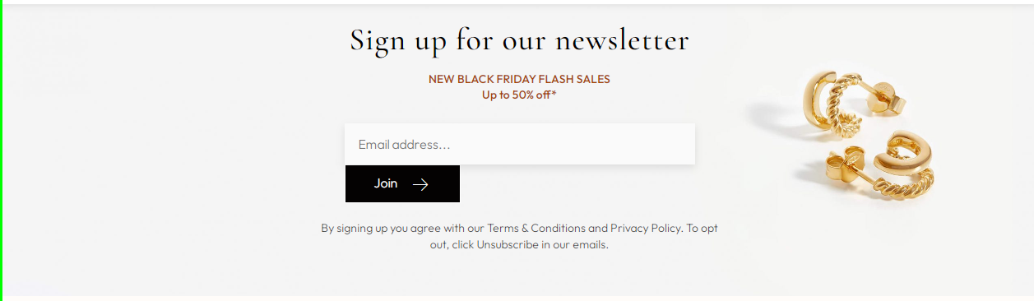

FAQ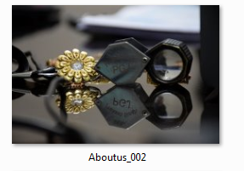
How can I request more information regarding a specific piece (Carat weight, metal weight, stone clarity, whether or not a gemstone is natural or created, measurements etc)?
If the information that you are looking for about an item is not included in the description on our website, you can submit a request through email or on the phone. We will do our best to accommodate your request as soon as possible, usually within the same day.

Do you have any physical presence?
Yes, we have our manufacturing plant in Jaipur, India.

Do you ship internationally?
Yes, we ship internationally. We are authorized exporter.

What payment method do you prefer?
We prefer Paypal or credit card for payment or bank transfer.

What is calibrated gems?
A calibrated gemstone is one that has been cut to fit standard size commercial gemstone jewelry mountings and settings. Examples are 7 mm x 5 mm oval shape gemstones, or a 6 mm round shape gem. Calibrated gemstones are not cut to exact measurements, but they are cut to sizes that most standard size mountings can accommodate. We workwith fancy and calibrated all gemstones & beads.
There will always be some variance; usually for gemstones over 1 carat in weight, a size variance within +/-.3 is acceptable, depending on the exact jewelry design of course. Above in the photo are two 6 mm round diameter stones, but the diamond is almost half the weight of the sapphire.This is why gemstones should be bought by size rather than weight.
Are all Gemstones used at PGJ Natural ?
We usually use natural gemstones.. But, We do synthetic or lab-created gems on orders only.
We disclose all our gems to be natural or lab-made in description. Gemstones may be enhanced through treatment, but we fully disclose any and all treatments individually on each of our gemstone detail pages. Some examples of gemstone treatments / enhancements include routing heating, oiling and diffusion and assembling (opal doublets and ammolite). Doublets and assembled gemstones should not be confused with 'composite gemstones'.
Do you provide certificates for your gems?
Yes, you may order a certificate with some additional fees.

Services we provide -

Designing Assistance - We have well trained and experienced designers to understand the needs of our clients. They work as a bridge between client's vision and artisans crafting it.

Handmade to Casted - Our unit is well equipped with latest machinery to meet today's standards, and our artisans are well trained to craft handmade jewelry and casted jewelry.

Setting - Every gemstone is checked by our assortment department before it goes for setting. Each piece is carefully studded in jewelry with high precision to give best finish.

Polishing - polishing of surface is done prior to setting to repair any error and on final finishing

Plating - We have all kinds of plating plants Yellow gold, Rhodium, Rose Gold, Silver, Antique finish Silver & Gold, mix tone, Dye Gold etc.

Packaging - Each product is packed in proper way so that it doesn't get damaged in the transit.

We care for your jewelry.
