**Day 24 coding Statement: Write a program to print Pyramid pattern using stars**

**Description**

Get the number of lines as the input and print stars in that many lines or rows in a pyramid shape.

**Input**

4

**Output**

  *

 ***

*****

*******

**Code:**

import java.util.Scanner;

public class Day_24 {

    public static void main(String args[]) {

        int row;

        Scanner sc = new Scanner(System.in);

        System.out.print("Enter row numbes : ");

        try {

            row = sc.nextInt();

        } catch (Exception e) {

            System.out.println("Please enter positive Integer  number only :\n" + e + "\nThank You...\nexited ");

            return;

        }

        for (int i = 1; i <= row; i++) {

            for (int j = 1; j <= row + (row - 1); j++) {

                int startPrint = row-(i-1);

                int stillPrint = startPrint + (i + (i - 1));

                if ((startPrint<=j) && (stillPrint>j)) {

                    System.out.print("*");

                } else {

                    System.out.print(" ");

                }

            }

            System.out.println("");

        }

    }

}

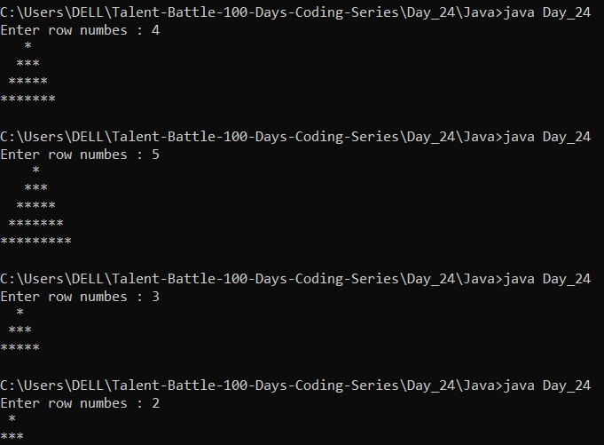 **Output :**