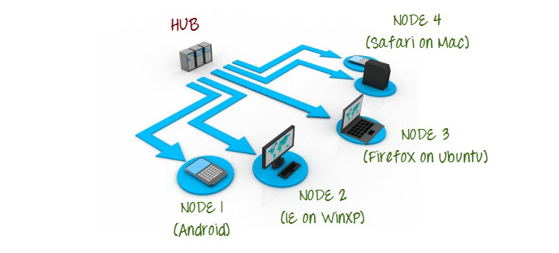

Steps & Commands in Hub Machine

1.Setting Up Hub:

Step 1: Move the control to the location of the stand-alone server using cd command. Then invoke the jar file using the following command. And set the role to hub.

**java -jar selenium-server-standalone-2.44.0.jar -role hub**

**2.Validating Hub started**

[**http://localhost:4444/grid/console**](http://localhost:4444/grid/console)

Steps & Commands in Node Machine

Step 1: Once the hub is registered and verified. Make sure you have JAVA, webdriver in the node machine. Then open terminal and run the following command.

**java -Dwebdriver.gecko.driver=”path_to_the_webDriver” -jar selenium-server-standalone-2.44.0.jar -role webdriver -hub** [http://ipOfHub:4444 (port](http://ipOfHub:4444%20(port) **of hub)/grid/register/ -port 9999 (your fav port on node machine)**

Step 2: Now make sure your node is register in the hub cmd.

Step 3: Run the following code in hub machine:

**Code in Hub Machine**

import java.net.MalformedURLException;

import java.net.URL;

import org.openqa.selenium.Platform;

import org.openqa.selenium.remote.DesiredCapabilities;

import org.openqa.selenium.remote.RemoteWebDriver;

public class GridRunning {

public static void main(String[] args) throws MalformedURLException, InterruptedException {

// **TODO** Auto-generated method stub

DesiredCapabilities dc = new DesiredCapabilities();

dc.setBrowserName("firefox");

dc.setPlatform(*Platform*.***WINDOWS***);

RemoteWebDriver driver = new RemoteWebDriver(new URL("http://192.168.0.32:4444/wd/hub"), dc);

driver.get("https://www.google.com");

Thread.*sleep*(5000);

driver.quit();

}

}