I have pushed all 3 codes ie WEBAPI, angular and sql to docker based on the ask from last session, please find screen from my dockerhub

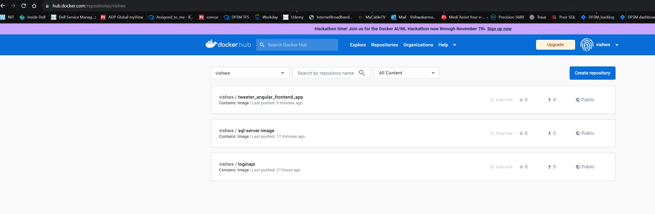

1. **Publishing webapi project to docker using visual studio**

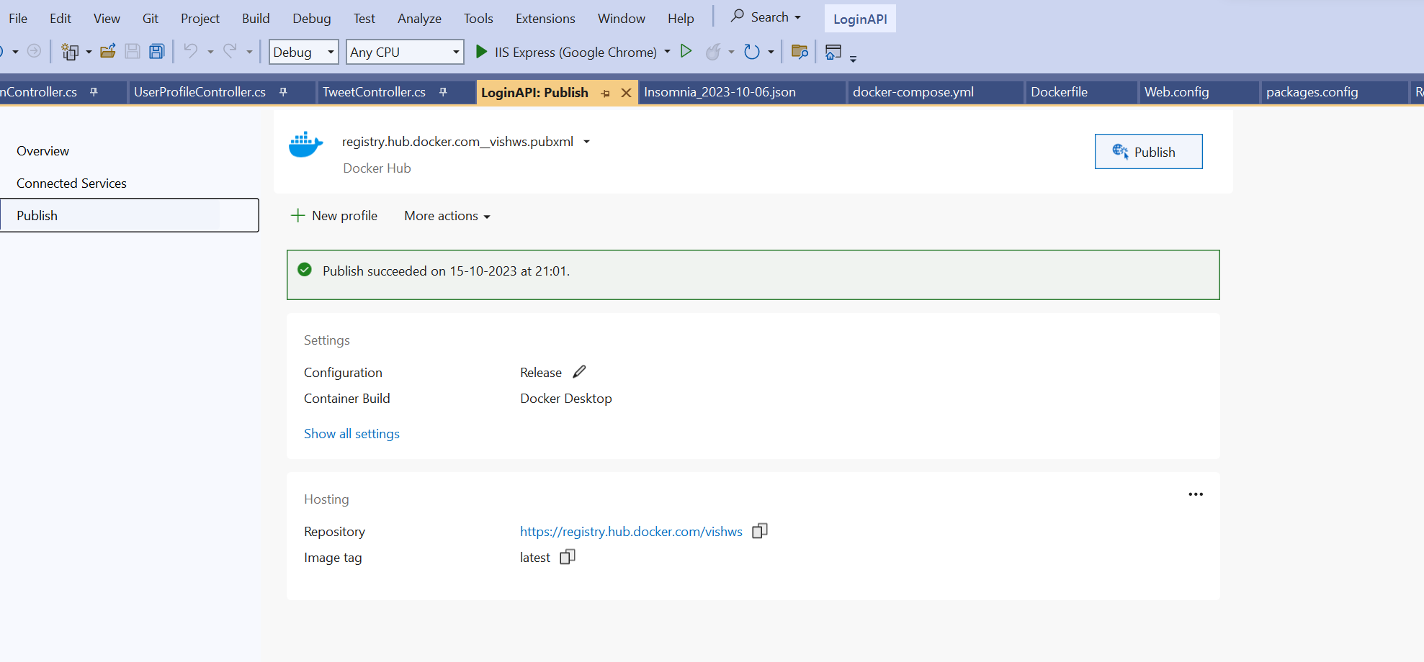

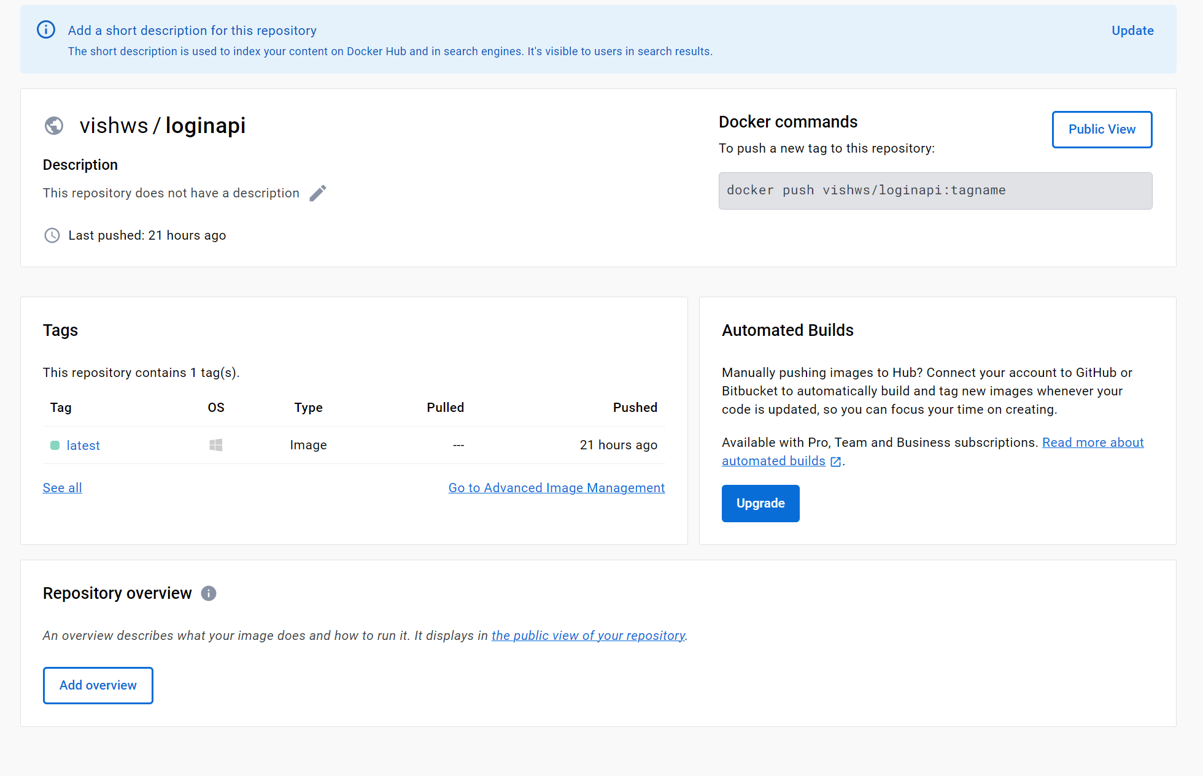

pull command: docker pull vishws/loginapi:latest

you can use this command to pull this image and run it in your system.

PS: just in case something not running you can pull the entire code from my github

<https://github.com/vishws/tweeter_project_backend.git> , get it clone , export the backpac file and then you should be able to run the webapi locally

1. **Pushing angular project to docker using a dockerfile , exposing it to port 8080**

**We can access it from docker**

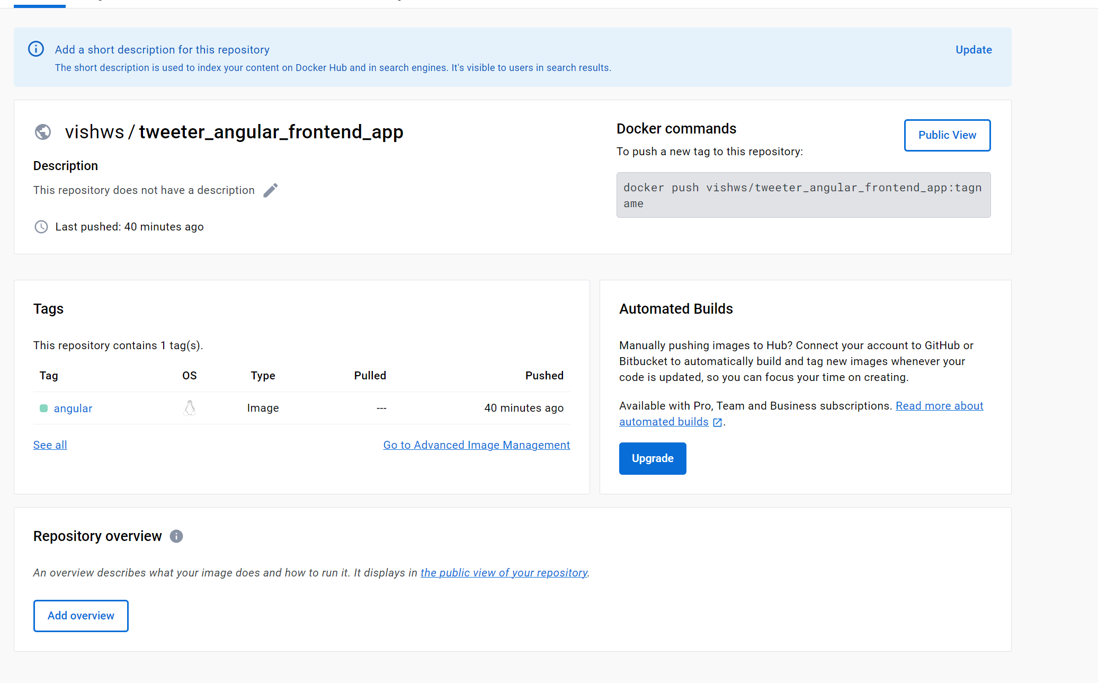

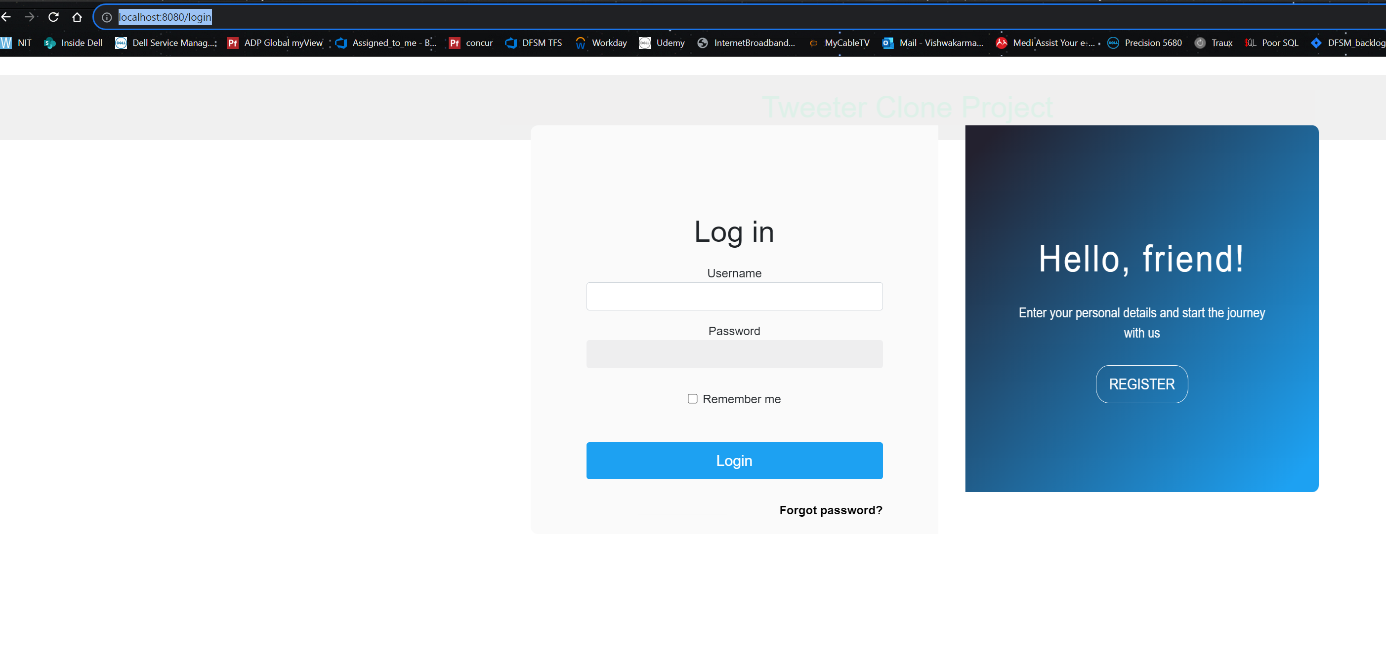

Pull command : docker pull vishws/tweeter_angular_frontend_app:angular

PS: just in case something not running you can pull the entire code from my github

<https://github.com/vishws/tweeter_frontend_angular.git> , , get it clone , make sure web API is running in the behind and front end should interact with webapis

1. **Sql db backfile : which you need to restore before running the webapi**



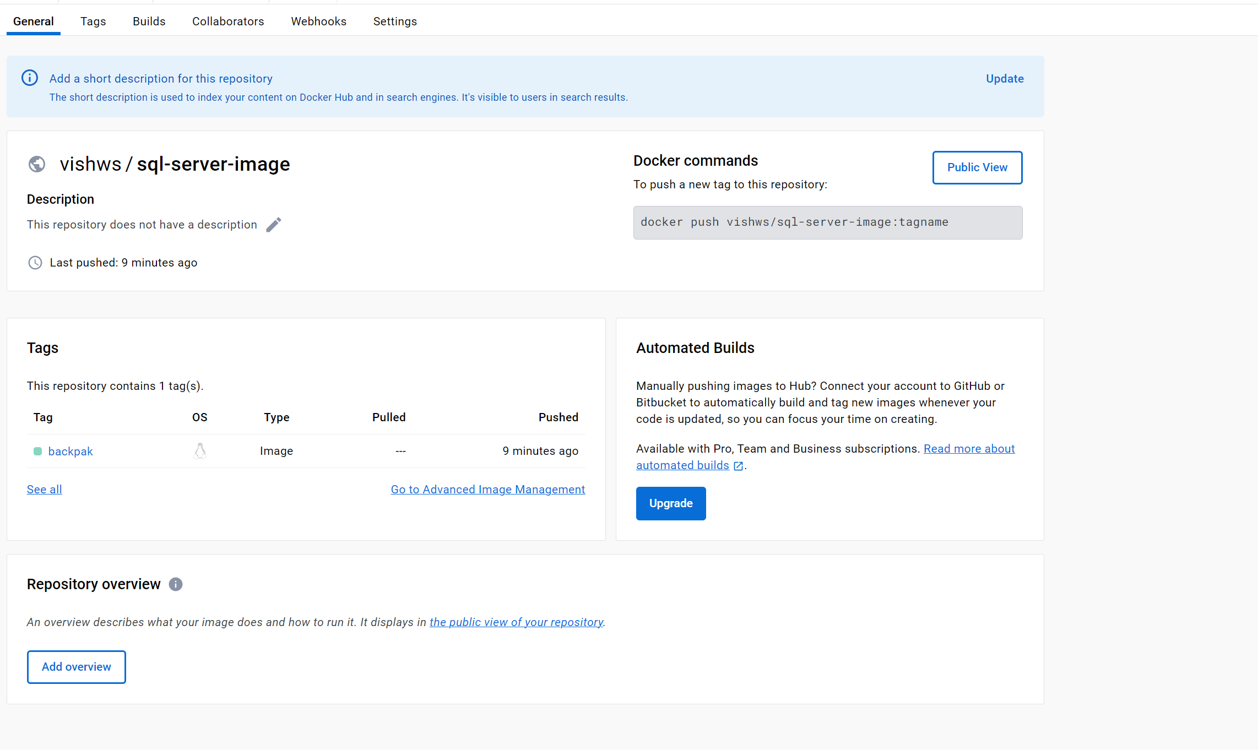

Pull command : docker pull vishws/sql-server-image:backpak

Github location for these files: <https://github.com/vishws/tweeter_project_backend.git> , get the bacpac file to restore my complete db and then web api should , below is the screenshot to restore the backfile manually in sql server for the provided backpac file

