* Published the WEBAPI to docker using Docker in VS

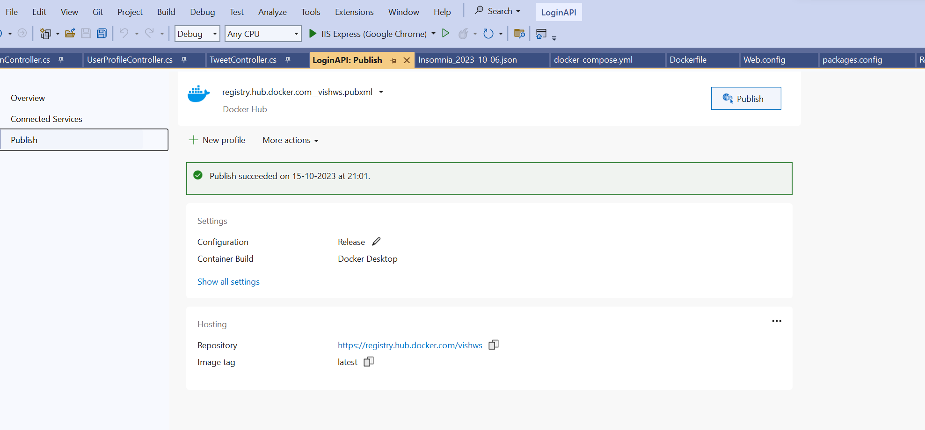

* Same is now available on dockerhub and we can pull and run it

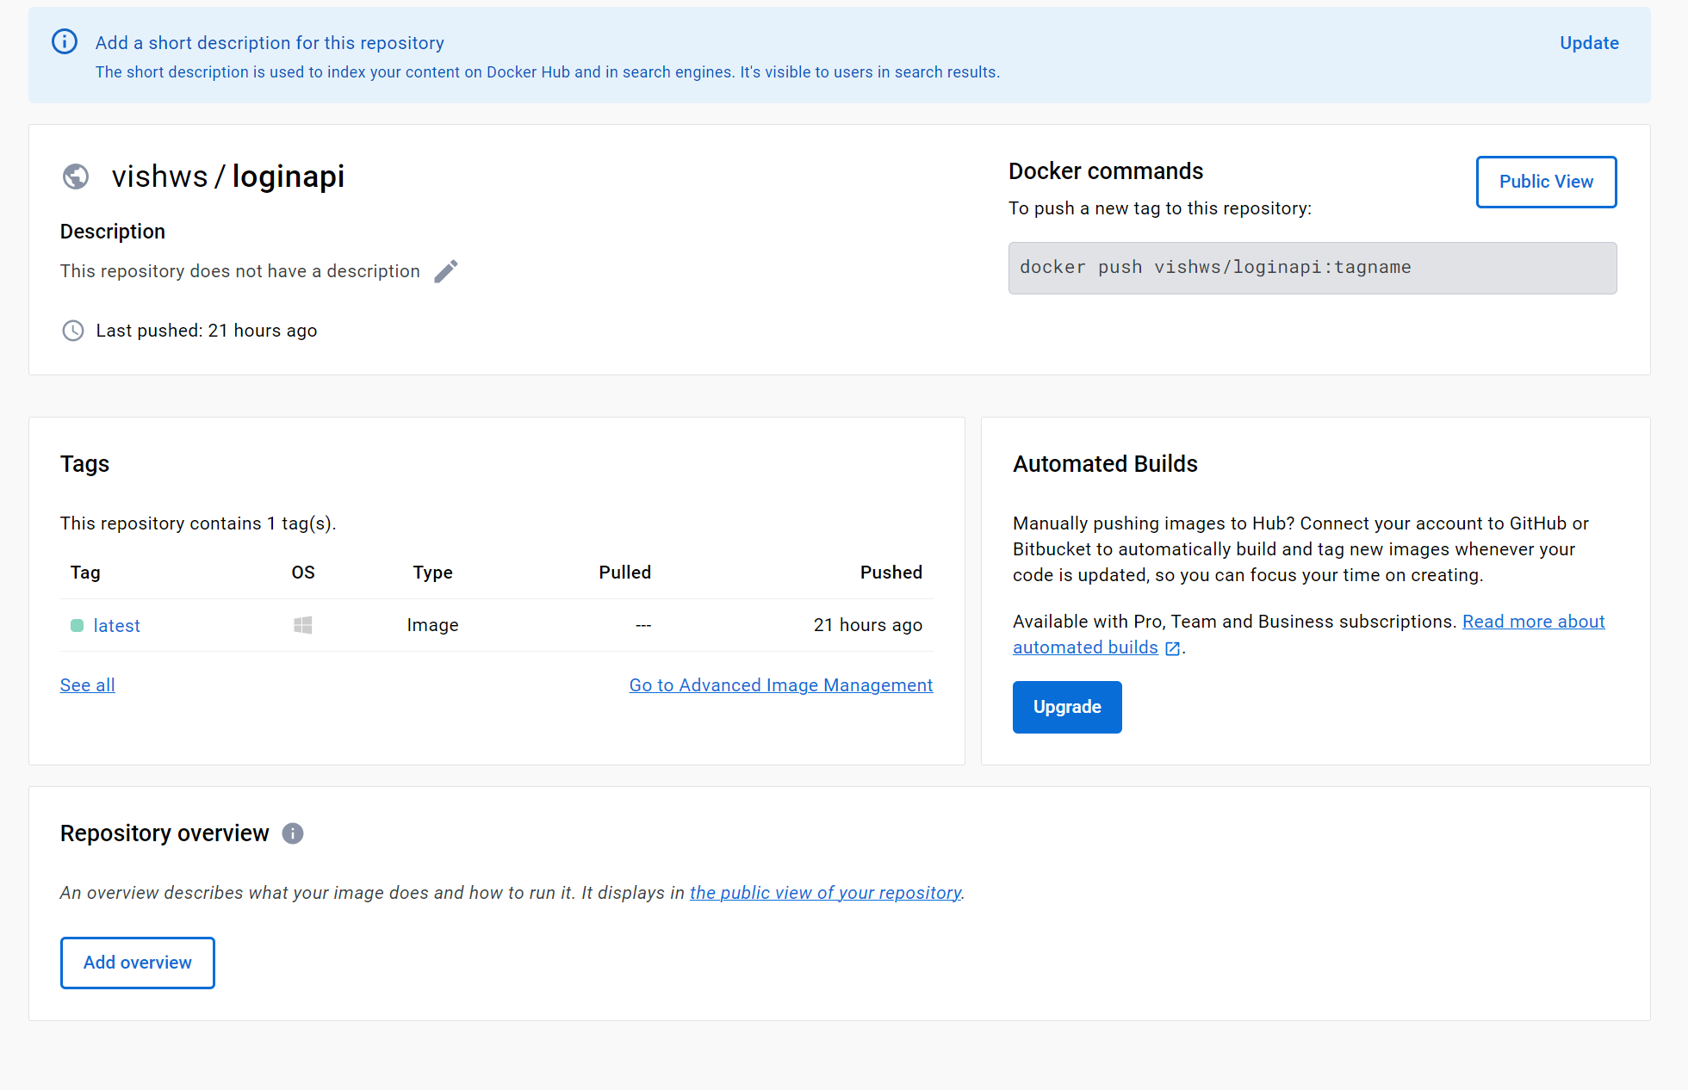

Repository name: loginapi

* Created dockerfile for angular and sql file to push build and generate images locally and then pushed the images to containers which I created in dockerhub

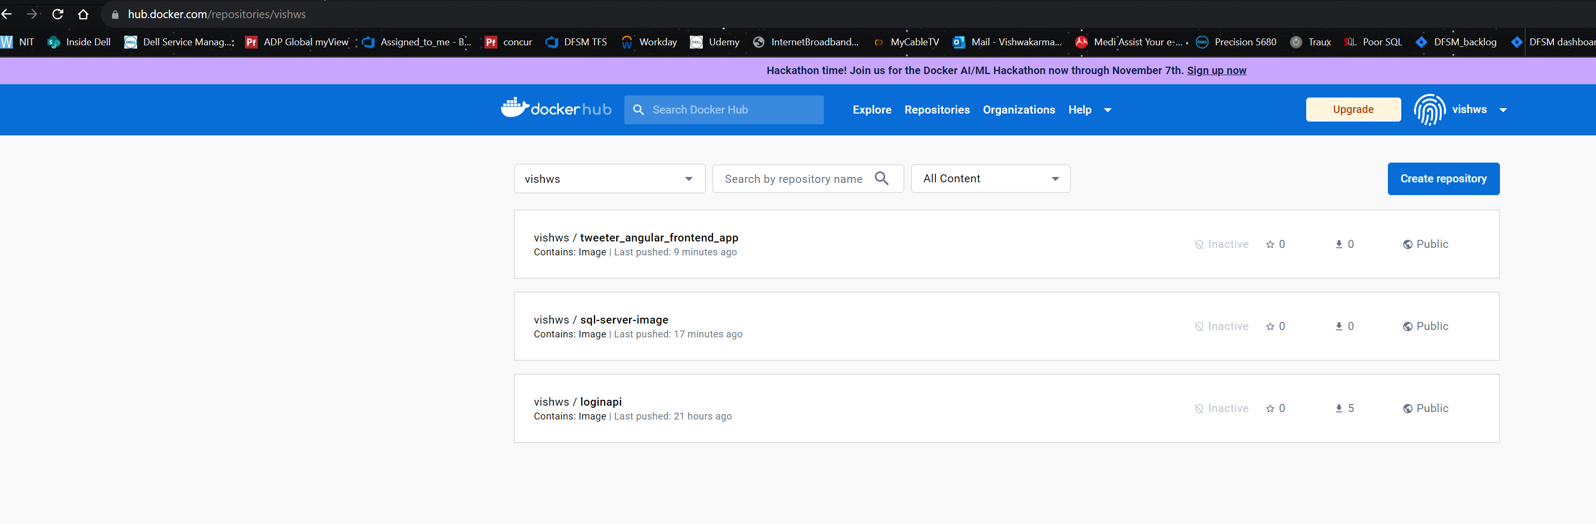

-all the 3 webapi, angular and sql are now pushed to docker and are available to be pulled and run locally

- I have shared the screenshots and pull commands in the screenshot document, do refer it for more details.