Untitled

vishy

October 7, 2015

Top searches for ‘Sysco’ in Twitter

This is an R Markdown document. Markdown is a simple formatting syntax for authoring HTML, PDF, and MS Word documents. For more details on using R Markdown see <http://rmarkdown.rstudio.com>.

When you click the **Knit** button a document will be generated that includes both content as well as the output of any embedded R code chunks within the document. You can embed an R code chunk like this:

## Warning: package 'tm' was built under R version 3.2.2

## Loading required package: NLP

## Warning: package 'NLP' was built under R version 3.2.2

## Warning: package 'topicmodels' was built under R version 3.2.2

## dimension of sysco document term matrix is:

42, 215

## Warning: package 'slam' was built under R version 3.2.2

summary(sysco_term_tfidf)

## Min. 1st Qu. Median Mean 3rd Qu. Max.   
## 0.003855 0.366000 0.449400 0.465600 0.539200 1.348000

optimizing tfidif, i.e, getting values where tfidf>0.1:

summary(col_sums(syscodtm))

## Min. 1st Qu. Median Mean 3rd Qu. Max.   
## 1.000 1.000 1.000 1.902 2.000 14.000

Summary after optimization

dim(syscodtm)

## [1] 42 214

## Warning: package 'wordcloud' was built under R version 3.2.2

## Loading required package: RColorBrewer

## Warning in wordcloud(words = frequent_sysco_terms, freq = word.freq,  
## min.freq = 2, : corpchefkelowna could not be fit on page. It will not be  
## plotted.

## Warning in wordcloud(words = frequent_sysco_terms, freq = word.freq,  
## min.freq = 2, : foodshow could not be fit on page. It will not be plotted.

## Warning in wordcloud(words = frequent_sysco_terms, freq = word.freq,  
## min.freq = 2, : goodthingsbistro could not be fit on page. It will not be  
## plotted.

## Warning in wordcloud(words = frequent_sysco_terms, freq = word.freq,  
## min.freq = 2, : menu could not be fit on page. It will not be plotted.

## Warning in wordcloud(words = frequent_sysco_terms, freq = word.freq,  
## min.freq = 2, : need could not be fit on page. It will not be plotted.

## Warning in wordcloud(words = frequent_sysco_terms, freq = word.freq,  
## min.freq = 2, : now could not be fit on page. It will not be plotted.

## Warning in wordcloud(words = frequent_sysco_terms, freq = word.freq,  
## min.freq = 2, : sayhi could not be fit on page. It will not be plotted.

## Warning in wordcloud(words = frequent_sysco_terms, freq = word.freq,  
## min.freq = 2, : show could not be fit on page. It will not be plotted.

## Warning in wordcloud(words = frequent_sysco_terms, freq = word.freq,  
## min.freq = 2, : sign could not be fit on page. It will not be plotted.

## Warning in wordcloud(words = frequent_sysco_terms, freq = word.freq,  
## min.freq = 2, : sneakpeak could not be fit on page. It will not be plotted.

## Warning in wordcloud(words = frequent_sysco_terms, freq = word.freq,  
## min.freq = 2, : supervisor could not be fit on page. It will not be  
## plotted.

## Warning in wordcloud(words = frequent_sysco_terms, freq = word.freq,  
## min.freq = 2, : togeth could not be fit on page. It will not be plotted.

## Warning in wordcloud(words = frequent_sysco_terms, freq = word.freq,  
## min.freq = 2, : transport could not be fit on page. It will not be plotted.

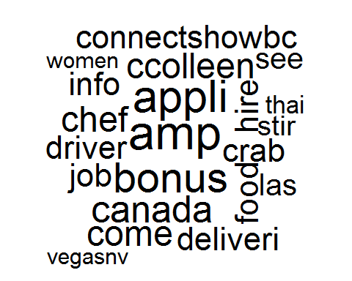 Topic modelling: Applying LDA

## Topic 1 Topic 2 Topic 3 Topic 4 Topic 5   
## [1,] "come" "job" "crab" "las" "food"   
## [2,] "ccolleen" "appli" "thai" "supervisor" "foodshow"  
## [3,] "connectshowbc" "deliveri" "advertis" "transport" "show"   
## [4,] "goodthingsbistro" "driver" "amp" "vegasnv" "need"

Note that the echo = FALSE parameter was added to the code chunk to prevent printing of the R code that generated the plot.