Organisation Name: | Physical 3D
Department: | General Office
SOP Effective Date:
SOP Review Date:

 |  | Name | Job Title | Signature | Effective Date | Review Date
SOP Creator |  | Sonia Welsh | Office Manager |  | 09/04/23 | 09/04/24
Authorised |  | Mel Khan | Director | 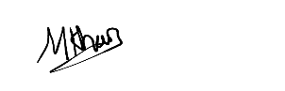 | 23/04/23
Purpose: To establish a consistent, efficient, and safe process for keeping the office clean, tidy, and safe, in order to promote a healthy and productive work environment.
Scope: This SOP applies to all staff members in the office.
Responsibilities:
• All staff members are responsible for maintaining a clean, tidy, and safe work environment.
• The office manager or supervisor is responsible for ensuring that this SOP is followed consistently.

General Cleaning:
Floors should be swept and/or vacuumed regularly to remove any debris or dirt
Trash and Recycling:
Emergency Preparedness:

