Chengdu Technological University

Department: Major: Class student ID: Name: Seat number:

Confidentiality Margin Confidentiality Margin Confidentiality Margin
Final Exam Paper for Spring 2025 Semester

Exam Subjects: Discrete Mathematics (Paper B )Exam Duration: 120 m Exam Format: Closed-Book
Exam Cohort: Computer Science and Technology International Cohort ( Fall 2024 )

Question Number | Section Ⅰ | Section Ⅱ | Section Ⅲ | Section Ⅳ | Score Aggregator | Score Consolidator | Verification Officer
Score
Notes:
- The exam paper has 100 points in total, and its surface is clean, the handwriting is neat, and there are no typos.
2.The name, class, and student ID must be filled out completely, accurately, and clearly in the designated area of the exam paper, otherwise it will be considered invalid.
3. Examinee must sign in on the attendance sheet. If there is any omission, the consequences will be borne by oneself.
4.If there is an answer sheet, please fill in all the answers on the answer sheet, otherwise no points will be given.
5. Please return the answer sheet and test paper together after the exam, otherwise no points will be given.
6. Please answer in Chinese or in English.
Examination Questions
Score | Grading Examiner
Section Ⅰ Single Choice Questions
Directions:
In this section, there are 15 questions from 1 to 15, each of which is provided with four choices A, B, C and D. Choose the best answer, and then mark the corresponding letter on the ANSWER SHEET with a single line through the center. (2 points each, 30 points in all)
1. Indicate which of the following sentence is a compound proposition ( ).
A. I am lying. B. Tomorrow is sunny.
C. Life exists on Mars. D. George Boole is not a boy.
2. Translate the given statements into proposition logic expressions using the propositions provided. Two triangles are congruent if and only if their three corresponding sides are equal. Express your answer in terms of p: “ Two triangles are congruent.” and q: “The three corresponding sides of two triangles are equal.” ( ).
A. B. C. D.
3. In predicate formula A=, the variable y is ( ).
A. free B. bound C. uncertain D. both and free
4. Negation of the statement “Not everyone likes flowers.” is ( ).
A. All people like flowers. B. Some people don't like flowers.
C. Some people like flowers. D. All people don't like flowers.
5. Let A ={1, 2, 3, 4} and B ={4, 5, 6}. Consider the following statements:
(i) A and B are joint sets; (ii) A∪B is a singleton set; (iii) A∪B is a null set; (iv) |A∪B|= 6.
Which of the following statements are true ( )?
- (i) & (ii) B. (i) & (iv) C. (i) & (iii) D. (ii)&(iv)
6. Which of the following is an equivalence relation on the set A={a, b, c, d} ( ) ?
A. {<a,b>, <a,a>, <b,a>,<b,b>,<c,c>,<d,d>} B. {<a,b>, <b,a>,<b,c>,<c,d>}
C. {<a,b>, <a,a>, <b,a>} D. {<a,b>, <a,a>, <b,a>,<b,b>,<c,c>}
7. If A = {1, 2, 3} and R = {<1, 2>, <2, 3>, <1, 3>} is a relation on A, then R is ( ).
A. reflexive and transitive B. reflexive and symmetric
C. irreflexive, anti-symmetric and transitive D. symmetric but not transitive
8. Which of the arrow diagrams in Figure define a function from X={a, b, c} to Y={1, 2, 3} ( )?
- 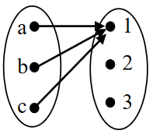 B. 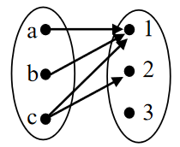 C. 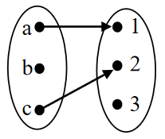 D. 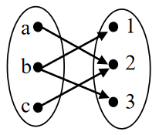
- Assuming D=(V, E) is a simple directed graph, if there is a path from a to b and from b to a whenever a and b are vertices in V, then this graph is ( )?
- unilaterally connected B. unconnected graph
C. strongly connected D.weakly connected
10.Which of the following graph is non-isomorphic to the graph in figure ( )?
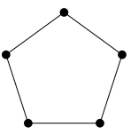
( Figure of Question 10)
A. 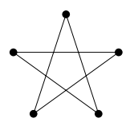 B. 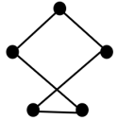 C. 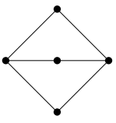 D. 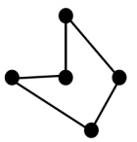
11. The out-degree(v₁) of vertex v₁ in the following graph G is ( )?
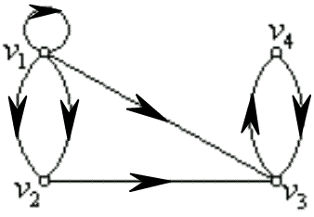
( Figure of Question 11)
- 4 B. 5 C. 1 D. 3
12. Which graph in the following is both an Euler graph and a Hamilton graph ( ).
A. 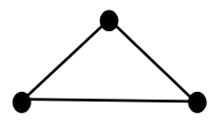 B. 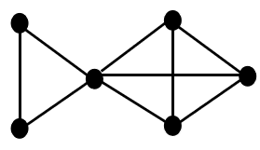 C. 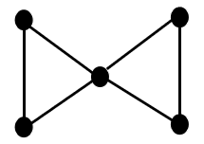 D. 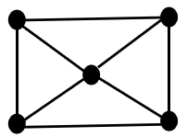
13. Let <{a, b ,c , e}, *> is an algebraic system, and the operation * is defined as follows, then its identity element is ( ).
* | e | a | b | c
e | e | a | b | c
a | a | e | c | b
b | b | c | e | a
c | c | b | a | e
( Table of Question 13)
- a B. b C. c D. e
- Define several a operations “☉” on the integer set Z, which one satisfies the associative law ( )?
- a☉b=ab+a B. a☉b=a+3b C. a☉b= ab+a-b D. a☉b = a
15. Assuming N is the natural number set, which of the following operations “*” is not defined as a binary operation on N ( )?
A. a*b = a+b B. a*b = a-b C. a*b= a D. a*b= b
Score | Grading Examiner
Section Ⅱ True or False Questions
Directions:
In this section, there are 10 sentences from 16 to 25. Each one, write “T” for true and “F” for false. Then, mark the corresponding letter on the ANSWER SHEET with a single line through the center. (1 point each, 10 points in all)
( )16. The negation of the sentence “2 + 2 = 4” is the sentence “2 + 2 = 5”.
( )17. The wff ¬(¬p∨q)∧q is not a contradiction.
( )18. ∀xP(x)→∃xP(x) is valid.
( )19. P(x) is a one-place predicate.
( )20. Let A={a, b, c}, and R={<a, a>, <b, b>, <c, c>, <a, b>} is a relation defined on A, then R is a equivalence relation.
( )21.Assuming f : N→N defined as f (x)=x²−4x+1, then it is a many-one function ( N is the natural number set).
( )22. T is tree T is connected and m＝n－1.
( )23. In an undirected graph, the sum of the degrees of all vertices is equal to twice the number of edges.
( )24. Neither addition nor multiplication operations satisfies the associative law over the set of real numbers.
( )25. Let the set X={0,1}, then the operation addition is closed on set X.
Score | Grading Examiner
Section Ⅲ Blank-filling Questions
Confidentiality Margin Confidentiality Margin Confidentiality Margin
Directions:
In this section, there are 10 questions from 26 to 30. Write your answers in the corresponding positions on the ANSWER SHEET. ( 1 point each blank, 10 points in all )
26. Let p, q, and r be the propositions:
p: You have the flu. q: You miss the final examination. r: You pass the course.
Translate the given statements into proposition logic expressions using the positions provided.
Statement 1: If you miss the final examination, you will not pass the course.
Statement 2: You have flu, or miss the final examination, or also pass the course .
27. Let P(x): x=5 and the universe of discourse for x is the set {1, 2, 3, 4}, then the truth value of ∃x(P(x) is
28. Let A={a, b, c}, R={<a, a>,<a, b>,<a, c>} and S={<a,a>,<b,a>} are both relations on the set A, then the inverse of S is , the power set of A is , Which is a function, R or S? .
29. The undirected graph G is shown in the figure below. Then, draw the complement graph of G ; and determine which of G and its complement is(are) planar graph(s) .
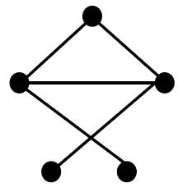
( Figure of Question 29)
30. Define a binary operation a*b as: a*b=a on integer number set Z, then (-5)*(-5)= , and determine whether this operation satisfies the commutative law (answer yes or no) .
Score | Grading Examiner
Section Ⅳ Problem-Solving Questions
Directions:
In this section, there are 5 questions from 31 to 35. Write your answer in the corresponding positions on the ANSWER SHEET. ( 6 points for Question 31, 10 points for Question 32, 16 points for Question 33, 8 points for Question 34, 10 points for Question 35, 50 points in all )
- We designed a Digital Logic Circuits shown in the figure. p and q be the input signals, where each may be either logic 0 or logic 1. Then answer the following questions:
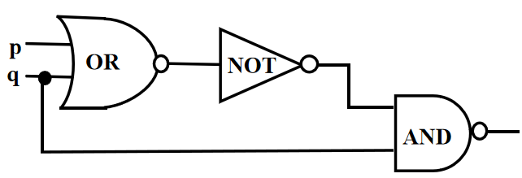
( Figure of Question 31)
- (2 points) Write the logical expression of this digital circuit with p, q and propositional connectives;
- (4 points) Construct the input/output table for the designed Digital Logic Circuits;
32. (10 points) Given the premises: ﹁p∨q, r∨﹁q, r→s, get the conclusion: p→s.
Department: Major: Class student ID: Name: Seat number:

Confidentiality Margin Confidentiality Margin Confidentiality Margin
33. Let U={a, b, c, d, e, f} be the universal set, and let A={a, b, c, d} and B={c, d, e} be two subsets of U. Let R={<a, a>, <b, b>, <c, c>, <d, d>, <a, b>, <b, a>, <b, d>, <d, b>} is a relation defined on the set A. Try answering the following questions:
(1)(2 points) Find the complement of B ( denoted as B^{C} ) with respect to the universal set U;
(2)(2 points) Find the intersection of A and B ( denoted as A∩B);
(3)(2 points) Find the Cartesian product of A and B ( denoted as B^{C}×(A∩B));
(4)(4 points) Draw the directed graph (diagraph) of the relation R;
(5)(4 points) Write the matrix that represents R;
(6)(3 points) State the properties of R.
34. (8 points) For the digraph D=<V, E>, where V={A, B ,C, D}, and its adjacent Matrix is A =. Find the in-degree and out-degree of each vertex.
35. Let A ={a, b, c, d} is a set, R is a lattice on A, the Hasse diagram of R is shown below, then try to answer the following questions:
(1) (4 points) Represent the relation R using set;
(2) (6 points) Fill in the blank cells of the following table.
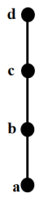
( Figure of Question 35)
(Table of Question 35)
Subset of A | The least upper bound of B_{i} (i=1,2,...,6) | The greatest lower bound of B_{i} (i=1,2,...,6)
B₁={a, b} | {b} | {a}
B₂={a, c}
B₃={a, d}
B₄={b, c} | {c} | {b}
B₅={b, d}
B₆={c, d} | {d} | {c}

